CIRRASPEC Biobank Site  
User’s Manual

System Version: 3.0

Revision History

|  |  |  |  |
| --- | --- | --- | --- |
| **Document Version** | **Date** | **Name** | **Description** |
| 3.0 | 1/15/2018 | Sayali Dev | User Manual Created for Biobank user |

**Table of Contents**

Revision History 2

Accessing the Application 7

Login Guidelines 7

Logging into the Application 7

Logging off the Application 8

Accessing the Home Page 9

Accessing the My Account Page 10

To set user profiles on My Account page : 11

Site Settings 11

Changing Your Password 11

Navigating through the application 12

Workflow for Biobank Research Technician – At Biobank site 15

Create and Assemble Kits 16

Viewing the Kit Search Page 16

Searching for a Kit 18

Viewing Kit Details 20

Viewing the Status History for a Kit Content 23

Generating a Kit Manifest 24

Generating a Label from the Kit Search Page 25

Downloading all Forms Associated with a Kit 28

Distributing a Kit 29

Create and Send Kits 30

Adding a Kit Item 35

Deleting a Kit Item 37

Adding Product Information for a Kit Item 39

Assigning an Identifier to a Kit Item 41

Printing a Barcode Label While Viewing a Kit 42

Downloading a Form While Viewing a Kit 44

Create Kits shipment and send to the Collection site 45

Creating a Kits Shipment 45

Modifying/Deleting a Kits Shipment 47

Viewing a List of Kit Shipments 48

Sending a Kits Shipment 49

Receive Specimens Shipments and Check in samples into the Inventory 51

Viewing the Shipment Search Page 51

Searching for a Shipment 53

Viewing Shipment Details 55

Printing a Shipment Report 57

Receiving a Biospecimens Shipment 58

Checking In a Biospecimens Shipment 60

Checking In Biospecimens in Bulk 66

Create and Manage Worklists 76

Viewing a List of Worklists 76

Searching for a Worklist 77

Viewing Worklist Details 79

Creating a Worklist 82

Modifying a Worklist 86

Deleting a Worklist 90

Adding an Event for Worklist Biospecimens 91

Assigning Storage for Worklist Biospecimens 94

Generating a Label for Worklist Biospecimens 98

Generating a Report for Worklist Biospecimens 100

Initiating a Workflow Process for Worklist Biospecimens 101

Modifying Worklist Biospecimens 102

Move worklist biospecimens to a bulk container 104

Adding a Biospecimens Shipment to a Worklist 106

Uploading a File for Worklist Biospecimens 112

Search and Modify workflows, Perform Sample Processing Workflows and Generate Reports 114

Initiating a Workflow 114

Viewing a List of Sample Processing Workflows 120

Searching for a Workflow 121

Using the Search Samples and Worklists Window 123

Viewing the Workflow Details 126

Modifying a Workflow 128

Confirming a Workflow 134

Adding a New Identifier 137

Assigning a Storage Location to Workflow Biospecimens 138

Adding Workflow Biospecimens to a Worklist 142

Generating a Workflow Process Report 144

Generating a Barcode Label for a Workflow Biospecimen 145

Uploading Files for Workflow Biospecimens 146

Accessing a Workflow Processing Form 149

Enroll Subjects/Donor/Patients and View subjects, Modify Forms, Update Collection Event, Attach Files: 152

Viewing a list of Subjects 152

Searching for a Subject 153

Viewing the Subject Details 155

Creating a Subject 157

Adding a New Identifier to a Subject 158

Printing a Subject Label 159

Viewing the Collection Event Details 160

Modifying the Collection Event Details 161

Assigning a Kit to a Collection Event 163

Assigning a Non Kit Item to a Collection Event 165

Viewing the Form Details 167

Modifying the Form Details 169

Changing the Status of a Form 171

Printing a Form 173

Other Tasks: 175

Perform Redistribution shipments 175

Creating a Redistribution Shipment 175

Modifying a Redistribution Shipment 178

Deleting Redistribution Shipment 180

Sending a Redistribution Shipment 181

Recording Receipt of a Redistribution Shipment 183

In Inventory, Find, View and Manage Biospecimens 185

Searching for a Biospecimen 185

Creating Inventory 188

Generating a Biospecimen Report 190

Adding a Biospecimen to a Worklist 191

Viewing Biospecimen Details 195

Printing a Barcode Label for a Biospecimen 200

Modifying the Biospecimen Information 202

Deleting a Biospecimen 209

Updating a Specimen Collection Form for a Biospecimen 211

Perform Actions on a group of biospecimens 216

Using the Search Samples and Worklists Window 217

Filtering the Search Results List 220

Adding a New Identifier on the Inventory Bulk Modifications Page 221

Modifying Biospecimens in Bulk 222

Uploading Files in Bulk 225

Adding an Event in Bulk 228

Assigning a Storage Location in Bulk 231

Generating a Report for Biospecimens in Bulk 235

Deleting Biospecimens in Bulk 236

Generating Labels for Biospecimens in Bulk 238

Search by Date Ranges, Change Search Results display, Manage Events and Upload Files 240

Understanding the Date Range Search Options 240

Changing the Search Results Display 242

Changing the Number of Records Per Page 242

Changing the Display Columns 243

Sorting Search Results 244

Managing Events 247

Viewing an Event 247

Creating an Event 249

Changing the Status of an Event 251

Viewing or Adding Comments to an Event 252

Adding an Action for an Event 253

Viewing the Actions Associated with an Event 254

Common File Upload 255

Uploading a File 255

Downloading a File 258

Deleting a File 259

Upload Data using predefined spreadsheets 260

Uploading an Inventory Bulk spreadsheet 263

Uploading a Kit Creation / Shipment spreadsheet 268

Uploading a Batch Specimen Shipment spreadsheet 272

Uploading a Redistribution Shipment between Biobank spreadsheet 279

Uploading a Forms spreadsheet 283

Uploading a LIMS Workflow spreadsheet 286

Reports 289

Viewing Reports Page 289

View Dashboard 290

View Shipment Status 291

View Inventory Status 292

View Study Specimen Location 293

Custom Report Generation 294

Alternative Paths on Home Page for Common Use Functionalities: 295

# 

# Accessing the Application

To access the CIRRASPEC application, you must have a valid user name and password.

### Login Guidelines

* The password must contain a minimum of six characters and is case sensitive.
* The password must contain at least one alphabet, one number and one special character such as !, @, #, &, etc.
* The application prompts you to change your password after you login for the first time. For more information about how to change your password, see **Changing Your Password**.
* This application supports the following browsers:
  + Firefox 3.5 and above
  + IE 8.0 and above
* You must not run IE 8.0 in the Compatibility mode. You can check the IE compatibility view by clicking **Tools** > **Compatibility View settings**.
* You must ensure that any pop-up blocker software is turned off.

## Logging into the Application

To log in:

1. Enter CIRRASPEC web site URL In the address bar of a Web browser.

The **Login** page appears.

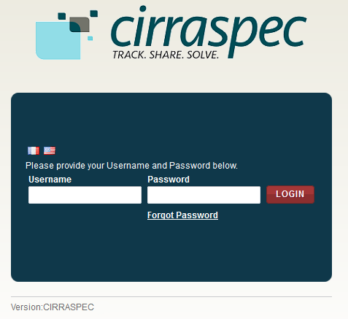

1. In the **Username** box, type your username and in the **Password** box, type your password.

**Note:**

If you have forgotten your login credentials or need login assistance, send an e-mail to [cirraspec@tgen.org](mailto:Bio4Dhelp@tgen.org).

1. Click **Login**.

The CIRRASPEC **home page** appears.

On top right, below the My Account link, Home page displays Welcome note:“Welcome User Sitename”

**Note:**

* If you have more than one assigned collection site locations, you are prompted to select the appropriate location for this Web session.
* Click on **SAVE,** the home page displays the location selected on top right Welcome note.

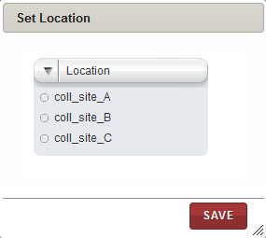

## Logging off the Application

To log off from the application, in the upper-right corner of any page, click the **Logout** link.

On successful logout, The **Login** page appears.

## Accessing the Home Page

You can access the CIRRASPEC home page from any other page by clicking the **Home** tab.

1. Allows you to access the CIRRASPEC home page
2. Allows you to access your account for password and user profile maintenance
3. Welcome note displaying user logging to the site
4. Allows you to log off from the application.
5. Easy Access Links

2

4

3

1

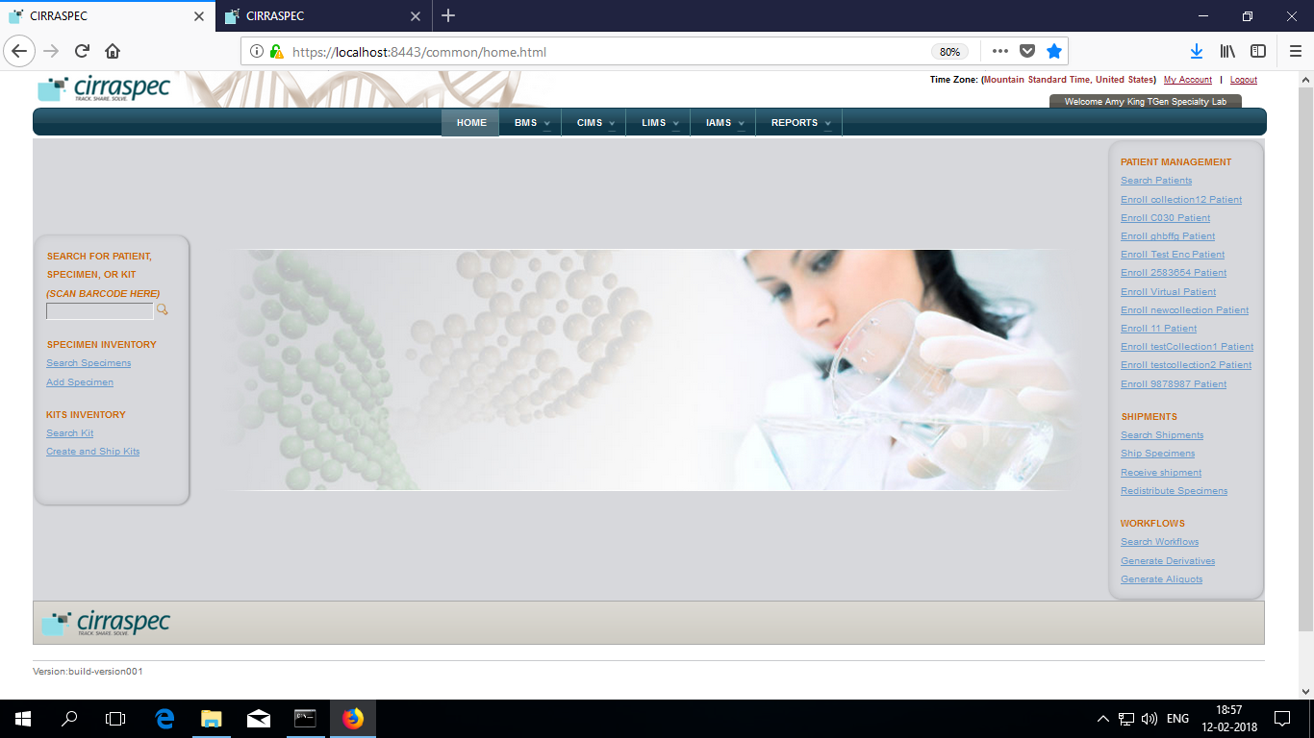

5

5

## Accessing the My Account Page

You can use the My Account page to update your user profile (language and location preferences) and your login password.

To access the **My Account** page:

1. In the upper-right corner of any page, click the **My Account** link.

The **My Account** page appears.

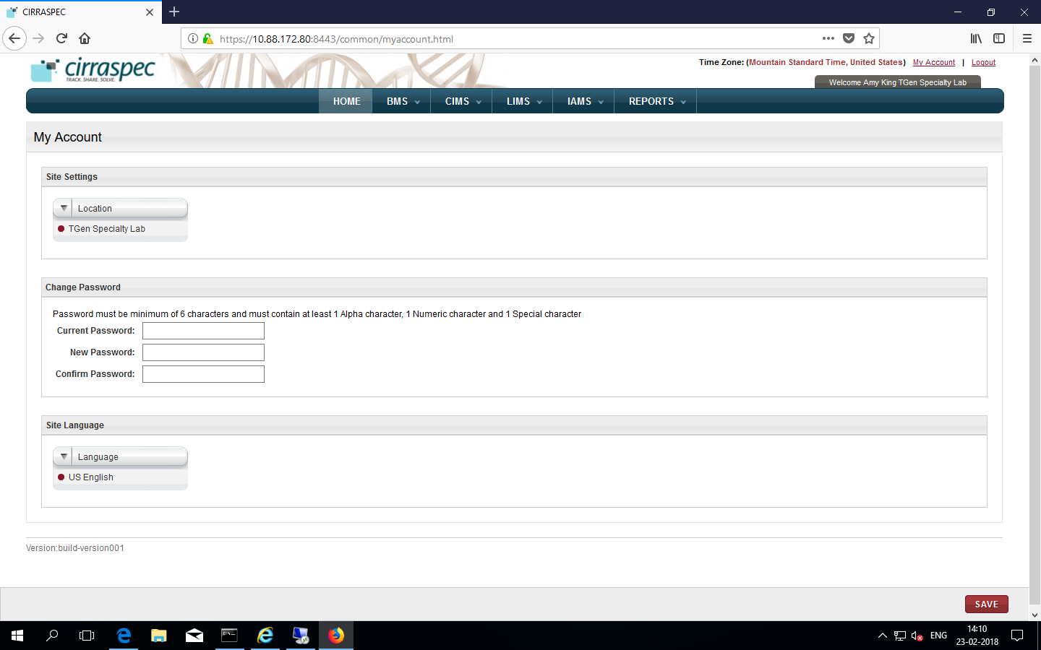

### 

### To set user profiles on My Account page :

### Site Settings

Allows you to select a different collection site location to view information and perform tasks associated with that location.

To select a different location:

1. Click on the **Location** list dropdown arrow.

Locations list displays all locations assigned to you based on your user role and access permissions.

1. Select the desired location.
2. Click **SAVE**.

The location is updated. Information associated with that location is displayed on the CIRRASPEC pages.

### Changing Your Password

Allows you to update the password for login to Cirraspec application.

Password Guidelines:

* The password must contain a minimum of six characters and is case sensitive.
* The password must contain at least one alphabet, one number and one special character such as !, @, #, &, etc.

To change your password:

1. In the **Current Password** boxof the **Change Password** area, type your current password.
2. In the **New Password** box, type a new password.
3. In the **Confirm Password** box, type the new password again.
4. Click **SAVE**.  
   Your password is changed.

**Note:** For assistance with the username or password, send an email to [cirraspec@tgen.org](mailto:Bio4Dhelp@tgen.org)

# 

# Navigating through the application

**NOTE**: You can scan barcode for the specimen /kit to enter source identifiers into the application.

BMS tab:

|  |  |  |
| --- | --- | --- |
| Tab | Function | Events: |
| Bulk Modifications | Allows to search and perform activities on batches or on group of biospecimens. | Assigning Storage Locations, modifying biospecimens, uploading files, adding events, generating labels |
| Inventory | Allows to search for biospecimens, view biospecimen details and modify theinventory records.  Allows to create inventory. | View, print label, modify information, complete form, generate report, add to worklist, delete biospecimens |
| Kits Inventory | Allows to perform kit related activities. | Search kits, modify kit contents, generate reports, print labels, download forms. |
| Kits Shipment | Allows to receive kits shipments | Receive Shipments, Check the Biospecimens into inventory Redistribute shipment |
| Shipments | Allows to ship kits from collection site to biobank sites. | Create kits shipment, send shipment,  Modify/delete kits shipments |
| Worklists | Allows you to create and work on a group of biospecimens as a worklist | Define, search worklists, upate information, generate labels |

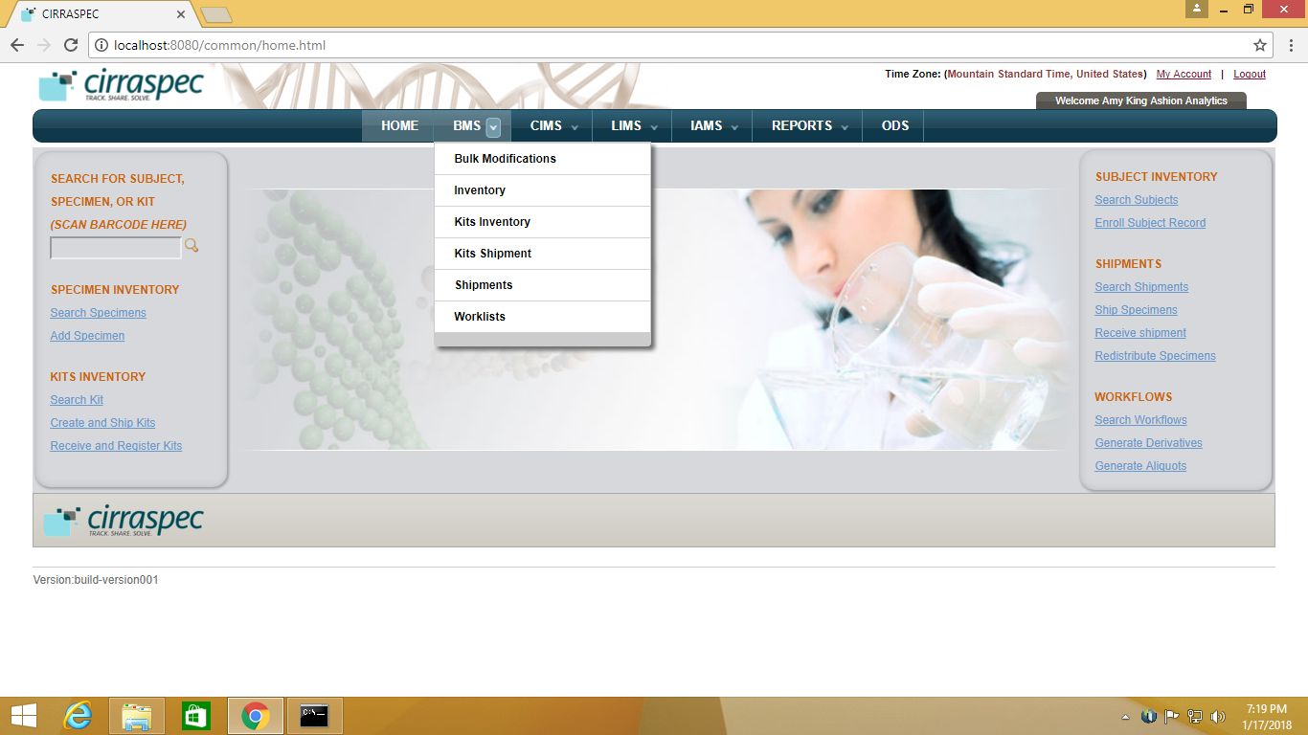

CIMS tab:

|  |  |  |
| --- | --- | --- |
| Tab | Function | Events |
| Subject Centric View | Allows subject /donor / patient mangement | Update forms, assign kits to collection events, collect subject specimens, download reports. |

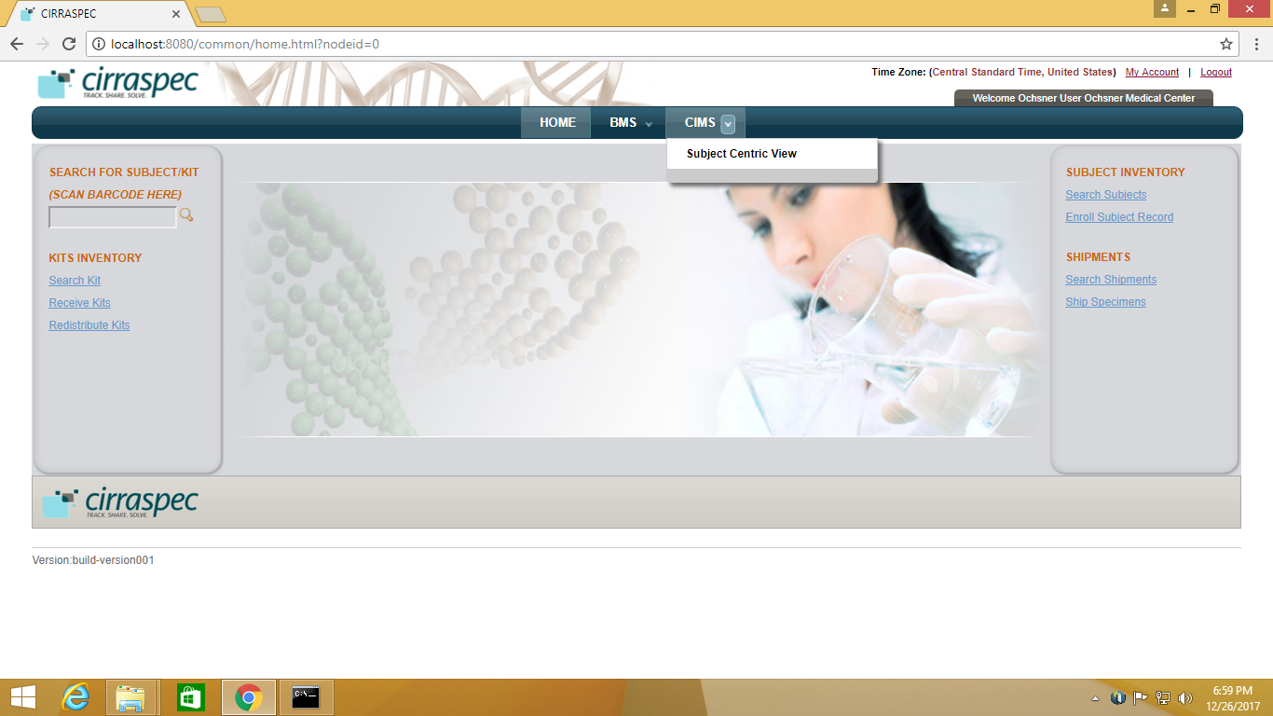

LIMS tab:

|  |  |  |
| --- | --- | --- |
| Tab | Function | Events |
| Workflows | Allwos to create sample processing workflows | Create workflows, View and Modify Workflows, Manage Workflows |

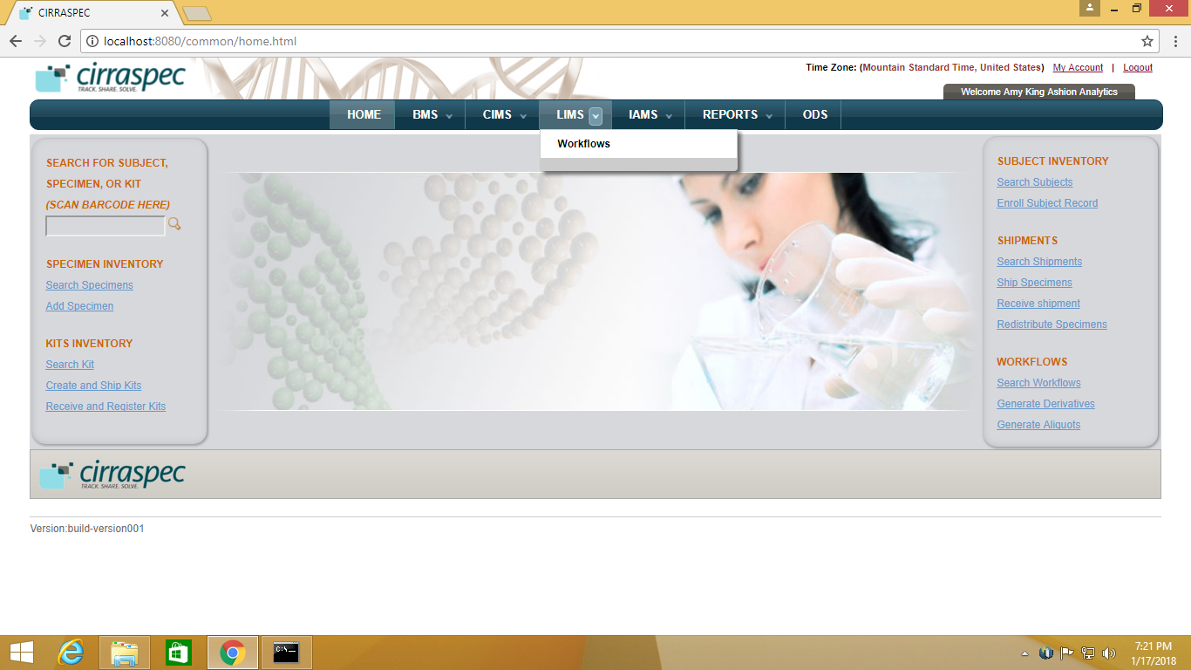

IAMS tab:

|  |  |  |
| --- | --- | --- |
| Tab | Function | Events |
| Import Data | Allows to import data by uploading a pre-defined spreadsheet templates | Process Template Upload, Inventory Bulk Upload template, Kit Creation / Shipment template  Batch Specimen Shipment template  Create Subjects template upload, Create Forms template upload, LIMS Workflow Upload template |



Reports Tab:

|  |  |  |
| --- | --- | --- |
| Tab | Function | Events |
| Reports | Allows you to view reports | View Dashboard, View Shipment Status Report, View Specimen Study Location Dashboard, View Inventory Status report,  Search and View Custom Report |



# Workflow for Biobank Research Technician – At Biobank site

**Common workflow:**

Create and Assemble Kits *on page 16*

Create Kits shipment and send to the Collection site *on page 45*

Receive Specimen Shipments and Check in samples into the Inventory *on page 51*

Create and Manage Worklists *on page 76*

Search and Modify workflows, Perform Sample Processing Workflows and Generate Reports *on page 114*

Enroll Subjects/Donor/Patients and View subjects, Modify Forms, Update Collection Event, Attach Files

*on page 152*

**Other tasks:**

Perform Redistribution shipments *on page 175*

Find, View and Manage Biospecimens In Inventory *on page 185*

Perform Actions on a group of biospecimens (Bulk) *on page 216*

Search by Date Ranges, Change Results display, Manage Events and Upload Files *on page 240*

Upload Data for Forms/Workflows/Processes/Donor/Inventory using predefined spreadsheets *on page 260*

View and Download Reports *on page 289*

**Easy links on Home Page for Common tasks** *on page 295*

# Create and Assemble Kits

### Viewing the Kit Search Page

You can view a list of subjects biospecimen kits that are ready for distribution or are distributed to a Collection Site.

To view the list of subjects biospecimen kits:

1. Log into the application using your logon credentials.

**Note:** If you have more than one assigned location, you are prompted to select the location for which you want to access CIRRASPEC data.

1. Point to the arrow of the **BMS** tab, and then click **Kits Inventory**.   
   The **Kit Search** page appears.
2. Click **SEARCH**.  
   The kit search page displays a list of all kits that are accessible based on your login location.

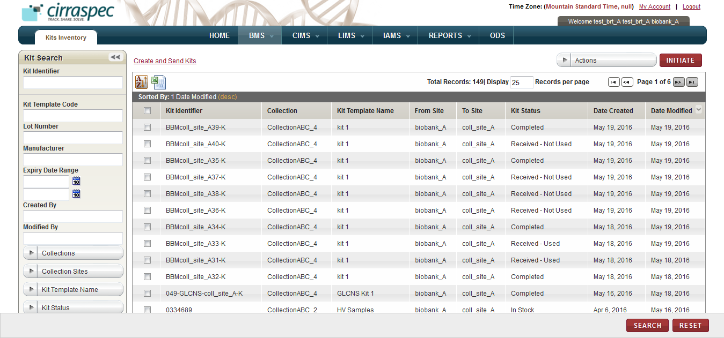

1. Kit Search page

For information about how to sort the kits list, change the column display and/or the number of records per page, see **Changing Search Results Display**

On the kit search page, all CIRRASPEC users can perform the following tasks:

* **Print a kit list as an excel spreadsheet:** Click the **Export current view to CSV** icon 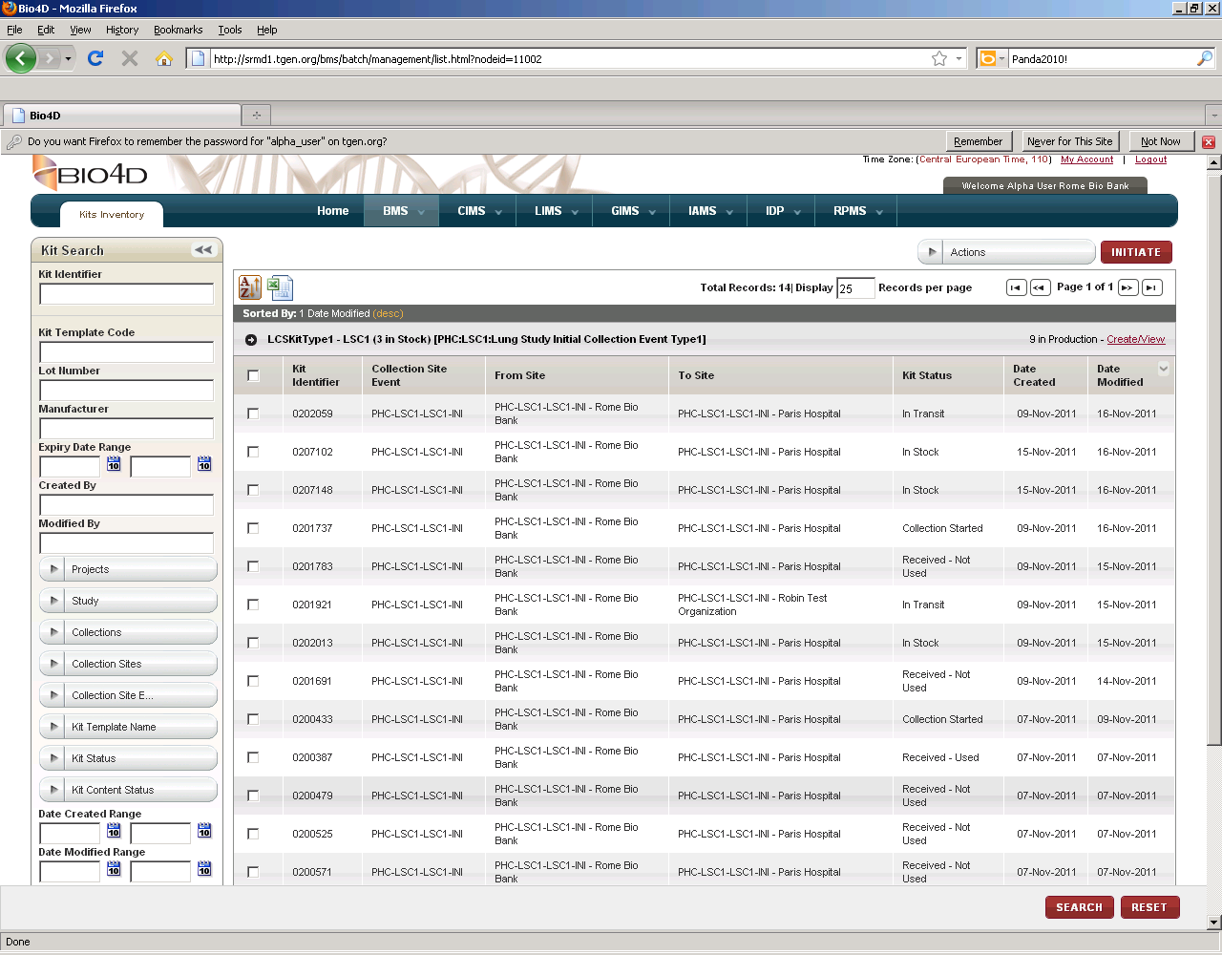, and then in the **File Download** window, click **Save**. The kit list file is saved to your machine for viewing/printing.
* **Perform a search for a kit**: For more information about how to search for a specific kit or a group of kits, see **Searching for a Kit**.
* **View details of a kit:** For more information about how to view the details of a kit, see **Viewing Kit Details**.
* **Generate a kit manifest:** For more information about how to generate a kit manifest, see **Generating a Kit Manifest**.
* **Generate barcode labels for a kit:** For more information about how to generate barcode labels, see **Generating a Label from the Kit Search Page**.
* **View, print, and save all forms for a kit:** For more information about how to download forms, see **Downloading all Forms Associated with a Kit****.**

On the kit search page, you can perform the following tasks as a Biobank user:

* **Create a new kit:** For more information about how to create a new a kit, see **Creating a Kit****.**
* **Distribute a kit**: For more information about how to distribute kit, see **Distributing a Kit****.**

### Searching for a Kit

To search for a specific kit or a group of kits that is ready for distribution or is distributed:

1. Point to the arrow of the **BMS** tab, and then click **Kits Inventory**.   
   The **Kit Search** page displays the Kit Search pane on left.

Arrow hides/displays

the Kit Search pane



1. Kit Search page
2. Specify your search criteria by completing one or more fields in the **Kit Search** pane.

**Note:**

* You can use one field or a combination of fields to search for a kit.
* You can type the full or partial value in a search field along with an asterisk (*) before or after the partial value. For example, if you type **02\***, you obtain records that begin with 02. If you type **\*02**, you obtain records that end with 02

Following table lists each search field and its description:

**Table 1: Kit Search Fields**

| **Field** | **Description** |
| --- | --- |
| **Kit Identifier** | Type or scan the identifier of the kit that you want to search for. |
| **Kit Template Code** | Type the kit template code to search for the group of kits associated with this code. |
| **Lot Number** | Type the lot number to search for kits associated with this lot number. |
| **Manufacturer** | Type the name of a manufacturer to search for kits associated with this manufacturer. |
| **Expiry Date Range** | Click the date icon and then in the pop-up, select the appropriate date option to search for kits that expire in this timeframe.  For more information, see **Understanding the Date Range Options** |
| **Created By** | Type the login username of the user to search for kits created by that user. |
| **Modified By** | Type the login username of the user to search for kits modified by that user. |
| **Collections** | Select the appropriate collection to search for kits associated with this collection.  **Note:** To search for kits associated with all the collections, Select **All**. |
| **Collection Sites** | Select the appropriate collection site to search for kits associated with this collection site.  **Note:** To search for kits associated with all the collection sites, Select **All**. |
| **Kit Template Name** | Select the appropriate kit template to search for kits associated with this kit template.  **Note:** To search for kits associated with all the kit templates, Select **All**. |
| **Kit Status** | Select the appropriate kit status to search for kits with this status.  **Note:** To search for kits with any status, Select **All**. |
| **Kit Content Status** | Select the appropriate kit content status to search for kit contents with this status.  **Note:** To search for kit content with any status, Select **All**. |
| **Date Created Range** | Click the date icon and then in the pop-up, select the appropriate date option to search for kits created in this timeframe.  For more information, see **Understanding the Date Range Options** |
| **Date Modified Range** | Click the date icon and then in the pop-up, select the appropriate date option to search for kits modified in this timeframe.  For more information, see **Understanding the Date Range Options** |

1. Click **SEARCH**.  
   The search results appear.   
   **Note:**

* The list displays all kits that are accessible based on your login location.
* Click the header of the column with which you want to sort the results. For more information about how to sort the search results, see **Sorting Search Results**

NOTE:

* All kits created by all assigned BRT on this site are seen on the kits view page.

### Viewing Kit Details

You can view the contents of a kit and the data collection forms that are associated with this kit.

To view kit details:

1. Log into the application using your login credentials.

**Note:** If you have more than one assigned location, you are prompted to select the location for which you want to access CIRRASPEC data.  
The home page appears.

1. Point to the arrow of the **BMS** tab, and then click **Kits Inventory**.

The **Kit Search** page appears.

1. Click **SEARCH**.

The kit search page displays a list of all kits that are accessible based on your login location.

1. On the list of kits, click on the identifier row of the kit you want to view.

The **View Kit** page appears.

**Note:** To expand the **Comments History** box to display additional previous comments, click the expand icon .

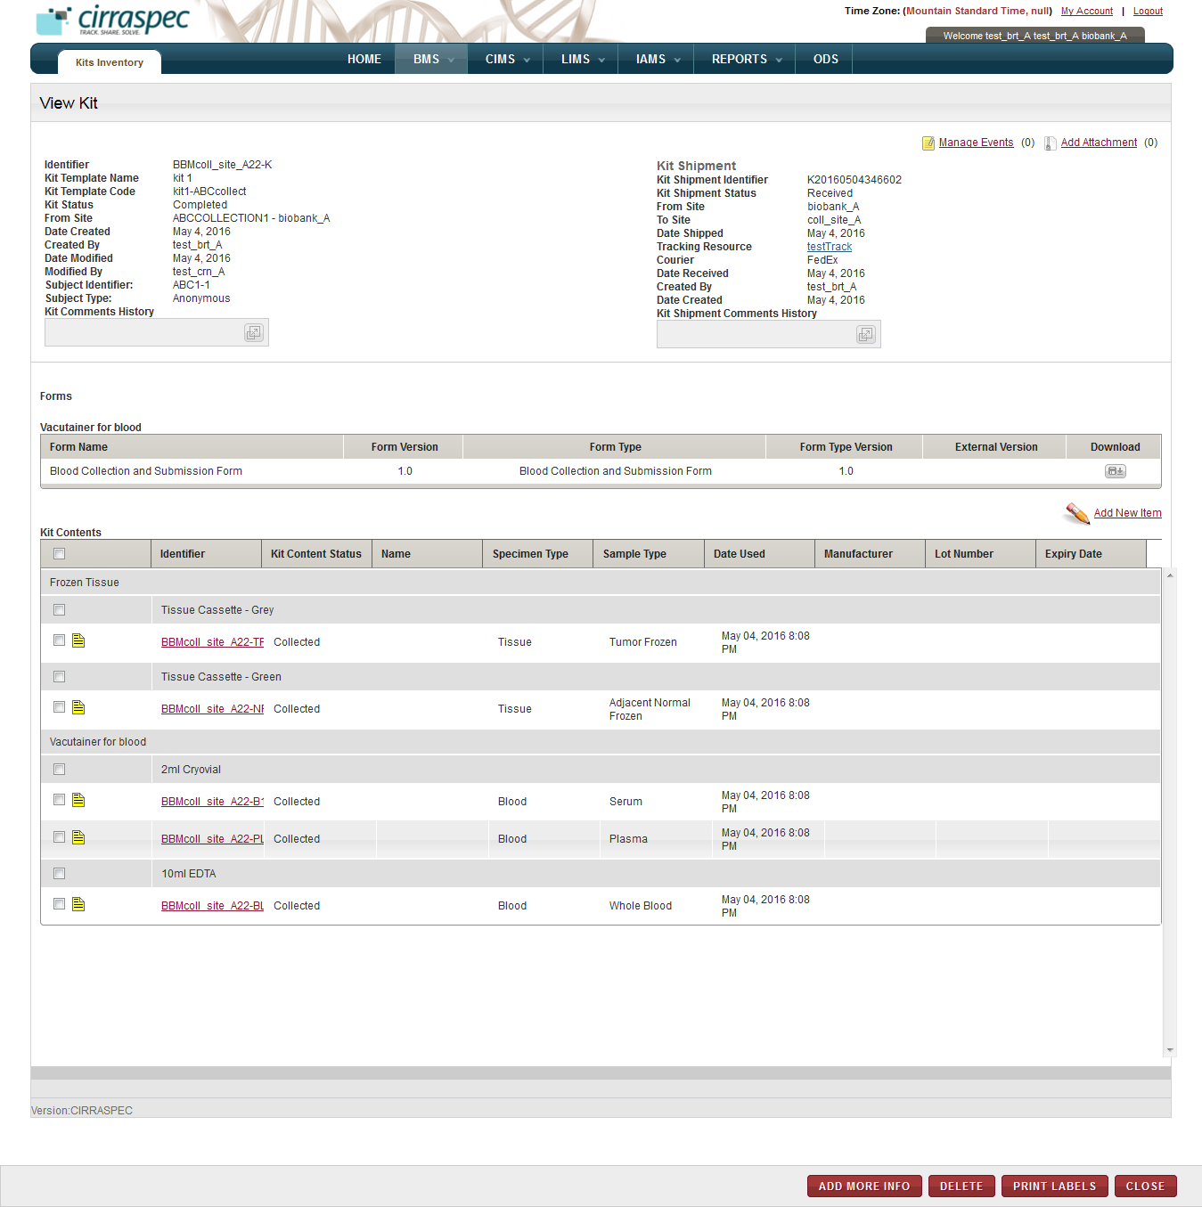

1. View Kit page

On the view kit page, you can perform the following tasks:

* **View the status history:** You can viewa history of the status changes to a content item. For more information about how to view the status history, see **Viewing the Status History for a Kit Content**.
* **Manage events:** You can view and add events to a kit by clicking the **Manage Events** link. For more information about how to manage events, see **Managing Events**
* **Add Attachment:** You can upload, download, and delete files that are attached to a kit by clicking the **Add Attachment** link. For more information about how to add files, see **Common File Upload**
* **Add a kit item:** You can add a new item to a kit. For more information about how to add a new item to a kit, see **Adding a Kit Item**.
* **Add an identifier:** You can add an identifier to a kit item. For more information about how to add a kit identifier to a kit item, see **Assigning an Identifier to a Kit Item**.
* **Download a form while viewing a kit:** You can download specimen collection or sample processing forms while viewing a kit. For more information about how to download a kit form, see **Downloading a Form While Viewing a Kit**.
* **Add information about a kit item**: For more information about how to add product information for a kit item, see **Adding Product Information for a Kit Item**.
* **Delete a kit item:** For more information about how to delete a kit item, see **Deleting a Kit Item**.
* **Print a barcode label:** You can print a barcode label while viewing a kit. For more information about how to print a barcode label, see **Printing a Barcode Label While Viewing a Kit**.
* **Record a collection of biospecimen:** You can document the collection of a subject’s biospecimen for a kit item. For more information about how to record the collection of specimen, see **Recording the Collection of a Subject's Biospecimen**.

### Viewing the Status History for a Kit Content

To view the status history:

1. Log in to the application using your login credentials.

The home page appears.

1. Point to the arrow of the **BMS** tab, and then click **Kits Inventory**.

The **Kit Search** page appears.

1. Click **SEARCH**.

The kit search page displays a list of all kits that are accessible based on your login location.

1. Click the kit for which you want to view the status history of the contents.

The **View Kit** page appears.

1. For the status of a kit content item, click the **Status History** icon  in front of the applicable sample Identifier in the **Kit Contents** table.

The **Status History** window appears.

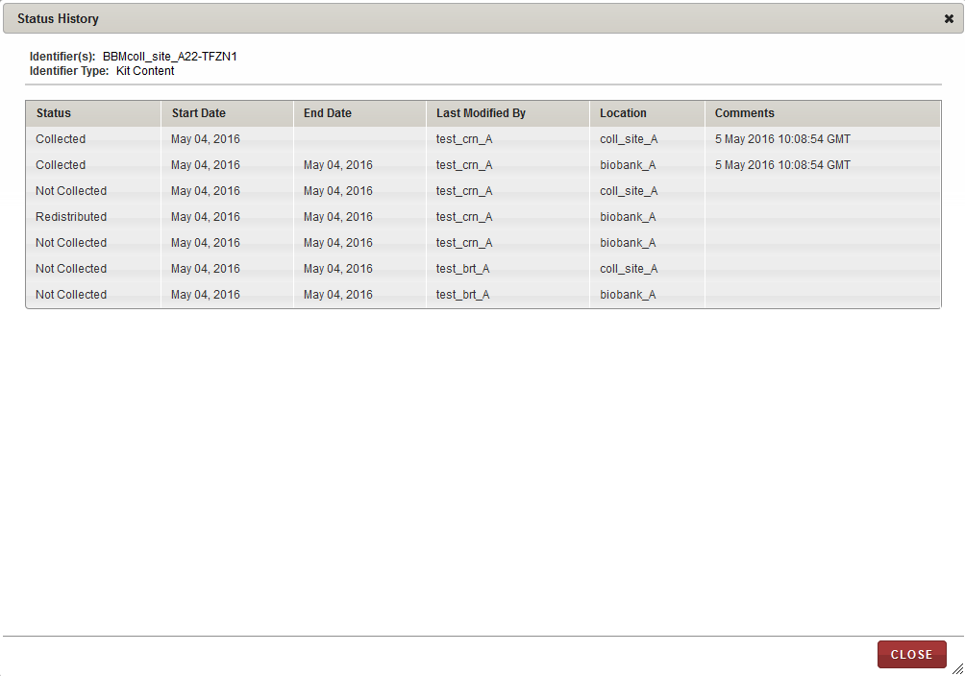

1. View status history

### Generating a Kit Manifest

You can generate a manifest report in PDF format for one or more kits. This report provides kit template and shipment summary information, and a description of the contents of each kit.

To generate a manifest report:

1. Log in to the application using your log in credentials.

The home page appears.

1. Point to the arrow of the **BMS** tab, and then click **Kits Inventory**.

The **Kit Search** page appears.

1. Click **SEARCH**.

The kit search page displays a list of all kits that are accessible based on your login location.



1. Kit search page – Generate Manifest action
2. Select the checkbox of the kit(s) for which you want to generate a manifest.

**Note:** To generate a manifest for all kits, select the checkbox on the header.

1. In the **Actions** list, click **Generate Manifest**, and then click **INITIATE**.

The kit manifest appears in a new tab.

1. View, print and/or save the file, as needed.   
   **Note**: Hover the cursor over the icons in the horizontal and vertical navigation bars to identify tools for viewing multiple pages, printing the report and saving the file to your machine.

Please find attached example of kit manifest pdf file :



Generating a Label from the Kit Search Page

You can generate a PDF image of the barcode labels for a kit.

To generate a label:

1. Log in to the application using your log in credentials.

The **Home** page appears.

1. Point to the arrow of the **BMS** tab, and then click **Kits Inventory**.   
   The **Kit Search** page appears.
2. Click **SEARCH**.

The kit search page displays a list of all kits that are accessible based on your login location.

1. Select the checkbox of the kit(s) for which you want to generate a label.

**Note:** To generate labels for all kits, select the checkbox on the header.

1. In the **Actions** list, click **Generate Labels**, and then click **INITIATE**.   
   The print barcode window appears.

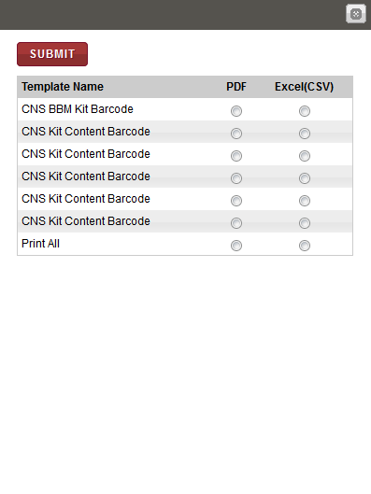

1. Print barcode window
2. Click the **PDF** option for the template for which you want to generate a label, and then click **SUBMIT**.

A PDF report appears at the bottom of the window and displays images of all the barcode labels that are associated with this kit for the template that you selected.

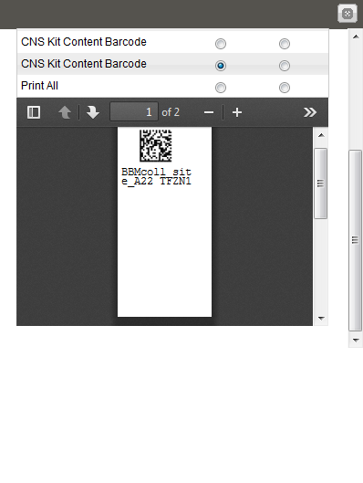

1. Figure 2: Barcode label

**Note**: To identify tools for viewing multiple labels, printing labels and saving the file to your machine, hover the cursor over the icons in the horizontal navigation bars.

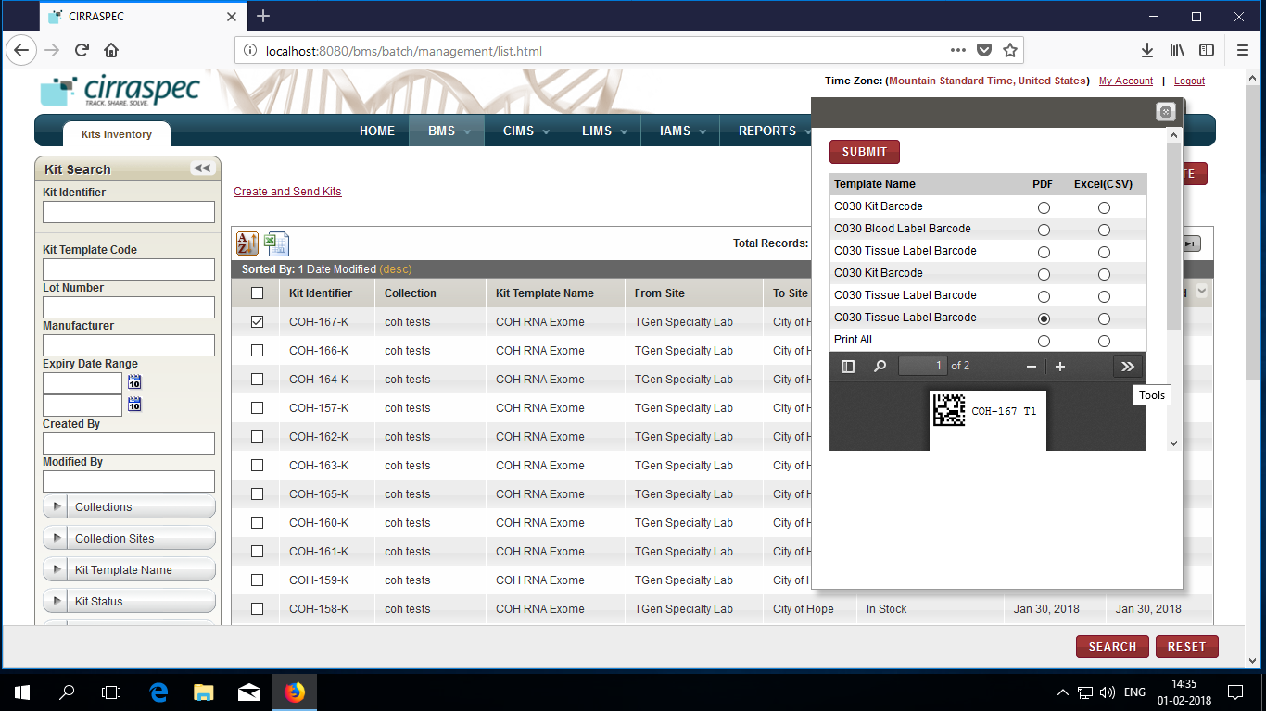

1. To get the labels list in the excel file, Click on the Excel(CSV) and Click Submit.
2. Click on open or Save on confirmation popup that appears and view the excel as below:

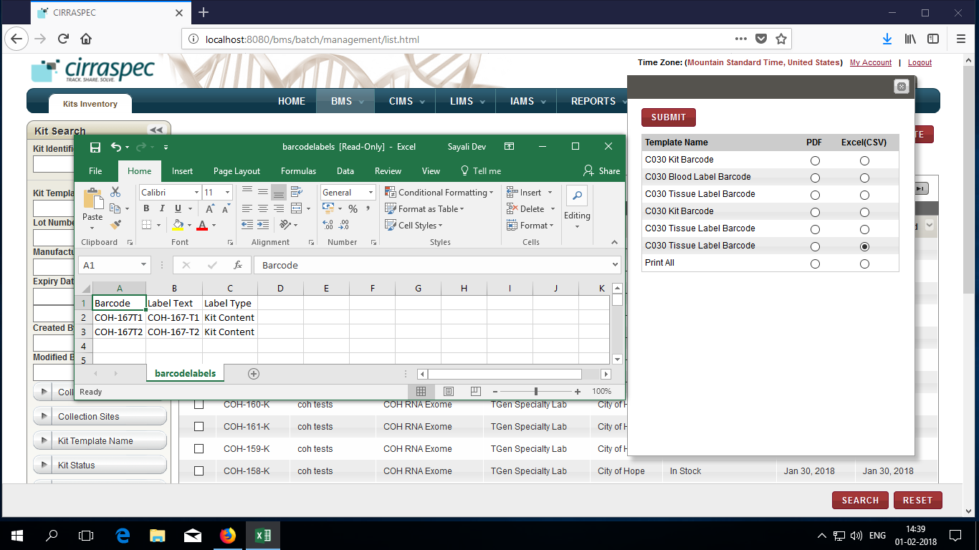

### Downloading all Forms Associated with a Kit

You can download all specimen collection or sample processing forms associated with one or more kits. Forms are downloaded as a file in PDF format.

To download all forms associated with a kit:

1. Log in to the application using your log in credentials.

The home page appears.

1. Point to the arrow of the **BMS** tab, and then click **Kits Inventory**.

The **Kit Search** page appears.

1. Click **SEARCH**.

The kit search page displays a list of all kits that are accessible based on your login location.

1. Select the checkbox of the kit(s) for which you want to download a form.

**Note:** To download forms of all kits, select the checkbox on the header.

1. In the **Actions** list, click **Download Forms**, and then click **INITIATE**.  
   The **Opening download forms** window appears.
2. Click the applicable field to either open the zipped folder or to save it to your machine.  
   Following table provides a description of the download fields:

Table 3: Download fields

| **Field** | **Description** |
| --- | --- |
| **Open with** | Click this field if you just want to open and view the contents of the zipped folder. |
| **Save File** | Click this field to save the zipped folder to your machine. |

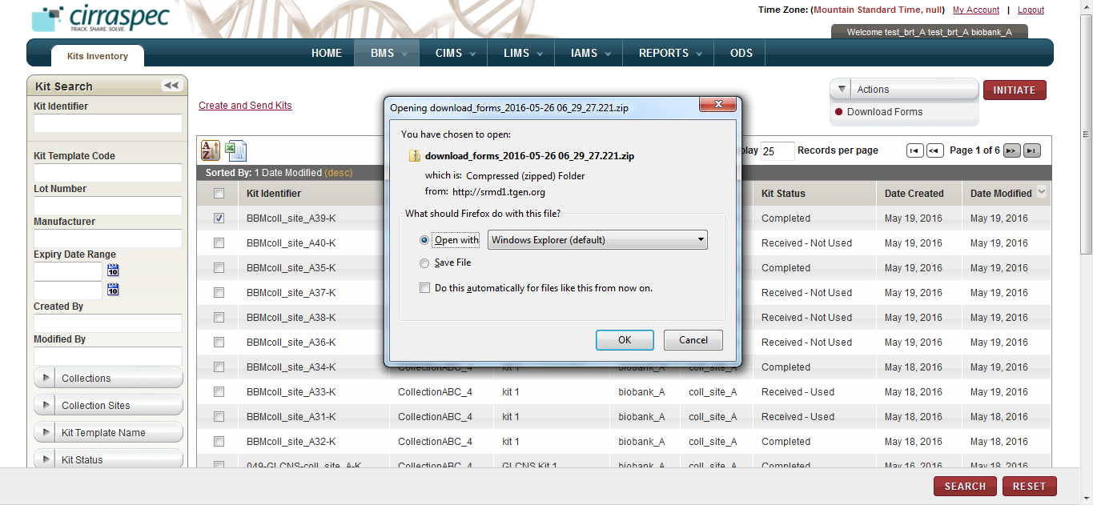

1. Download forms window

### Distributing a Kit

**Note:** You can distribute only those kits that have the status as **In Stock.**

To distribute a kit:

1. Log in to the application using your log in credentials.

The **Home** page appears.

1. Point to the arrow of the **BMS** tab, and then click **Kits Inventory**.

The **Kit Search** page appears.

1. Click **SEARCH**.

The **kit Search** page displays a list of all kits that are accessible based on your login location.

1. Select the checkbox of one or more kits that you want to distribute. These kits should be with the **In Stock** status.

**Note:** To distribute all kits, select the checkbox on the header.

1. In the **Actions** list, click **Distribute Kits**, and then click **INITIATE**.   
   The **Distribute Kits** window appears.

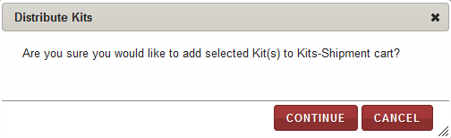

1. Distribute Kits window
2. Click **Continue**.

The **Create Kits Shipment** page appears and displays the kit/s that you selected.   
  
Refer to **Creating a Kits Shipment** in the **Kits Shipment** section for detailed instructions for completing that screen.

1. Select **Contact Details** andClick **SAVE.**

**View Kits Shipment page** appears**.**

1. Click **SEND.**

**Send Kits Shipment** pageappears**.**

1. Select **Courier**, Enter or scan **Tracking Resource** and update other details if required and Click **SAVE**.

**View Kits Shipment** page is displayed.

The **Kit status** and **Kit Shipment Status** appears as **In Transit**

### Create and Send Kits

The **Create and Send Kits** link on the Kit Search page allows you to combine the steps of creating and sending the kits.

**Note:** Only an authorized Biobank user can create new kits and send them to another site.

To create and send kits:

1. Log in to the application using your log in credentials.

The home page appears.

1. Point to the arrow of the **BMS** tab, and then click **Kits Inventory**.

The **Kit Search** page appears.

1. Click **Create and Send Kits** link at the top upper-left corner of the **Kits Search** page.



1. Create and Send Kits link
2. The **Kit Batch Creation** page appears.

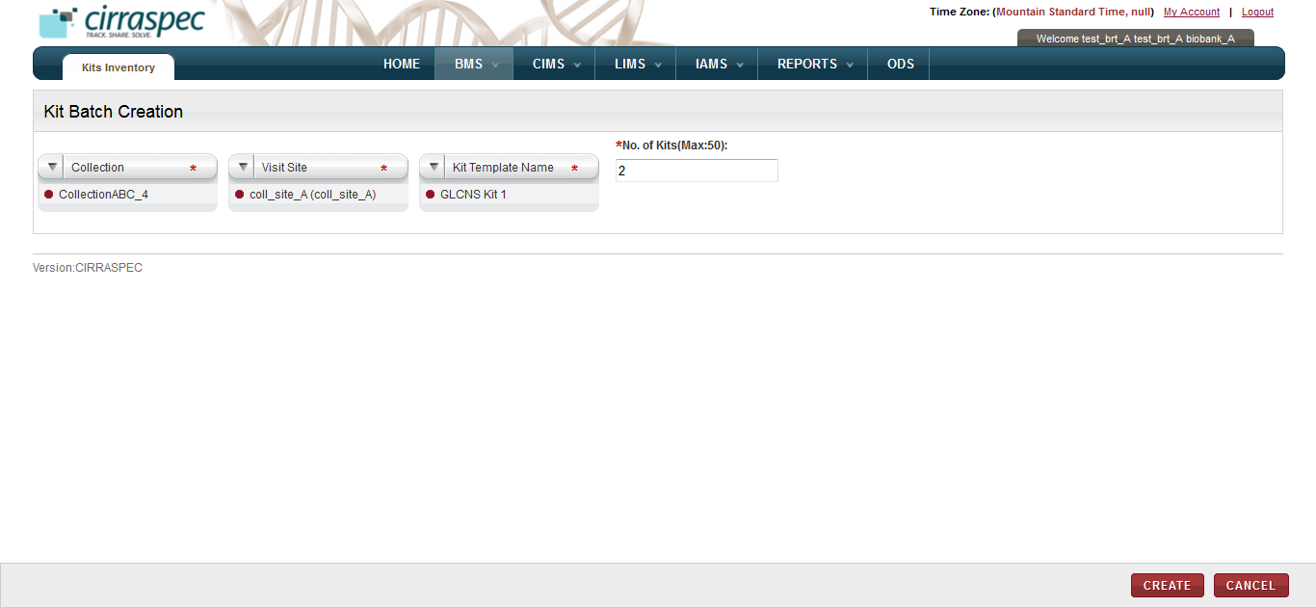

1. Kit Batch Creation page

Enter appropriate information in each field. Following table lists each field and its description.

**Note:** Fields that are marked with the red asterisk (*) are mandatory.

Table 4: Adding a new item

| **Field** | **Description** |
| --- | --- |
| **Collection** | Click appropriate Collection for which you want to create and send kits. |
| **Visit Site** | Click appropriate Visit Site of the selected Collection, for which you want to create and send kits. |
| **Kit Template Name** | Click the appropriate kit template associated with the selected Collection, for which you want to create and send kits. |
| **No. of Kits (Max:50)** | Type the number of kits you want to create and send to the selected Collection Site. |

1. Click **CREATE**.

The **View Kits Batch Summary** page appears.

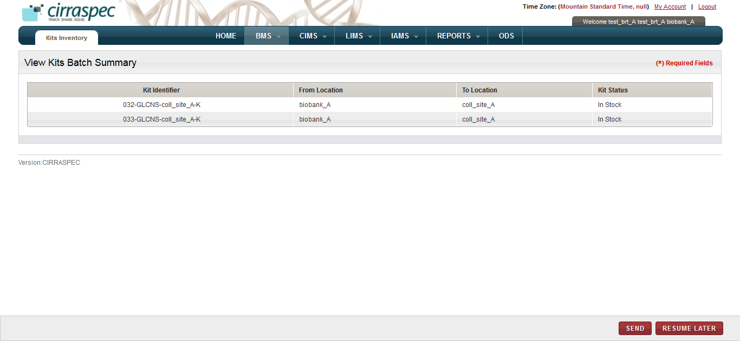

1. View Kits Batch Summary page
2. Click **SEND**.

The **View Kits Shipment** page appears with the details of the kit shipment.

**Note:** To expand the **Comments History** box to display additional previous comments, click the expand icon .

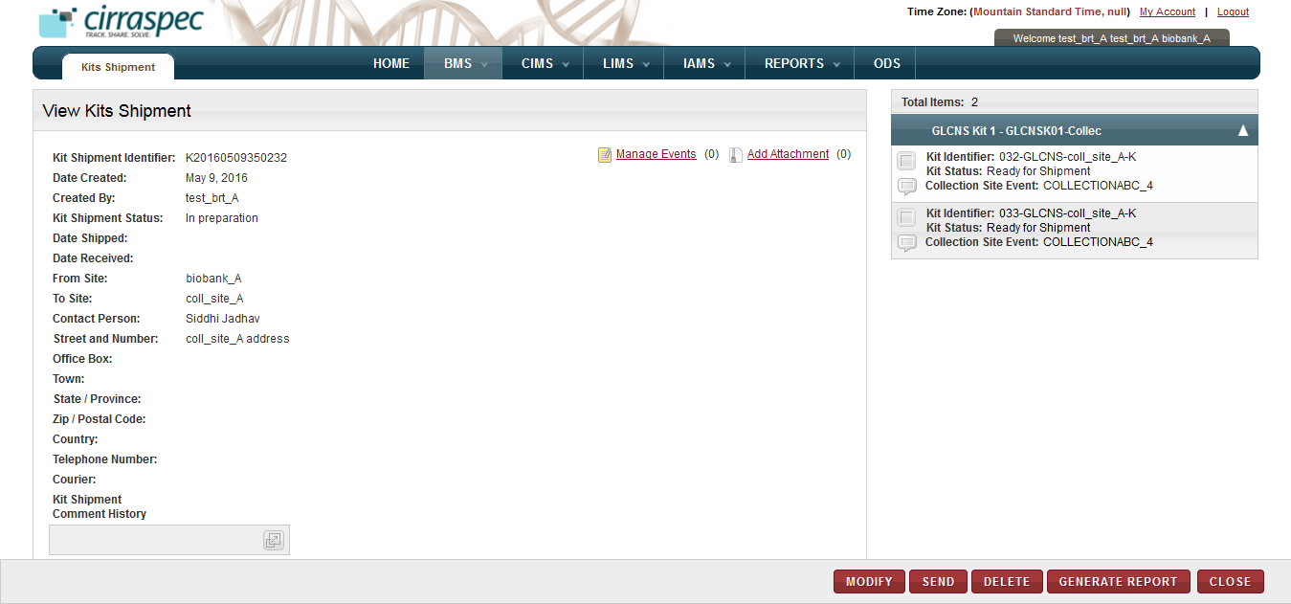

1. View Kits Shipment page

**Note**: To send the kits later, click **RESUME LATER**.

This will bring you to the **Kit Search** page. The kits remain in the **In Stock** status.

You can later send out the shipment as needed.

1. Click **SEND**.

The **Send Kits Shipment** page appears.

**Note**: You can modify a kit shipment before sending it. For more information, see **Modifying a Kits** **Shipment**.

Make the required changes and save them. Then click **SEND** from the **View Kits Shipment page**.

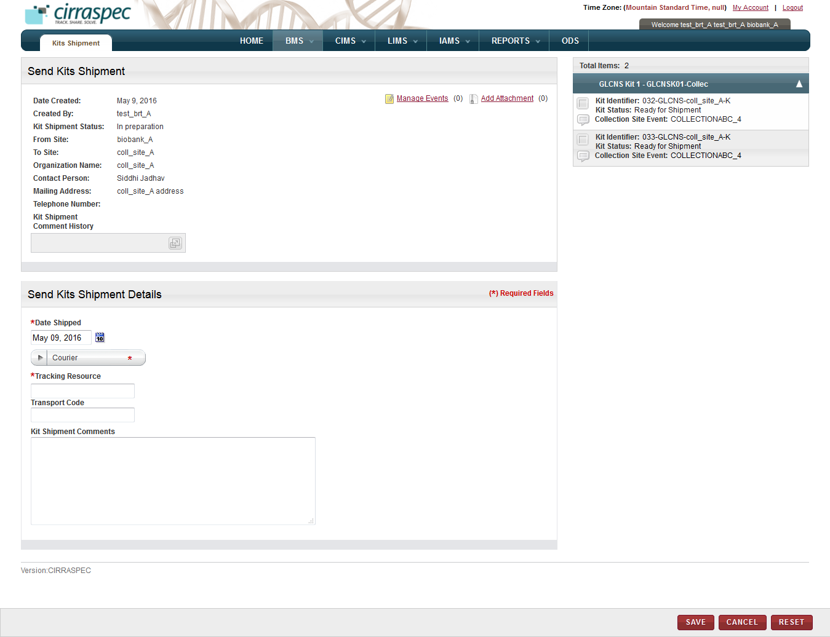

1. Send Kits Shipment page
2. Enter appropriate information in each field. Following table lists each field and its description.

**Note:** Fields that are marked with the red asterisk (*) are mandatory.

Table 5: Sending a kits shipment

| **Field** | **Description** |
| --- | --- |
| **Date Shipped**\* | Click the date icon Search calendar, and then click the date when you want to send the kits shipment.  The date appears in the **Date Shipped** box. |
| **Courier**\* | Click the appropriate shipping courier. |
| **Tracking Resource**\* | Type or scan the shipping courier’s tracking number. |
| **Transport Code** | Type the transport code, if applicable. |
| **Kit Shipment Comments** | Type comments, as needed. |

1. To add an event to this shipment, click the **Manage Events** link.   
   The **Manage Events** window appears.  
   **Note**: For more information about how to add an event, see **Managing Events**.
2. To attach a file to this shipment, click the **Add Attachment** link.   
   The **Manage Attachments** window appears.  
   **Note**: For more information about how to attach a file, see **Common File Upload**.
3. Click **SAVE**.

The **View Kits Shipment** page appears.

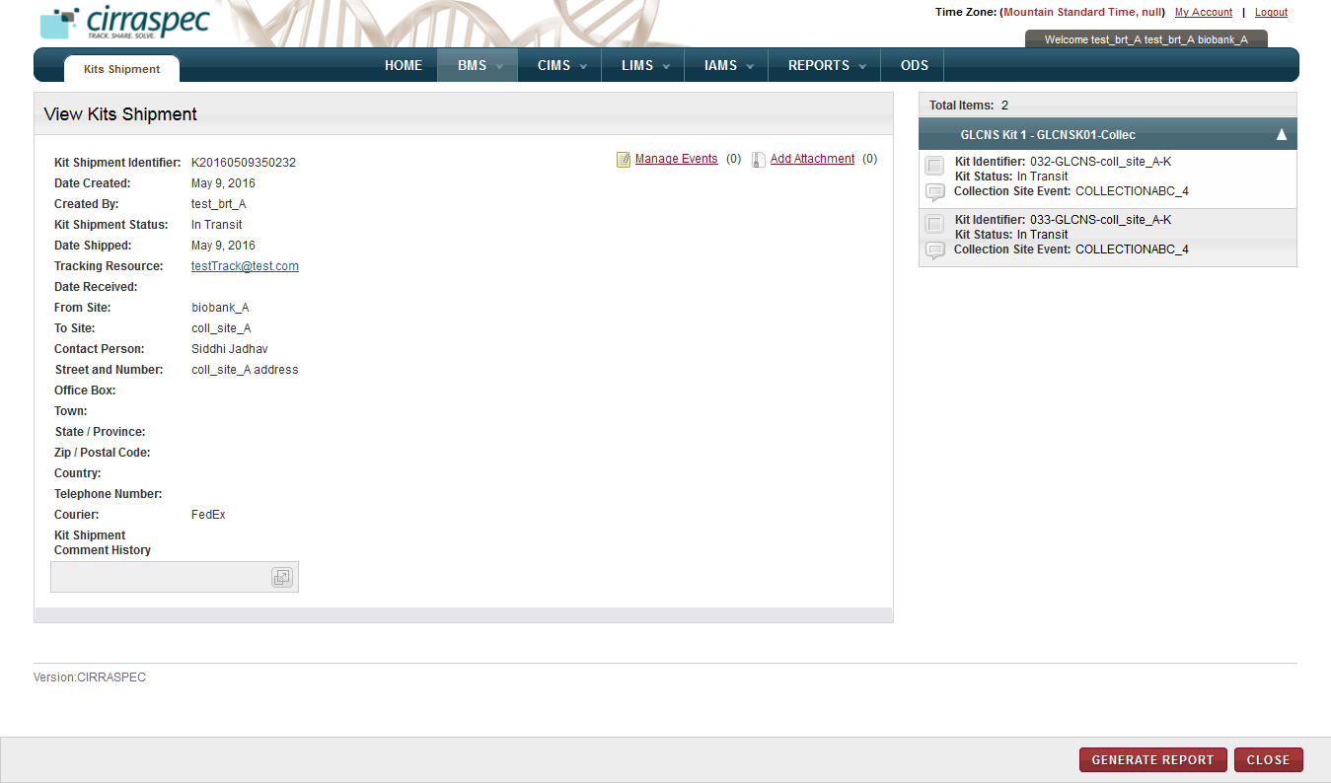

1. View Kits Shipment page

The status of all the kits and the kit shipment appears as **In Transit** on the **View Kits Shipment** page.

### Adding a Kit Item

To add a kit item:

1. Log in to the application using your log in credentials.

The home page appears.

1. Point to the arrow of the **BMS** tab, and then click **Kits Inventory**.

The **Kit Search** page appears.

1. Click **SEARCH**.

The kit search page displays a list of all kits that are accessible based on your login location.

1. Click the kit for which you want to add an item.

The **View Kit** page appears.

1. Click the **Add New Item** link.

The **Add New Item** window appears.

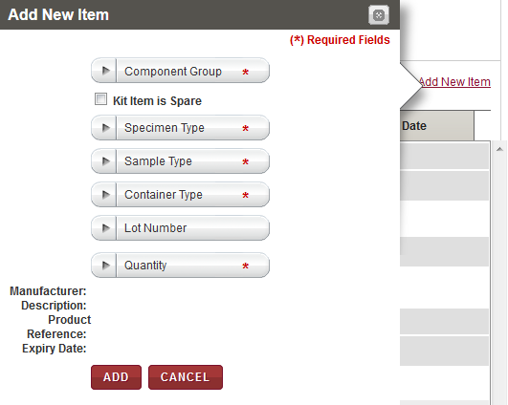

1. Add New Item window
2. Enter appropriate information in each field. Following table lists each field and its description.

**Note:** Fields that are marked with the red asterisk (*) are mandatory.

Table 6: Adding a new item

| **Field** | **Description** |
| --- | --- |
| **Component Group**\* | Click appropriate component group to which the item is to be added. |
| **Kit Item is Spare** | Select this checkbox if the item to be added to the kit is a spare item.  **Note:** If you select this checkbox, skip the Specimen Type, Sample Type, Container Type and Lot Number fields below. |
| **Specimen Type**\* | Click appropriate specimen type for the new item.  **Note:** This field is inactivated when adding a spare item. |
| **Sample Type**\* | Click appropriate sample type for the new item.  **Note:** This field is inactivated when adding a spare item. |
| **Container Type**\* | Click appropriate container type for the new item.  **Note:** This field is inactivated when adding a spare item. |
| **Lot Number** | Click appropriate product lot number for the new item if there is a lot number associated with the new item.  **Note:**   * This field is inactivated when adding a spare item. * Selecting a lot number automatically populates the manufacturer and product related text fields displayed at the bottom of the window. * This field only displays lot numbers already on record. If a desired lot number is *not* displayed, send an email to [cirraspec@tgen.org](mailto:Bio4Dhelp@tgen.org) with the lot number(s) and product information to be added to the application. |
| **Quantity**\* | Click appropriate number of items to be added. |
| **Spare Item Name**\* | Type a name for the item if the item is a spare item. |

1. Click **ADD**.

The **Electronic Signature** window appears.

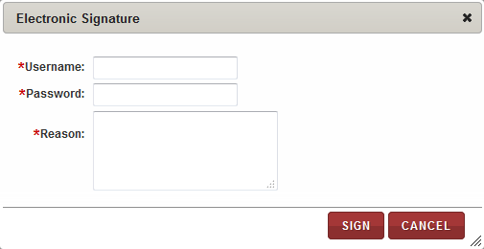

1. Electronic Signature window
2. Enter appropriate information in each field. Following table lists each field and its description.

**Note:** Fields that are marked with the red asterisk (*) are mandatory.

Table 7: Adding an electronic signature

| **Field** | **Description** |
| --- | --- |
| **Username**\* | Type your username for login. |
| **Password**\* | Type your password. |
| **Reason**\* | Type a reason for this action. |

1. Click **SIGN**.

The kit item is added to the kit contents on the **View Kit** page.

### Deleting a Kit Item

To delete a kit item:

1. Log in to the application using your log in credentials.

The home page appears.

1. Point to the arrow of the **BMS** tab, and then click **Kits Inventory**.

The **Kit Search** page appears.

1. Click **SEARCH**.

The kit search page displays a list of all kits that are accessible based on your login location.

1. Click the row of the kit for which you want to delete an item.

The **View Kit** page appears. This page displays the **Kit Contents** area that lists the kit items.

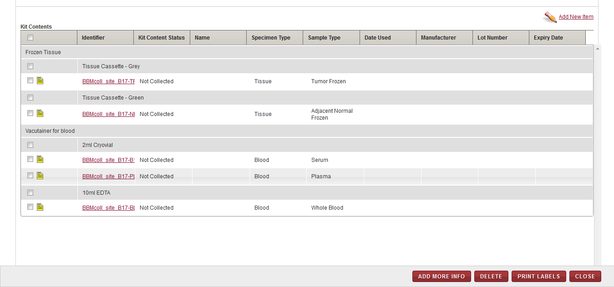

1. Kit Contents area
2. Select the checkboxes of the kit items that you want to delete.

**Note:**

* To delete all the kit items in a component group, select the checkbox on the component group header.
* You cannot delete a kit item with a Kit Content Status of **Collected** if it is in the process of being shipped or has been shipped by the collection site.

1. Click **DELETE**.   
   The **Electronic Signature** window appears.

**Note:** If you select a collected kit item that has been shipped or is in the process of being shipped, the item appears highlighted in red and cannot be deleted.

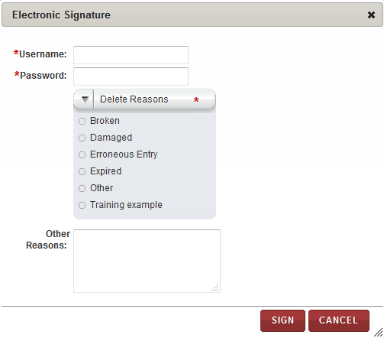

1. Electronic Signature window for deleting a kit item
2. Enter appropriate information in each field. Following table lists each field and its description.

**Note:** Fields that are marked with the red asterisk (*) are mandatory.

Table 8: Adding an electronic signature

| **Field** | **Description** |
| --- | --- |
| **Username**\* | Type your user log in ID. |
| **Password**\* | Type your password. |
| **Delete Reasons**\* | Click the appropriate reason for deleting this kit item. |
| **Other Reasons** | If you clicked **Other** in the **Delete Reasons** list, type a reason for deleting the item. |

1. Click **SIGN**.

The kit content status appears as **Deleted** on the **View Kit** page, and the kit item is no longer available for use**.**

### Adding Product Information for a Kit Item

To add product information for a kit item:

1. Log in to the application using your log in credentials.

The home page appears.

1. Point to the arrow of the **BMS** tab, and then click **Kits Inventory**.

The **Kit Search** page appears.

1. Click **SEARCH**.

The kit search page displays a list of kits.

1. Click the row of the appropriate kit.

The **View Kit** page appears. This page displays the **Kit Contents** area that lists the kit items.

1. Select the checkboxes of the kit items for which you want to add product information.

**Note:** To add the same information for all the kit items, select the checkbox on the header.

1. Click **ADD MORE INFO**.

The **Add More Info** window appears.

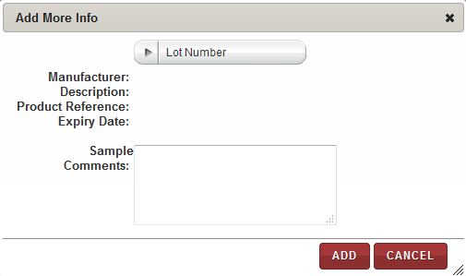

1. Add More Info window
2. Enter appropriate information in each field. Following table lists each field and its description.

Table 9: Adding product information for a kit item

| **Field** | **Description** |
| --- | --- |
| **Lot Number** | Click appropriate product lot number to be associated with the kit item.  **Note:**   * Selecting a lot number automatically populates the manufacturer and product related text fields displayed at the bottom of the window. * This field displays lot numbers already on record. If a desired Lot Number is *not* displayed, send an email to [cirraspec@tgen.org](mailto:Bio4Dhelp@tgen.org) with the lot number(s) and product information to be added to the application. |
| **Sample Comments** | Type a comment, as needed. |

1. Click **ADD**.

The product information for the selected kit item appears on the **View Kit** page.

### Assigning an Identifier to a Kit Item

To assign an identifier to a kit item:

1. Log in to the application using your log in credentials.

The home page appears.

1. Point to the arrow of the **BMS** tab, and then click **Kits Inventory**.

The **Kit Search** page appears.

1. Click **SEARCH**.

The kit search page displays a list of kits.

1. Click the row of the appropriate kit.

The **View Kit** page appears. This page displays the **Kit Contents** area that lists the kit items.

1. Click the **Identifier** of the kit item to which you want to assign an identifier.

The **Add Identifier(s)** window appears.

1. To add an identifier, click the add icon .

The identifier fields appear.

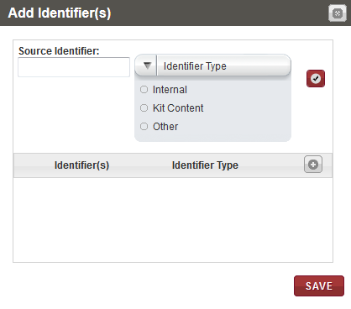

1. Add Identifier(s) window with identifier fields
2. In the **Source Identifier** box, type the identifier to be assigned to the kit item.
3. In the **Identifier** **Type** list, click the appropriate type for the new identifier to be assigned.
4. Click the check mark icon .

The identifier and its type appear in the list below.

1. Click **SAVE**.

The new identifier is assigned to the kit item and appears on the **View Kit** page.

### Printing a Barcode Label While Viewing a Kit

To print a barcode label while viewing a kit:

1. Log in to the application using your log in credentials.

The home page appears.

1. Point to the arrow of the **BMS** tab, and then click **Kits Inventory**.

The **Kit Search** page appears.

1. Click **SEARCH**.

The kit search page displays a list of kits.

1. Click the row of the appropriate kit.

The **View Kit** page appears. This page displays the **Kit Contents** area that lists the kit items.

1. Select the checkboxes of the kit items for which you want to print labels.

**Note:** To print labels for all the kit items,select the checkbox on the header.

1. Click **PRINT LABELS**.

The print labels window appears.

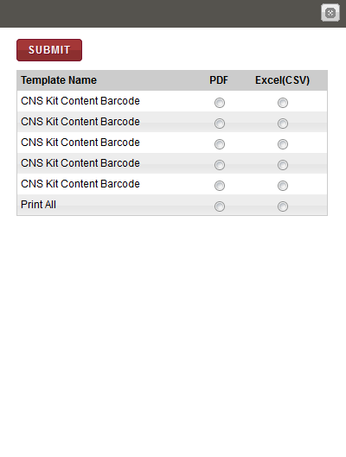

1. Print labels window
2. To print labels to a PDF file, click **PDF**, and then click **SUBMIT**.

The image of the barcode label(s) associated with the kit and the selected template appear below.

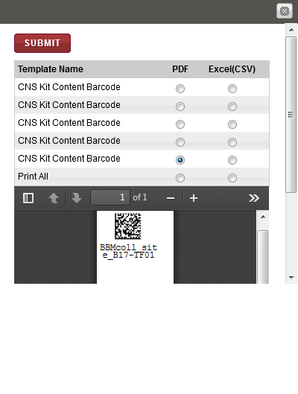

1. Print labels window with labels

**Note**: To identify tools for viewing multiple labels, printing labels and saving the file to your machine, hover the cursor over the icons in the horizontal and vertical navigation bars.

### Downloading a Form While Viewing a Kit

To download a form while viewing a kit:

1. Log in to the application using your log in credentials.

The home page appears.

1. Point to the arrow of the **BMS** tab, and then click **Kits Inventory**.

The **Kit Search** page appears.

1. Click **SEARCH**.

The kit search page displays a list of kits.

1. Click the row of the appropriate kit.

The **View Kit** page appears. This page displays the **FORMS** area that lists the forms associated with the kit.

1. Click on the **Download Form** icon (last column of forms table) for the desired form.  
   The selected form appears in a new window.

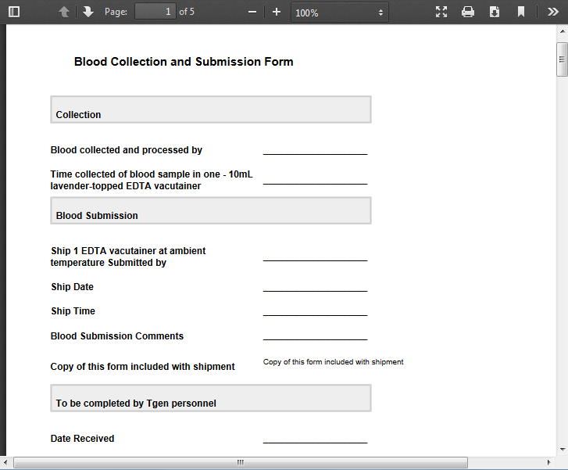

1. View Kit - Download forms window
2. View, print and/or save the file, as needed.   
   **Note**: Hover the cursor over the icons in the horizontal and vertical navigation bars to identify tools for viewing multiple pages, printing and saving the file to your machine.



# Create Kits shipment and send to the Collection site

### Creating a Kits Shipment

To create a kit shipment:

1. Log in to the application using your log in credentials.

The CIRRASPEC home page appears.

1. Point to the arrow of the **BMS** tab, and then click **Kits Shipment**.

The **Kit Shipment** search page appears.

1. Click the **Create New Kit Shipment** link.

Shipment Cart

The **Create Kits Shipment** page appears.

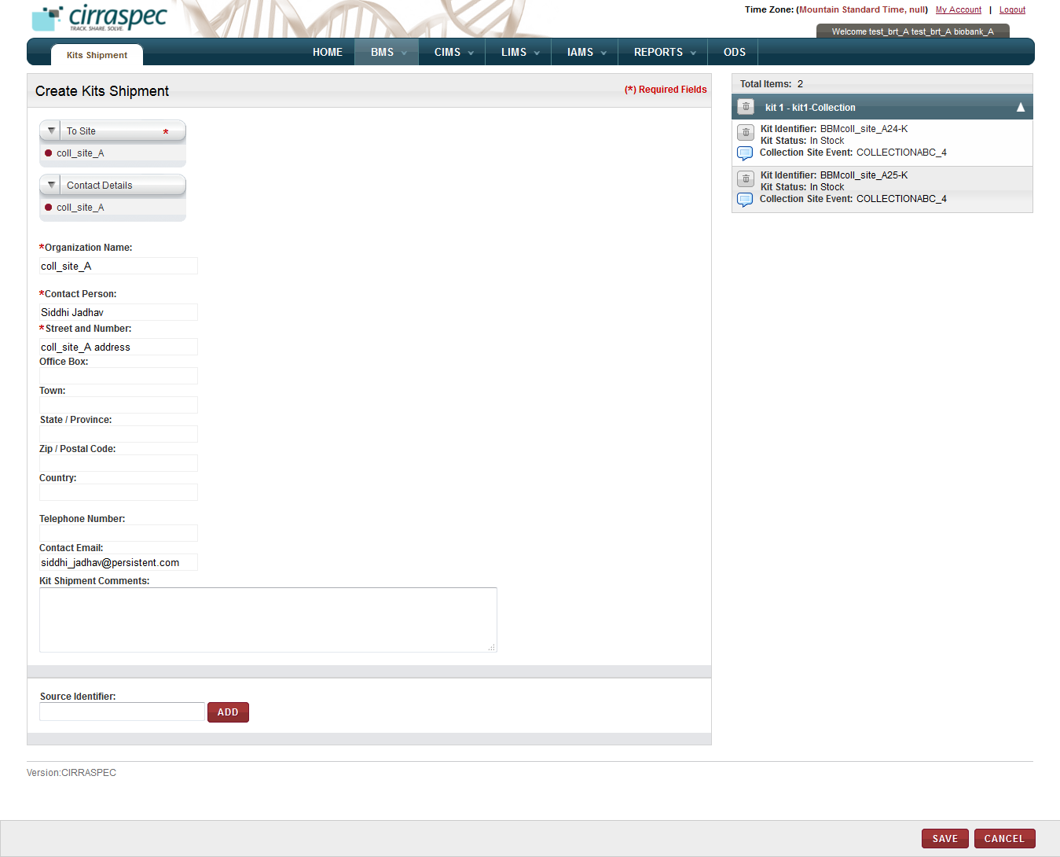

1. Create Kits Shipment page

1. Enter appropriate information in each field. Following table lists each field and its description.

**Note:** Fields that are marked with the red asterisk (*) are mandatory.

Table 10: Creating a kit shipment

| **Field** | **Description** |
| --- | --- |
| **To Site**\* | Click appropriate location to which you want to send the kit shipment. |
| **Contact Details** | Click the appropriate contact.  **Note:** If you click a known contact, the rest of the fields are populated with data related to this contact. |
| **Organization Name**\* | Type name of the organization associated with the specified delivery location. |
| **Contact Person**\* | Type name of the contact. |
| **Street and Number**\* | Type street address for the contact. |
| **Office Box** | Type office box or mail stop for the contact’s mailing address, if applicable. |
| **Town** | Type town or city of the contact’s mailing address. |
| **State / Province** | Type state or province of the contact’s mailing address. |
| **Zip / Postal Code** | Type postal code of the contact’s mailing address. |
| **Country** | Type country of the contacts mailing address if other than USA. |
| **Telephone Number** | Type contact’s telephone number, if known. |
| **Contact Email** | Type contact’s email address, if known. |
| **Kit Shipment Comments** | Type comments, as needed. |
| **Source Identifier** | Type or scan the Kit Identifier of the kit you want to add to the shipment and click **ADD.**  Repeat for each kit you want added to the shipment (one kit at a time).  The specified kits appear in the kit shipment cart (right side). **Note:** Kit Status must be **In Stock** to add the kit to the shipment. |

1. To delete a kit from the shipment cart:

Click the trash can icon  for the appropriate kit.

**Note:** To delete all kits, click the trash can icon  on the blue bar.

1. To add a comment for a kit:
2. In the **Total Items** area, click the comments icon  for the appropriate kit.  
   The **Comments** window appears.

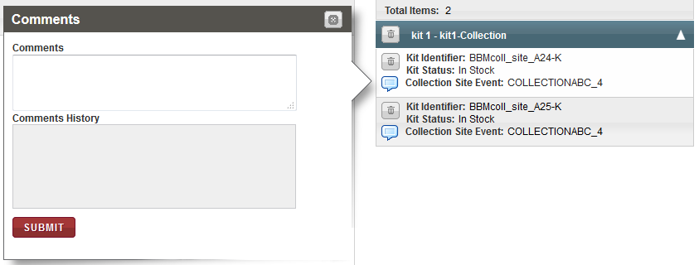

Figure 11: Comments window

1. In the **Comments** box, type the appropriate comments for this kit.
2. Click **SUBMIT**.

The comment is saved.

1. Click **SAVE**.

The kit shipment is created. View Kits Shipment page appears.

The status of all the kits in this shipment appears as ***Ready for Shipment*** and the kit shipment status appears as ***In Preparation***.

### Modifying/Deleting a Kits Shipment

To modify or delete a kits shipment:

1. Log in to the application using your log in credentials.

The CIRRASPEC home page appears.

1. Point to the arrow of the **BMS** tab, and then click **Kits Shipment**.

The **Kit Shipment Search** page appears.

1. Click **SEARCH**.

The **Kit Shipment Search** page displays a list of kit shipments that are accessible based on your login location.

1. Click the row of the kit shipment that you want to modify.

The **View Kits Shipment** page appears with the details of the kits shipment that you selected.

To modify the kits shipment:

1. Click **MODIFY**.

The **Modify Kits Shipment** page appears.

1. Click **SAVE**.  
   The kit shipment is modified.

OR

To delete a kits Shipment:

1. Click Delete.

The delete confirmation window appears.

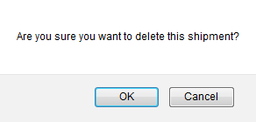

1. Delete window
2. Click **OK**.

The kits shipment is deleted and the status of all kits appears as **In Stock** on the **Kit Search** page.

### Viewing a List of Kit Shipments

To view a list of kit shipments:

1. Log in to Cirraspec using your credentials.
2. Point to the arrow of the **BMS** tab, and then click **Kits Shipment**.   
   The **Kit Shipment Search** page appears.
3. Click **SEARCH**.  
   The kit shipment search page displays a list of all kit shipments.

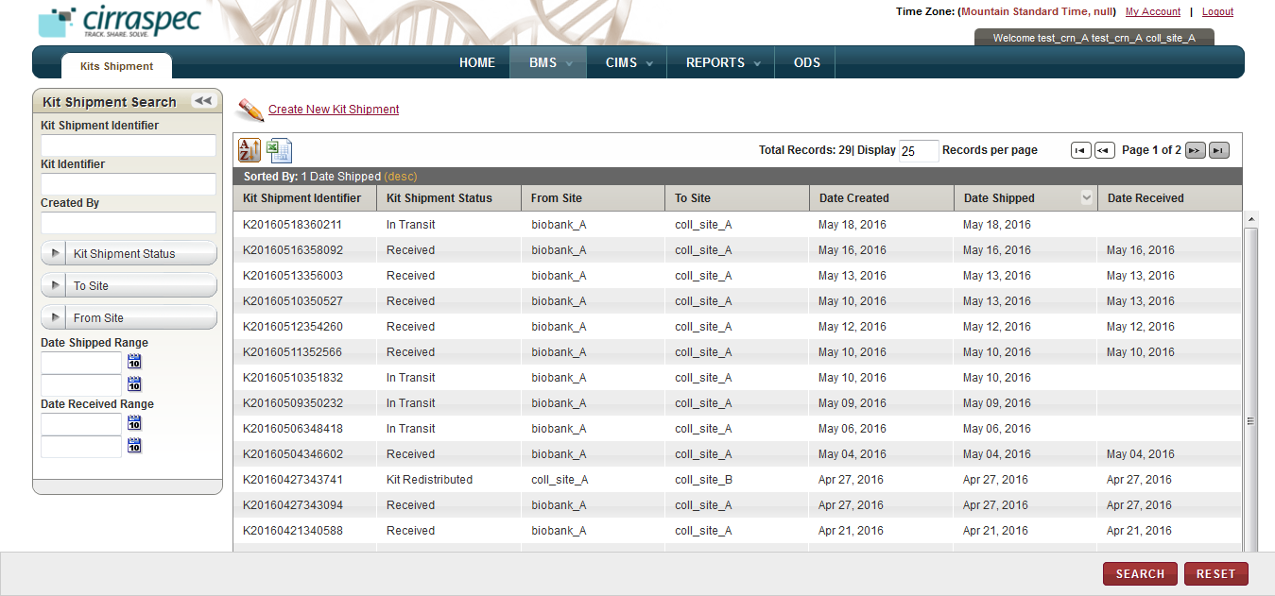

1. To search for a specific shipment, type the Identifier of the kit shipment in the **Kit Shipment Identifier** box. Or specify other search criteria by completing one or more fields in the **Kit Shipment Search** pane.

**Note:**

* You can use one field or a combination of fields to search for a kit shipment.
* You can type the full or partial value in a search field along with an asterisk (*) before or after the partial value. For example, if you type **02\***, you obtain records that begin with 02. If you type **\*02**, you obtain records that end with 02

1. Click **SEARCH**.

The kit shipment search page displays required list of all kit shipments as per the search criteria entered.

### Sending a Kits Shipment

**Note**: You can send only those kit shipments that have the status as **In Preparation**.

To send a kits shipment:

1. Log in to the application using your log in credentials.

The CIRRASPEC home page appears.

1. Point to the arrow of the **BMS** tab, and then click **Kits Shipment**.

The **Kit Shipment Search** page appears.

1. Click **SEARCH**.

The kit shipment search page displays a list of kit shipments that are accessible based on your login location.

1. Click the row of the kits shipment that you want to send.  
   The **View Kits Shipment** page appears with the details of the kits shipment that you selected.
2. Click **SEND**.   
   The **Send Kits Shipment** page appears.

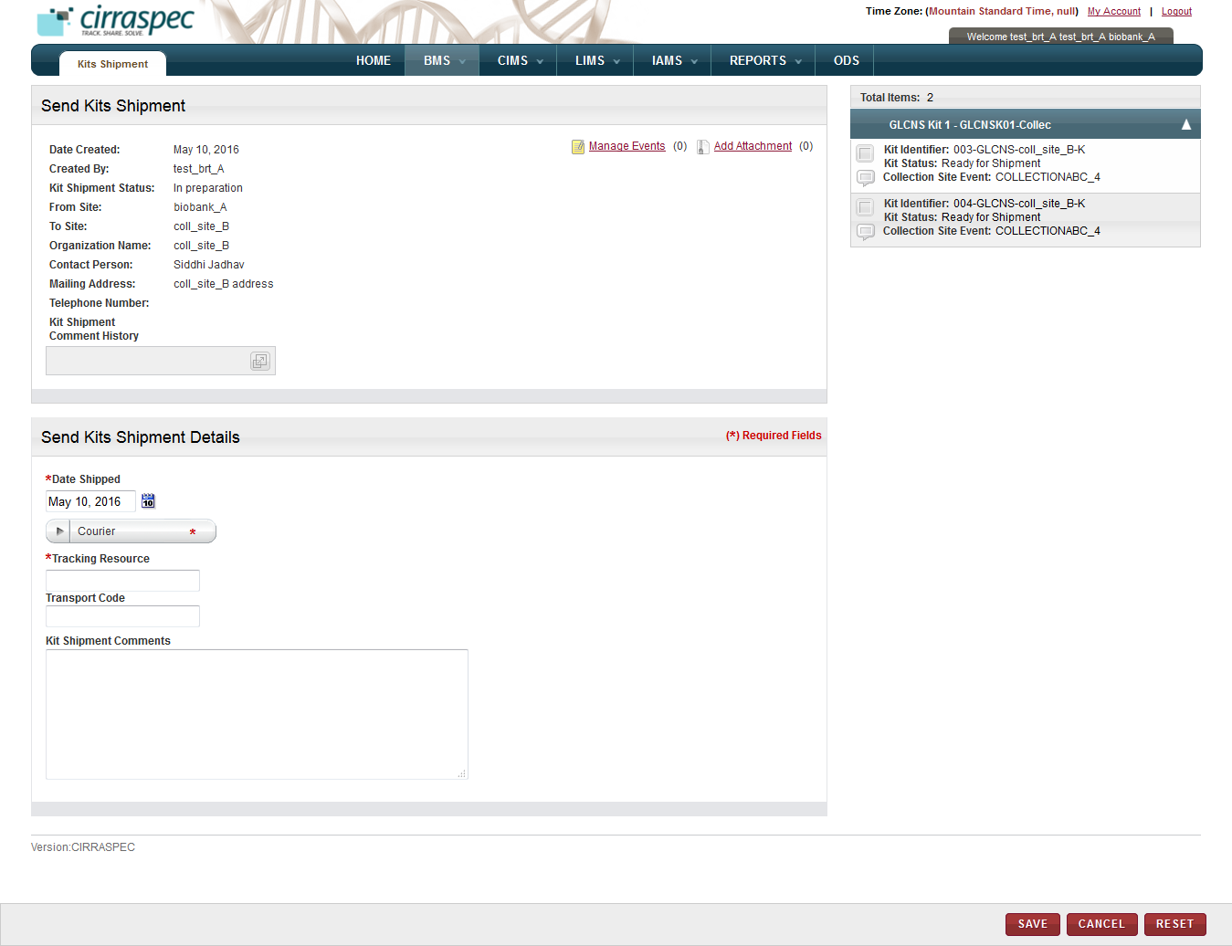

1. Send Kits Shipment page
2. Enter appropriate information in each field. Following table lists each field and its description.

**Note:** Fields that are marked with the red asterisk (*) are mandatory.

Table 12: Sending a kits shipment

| **Field** | **Description** |
| --- | --- |
| **Date Shipped**\* | Click the date icon Search calendar, and then click the date when you want to send the kits shipment.  The date appears in the **Date Shipped** box. |
| **Courier**\* | Click the appropriate shipping courier. |
| **Tracking Resource**\* | Type or scan the shipping courier’s tracking number. |
| **Transport Code** | Type the transport code, if applicable. |
| **Kit Shipment Comments** | Type comments, as needed. |

1. To add an event to this shipment, click the **Manage Events** link.   
   The **Manage Events** window appears.  
   **Note:** For more information about how to add an event, see **Managing Events**.
2. To attach a file to this shipment, click the **Add Attachment** link.   
   The **Manage Attachments** window appears.  
   **Note:** For more information about how to attach a file, see **Common File Upload**.
3. Click SAVE



The status of all the kits of this shipment and the kit shipment appears as In Transit on the View Kits Shipment page.

# Receive Specimens Shipments and Check in samples into the Inventory

### Viewing the Shipment Search Page

**Note:** You can identify a redistribution shipment by the Identifier, which begins with “R”.

To view a list of shipments:

1. Log in to the application using your log in credentials.  
   **Note:** If you have more than one assigned location, you are prompted to select the location for which you want to access CIRRASPEC data.
2. Point to the arrow of the **BMS** tab, and then click **Shipments**.   
   The **Shipment Search** page appears.
3. Click **SEARCH**.  
   The shipment search page displays a list of shipments that are accessible based on your login location.

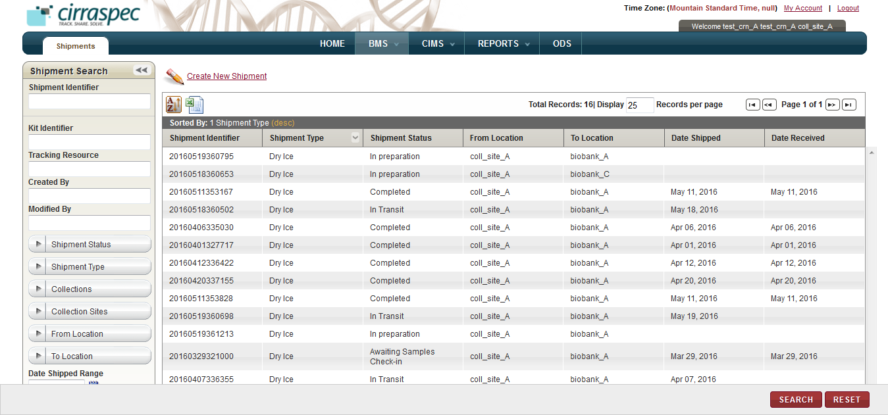

1. Shipment Search page

For information about how to sort the shipments list, change the column display and/or the number of records per page, see **Changing Search Results Display**

On the shipment search page:

* **Print a shipment list as an excel spreadsheet:** Click the **Export current view to CSV** icon , and then in the **File Download** window, click **Save**.   
  The shipment list file is saved to your machine for viewing/printing.
* **Perform a search for a shipment**: For more information about how to search for a specific shipment or a group of shipments, see **Searching for a Shipment**.
* **View details of a shipment:** For more information about how to view the details of a shipment, see **Viewing Shipment Details**.

On the shipment search page, you can perform the following task as a Biobank user:

* **Create a redistribution shipment**: For more information about how to create a redistribution shipment, see **Creating a Redistribution Shipment**.

### Searching for a Shipment

To search for a specific shipment or a group of shipments:

1. Point to the arrow of the **BMS** tab, and then click **Shipments**.   
   The **Shipment Search** page appears.

The search results list displays all shipments that are accessible based on your login location.

Arrow hides/displays

the Shipment Search pane



1. Shipment Search page
2. Specify your search criteria by completing one or more fields in the **Shipment Search** pane.

**Note:**

* You can use one field or a combination of fields to search for a shipment.
* You can type the full or partial value in a search field along with an asterisk (*) before or after the partial value. For example, if you type **02\***, you obtain records that begin with 02. If you type **\*02**, you obtain records that end with 02.

Following table lists each search field and its description.

Table 13: Shipment Search Fields

| **Field** | **Description** |
| --- | --- |
| **Shipment Identifier** | Type or scan identifier of the shipment that you want to search for. |
| **Kit Identifier** | Type or scan identifier of the kit that you want to search for. |
| **Tracking Resource** | Type or scan the courier’s tracking number to search for shipments associated with that tracking number. |
| **Created By** | Type the log in ID of the user to search for shipments created by that user. |
| **Modified By** | Type the log in ID of the user to search for shipments modified by that user. |
| **Shipment Status** | Click appropriate shipment status to search for shipments with this status.  **Note:** To search for shipments with any status, click **All**. |
| **Shipment Type** | Click appropriate shipment type to search for shipments of this type.  **Note:** To search for shipments with any status, click **All**. |
| **Collections** | Click appropriate Collection to search for shipments associated with this Collection.  **Note:** To search for shipments associated with all Collections, click **All**. |
| **Collections Sites** | Click appropriate Collection Site to search for shipments associated with this Collection Site.  **Note:** To search for shipments associated with all Collection Sites, click **All**. |
| **From Location** | Click appropriate location to search for shipments sent from this location. |
| **To Location** | Click appropriate location to search for shipments sent to this location. |
| **Date Shipped Range** | Click the date icon and then in the pop-up, select appropriate date option to search for shipments shipped in this timeframe. For more information, see **Understanding the Date Range Options** |
| **Date Received Range** | Click the date icon and then in the pop-up, select appropriate date option to search for shipments received in this timeframe. For more information, see **Understanding the Date Range Options** |

1. Click **SEARCH**.  
   The search results list displays all shipments as per the search criteria entered.  
     
   **Note:** Click the header of the column with which you want to sort the results. For more information about how to sort the search results, see **Sorting Search Results**



### 



### Viewing Shipment Details

To view a shipment:

1. Log in to the application using your log in credentials.

**Note:** If you have more than one assigned location, you are prompted to select the location for which you want to access CIRRASPEC data.  
The CIRRASPEC home page appears.

2. Point to the arrow of the **BMS** tab, and then click **Shipments**.

The **Shipment Search** page appears.

1. Click **SEARCH**.

The shipment search page displays a list of shipments that are accessible based on your login location.

1. Click the row of the shipment for which you want to view the details.

The **View Shipment** page appears.

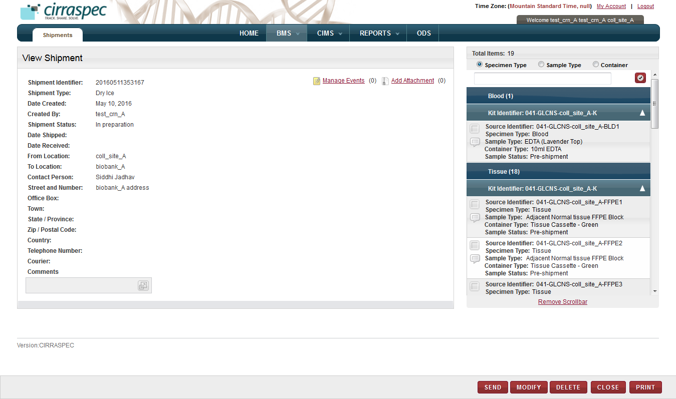

1. View Shipment page

On the **View Shipment** page, you can initiate the following tasks :

* **Print a shipment manifest:** You can print a list of the shipment contents or a detailed shipment manifest. For more information about how to print a shipment, see **Printing a Shipment Report**.
* **Receive biospecimens Shipment:**

You can receive biospecimens shipment sent from the collection site. For more information, see

**Receiving a Biospecimens Shipment**

* **Check In Biospecimens:**

You can check in shipment biospecimens in part or completely. For more information, see

**Checking In a Biospecimens Shipment**.

* **Modify a redistribution shipment:** For more information about how to modify a redistribution shipment or the biospecimens associated with this shipment, see **Modifying a Redistribution Shipment**.
* **Delete a redistribution shipment:** For more information about how to delete a redistribution shipment, see **Deleting a Redistribution Shipment**.
* **Record receipt of a Redistribution shipment:** For more information about how to manually record an external location’s receipt of a redistribution shipment, see **Recording Receipt of a Redistribution Shipment****.**

### Printing a Shipment Report

You can print a summary list of the shipment contents or you can print a complete shipment manifest with detailed shipment and content information.

To generate a shipment summary list or manifest:

1. Log in to the application using your log in credentials.

The CIRRASPEC home page appears.

1. Point to the arrow of the **BMS** tab, and then click **Shipments**.

The **Shipment Search** page appears.

1. Click **SEARCH**.

The **Shipment Search** page displays a list of shipments that are accessible based on your login location.

1. Click the row of the shipment for which you want to generate a report.

The **View Shipment** page appears with the details of the kit shipment that you selected.

1. Click **Print**.   
   The **Print** options window appears with two options as below:

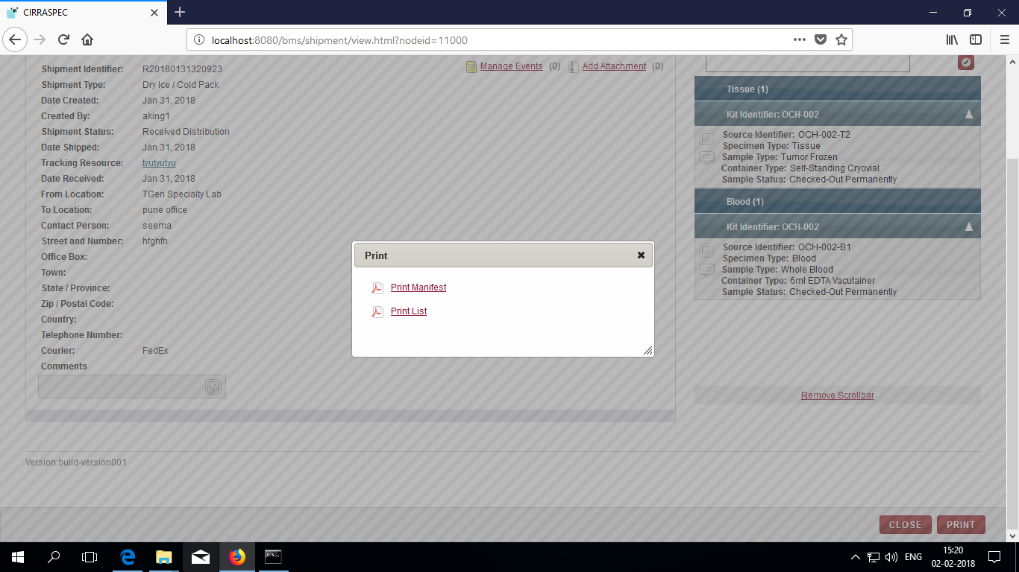

1. a. To print a shipment manifest with detailed shipment and content information, click **Print Manifest**.

b.

The shipment list or manifest appears in a new window.

1. View, print and/or save the file, as needed.   
   **Note**: Hover the cursor over the icons in the horizontal and vertical navigation bars to identify tools for viewing multiple pages, printing the report and saving the file to your machine.

### Receiving a Biospecimens Shipment

### 



**Note:** The shipments with **In Transit** status can be received:

To receive a biospecimens shipment:

1. Log in to the application using your log in credentials.

The home page appears.

1. Point to the arrow of the **BMS** tab, and then click **Shipments**.

The **Shipment Search** page appears.

1. Click **SEARCH**.

The shipment search page displays a list of shipments that are accessible based on your login location.

1. Click the row of the shipment that you want to receive.

The **View Shipment** page appears.

1. Click **Receive**.   
   The **Receive Shipment** page appears.

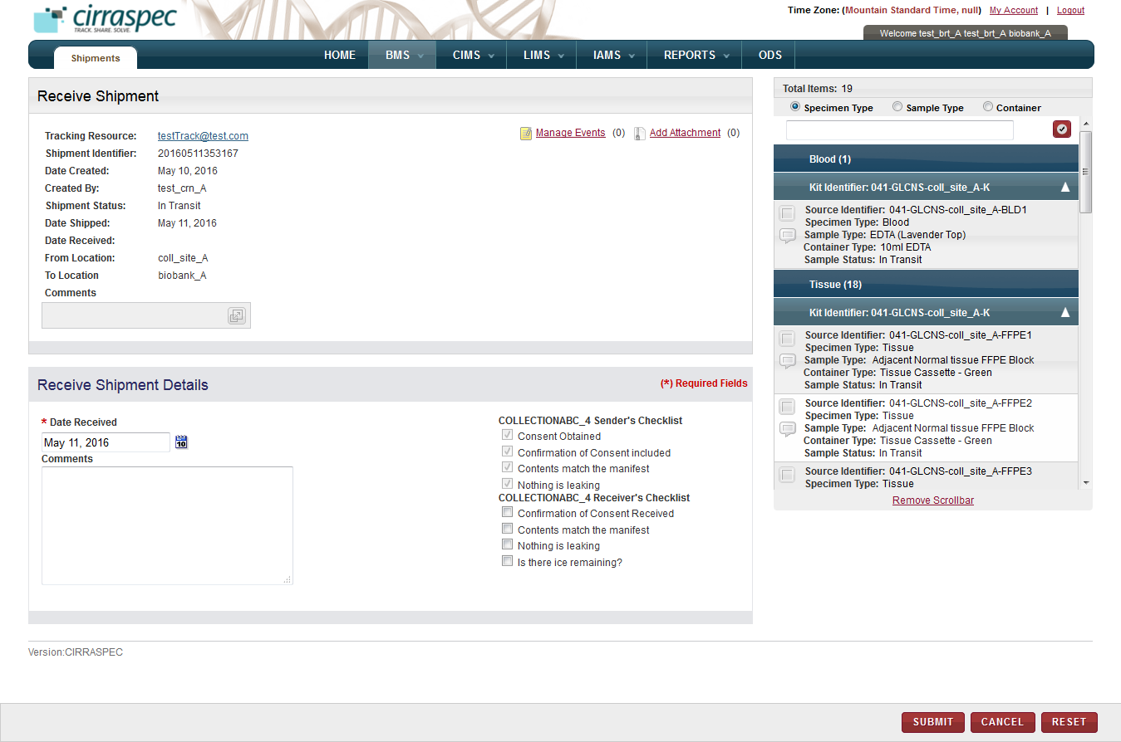

1. Receive Shipment page
2. In the **Receive Shipment Details** area, enter appropriate information in each field. Following table lists each field and its description.

**Note:** Fields that are marked with the red asterisk (*) are mandatory.

Table 17: Receiving a biospecimen shipment

| **Field** | **Description** |
| --- | --- |
| **Date Received**\* | Click the date icon Search calendar, and then click the date when you received the shipment.  The date appears in the **Date Received** box. |
| **Comments** | Type |
| **Receiver’s Checklist** | Select the checkboxes from this list and ensure that the respective actions have been taken.  **Note**: If user does not select any or all of the checkboxes, a message box reading “Receivers checklist is not complete. Do you still want to continue?” is shown. If you need to proceed without selecting these checkboxes, click the OK button. |

1. To add an event to this shipment, click the **Manage Events** link.   
   The **Manage Events** window appears.  
   **Note:** For more information about how to add an event, see **Managing Events**.

1. To attach a file to this shipment, click the **Add Attachment** link.   
   The **Manage Attachments** window appears.  
   **Note:** For more information about how to attach a file, see **Common File Upload**.
2. Click **SUBMIT**.

On the **View Shipment** page:

The shipment status changes to **Awaiting Samples Check-in** and the status for all biospecimens in the shipment cart appears as **In Transit** .

### Checking In a Biospecimens Shipment

**Note:**

* The shipment must have the **Awaiting Samples Check-in** status.
* The shipment status does not change to **Completed** until all the biospecimens associated with this shipment are checked in

To check in a shipment biospecimen:

1. Log in to the application using your log in credentials.

The home page appears.

1. Point to the arrow of the **BMS** tab, and then click **Shipments**.

The **Shipment Search** page appears.

1. Click **SEARCH**.

The shipment search page displays a list of shipments that are accessible based on your login location.

1. Click the row of the shipment for which you want to check in biospecimens.

The **View Shipment** page appears.

1. Click **CHECK IN SAMPLES**.

The **Check-in-Sample** page appears.

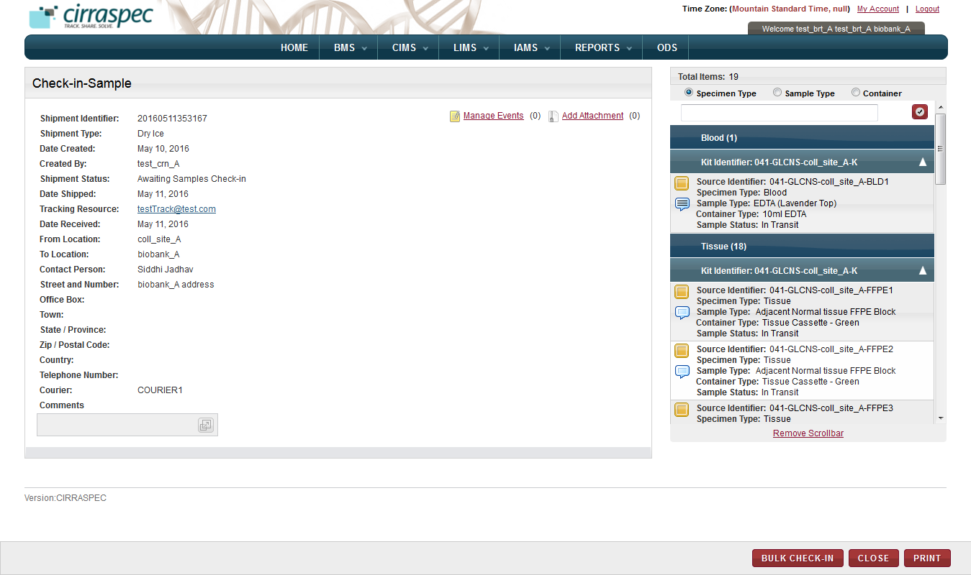

1. Check-in-Sample page
2. In the shipping cart, Click the yellow box against the biospecimen that you want to check in.

**Note:**

* Biospecimens that are not checked in are marked with a yellow box.
* Biospecimens that are checked in are marked with a blue check mark box.
* You can sort biospecimens by clicking the appropriate type under **Total Items**.
* To search for a biospecimen, in the box under **Total Items**, type the appropriate shipment or biospecimen identifier, and then click the check mark icon .

The **Sample** window appears.

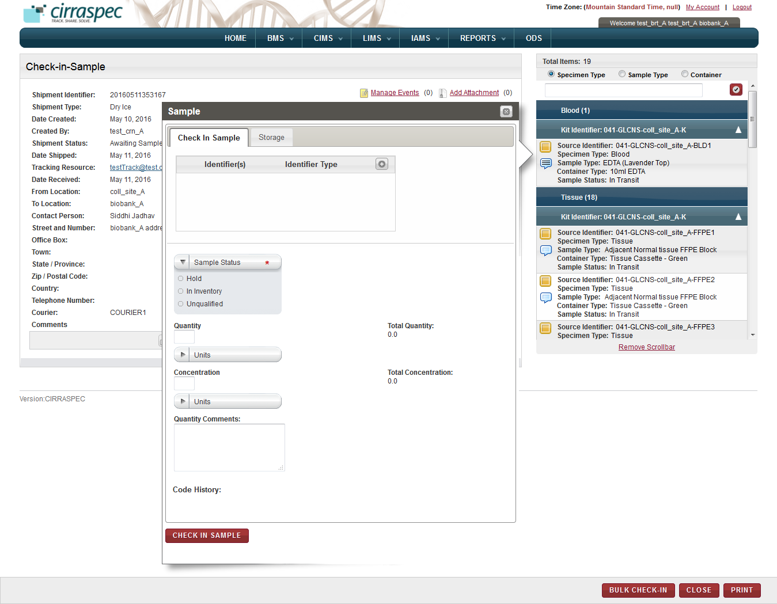

1. Sample window
2. On the **Check In** **Sample** tab, enter appropriate information in each field.   
   Following table lists each field and its description.

Table 18: Checking in a biospecimen

| **Field** | **Description** |
| --- | --- |
| **Identifier(s)** | If you want to add a new identifier for this biospecimen:   1. Click on the add icon add icon. 2. In the **Source Identifier** box, type the new identifier. 3. In the **Identifier Type** list, click the appropriate identifier type.  **Note:** The **Identifier Type** list displays the following identifier types:  * **Internal:** For user-assigned identifiers based on lab or site naming or numbering conventions. * **Kit Content:** For identifying the biospecimen contained within a kit. * **Other:** For any other identifier type.  1. Click the check mark icon check mark icon.   The new identifier is added. |
| **Sample Status** | Click appropriate status for this biospecimen. |
| **Quantity** | Type quantity of this biospecimen. |
| **Units** | Click appropriate unit of measure associated with the Quantity field. |
| **Concentration** | Type concentration of this biospecimen. |
| **Units** | Click appropriate unit of measure associated with the Concentration field. |
| **Quantity Comments** | Type comments regarding the quantity, as needed. |

**Note:** If quantity / concentration is entered, units entry is mandatory.

1. If you want to assign a storage location for this biospecimen, click the **Storage** tab.

Or to proceed further, skip this step and perform next step 9.

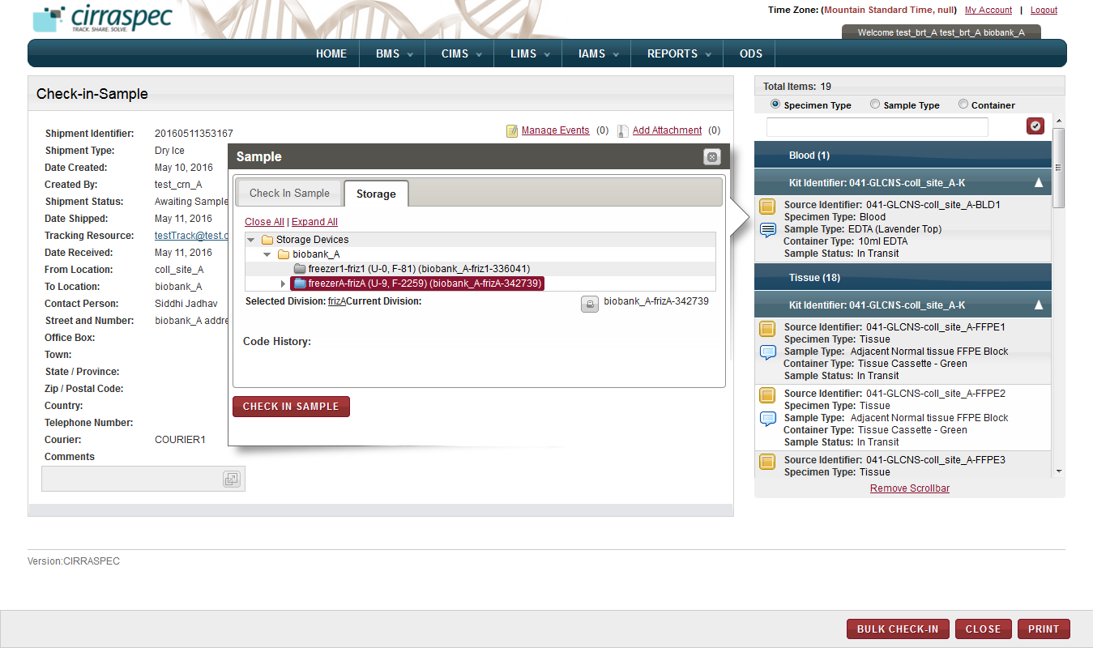

1. Storage tab

To assign a storage location, perform the following steps:

1. Click the **Expand All** link to expand the **Storage Devices** folder to show all storage devices.
2. Click appropriate storage device name (blue folder) to display all levels of storage within that device.

Note:

* Device not available appears as grey folder
* Device with space available appears as blue folder

1. Click the device level where you want to store the biospecimen.

For example, Freezer X, Shelf 1, Rack 2, and Box 3.  
The storage map appears and displays the used cells and available cells for the selected level.

**Note:**

* Storage Map cells that are available appear in beige or brown color.
* Cells that are used appear in red or rust color.
* The current selection appears in green color.

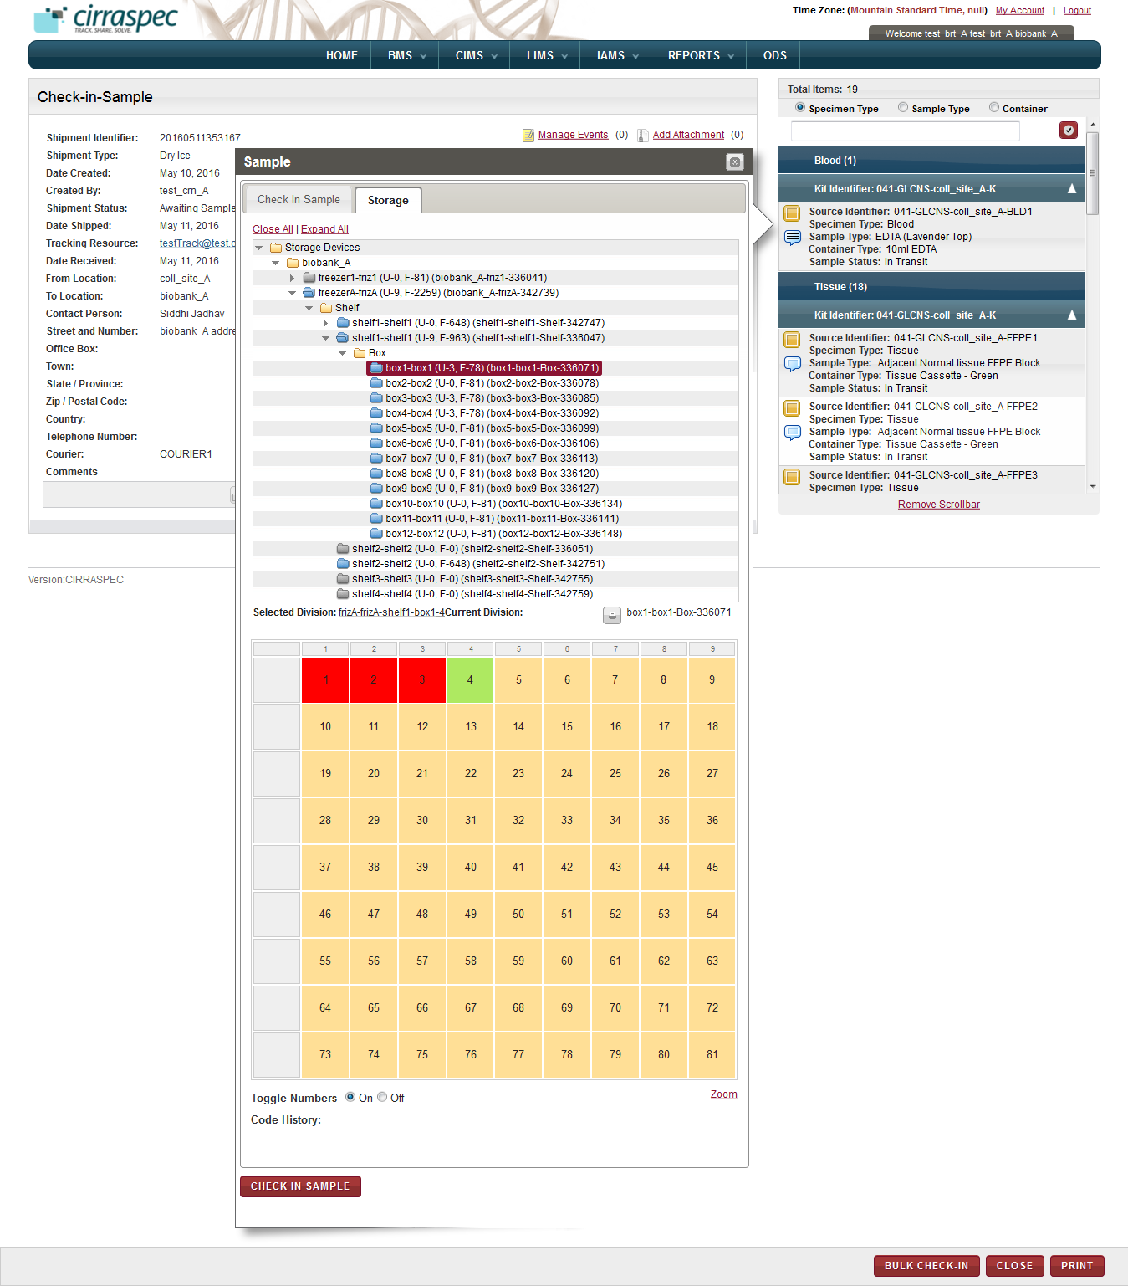

1. Storage map
2. Click the cell where you want to store the biospecimen.

**Note:**

* To view the biospecimens that are stored, move the cursor over the red cells.
* To display or hide numbers in the cells, in the **Toggle Numbers** field, click **Off**.

1. Click **CHECK IN SAMPLE**.

The **Sample** window closes. The biospecimen is checked in. In the shipment cart, a blue check mark appears next to this biospecimen. The Specimen status in the shipment cart is updated to **In Inventory** andstorage location reflects as specified in the **Sample** window.

**Note:**

* The shipment status remains **Awaiting Samples Check-in** until the last biospecimen is checked in.
* After you check in the last biospecimen of a shipment, the status changes to **Completed.**
* To modify a biospecimen that you checked in, click the blue check mark icon, repeat steps 7 to 9, and then click **MODIFY**.
* In sample window, when you modify a current storage location, the previous location changes to gray color and the new selection is set to green color.

### Checking In Biospecimens in Bulk

You can check in all the biospecimens of a shipment as a group and perform several tasks on multiple biospecimens of a shipment. On the **Bulk Check-In** page, you can perform the following tasks:

* Add an identifier to a shipment biospecimen.
* Perform searches for specific shipment biospecimens.
* Check in multiple shipment biospecimens.
* Generate, view, and print labels for multiple shipment biospecimens.
* Generate a list of multiple shipment biospecimens.

**Note:**

* The shipment must have the **Awaiting Samples Check-in** status.

To access the **Bulk Check-In** page:

1. Log in to the application using your log in credentials.

The home page appears.

1. Point to the arrow of the **BMS** tab, and then click **Shipments**.

The **Shipment Search** page appears.

1. Click **SEARCH**.

The shipment search page displays a list of shipments that are accessible based on your login location.

1. Click the row of the shipment for which you want to check in biospecimens in bulk.

The **View Shipment** page appears.

1. Click **BULK CHECK-IN**.

The **Bulk Check-In** page appears.

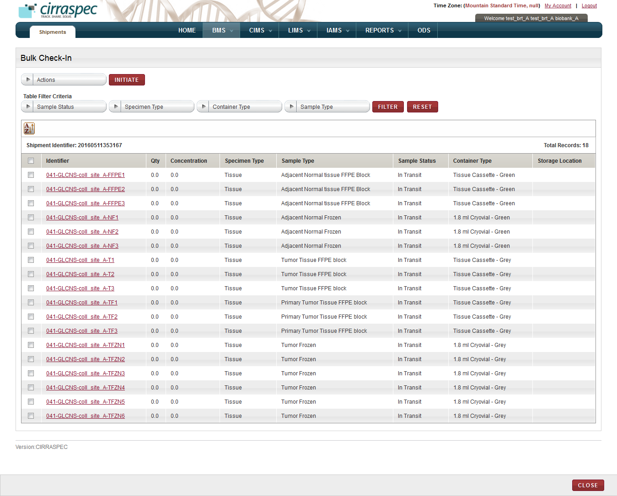

1. Bulk Check-In page
2. To search for specific biospecimens in the shipment, enter appropriate information in the **Table Filter Criteria** fields. Following table lists each field and its description.

Table 19: Performing a searching of biospecimens in the shipment

| **Field** | **Description** |
| --- | --- |
| **Sample Status** | Click the appropriate status for which you want to search. |
| **Specimen Type** | Click the appropriate specimen type for which you want to search. |
| **Container Type** | Click the appropriate container type for which you want to search. |
| **Sample Type** | Click the appropriate sample type for which you want to search. |

1. Click **FILTER**

The biospecimens list at the bottom of the screen displays the search results based on the selections you made above.  
  
For example: If you select **In Inventory** as the Sample Status and **Blood** as the Specimen Type and click **FILTER**, the biospecimens list displays only blood biospecimens with status of **In Inventory** in this shipment.

1. To add a new identifier to a biospecimen:
2. Click on the **Identifier** of the biospecimen for whichyou want to add a new identifier.  
   The **Add Identifier(s)** window is displayed.
3. Click on the add icon .   
   The Source identifier and Identifier Type fields are added to the Add identifier(s) window.
4. In the **Source Identifier** box, type the new identifier.
5. In the **Identifier Type** list, click on the appropriate identifier type.   
   **Note:** The **Identifier Type** list displays the following identifier types:

* **Internal:** For user-assigned identifiers based on lab or site naming or numbering conventions.
* **Kit Content:** For identifying biospecimen content within a kit.
* **Other:** For any other identifier type.

1. Click the check mark icon .  
   The new identifier is added to the list of Identifiers in the window.
2. Click **SAVE.**  
   The new identifier replaces the previous identifier on the Bulk Check-in page.
3. To generate a biospecimen list report:
   1. Select the checkboxes of the biospecimens for which you want to generate a report.

**Note:** To generate a report of all the biospecimens in the shipment, select the checkbox on the gray header.

* 1. In the **Actions** list, click **Generate Report**.
  2. Click **INITIATE**.

The report for the biospecimens that you selected appears in a new window.

1. To generate a barcode label for one or more biospecimens:
2. Select the checkboxes of the biospecimens for which you want to generate a barcode label.

**Note:** To generate barcode labels for all the biospecimens, select the checkbox on the gray header.

1. In the **Actions** list, click **Generate Labels**.
2. Click **INITIATE**.

The print barcode window appears.

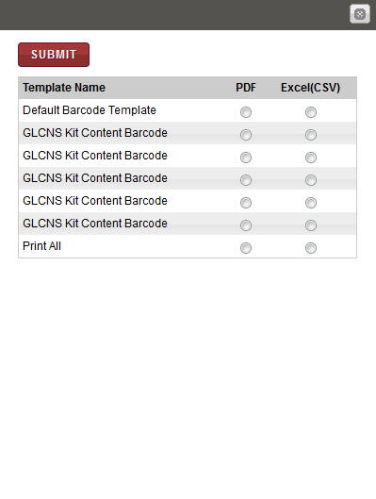

1. Print barcode window

1. To generate a PDF copy of the labels, click **PDF** for the appropriate template type, and then click **SUBMIT**.

The image of the barcode labels that are associated with the biospecimens appear below.

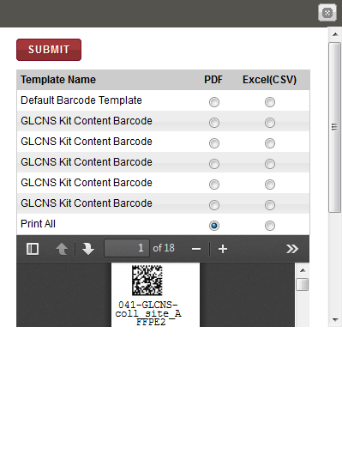

1. Print labels window with labels

**Note**: To identify tools for viewing multiple labels, printing labels and saving the file to your machine, hover the cursor over the icons in the horizontal and vertical navigation bars.

1. To check in biospecimens:
2. Select the checkboxes of the biospecimens that you want to check in.

**Note:** To check in all the biospecimens, select the checkbox on the gray header.

1. In the **Actions** list, click **Check-In Samples**.
2. Click **INITIATE**.

The **Check-In Samples** window appears.

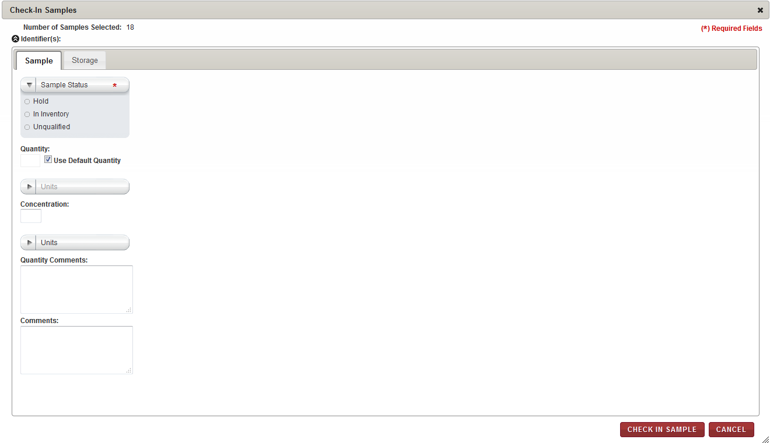

1. Check-In Samples window – Sample tab

1. On the **Sample** tab, enter appropriate information in each field. Following table lists each field and its description.

Table 20: Checking in a biospecimen – Sample tab

| **Field** | **Description** |
| --- | --- |
| **Sample Status\*** | Click appropriate status for the biospecimens. |
| **Use Default Quantity** | This checkbox is selected by default. Keep this checkbox selected if you want to use the default quantity that is defined for the Kit Template associated with the biospecimens. **Note:** If checked, the Quantity and Units fields below are disabled and the default values defined in RPMS for this kit item are automatically used. |
| **Quantity** | If not using the Default Quantity, type the quantity of this biospecimen. |
| **Units** | If not using the Default Quantity, click the appropriate unit of measure associated with the Quantity field. |
| **Concentration** | Type the concentration of this biospecimen. |
| **Units** | Click the appropriate unit of measure associated with the Concentration field. |
| **Quantity Comments** | Type comments regarding the quantity, as needed. |
| **Comments** | Type comments regarding the shipment, as needed |

1. To assign a storage location, click the **Storage** tab.  
   The storage assignment fields are displayed.

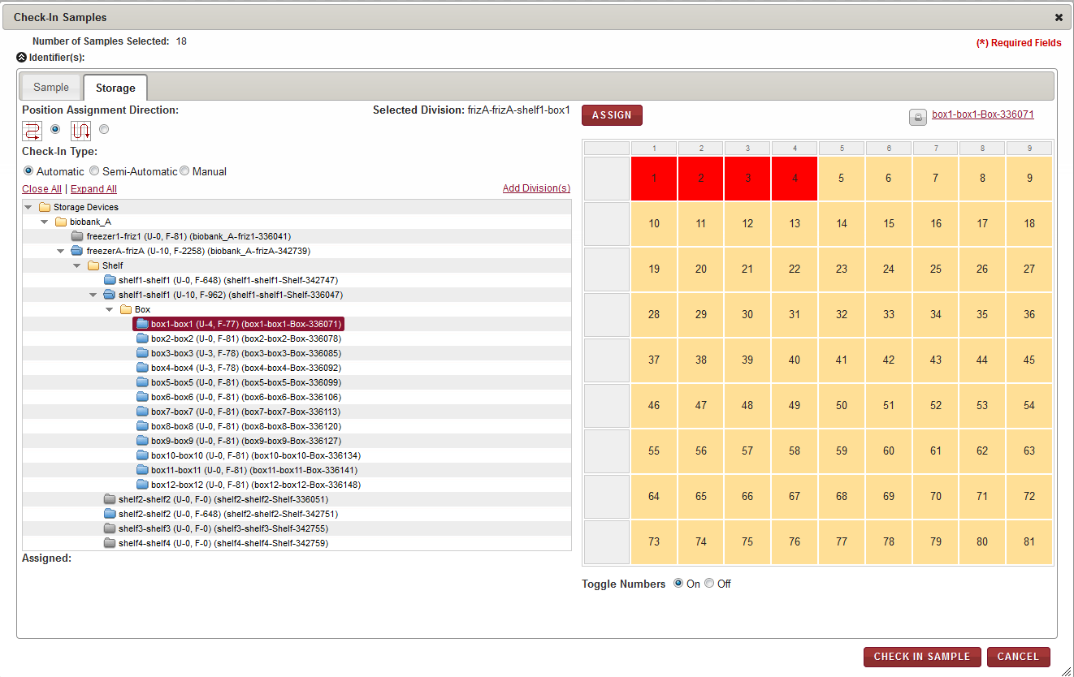

1. Check-In Samples page Storage tab
2. Enter appropriate information in each field. Following table lists each field and its description.

Table 21: Checking in a biospecimen – Storage tab

| **Field** | **Description** |
| --- | --- |
| **Position Assignment Direction** | Click the appropriate direction for assigning a storage location to each of the biospecimens.  **Note:**   * The arrow icon that goes right and left depicts assignment of biospecimens to available cells on the storage map in horizontal rows. * The arrow icon that goes up and down depicts assignment of biospecimens to available cells on the storage map in vertical columns. |
| **Check-In Type** | Click the appropriate means of assigning the storage location:  **Automatic:** The application automatically assigns the biospecimens that you select to available locations in the storage device starting with the first available location.  **Semi-Automatic:** You can select the initial location and assign it to a biospecimen. The application then assigns each biospecimen to the next available location.  **Manual:** You can assign each biospecimen to a location by selecting a cell on the storage map each time. |

1. To select the storage division where you want the biospecimens stored:
2. Click **Expand All** to expand the Storage Devices taxonomy to show all storage devices.
3. Click the appropriate storage device name (blue folder) to display all storage divisions within that device.
4. Click the division where you want to store the biospecimens. For example, Freezer X, Shelf 1, Box 3.  
   The storage map of the cell positions within this division appears on the right.
5. If you selected **Automatic** as **Check-In Type**, click **ASSIGN**.

The application performs the following actions:

* Assigns each biospecimen to the next available location within the selected device.
* Updates the storage map with the new assignments.
* Displays the position assignments in the **Assigned** field at the bottom.

**Note:** If a division does not have enough available positions for all the selected biospecimens, you can select another division and proceed until all biospecimens are assigned.

1. If you selected **Semi-Automatic** as **Check-In Type**, perform the following steps:
2. Click the available cell on the storage map where you want to store the first biospecimen.

**Note:**

* Storage Map positions that are available appear in tan or goldenrod color.
* Positions that are used appear in red or rust color.
* The current selection appears in green color.

The **Assign Identifier** window appears.

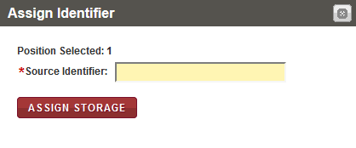

1. Assign Identifier window
2. In the **Source Identifier** box, scan or type the identifier of the first biospecimen that you want to assign to the selected storage map cell.  
   **Note:** You can display the identifiers of the biospecimens to be assigned by clicking on the arrow icon beside the **Identifiers** field in the top left corner of the **Check-In Samples** window.
3. Click **ASSIGN STORAGE**.

The application performs the following functions:

* Assigns the biospecimen to the cell that you selected and updates the storage map.
* Displays the window again with the **Position Selected** field automatically displaying the next available position.

1. Confirm the assignment of each biospecimen by clicking on **Assign Storage** each time the **Assign Identifier** window appears until all biospecimens are assigned.

**Note:**

* If the container type associated with the specified biospecimen is not valid for this storage location, an error message appears. You can select another division and repeat steps b. - c.
* If the storage division does not have enough available positions for all the biospecimens, you can select another division.

1. If you selected **Manual** as **Check-In Type**, perform the following steps:
2. Click the available cell on the storage map where you want to store the first biospecimen.

**Note:**

* Storage Map positions that are available appear in tan or goldenrod color.
* Positions that are used appear in red or rust color.
* The current selection appears in green color.

The **Assign Identifier** window appears.

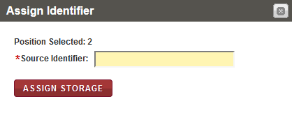

1. Assign Identifier window
2. In the **Source Identifier** box, scan or type the identifier of the first biospecimen that you want to assign to the selected storage map cell.  
   **Note:** You can display the identifiers of the biospecimens to be assigned by clicking on the arrow icon beside the **Identifiers** field in the top left corner of the **Check-In Samples** window.
3. Click **ASSIGN STORAGE**.

The application assigns the biospecimen to the cell that you selected and updates the storage map.

1. Repeat steps a. – c. until all biospecimens are assigned.

**Note:**

* If the container type associated with the specified biospecimen is not valid for this storage location, an error message appears. You can select another division and repeat steps a. - c.
* If the storage division does not have enough available positions for all the biospecimens, you can select another division.

1. Click **CHECK IN SAMPLE**.

The **Check-In Samples** window closes. These biospecimens, onthe **Bulk Check-In** page appear reflecting the status assigned to them.

Click **CLOSE** button on the **Bulk Check-In** page.

The biospecimens also appear as checked-in with a blue check mark on the **View Shipment** page. The status of the shipment on the **View Shipment** page remains **Awaiting Samples Check-in** until all the biospecimens are checked in. Once all biospecimens are checked in, the status of the shipment changes to **Complete.**

# 

# Create and Manage Worklists

The Worklists module allows you to define a group of biospecimens as a worklist, such as all biospecimens in a shipment.

You can then use that worklist to easily access the biospecimens as a group.

### Viewing a List of Worklists

To view a list of worklists:

1. Log in to the application using your log in credentials.  
   **Note:** If you have more than one assigned location, you are prompted to select the location for which you want to access CIRRASPEC data.
2. Point to the arrow of the **BMS** tab, and then click **Worklists**.   
   The **Worklist Search** page appears.
3. Click **SEARCH**.  
   The worklist search page displays a list of worklists that are accessible based on your login location.

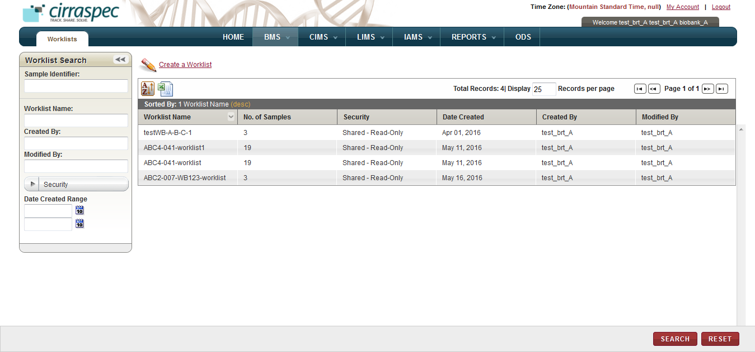

1. Worklist Search page

For information about how to sort the list, change the column display and/or the number of records per page, see **Changing Search Results Display**

### Searching for a Worklist

To search for a specific worklist or a group of worklists:

1. Point to the arrow of the **BMS** tab, and then click **Worklists**.   
   The **Worklist Search** page displays the Worklist Search pane.

Arrow hides/displays

the Worklist Search pane



1. Worklist Search page
2. Specify your search criteria by completing one or more fields in the **Worklist Search** pane.

**Note:**

* You can use one field or a combination of fields to search for a worklist.
* You can type the full or partial value in a search field along with an asterisk (*) before or after the partial value. For example, if you type **02\***, you obtain records that begin with 02. If you type **\*02**, you obtain records that end with 02.

Following table lists each search field and its description.

Table 22: Worklist Search Fields

| **Field** | **Description** |
| --- | --- |
| **Sample Identifier** | Type or scan the identifier of the biospecimen for which you want to search for a worklist. |
| **Worklist Name** | Type name of the worklist that you want to search for. |
| **Created By** | Type login username to search for worklists created by that user. |
| **Modified By** | Type login username to search for worklists modified by that user. |
| **Security** | Click the appropriate security option to search for worklists with that security.   * **Private**: Can be viewed, modified or deleted only by the creator of the worklist. Cannot be viewed by other users. * **Shared – Read-Only**: Can be viewed and used by any other authorized users within the organization. Can be viewed, modified or deleted only by the creator of the worklist. * **Shared – Read-Write**: Can be viewed or modified by any authorized user within the organization. Only the creator of the worklist can change the security level or delete the worklist. |
| **Date Created Range** | Click the date icon and then in the pop-up, select appropriate date option to search for worklists created in this timeframe. For more information, see **Understanding the Date Range Options** |

1. Click **SEARCH**.  
   The search results list displays all worklists that are accessible based on your login location.   
     
   **Note:** Click the header of the column with which you want to sort the results. For more information about how to sort the search results, see **Sorting Search Results**

### Viewing Worklist Details

To view details for a worklist:

1. Log in to the application using your log in credentials.

The CIRRASPEC home page appears.

1. Point to the arrow of the **BMS** tab, and then click **Worklists**.

The **Worklist Search** page appears.

1. Click **SEARCH**.

The worklist search page displays a list of worklists that are accessible based on your login location.

1. Click the worklist that you want to view.

The **View Worklist** page appears.

**Note**: If you do not have access permission to all the samples associated with the worklist being viewed, the view worklist page displays:

* Only the samples to which you have access.
* The following message: “Note: Not all samples in the worklist are accessible due to permission or privileges”.

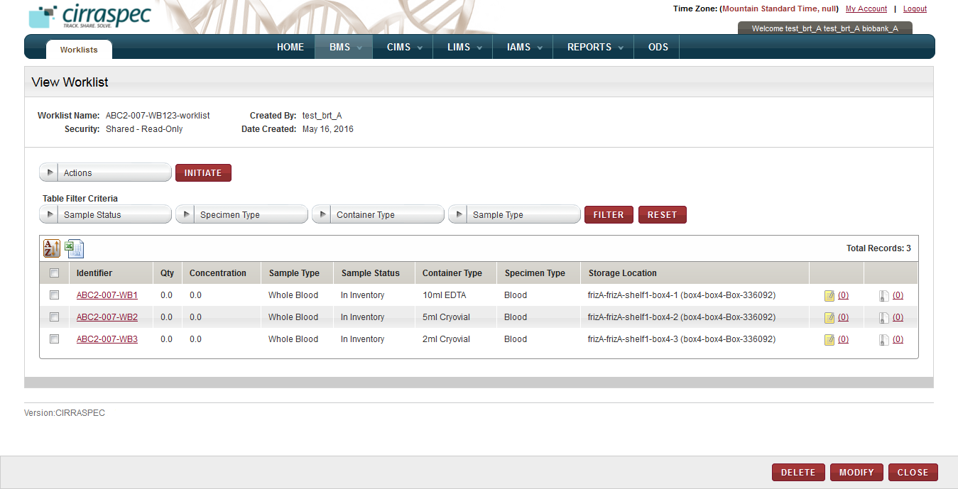

1. View Worklist page
2. To search for specific biospecimens associated with this worklist, enter appropriate information in the **Table Filter Criteria** fields. Following table lists each field and its description.

Table 23: Performing a search for biospecimens in the worklist

| **Field** | **Description** |
| --- | --- |
| **Sample Status** | Click the appropriate status for which you want to search. |
| **Specimen Type** | Click the appropriate specimen type for which you want to search. |
| **Container Type** | Click the appropriate container type for which you want to search. |
| **Sample Type** | Click the appropriate sample type for which you want to search. |

1. Click **FILTER**

The biospecimens list below displays the search results based on the selections you made above.  
  
For example: If you select **In Inventory** as the Sample Status and **Blood** as the Specimen Type and click **FILTER**, the biospecimens list displays only blood biospecimens with status of **In Inventory** for this worklist.

1. To add a new identifier to a biospecimen:
2. Click on the **Identifier** of the biospecimen for whichyou want to add a new identifier.  
   The **Add Identifier(s)** window is displayed.
3. Click on the add icon .   
   The **Source Identifier** and **Identifier Type** fields are added to the **Add identifier(s)** window.
4. In the **Source Identifier** box, type the new identifier.
5. In the **Identifier Type** list, click on the appropriate identifier type.   
   **Note:** The **Identifier Type** list displays the following identifier types:

* **Internal:** For user-assigned identifiers based on lab or site naming or numbering conventions.
* **Kit Content:** For identifying biospecimen content within a kit.
* **Other:** For any other identifier type.

1. Click the check mark icon .  
   The new identifier is added to the list of Identifiers in the window.
2. Click **Save.**  
   The new identifier replaces the previous identifier on the **View Worklist** page.
3. To add an event to a biospecimen associated with this worklist, click the **Manage Events**  icon on the right side of the list table.   
   The **Manage Events** window appears.  
   **Note:** For more information about how to add an event, see **Managing Events**.
4. To attach a file to a biospecimen associated with this worklist, click the **Add Attachment**  icon on the right side of the list table.   
   The **Manage Attachments** window appears.  
   **Note:** For more information about how to attach a file, see **Common File Upload**.

On the **View Worklist** page, you can initiate the following tasks using the **Actions** list:

* **Add Events** on the **Actions** menu allows you to add a quality control event for selected biospecimens or all biospecimens associated with this worklist. For more information about how to add events, see **Adding an Event for Worklist Biospecimens**.
* **Assign Storage Location** on the **Actions** menu allows you to assign a storage location for selected biospecimens or all biospecimens associated with a worklist. For more information about how to assign a storage location, see**Assigning Storage for Worklist Biospecimens**.
* **Generate Labels** on the **Actions** menu allows you to view/print barcode labels for selected biospecimens or all biospecimens associated with a worklist. For more information about how to generate labels, see **Generating a Label for Worklist Biospecimens**.
* **Generate Report** on the Actions menu allows you to generate a biospecimen report of selected biospecimens or all biospecimens associated with a worklist. For more information about how to a generate report, see **Generating a Report for Worklist Biospecimens**.
* **Initiate Workflow** on the **Actions** menu allows you to initiate a LIMS sample processing workflow for selected biospecimens or all biospecimens associated with a worklist. For more information about how to initiate a workflow, see **Initiating a Workflow Process for Worklist Biospecimens**.
* **Modify Samples** on the **Actions** menu allows you to modify quantity and concentration for selected biospecimens or all biospecimens associated with a worklist. For more information about how to modify samples, see **Modifying Worklist Biospecimens**.
* **Upload Files** on the **Actions** menu allows you to upload, download, and delete files attached to selected biospecimens or all biospecimens associated with a worklist. For more information about how to do this, see **Uploading a File for Worklist Biospecimens**.
* **Move to Bulk Container** on the **Actions** menu allows you to assign storage location of biospecimens selected into a bulk container. For more information, see **Move to Bulk Container**

### Creating a Worklist

To create a worklist:

1. Log in to the application using your log in credentials.

The CIRRASPEC home page appears.

1. Point to the arrow of the **BMS** tab, and then click **Worklists**.

The **Worklist Search** page appears.

1. Click the **Create a Worklist** link.

The **Create/Modify Worklist** page appears.

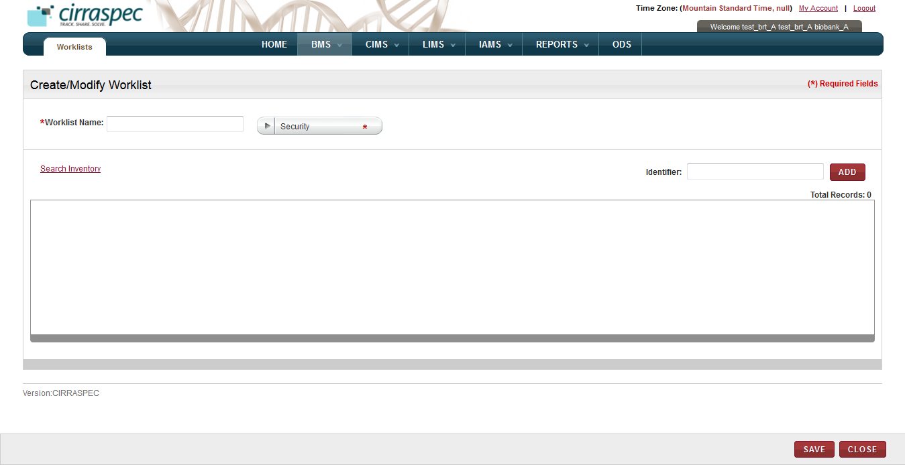

1. Create/Modify Worklist page
2. Enter appropriate information in each field. Following table lists each field and its description.   
   **Note:** Fields that are marked with the red asterisk (*) are mandatory.

Table 24: Creating a worklist

| **Field** | **Description** |
| --- | --- |
| **Worklist Name**\* | Type a name for the worklist. |
| **Security**\* | Click the appropriate security for this worklist.  **Note:**   * **Private**: Can be viewed, modified or deleted only by the creator of the worklist. Cannot be viewed by other users. * **Shared – Read-Only**: Can be viewed and used by any other authorized users within the organization. Can be viewed, modified or deleted only by the creator of the worklist. * **Shared – Read-Write**: Can be viewed or modified by any authorized user within the organization. Only the creator of the worklist can change the security level or delete the worklist. |

1. To add a known biospecimen to the worklist, in the **Identifier** box, type the appropriate kit or biospecimen identifier, and then click **ADD**.

**Note:** You can add multiple known biospecimens.

The biospecimens appear on the **Create/Modify Worklist** page.

1. To search and select additional biospecimens by Basic, Inventory or LIMS data:
2. Click the **Search Inventory** link.  
   The **Search Samples and Worklists** page appears.
3. Select the appropriate checkbox to display the Basic, Inventory or LIMS search fields.  
   **Note:** You can select more than one checkbox.   
   The search fields associated with your selection appear.

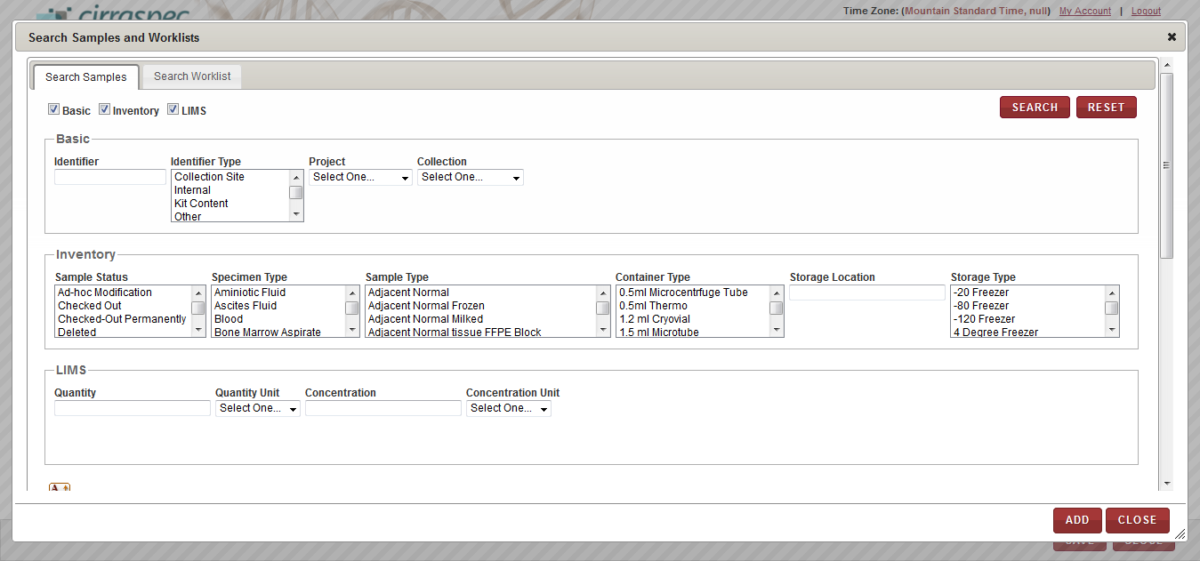

1. Search Samples window – search fields
2. Enter appropriate information in each field. Following table lists each field and its description.   
   **Note:** You can specify multiple search criteria.

Table 25: Selecting additional biospecimens

| **Field** | **Description** |
| --- | --- |
| **Basic** search fields | |
| **Identifier** | Type a biospecimen identifier to search for a specific biospecimen. |
| **Identifier Type** | Click one or more identifier types to search for all biospecimens with that identifier type. |
| **Project** | Click the appropriate Project to search for all biospecimens associated with that Project. |
| **Collection** | Click the appropriate Collection to search for all biospecimens associated with that Collection. |
| **Inventory** search fields | |
| **Sample Status** | Click one or more biospecimen statuses to search for all biospecimens with that status. |
| **Specimen Type** | Click one or more specimen types to search for all biospecimens with that specimen type. |
| **Sample Type** | Click one or more sample types to search for all biospecimens with that sample type. |
| **Container Type** | Click one or more container types to search for all biospecimens with that container type. |
| **Storage Location** | Type a storage location to search for all biospecimens stored in that location. |
| **Storage Type** | Click one or more storage types to search for all biospecimens with that storage type. |
| **LIMS** search fields | |
| **Quantity** | Type a quantity to search for all biospecimens of that quantity. |
| **Quantity Unit** | Click the appropriate unit of measure to search for all biospecimens using that quantity unit of measure. |
| **Concentration** | Type a concentration to search for all biospecimens of that concentration. |
| **Concentration Unit** | Click the appropriate unit of measure to search for all biospecimens using that concentration unit of measure. |

1. Click **SEARCH**.

A list of biospecimens that match your search criteria appears.

1. On the list, click each biospecimen that you want to add to the worklist.

The biospecimen identifiers appear in the list below.

1. Click **ADD**.

The search window closes and the biospecimen identifiers appear on the **Create/Modify Worklist** page.

1. To search and select additional biospecimens that are associated with another worklist:
2. Click the **Search Inventory** link.  
   The **Search Samples and Worklists** page appears.
3. Click the **Search Worklist** tab.
4. In the **Worklist Name** box, type the name of the personal worklist, and click **Search**. **Note:** You can type a partial or full name of the worklist.   
   A list of worklists that match your search criteria appears.
5. Click the appropriate worklist.   
   The list of biospecimens that are associated with the worklist appears below.

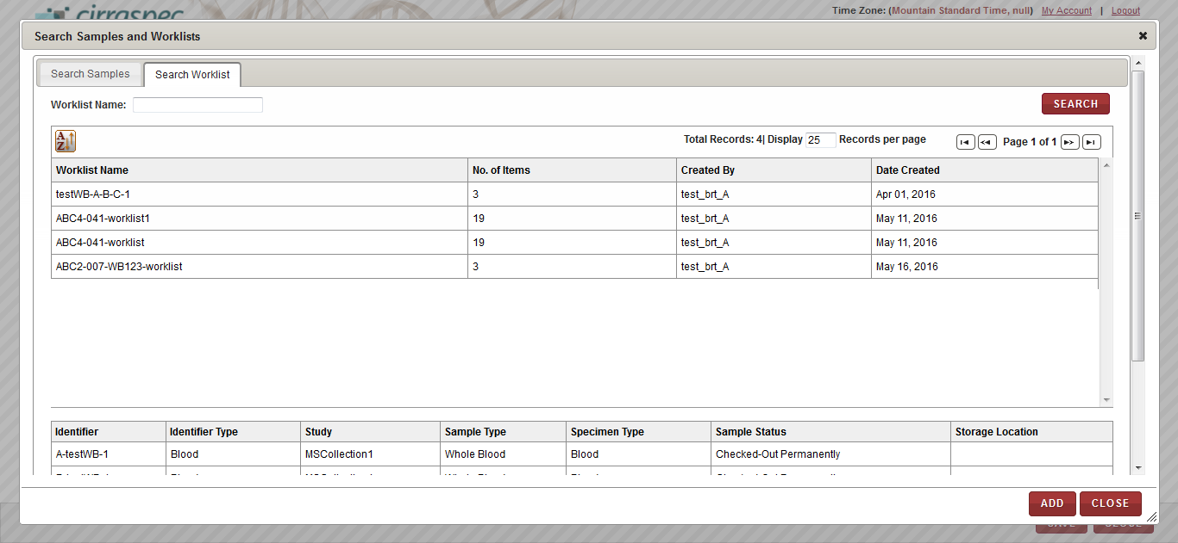

1. Search Worklist window
2. Click **ADD**.

The biospecimens associated with the worklist appear on the **Create/Modify Worklist** page.

1. To remove a biospecimen from the list on the **Create/Modify Worklist** page.
2. Click the trash can icon  next to the appropriate biospecimen identifier.

**Note:** To remove all the biospecimens from the list, click the trash can icon  on the header.

A confirmation window appears.

1. Click **OK**.

The biospecimen is removed from the list.

1. Click **SAVE**.

Worklist is created and new information appears on **View Worklist** page.

NOTE:

For worklist creation:

The samples checked into the Inventory will be visible on Search Inventory

The shared worklists will be visible on Worklists tab

### Modifying a Worklist

To modify a worklist:

1. Log in to the application using your log in credentials.

The CIRRASPEC home page appears.

1. Point to the arrow of the **BMS** tab, and then click **Worklists**.

The **Worklist Search** page appears.

1. Click **SEARCH**.

The worklist search page displays a list of worklists that are accessible based on your login location.

1. Click the worklist that you want to modify.

The **View Worklist** page appears.

1. Click **Modify**.

The **Create/Modify Worklist** page appears.

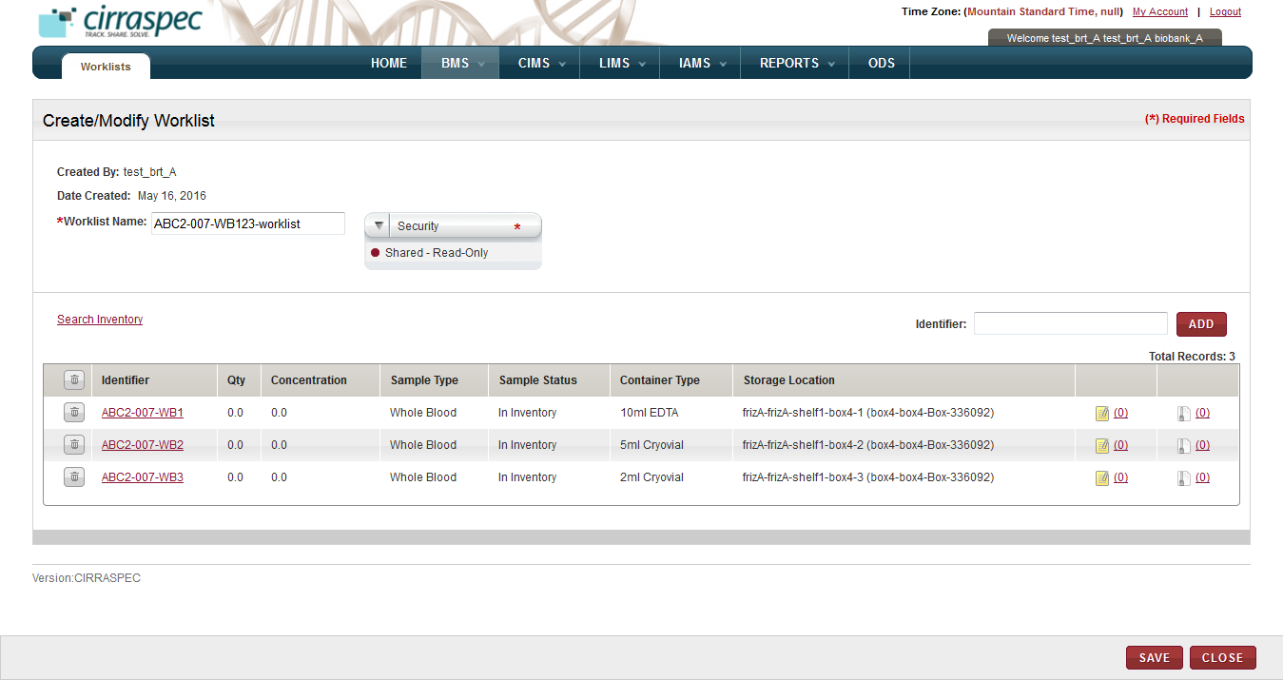

1. Create/Modify Worklist page
2. Click the appropriate security for this worklist if you want to change the security.   
   **Note:**

* This field is only enabled if you were the creator of the worklist or the current security setting is **Shared – Read-Write**.
* If you want any authorized user to view and modify this list, click **Shared – Read-Write**.
* If you want only you to modify this worklist, and any authorized user to view this worklist, click **Shared – Read-Only**.
* If you want only yourself to view and modify this worklist, click **Private**.

1. To add a known biospecimen to the worklist, in the **Identifier** box, type the appropriate kit or biospecimen identifier, and then click **ADD**.

**Note:** You can add multiple known biospecimens.

The biospecimens appear on the **Create/Modify Worklist** page.

1. To search and select additional biospecimens by Identifier, Collection, Sample Type, Specimen Type, or LIMS workflow type:
2. Click the **Search Inventory** link.  
   The **Search Samples and Worklists** page appears.
3. Select the appropriate checkbox to display the Basic, Inventory or LIMS search fields.  
   **Note:** You can select more than one checkbox.   
   The search fields associated with your selection appear.

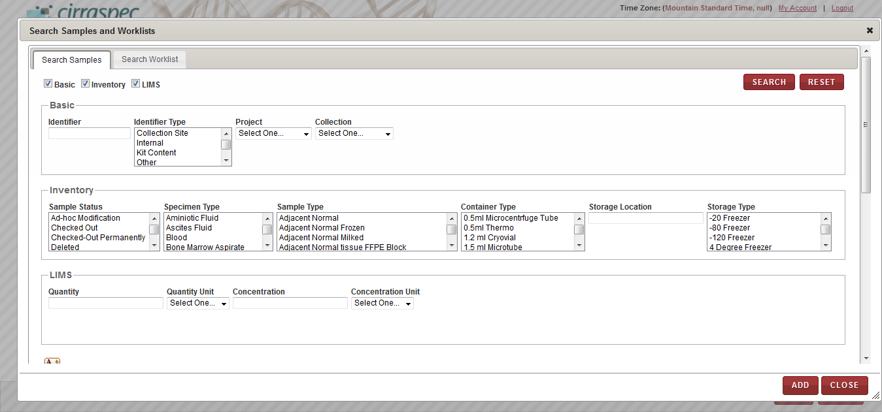

1. Search Samples window – search fields
2. Enter appropriate information in each field. Following table lists each field and its description.   
   **Note:** You can specify multiple search criteria.

Table 26: Selecting additional biospecimens

| **Field** | **Description** |
| --- | --- |
| **Basic** search fields | |
| **Identifier** | Type a biospecimen identifier to search for a specific biospecimen. |
| **Identifier Type** | Click one or more identifier types to search for all biospecimens with that identifier type. |
| **Project** | Click the appropriate Project to search for all biospecimens associated with that Project. |
| **Collection** | Click the appropriate Collection to search for all biospecimens associated with that Collection. |
| **Inventory** search fields | |
| **Sample Status** | Click one or more biospecimen statuses to search for all biospecimens with that status. |
| **Specimen Type** | Click one or more specimen types to search for all biospecimens with that specimen type. |
| **Sample Type** | Click one or more sample types to search for all biospecimens with that sample type. |
| **Container Type** | Click one or more container types to search for all biospecimens with that container type. |
| **Storage Location** | Type a storage location to search for all biospecimens stored in that location. |
| **Storage Type** | Click one or more storage types to search for all biospecimens with that storage type. |
| **LIMS** search fields | |
| **Quantity** | Type a quantity to search for all biospecimens of that quantity. |
| **Quantity Unit** | Click the appropriate unit of measure to search for all biospecimens using that quantity unit of measure. |
| **Concentration** | Type a concentration to search for all biospecimens of that concentration. |
| **Concentration Unit** | Click the appropriate unit of measure to search for all biospecimens using that concentration unit of measure. |

1. Click **SEARCH**.

A list of biospecimens that match your search criteria appears.

1. Click each biospecimen that you want to add to the worklist.

The biospecimen identifiers appear in the list below.

1. Click **ADD**.

The search window closes and the biospecimen identifiers appear on the **Create/Modify Worklist** page.

1. To search and select additional biospecimens that are associated with another worklist:
2. Click the **Search Inventory** link.  
   The **Search Samples and Worklists** page appears.
3. Click the **Search Worklist** tab.
4. In the **Worklist Name** box, type the name of the personal worklist, and click **Search**. **Note:** You can type a partial or full name of the worklist.   
   A list of worklists that match your search criteria appears.
5. Click the appropriate worklist.   
   The list of biospecimens that are associated with the worklist appears below.

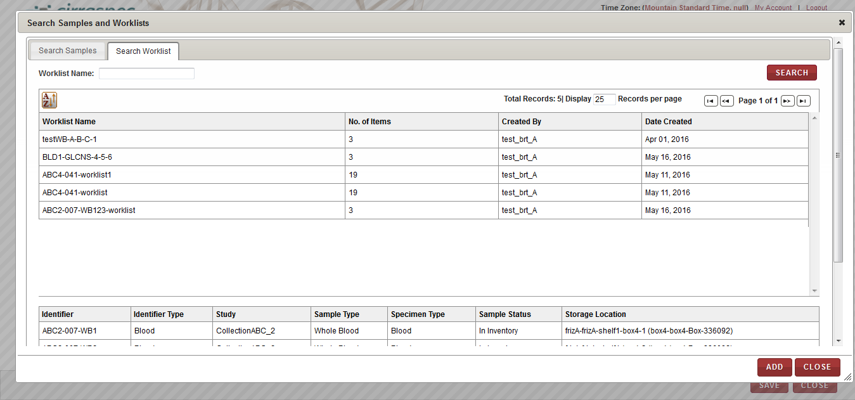

1. Search Worklist window
2. Click **ADD**.

All the biospecimens associated with the worklist appear on the **Create/Modify Worklists** page.

1. To remove a biospecimen from the list on the **Create/Modify Worklist** page.
2. Click the trash can icon  next to the appropriate biospecimen identifier.

**Note:** To remove all the biospecimens from the list, click the trash can icon  on the header.

A confirmation window appears.

1. Click **OK**.

The biospecimen is removed from the list.

1. Click **SAVE**.

Worklist is modified and new information appears on **View Worklist** page.

### Deleting a Worklist

**Note:** Only the creator of a worklist can delete a worklist.

To delete a worklist:

1. Log in to the application using your log in credentials.

The CIRRASPEC home page appears.

1. Point to the arrow of the **BMS** tab, and then click **Worklists**.

The **Worklist Search** page appears.

1. Click **SEARCH**.

The worklist search page displays a list of worklists that are accessible based on your login location.

1. Click the worklist that you want to delete.

The **View Worklist** page appears.

1. Click **DELETE**.

A confirmation message appears.

1. Click **OK**.

The worklist is no longer available for use.

The samples previously associated with the worklist are not affected.

### Adding an Event for Worklist Biospecimens

To add an event for a biospecimen that is associated with a worklist:

1. Log in to the application using your log in credentials.

The CIRRASPEC home page appears.

1. Point to the arrow of the **BMS** tab, and then click **Worklists**.

The worklist search page appears.

1. Click **SEARCH**.

The worklist search page displays a list of worklists that are accessible based on your login location.

1. Click the worklist for which you want to add events for the biospecimens.

The **View Worklist** page appears.

1. To add an event for an individual biospecimen, click the **Manage Events** icon  for the appropriate biospecimen.

OR

To add an event for multiple biospecimens:

1. Select the checkbox of each biospecimen for which you want to add an event.  
   OR  
   Select the checkbox in the gray header to select all of the biospecimens.
2. In the **Actions** list, click **Add Events**, and then click **INITIATE**.

The **Manage Events** window appears with identifiers of the biospecimens that you selected.

1. Click the **Create New Event** link.

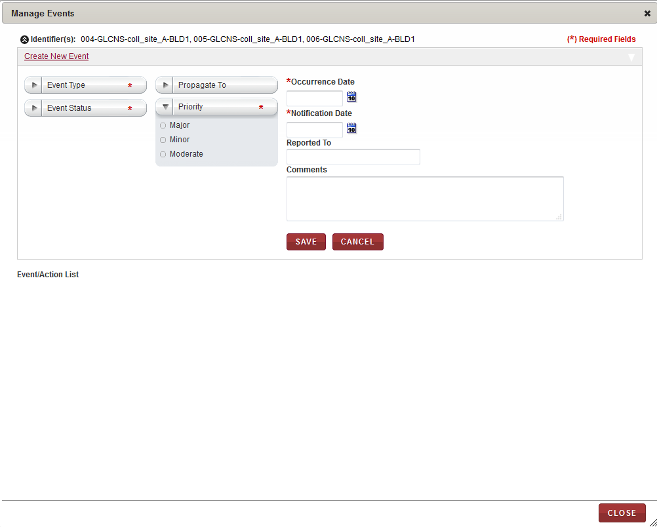

1. Manage Events window
2. Enter appropriate information in each field. Following table lists each field and its description.

**Note:** Fields that are marked with the red asterisk (*) are mandatory.

Table 27: Adding an event to multiple worklist biospecimens

| **Field** | **Description** |
| --- | --- |
| **Event Type**\* | Click the appropriate event type for this event. |
| **Event Status**\* | Click the appropriate status for this event. |
| **Propagate To** | Click the appropriate shipment cascading option to identify what items associated with the initial item should also have the event attached. Example: All items associated with the shipment, or biospecimens associated with the shipment. |
| **Priority**\* | Click the appropriate priority for this event. |
| **Occurrence Date**\* | Click the date icon Search calendar, and then click the date when the event occurred. |
| **Notification Date**\* | Click the date icon Search calendar, and then click the date when you were notified of the event. |
| **Reported To** | Type the person or organization to which the event was reported. |
| **Comments** | Type the appropriate comments for this event. |

1. Click **SAVE**.

The event is saved and it appears in the **Event/Action List** area of the **Manage Events** window.   
**Note:** You can add multiple events to the biospecimens.

1. Click **CLOSE** to close the **Manage Events** window.

### Assigning Storage for Worklist Biospecimens

To assign storage for biospecimens associated with a worklist:

1. Log in to the application using your log in credentials.

The CIRRASPEC home page appears.

1. Point to the arrow of the **BMS** tab, and then click **Worklists**.

The **Worklist Search** page appears.

1. Click **SEARCH**.

The worklist search page displays a list of worklists that are accessible based on your login location.

1. Click the worklist for which you want to assign storage locations for the biospecimens.

The **View Worklist** page appears.

1. Select the checkboxes of each biospecimen to which you want to assign storage.   
   **Note:**

* To assign storage for all the biospecimens, select the checkbox on the gray header.
* You cannot select biospecimens with a sample status shown on the **View Worklist** screen as **Checked Out**, **Reserved**, **Deleted** or **Distributed**.

1. In the **Actions** list, click **Assign Storage Location**, and then click **INITIATE**.   
   The **Bulk Storage Assignment** window appears.

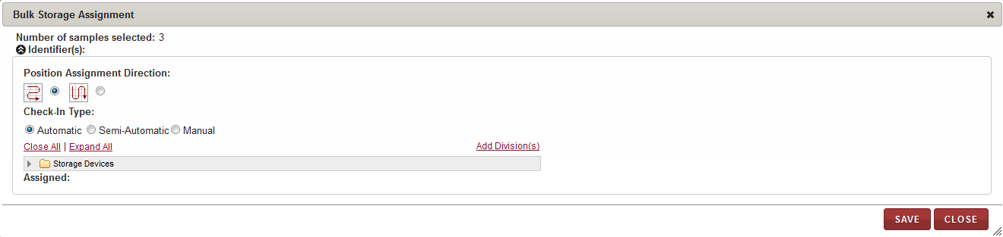

1. Bulk Storage Assignment window
2. Enter appropriate information in each field. Following table lists each field and its description.

Table 28: Assigning storage location

| **Field** | **Description** |
| --- | --- |
| **Position Assignment Direction** | Click the appropriate direction for assigning a storage location to each of the biospecimens.  **Note:**   * The arrow icon that goes right and left depicts assignment of biospecimens to available cells on the storage map in horizontal rows. * The arrow icon that goes up and down depicts assignment of biospecimens to available cells on the storage map in vertical columns. |
| **Check-In Type** | Click the appropriate means of assigning the storage location:  **Automatic:** The application automatically assigns the biospecimens that you select to available locations in the storage device starting with the first available location.  **Semi-Automatic:** You can select the initial location and assign it to a biospecimen. The application then assigns each biospecimen to the next available location.  **Manual:** You can assign each biospecimen to a location by selecting a cell on the storage map each time. |

1. To select the storage division where you want the biospecimens stored:
2. Click **Expand All** to expand the Storage Devices taxonomy to show all storage devices.
3. Click the appropriate storage device name (blue folder) to display all storage divisions within that device.
4. Click the division where you want to store the biospecimens. For example, Freezer X, Shelf 1, Box 3.  
   The storage map of the cell positions within this division appears on the right.
5. If you selected **Automatic** as **Check-In Type**, click **ASSIGN**.

The application performs the following actions:

* Assigns each biospecimen to the next available location within the selected device.
* Updates the storage map with the new assignments.
* Displays the position assignments in the **Assigned** field at the bottom.

**Note:** If a division does not have enough available positions for all the selected biospecimens, you can select another division and proceed until all biospecimens are assigned.

1. If you selected **Semi-Automatic** as **Check-In Type**, perform the following steps:
2. Click the available cell on the storage map where you want to store the first biospecimen.

**Note:**

* Storage Map positions that are available appear in tan or goldenrod color.
* Positions that are used appear in red or rust color.
* The current selection appears in green color.

The **Assign Identifier** window appears.  
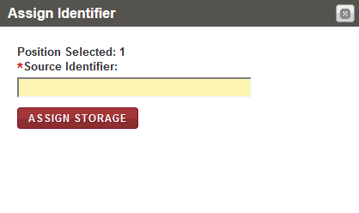

1. Assign Identifier window
2. In the **Source Identifier** box, scan or type the identifier of the first biospecimen that you want to assign to the selected storage map cell.  
   **Note:** You can display the identifiers of the biospecimens to be assigned by clicking on the arrow icon beside the **Identifiers** field in the top left corner of the **Bulk Storage Assignment** window.
3. Click **ASSIGN STORAGE**.

The application performs the following functions:

* Assigns the biospecimen to the cell that you selected and updates the storage map.
* Displays the window again with the **Position Selected** field automatically displaying the next available position.

1. Confirm the assignment of each biospecimen by clicking on **ASSIGN STORAGE** each time the **Assign Identifier** window appears until all biospecimens are assigned.

**Note:**

* If the container type associated with the specified biospecimen is not valid for this storage location, an error message appears. You can select another division and repeat steps a. - c.
* If the storage division does not have enough available positions for all the biospecimens, you can select another division.

1. If you selected **Manual** as **Check-In Type**, perform the following steps:
2. Click the available cell on the storage map where you want to store the first biospecimen.

**Note:**

* Storage Map positions that are available appear in tan or goldenrod color.
* Positions that are used appear in red or rust color.
* The current selection appears in green color.

The **Assign Identifier** window appears.

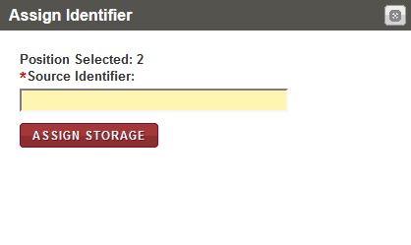

1. Assign Identifier window
2. In the **Source Identifier** box, scan or type the identifier of the first biospecimen that you want to assign to the selected storage map cell.  
   **Note:** You can display the identifiers of the biospecimens to be assigned by clicking on the arrow icon beside the **Identifiers** field in the top left corner of the **Bulk Storage Assignment** window.
3. Click **ASSIGN STORAGE**.

The application assigns the biospecimen to the cell that you selected and updates the storage map.

1. Repeat steps a. – c. until all biospecimens are assigned.

**Note:**

* If the container type associated with the specified biospecimen is not valid for this storage location, an error message appears. You can select another division and repeat steps a. - c.
* If the storage division does not have enough available positions for all the biospecimens, you can select another division.

1. Click **SAVE**.  
   The **Bulk Storage Assignment** window closes. The storage assignments are saved and appear in the **Storage Location** column on the **View Worklist** page.

### Generating a Label for Worklist Biospecimens

To generate a barcode label for a biospecimen that is associated with a worklist:

1. Log in to the application using your log in credentials.

The CIRRASPEC home page appears.

1. Point to the arrow of the **BMS** tab, and then click **Worklists**.

The **Worklist Search** page appears.

1. Click **SEARCH**.

The worklist search page displays a list of worklists that are accessible based on your login location.

1. Click the worklist for which you want to generate labels for the biospecimens.

The **View Worklist** page appears.

1. Select the checkbox of each biospecimen for which you want to generate a barcode label.

**Note:** To select all biospecimens, select the checkbox on the gray header.

1. In the **Actions** list, click **Generate Labels**, and then click **INITIATE**.

The print barcode window appears.

The kit template names for the selected biospecimens are shown on this window.

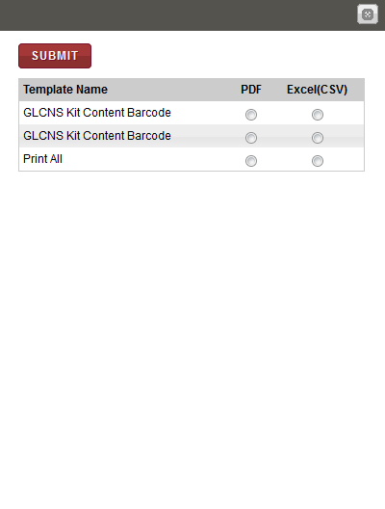

1. Print barcode window
2. To print labels to a PDF file, click **PDF** next to the label template for which you want to generate a barcode label, and then click **SUBMIT**.

The image of the barcode label that is associated with the biospecimen appears below.  
  
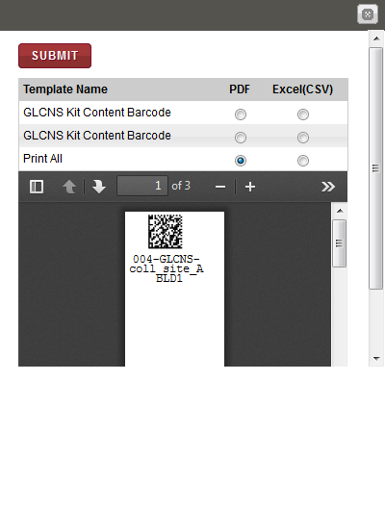

1. Print barcode window with label

**Note**: To identify tools for viewing multiple labels, printing labels and saving the file to your machine, hover the cursor over the icons in the horizontal and vertical navigation bars.

### Generating a Report for Worklist Biospecimens

To generate a report for biospecimens associated with a worklist:

1. Log in to the application using your log in credentials.

The CIRRASPEC home page appears.

1. Point to the arrow of the **BMS** tab, and then click **Worklists**.

The **Worklist Search** page appears.

1. Click **SEARCH**.

The worklist search page displays a list of worklists that are accessible based on your login location.

1. Click the worklist for which you want to generate a report for the biospecimens.

The **View Worklist** page appears.

1. Select the checkbox of each biospecimen for which you want to generate a report.

**Note:** To select all the biospecimens, select the checkbox on the gray header.

1. In the **Actions** list, click **Generate Report**, and then click **INITIATE**.

The report for the biospecimens appears in a new window.

1. View, print and/or save the file, as needed.   
   **Note**: Hover the cursor over the icons in the horizontal and vertical navigation bars to identify tools for viewing multiple pages, printing the report and saving the file to your machine.

**Example pdf report :**



### Initiating a Workflow Process for Worklist Biospecimens

To initiate a workflow process for biospecimens associated with a worklist:

1. Log in to the application using your log in credentials.

The CIRRASPEC home page appears.

1. Point to the arrow of the **BMS** tab, and then click **Worklists**.

The **Worklist Search** page appears.

1. Click **SEARCH**.

The worklist search page displays a list of worklists that are accessible based on your login location.

1. Click the worklist for which you want to initiate a workflow process for the biospecimens.

The **View Worklist** page appears.

1. Select the checkboxes of the biospecimens for which you want to initiate a workflow process.  
   **Note:** To select all the biospecimens, select the checkbox on the gray header.
2. In the **Actions** list, click **Initiate Workflow**, and then click **INITIATE**.

The **Create Workflow** page appears.

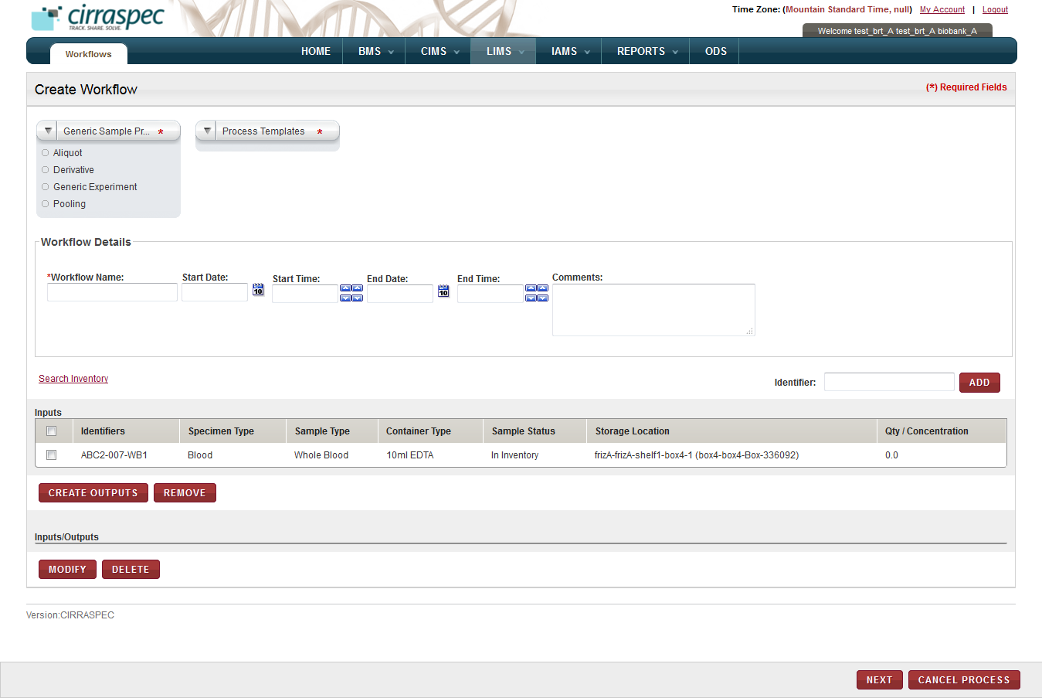

1. Create Workflow page
2. To complete **Create Workflow** screen, see **Create Workflow** and follow the steps from step 4.

### Modifying Worklist Biospecimens

To modify biospecimens associated with a worklist:

1. Log in to the application using your log in credentials.

The CIRRASPEC home page appears.

1. Point to the arrow of the **BMS** tab, and then click **Worklists**.

The **Worklist Search** page appears.

1. Click **SEARCH**.

The worklist search page displays a list of worklists that are accessible based on your login location.

1. Click the worklist for which you want to modify the biospecimens.

The **View Worklist** page appears.

1. Select the checkboxes of each biospecimen that you want to modify.   
   **Note:**

* To select all biospecimens, select the checkbox on the gray header.
* You cannot select biospecimens with a sample status shown on the **View Worklist** screen as **Checked Out**, **Reserved**, **Deleted** or **Distributed**.

1. In the **Actions** list, click **Modify Samples**, and then click **INITIATE**.

The **Modify Inventory** window appears and displays the identifiers of the biospecimens.

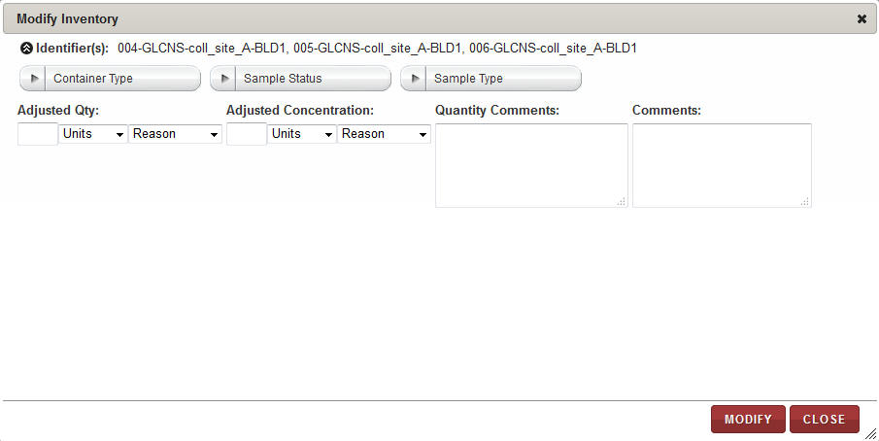

1. Modify Inventory page
2. Enter appropriate information in each field. Following table lists each field and its description.

Table 29: Modifying worklist biospecimens

| **Field** | **Description** |
| --- | --- |
| **Container Type** | Click the appropriate container type for the selected biospecimen. |
| **Sample Status** | Click the appropriate sample status type for the selected biospecimen. |
| **Sample Type** | Click the appropriate sample type for the selected biospecimen. |
| **Adjusted Qty** | To specify the new adjusted quantity:   * + 1. In the box, type the amount of change you want to make to the quantity. * To decrease the current quantity, type a negative number.  For example, to decrease the quantity from 1.50 to 1.00, type -.50. * To increase the current quantity, type a positive number.  For example, to increase the quantity from 1.50 to 2.00, type .50.   2. In the **Units** list, click the appropriate unit of measure for the quantity.  3. In the **Reason** list, click the reason for the adjustment. |
| **Adjusted Concentration** | To specify the new adjusted concentration:   * + 1. In the box, type the amount of change you want to make to the concentration. * To decrease the concentration, type a negative number.  For example, to decrease the concentration from 1.50 to 1.00, type -.50. * To increase the concentration, type a positive number.  For example, to increase the concentration from 1.50 to 2.00, type .50.   2. In the **Units** list, click the appropriate unit of measure for the concentration.  3. In the **Reason** list, click the reason for the adjustment. |
| **Quantity Comments** | Type your comments regarding the quantity adjustments, if applicable. |
| **Comments** | Type your comments regarding the modifications, if applicable. |

1. Click **MODIFY**.

The worklist biospecimens are modified and the new information appears on the **View Worklist** page.

### Move worklist biospecimens to a bulk container

To move biospecimens into a bulk container:

1. Log in to the application using your log in credentials.

The home page appears.

1. Point to the arrow of the **BMS** tab, and then click **Shipments**.

The **Shipment Search** page appears.

1. Click **SEARCH**.

The shipment search page displays a list of shipments that are accessible based on your login location.

1. Click the row of the shipment for which you want to move biospecimens to a bulk container.

The **View Shipment** page appears

1. Select biospecimens to move to bulk container.
2. Expand Actions, Select Move to Bulk Container and Click INITIATE.

Create Bulk Container page appears.

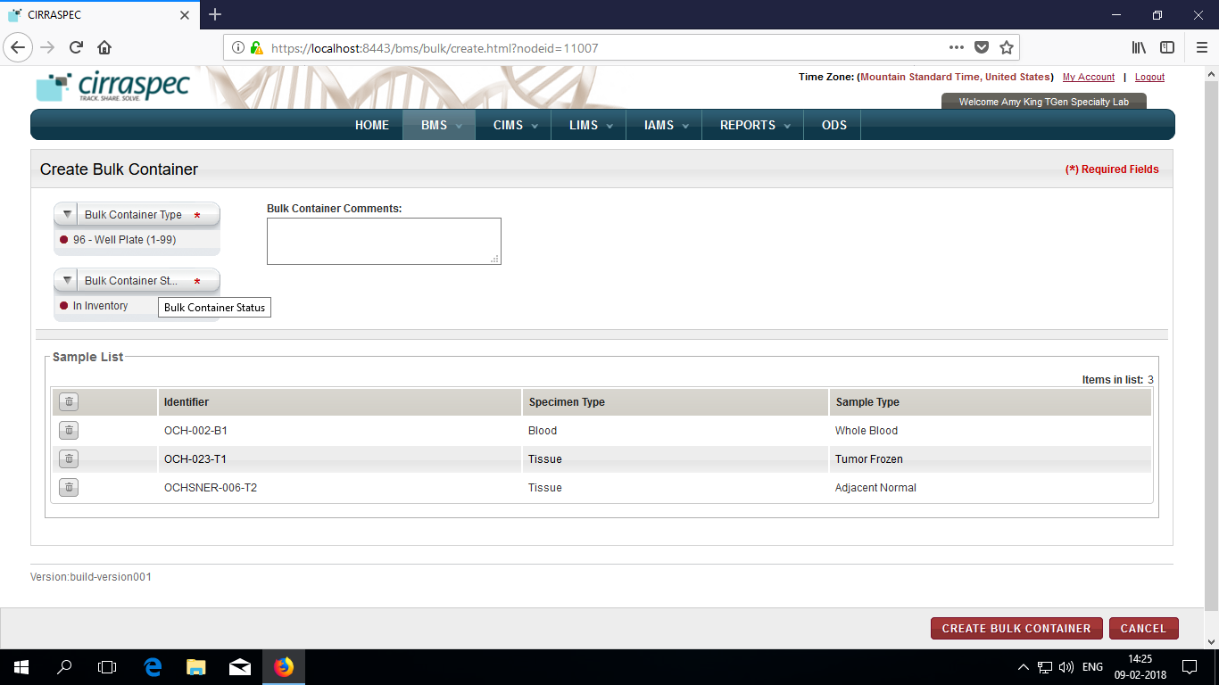

1. Select Bulk-Container Type, Bulk Container Status from dropdowns.
2. Enter Bulk Container Comments (optional)
3. Click **CREATE BULK CONTAINER.**

Modify Bulk Container page appears.

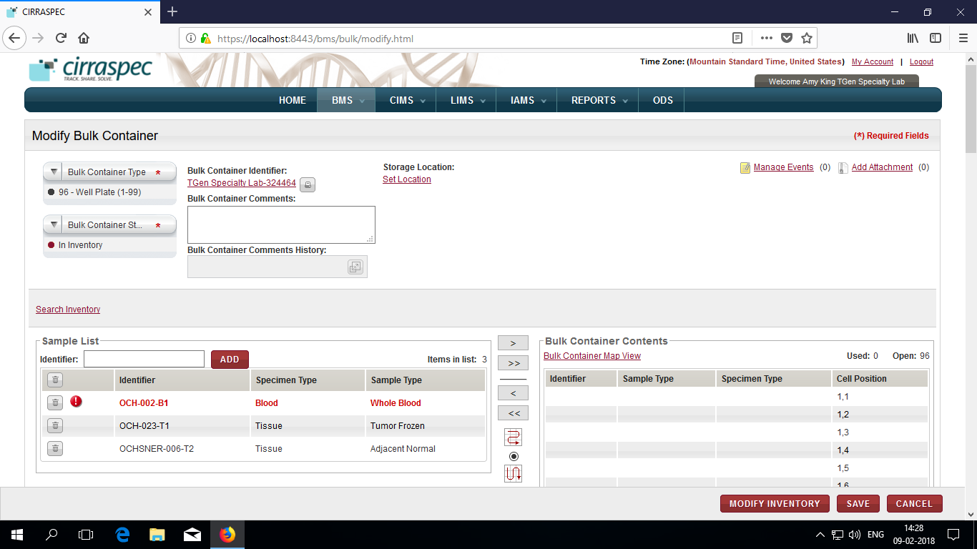

1. Click **SAVE.**

View Bulk Container page appears.

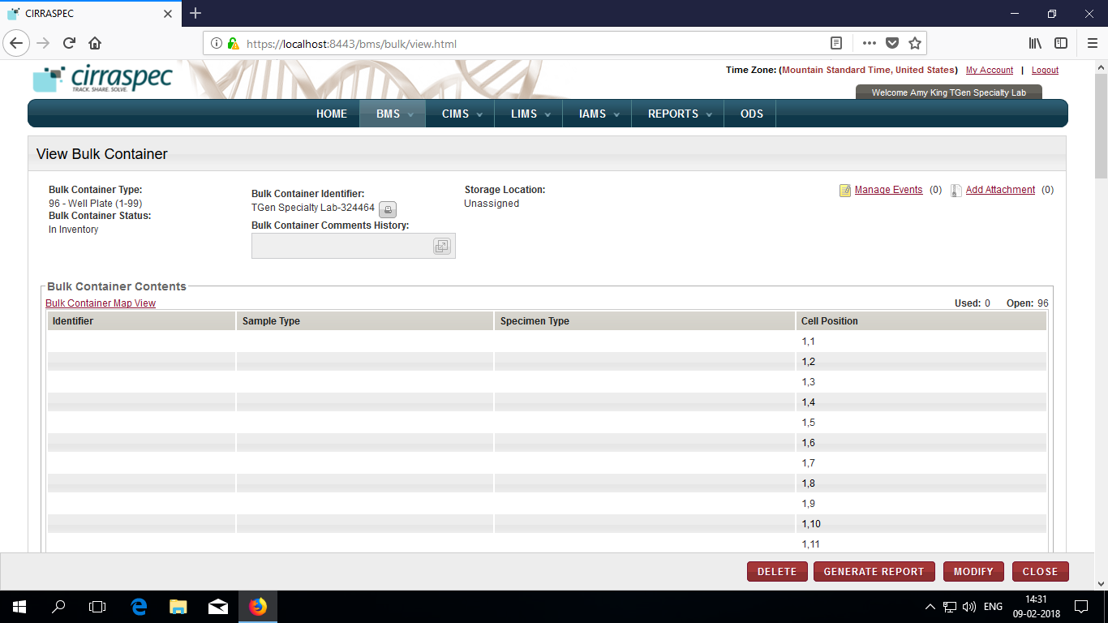

### Adding a Biospecimens Shipment to a Worklist

You can add a shipment biospecimen to an existing worklist or a new worklist.

**Note:**

* The shipment must have the **Awaiting Samples Check-in** or **Completed** status
* The biospecimens to be added to a worklist must have the **In Inventory** status.

To add a shipment biospecimen to a worklist:

1. Log in to the application using your log in credentials.

The home page appears.

1. Point to the arrow of the **BMS** tab, and then click **Shipments**.

The **Shipment Search** page appears.

1. Click **SEARCH**.

The shipment search page displays a list of shipments that are accessible based on your login location.

1. Click the row of the shipment for which you want to add biospecimens to a worklist.

The **View Shipment** page appears.

1. Click **Add to WORKLIST**.   
   A confirmation window appears indicating that only biospecimens with a status as **In Inventory** can be added to a worklist.
2. Click **OK** in confirmation window.

The **Create/Modify Worklist** page appears with the eligible shipment biospecimens listed.

**Note:**

If some biospecimens in the shipment cart have a status other than **In Inventory**, only the **In Inventory** biospecimens are transferred to the **Create/Modify Worklist** page.

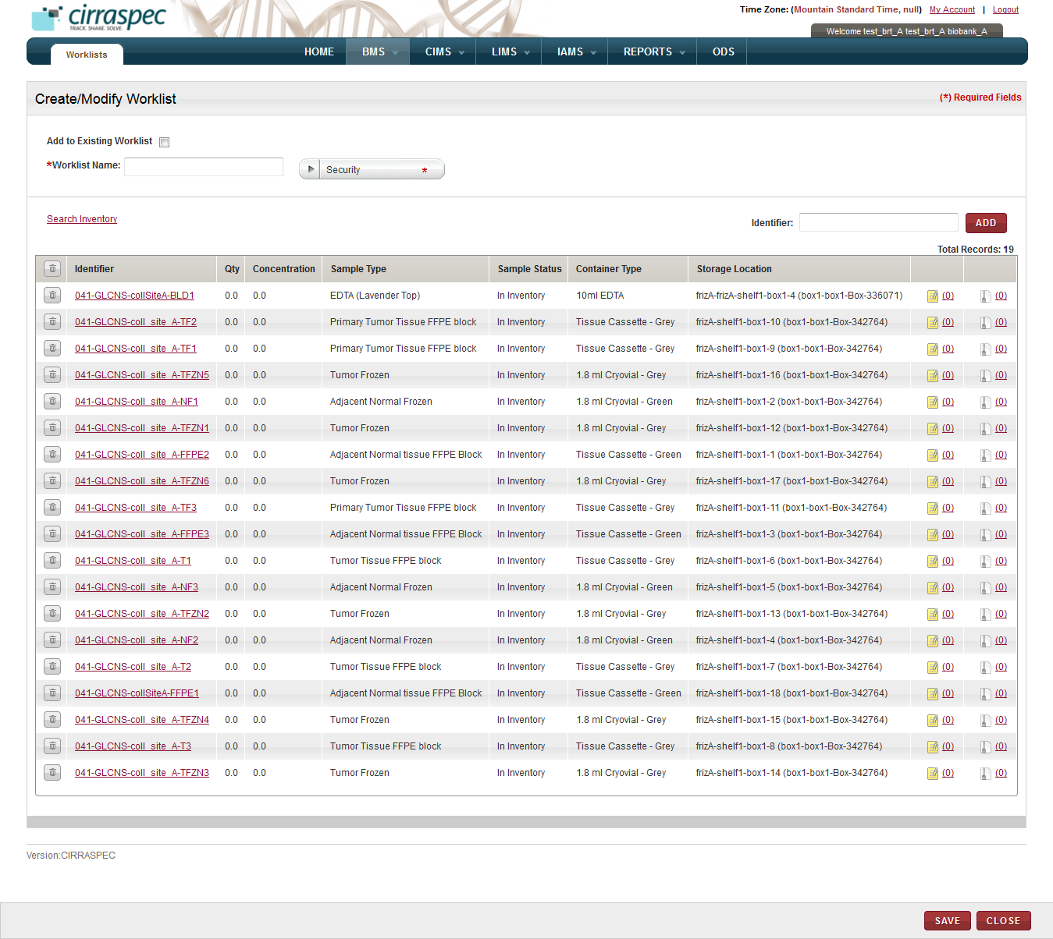

1. Create/Modify Worklist page
2. Enter appropriate information in each field. Following table lists each field and its description.   
   **Note:** Fields that are marked with the red asterisk (*) are mandatory.

Table 43: Adding shipment biospecimens to a worklist

| **Field** | **Description** |
| --- | --- |
| **Add to Existing Worklist** | If you want to add these biospecimens to an existing worklist, select this checkbox. |
| **Worklist Name**\* | If you checked the Add to Existing box, then type part or the entire existing worklist name in this field.  **Note:** As you type part of an existing name, a dropdown list appears with existing worklist names that you can select for this field.  If you want to add these biospecimens to a new worklist, type a name for the worklist. |
| **Security**\* | If you want to add these biospecimens to a new worklist, click on the appropriate **Security** value for the new worklist.   * **Private**: Can be viewed, modified or deleted only by the creator of the worklist. Cannot be viewed by other users. * **Shared – Read-Only**: Can be viewed and used by any other authorized users within the organization. Can be viewed, modified or deleted only by the creator of the worklist. * **Shared – Read-Write**: Can be viewed or modified by any authorized user within the organization. Only the creator of the worklist can change the security level or delete the worklist.   **Note:** This field is disabled if the **Add to Existing Worklist** box is checked. |
| **Identifier** | To manually add a known biospecimen that is not part of the shipment to the worklist, input or scan that item’s Kit or Sample Identifier in the **Source Identifier** textbox and click on the **ADD** button.  The biospecimen appears on the list below. **Note:** You can add multiple biospecimens to the worklist using this field. |

1. To search and select additional biospecimens by Identifier, Collection, Sample Type, Specimen Type, or LIMS workflow type:
2. Click the **Search Inventory** link.  
   The **Search Samples and Worklists** page appears.
3. Select the appropriate checkbox to display the Basic, Inventory or LIMS search fields.  
   **Note:** You can select more than one checkbox.   
   The search fields associated with your selection appear.

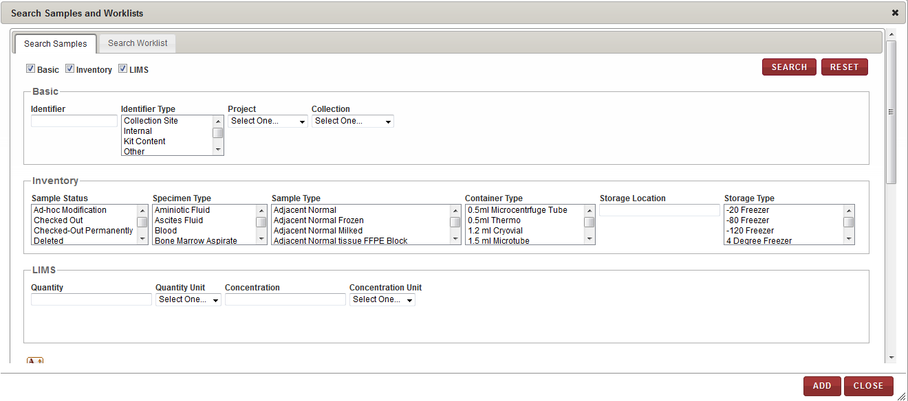

1. Figure Search Samples window – search fields
2. Enter appropriate information in each field. Following table lists each field and its description.   
   **Note:** You can specify multiple search criteria.

Table 44: Selecting additional biospecimens

| **Field** | **Description** |
| --- | --- |
| **Basic** search fields | |
| **Identifier** | Type a biospecimen identifier to search for a specific biospecimen. |
| **Identifier Type** | Click one or more identifier types to search for all biospecimens with that identifier type. |
| **Project** | Click the appropriate Project to search for all biospecimens associated with that Project. |
| **Collection** | Click the appropriate Collection to search for all biospecimens associated with that Collection. |
| **Inventory** search fields | |
| **Sample Status** | Click one or more biospecimen statuses to search for all biospecimens with that status. |
| **Specimen Type** | Click one or more specimen types to search for all biospecimens with that specimen type. |
| **Sample Type** | Click one or more sample types to search for all biospecimens with that sample type. |
| **Container Type** | Click one or more container types to search for all biospecimens with that container type. |
| **Storage Location** | Type a storage location to search for all biospecimens stored in that location. |
| **Storage Type** | Click one or more storage types to search for all biospecimens with that storage type. |
| **LIMS** search fields | |
| **Quantity** | Type a quantity to search for all biospecimens of that quantity. |
| **Quantity Unit** | Click the appropriate unit of measure to search for all biospecimens using that quantity unit of measure. |
| **Concentration** | Type a concentration to search for all biospecimens of that concentration. |
| **Concentration Unit** | Click the appropriate unit of measure to search for all biospecimens using that concentration unit of measure. |

1. Click **SEARCH**.

A list of biospecimens that match your search criteria appears.

1. Click each biospecimen that you want to add to the worklist.

The biospecimen identifiers appear in the list below.

1. Click **ADD**.

The search window closes and the biospecimen identifiers appear on the **Create/Modify Worklist** page.

1. To search and select additional biospecimens that are associated with another worklist:
2. Click the **Search Inventory** link.  
   The **Search Samples and Worklists** page appears.
3. Click the **Search Worklist** tab.
4. In the **Worklist Name** box, type the name of the personal worklist, and click **Search**. **Note:** You can type a partial or full name of the worklist.   
   A list of worklists that match your search criteria appears.
5. Click the appropriate worklist.   
   The list of biospecimens that are associated with the worklist appears below.

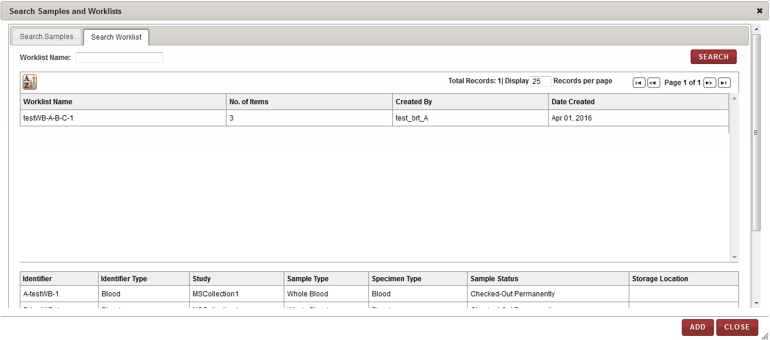

1. Search Worklist window
2. Click **ADD**.

The biospecimens associated with the worklist appear on the **Create/Modify Worklists** page.

1. To remove a biospecimen from the list on the **Create/Modify Worklists** page.
2. Click the trash can icon  next to the appropriate biospecimen identifier.

**Note:** To remove all the biospecimens from the list, click the trash can icon  on the header.

A confirmation window appears.

1. Click **OK**.

The biospecimen is removed from the list.

1. To add a new identifier to a biospecimen: Click the identifier link for the appropriate biospecimen. The **Add Identifier(s)** window appears.

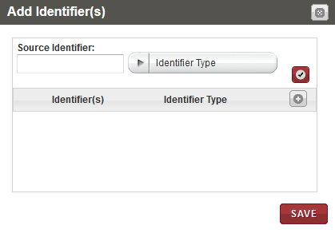

1. Add Identifier(s) window with identifier fields  
   1. Click the add icon .

The identifier fields appear.

* 1. Type the **Source Identifier** to be assigned to the biospecimen.
  2. Click the appropriate **Identifier** **Type** for the new identifier.
  3. Click the check mark icon .   
     The identifier and its type appear in the list below.
  4. Click **SAVE**.

The new identifier is assigned to the biospecimen and appears on the **Create/Modify Worklist** page.

1. Click **SAVE**.

Worklist is created and new information appears on View Worklist page.

### Uploading a File for Worklist Biospecimens

To upload a file for biospecimens associated with a worklist:

1. Log in to the application using your log in credentials.

The CIRRASPEC home page appears.

1. Point to the arrow of the **BMS** tab, and then click **Worklists**.

The **Worklist Search** page appears.

1. Click **SEARCH**.

The worklist search page displays a list of worklists that are accessible based on your login location.

1. Click the worklist for which you want to a upload file for the biospecimens.

The **View Worklist** page appears.

1. To upload a file to a biospecimen:
2. Select the checkbox of each biospecimen for which you want to upload a file.  
   **Note:** To select all biospecimens, select the checkbox on the gray header.
3. In the **Actions** list, click **Upload Files**, and then click **INITIATE**.

The **MANAGE ATTACHMENTS** window appears and displays the identifiers of the biospecimens that you selected.

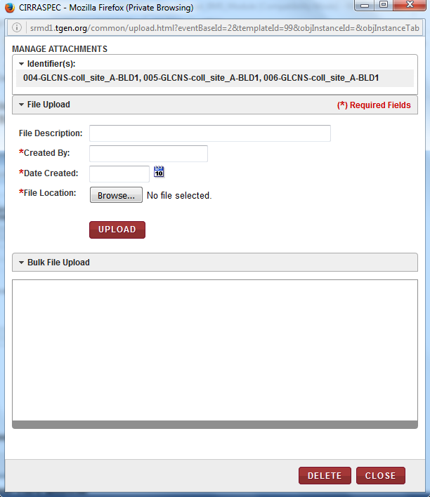

1. Manage Attachments window
2. Enter appropriate information in each field. Following table lists each field and its description.

**Note:** Fields that are marked with the red asterisk (*) are mandatory.

Table 74: Uploading files for worklist biospecimens

| **Field** | **Description** |
| --- | --- |
| **File Description** | Type a description of the file, if applicable. |
| **Created By**\* | Type the name of the person who created the file. |
| **Date Created**\* | Click the date icon date icon, and then click the date when the file was created. |
| **File Location**\* | 1. Click **Browse**, and then select the file that you want to upload.  2. Click **Open**.  The file name appears in a progress bar box below the **File Location** box. |

1. Click **UPLOAD**.  
   The file is uploaded and appears in the **Bulk File Upload** area.  
   **Note:** You can add multiple files to the biospecimens but you must browse and select the files one at a time.
2. To delete a file from the **Bulk File Upload** area:   
   Select the checkbox of the appropriate file.

**Note:** To delete all the files in this area, select the checkbox on the header.

1. Click **DELETE**.

A confirmation window appears.

1. Click **OK**.

The file(s) are deleted.

1. Click **CLOSE** to close the **Manage Attachments** window.

# Search and Modify workflows, Perform Sample Processing Workflows and Generate Reports

### Initiating a Workflow

The **Initiate New Workflow** link on the **Workflow Search** page allows Biobank users to initiate the following sample processes:

* Aliquot
* Derivative
* Pooling
* Generic Experiment

To initiate a workflow:

1. Log in to the application using your log in credentials.

The CIRRASPEC home page appears.

1. Point to the arrow of the **LIMS** tab, and then click **Workflows**.

The **Workflow Search** page appears.

1. Click the **Initiate New Workflow** link.

The **Create Workflow** page appears.

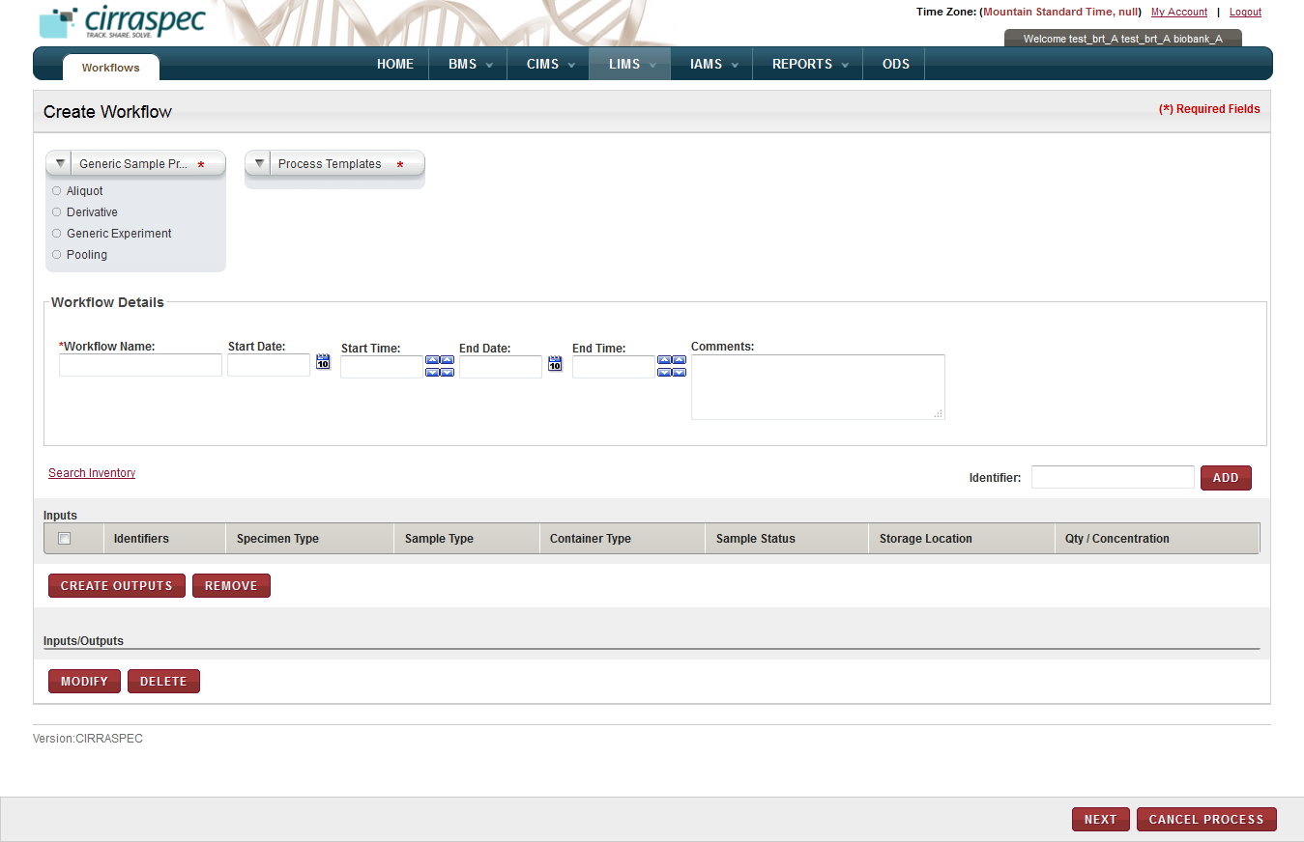

1. Create Workflow page
2. Enter appropriate information in each field. Following table lists each field and its description.   
   **Note:** Fields that are marked with the red asterisk (*) are mandatory.

Table 30: Initiating a workflow

| **Field** | **Description** |
| --- | --- |
| **Generic Sample Process**\* | Click the appropriate type of sample processing you want to initiate. |
| **Process Templates**\* | Click the appropriate template you want to use to pre-populate the sample processing output fields with standardized information.  **Note:**   * The list of templates shown varies based on which **Generic Sample Process** you select above. * The list includes all sample process templates that are available for your use when initiating a workflow. * Sample process templates are uploaded to the application using the **IAMS > Import Data** module. |
| **Workflow Details** | |
| **Workflow Name**\* | Type the name you want to use for this workflow. |
| **Start Date** | Click the date icon and then in the pop-up, select the appropriate date for the workflow start date, if applicable. |
| **Start Time** | Click the arrow icons to display the appropriate start time for this workflow. |
| **End Date** | If applicable, click the date icon and then in the pop-up, select the appropriate date for the workflow end date, if applicable.  **Note:** You cannot select a date prior to the start date. |
| **End Time** | Click the arrow icons to display the appropriate end time for this workflow, if applicable. |
| **Comments** | Type your comments regarding this workflow, if applicable |

1. To add biospecimens to the **Inputs** list:

1. If you want to add a known sample to this workflow, in the **Identifier** box, type the appropriate sample identifier, and then click **ADD**.
2. If you want to search for samples to add to this workflow, click the **Search Inventory** link.   
   For more information about how to search for inventory samples, see **Using the Search Samples and Worklists Window****.**   
   The specified biospecimens appear in the **Inputs** list on the **Create Workflow** page.
3. To remove a sample from the **Inputs** list, select the checkbox for the appropriate sample, and then click **REMOVE**.

**Note:** To remove all samples from the **Inputs** list, select the checkbox on the header.

The sample is removed and its status is set to **In Inventory**.

1. To create sample processing output:
2. Select the checkbox of the appropriate sample(s), and then click **create OUTPUTS**.

A confirmation window appears informing that this action requires sample checkout.

1. Click **OK**.

The processing details window appears.

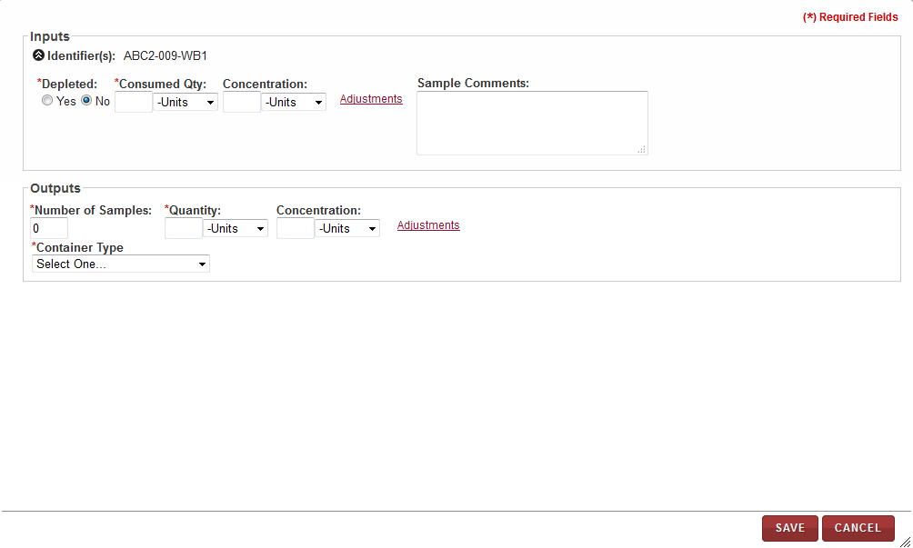

1. Processing details window
2. Enter appropriate information in each field. Following table lists each field and its description.   
   **Note:** Fields that are marked with the red asterisk (*) are mandatory.

Table 31: Creating sample processing output

| **Field** | **Description** |
| --- | --- |
| **Inputs Note:** If you selected Pooling as the processing type, the **Inputs** fields defined below are repeated and displayed for each selected input sample to allow specifying different quantities. | |
| **Depleted**\* | Click **Yes** or **No** to indicate whether or not the input sample quantity is being depleted in this process. |
| **Consumed Quantity**\* | To specify the consumed quantity:   1. In the box, type the amount of the input biospecimen that is to be used in this processing. 2. In the **Units** list, click the appropriate quantity unit of measurement. |
| **Concentration** | To specify the concentration:   1. In the box, type the concentration amount of the input biospecimen. 2. In the **Units** list, click the appropriate concentration unit of measurement. **Note:** You must complete this field if you input a concentration value in step 1. |
| **Adjustments** | To indicate the initial or to adjust the current quantity/concentration of the input biospecimen, click this link. The **Adjusted Qty** and **Adjusted Concentration** fields appear. |
| **Adjusted Qty** | **Note:** This field appears only when you click the **Adjustments** link.  To specify the adjusted quantity:   1. In the box, type the amount you want to add to or subtract from the current quantity for the input biospecimen.  **Note:** You can use decimal or whole numbers to add or subtract. You must use a minus sign to subtract. 2. In the **Units** list, click the appropriate adjusted quantity unit of measurement. **Note:** You must complete this field if you input an adjusted quantity value in step 1. 3. In the **Reason** list, click the appropriate reason for the adjustment. **Note:** You must complete this field if you input an adjusted quantity value in step 1. |
| **Adjusted Concentration** | **Note:** This field appears only when you click the **Adjustments** link.  To specify the adjusted concentration:   1. In the box, type the amount you want to add to or subtract from the current concentration for the input biospecimen.  **Note:** You can use decimal or whole numbers to add or subtract. You must use a minus sign to subtract. 2. In the **Units** list, click the appropriate adjusted concentration unit of measurement. **Note:** You must complete this field if you input an adjusted concentration value in step 1. 3. In the **Reason** list, click the appropriate reason for the adjustment. **Note:** You must complete this field if you input an adjusted concentration value in step 1. |
| **Sample Comments** | Type your comments regarding this processing, if applicable. |
| **Outputs** | |
| **Number of Samples**\* | Type the number of output biospecimen samples you want to create in this processing. **Note:** Outputs is optional for Generic Experiments. You may input a 0 (zero) in this field for a Generic Experiment. |
| **Quantity**\* | To specify the quantity:   1. In the box, type the quantity amount of each output biospecimen being created in this processing. **Note:** The **Number of Samples** multiplied by the **Quantity** shown in this section must equal the **Consumed Qty** in the **Inputs** section. 2. In the **Units** list, click the appropriate quantity unit of measurement. |
| **Concentration** | To specify the concentration:   1. In the box, type the concentration amount of each output biospecimen being created in this processing. 2. In the **Units** list, click the appropriate concentration unit of measurement. |
| **Adjustments** | To make an adjustment to the current quantity/concentration of the output biospecimen(s), click this link. The **Adjusted Qty** and **Adjusted Concentration** fields appear. |
| **Adjusted Qty** | **Note:** This field appears only when you click the **Adjustments** link.  To specify the adjusted quantity:   1. In the box, type the amount you want to add to or subtract from the current quantity for the output biospecimens.  **Note:** You can use decimal or whole numbers to add or subtract. You must use a minus sign to subtract. 2. In the **Units** list, click the appropriate adjusted quantity unit of measurement. **Note:** You must complete this field if you output an adjusted quantity value in step 1. 3. In the **Reason** list, click the appropriate reason for the adjustment. **Note:** You must complete this field if you input an adjusted quantity value in step 1. |
| **Adjusted Concentration** | **Note:** This field appears only when you click the **Adjustments** link.  To specify the adjusted concentration:   1. In the box, type the amount you want to add to or subtract from the current concentration for the output biospecimens.  **Note:** You can use decimal or whole numbers to add or subtract. You must use a minus sign to subtract. 2. In the **Units** list, click the appropriate adjusted concentration unit of measurement. **Note:** You must complete this field if you input an adjusted concentration value in step 1. 3. In the **Reason** list, click the appropriate reason for the adjustment. **Note:** You must complete this field if you input an adjusted concentration value in step 1. |
| **Container Type**\* | **Note:** This field does not appear for Generic Experiment workflows. Click the appropriate container type for the output biospecimen. |
| **Item Type**\* | **Note:** This field only appears for Derivative workflows.  Click the appropriate specimen type for the output biospecimen. |
| **Item State**\* | **Note:** This field only appears for Derivative workflows. If applicable, click the appropriate sample type for the output biospecimens. |
| **Protocol** | **Note:** This field only appears for Derivative workflows. If applicable, click the appropriate protocol for the output biospecimens. |
| **Technique** | **Note:** This field only appears for Derivative workflows. If applicable, click the appropriate technique for the output biospecimens. |

1. Click **SAVE**.

The **Inputs/Outputs** list displays the new output biospecimens.

1. To delete a biospecimen from the **Inputs/Outputs** list, select the checkbox of the appropriate biospecimen, and then click **DELETE**.

The selected biospecimen is deleted.  
**Note:** You cannot delete an input sample used to create outputs in this workflow without first deleting the related output samples.

1. To assign a new identifier to a biospecimen in the **Input/Outputs** list:
2. Click on the **Identifier** of the biospecimen for whichyou want to add a new identifier.  
   The **Add Identifier(s)** window is displayed.
3. Click on the add icon.   
   The **Source Identifier** and **Identifier Type** fields are added to the Add Identifier(s) window.
4. In the **Source Identifier** box, type the new identifier.
5. In the **Identifier Type** list, click on the appropriate identifier type.   
   **Note:** The **Identifier Type** list displays the following identifier types:

* **Internal:** For user-assigned identifiers based on lab or site naming or numbering conventions.
* **Kit Content:** For identifying biospecimen content within a kit.
* **Other:** For any other identifier type.

1. Click the check mark icon.  
   The new identifier appears on the list of **Identifiers** in the window.
2. Click **SAVE**  
   The Add Identifier(s) window closes. The new identifier replaces the previous identifier on the Create Workflow page.
3. To modify the quantity, concentration or container type for a biospecimen on the **Inputs/Outputs** list:
4. Select the checkbox of the biospecimen in the **Inputs/Outputs** list that you want to modify, and then click **MODIFY**.

The **Processing Details** window appears.

1. Make the appropriate changes and click **SAVE**.

The **Processing Details** window closes. The **Inputs/Outputs** list on the **Create Workflow** page displays the modified information.

1. Click **NEXT.**The **View Workflow** page appears.  
   Changes are saved and the workflow status is set to **In Process** until you confirm the processing.   
   To confirm the workflow processing, see **Confirming a Workflow**.

### Viewing a List of Sample Processing Workflows

To view a list of sample processing workflows:

1. Log in to the application using your log in credentials.

**Note:** If you have more than one assigned location, you are prompted to select the location for which you want to access CIRRASPEC data.

The CIRRASPEC home page appears.

1. Point to the arrow of the **LIMS** tab, and then click **Workflows**.

The **Workflow Search** page appears.

1. Click **SEARCH**.

The **Workflow Search** page displays a list of workflows.  
**Note:** The list displays all workflows that are accessible based on your login location.

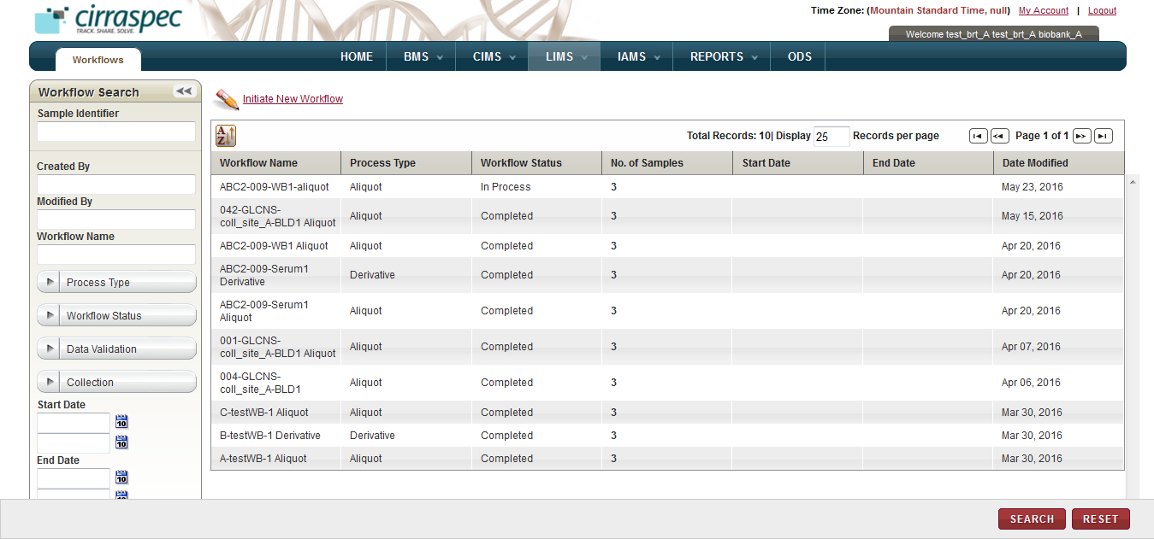

1. Workflow Search page

**Note:** To re-sort the list, click the header of the column by which you want to sort. For more information about other ways to sort the list, see **Sorting Search Results**

### Searching for a Workflow

To search for a specific workflow or group of workflows:

1. Point to the arrow of the **LIMS** tab, and then click **Workflows**.   
   The **Workflow Search** page appears.

Arrow hides/displays the Workflow Search pane



1. Workflow Search page
2. Specify your search criteria by completing one or more fields in the **Workflow Search** pane.

**Note:**

* You can use one field or a combination of fields to search for workflows.
* You can type the full or partial value in a search field along with an asterisk (*) before or after the partial value. For example, if you type **02\***, you obtain records that begin with 02. If you type **\*02**, you obtain records that end with 02.

Following table lists each search field and its description.

Table 32: Workflow Search Fields

| **Field** | **Description** |
| --- | --- |
| **Sample Identifier** | Type the identifier of a biospecimen to search for all workflows associated with that biospecimen. |
| **Created By** | Type the log in ID of the user to search for workflows created by that user. |
| **Modified By** | Type the log in ID of the user to search for workflows modified by that user. |
| **Workflow Name** | Type the name of the workflow that you want to search for. |
| **Process Type** | Click the appropriate sample processing type to search for workflows of that type.  **Note:** To search for all types of workflows, click **All**. |
| **Workflow Status** | Click the appropriate status to search for workflows with this status.  **Note:** To search for workflows with all statuses, click **All**. |
| **Data Validation** | Click the appropriate validation status to search for workflows with this status.  **Note:** To search for workflows with all validation statuses, click **All**. |
| **Collection** | Click the appropriate Collection to search for workflows associated with this Collection.  **Note:** To search for workflows associated with all Collections, click **All**. |
| **Start Date** | Click the date icon and then in the pop-up, select the appropriate date option to search for workflows with a start date in this timeframe. For more information, see **Understanding the Date Range Options** |
| **End Date** | Click the date icon and then in the pop-up, select the appropriate date option to search for workflows with an end date in this timeframe. For more information, see **Understanding the Date Range Options** |

1. Click **SEARCH**.  
   The search results appear.   
     
   **Note:**

* The list displays all workflows that are accessible based on your login location.
* Click the header of the column with which you want to sort the results. For more information about how to sort the search results, see **Sorting Search Results**

### Using the Search Samples and Worklists Window

You can use the **Search Samples and Worklists** window to search for biospecimen for your sample processing when creating or modifying a workflow.

To search for a biospecimen when initiating a new workflow or modifying an existing workflow:

1. On the **Create Workflow** page, click the **Search Inventory** link.

The **Search Samples and Worklists** window appears.

1. If you want to select biospecimens that are not associated with a worklist:
2. On the **Search Samples** tab, click the **Basic**, **Inventory** or **LIMS** checkbox to display the search fields for that search category.   
   The search fields appear.

**Note:** You can select multiple checkboxes.

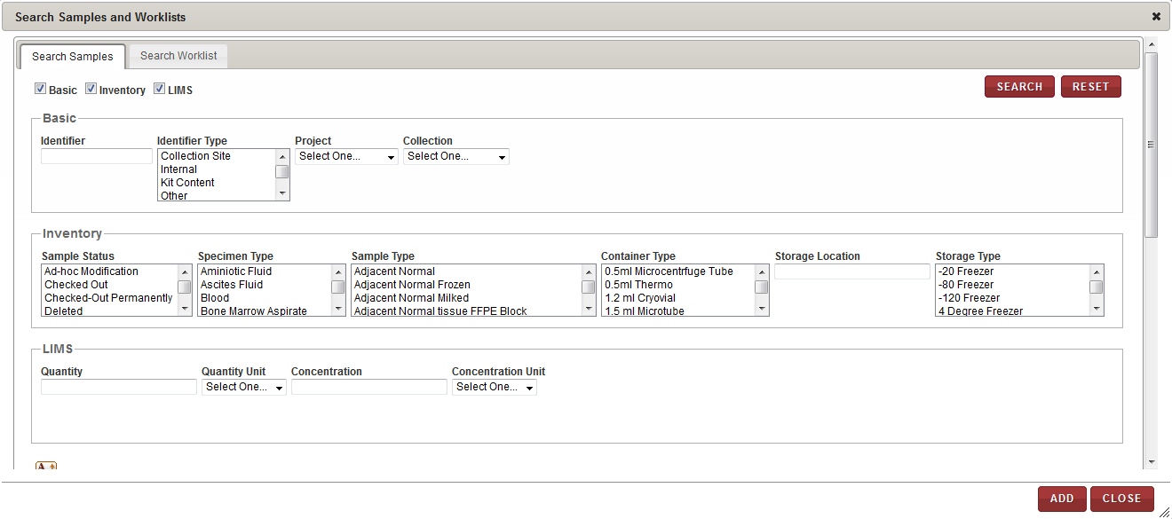

1. Search Samples and Worklists window – Search Samples tab
2. Specify your search criteria by completing one or more fields.   
   **Note:**

* You can use one field or a combination of fields to search for samples.
* You can type the full or partial value in a search field along with an asterisk (*) before or after the partial value. For example, if you type **02\***, you obtain records that begin with 02. If you type **\*02**, you obtain records that end with 02.

Following table lists each field and its description.

Table 33: Search fields

| **Field** | **Description** |
| --- | --- |
| **Basic** search fields | |
| **Identifier** | Scan or type the identifier of the biospecimen that you want to search for. |
| **Identifier Type** | Click the appropriate type to search for all biospecimens associated with that identifier type. |
| **Project** | Click the appropriate Project to search for all biospecimens associated with that Project. |
| **Collection** | Click the appropriate Collection to search for all biospecimens associated with that Collection. |
| **Inventory** search fields | |
| **Sample Status** | Click the appropriate sample status to search for all biospecimens associated with that status. |
| **Specimen Type** | Click the appropriate specimen type to search for all biospecimens associated with that specimen type. |
| **Sample Type** | Click the appropriate sample type to search for all biospecimens associated with that sample type. |
| **Container Type** | Click the appropriate container type to search for all biospecimens associated with that container type. |
| **Storage Location** | Type the appropriate storage location to search for all biospecimens associated with that storage location. |
| **Storage Type** | Click the appropriate storage type to search for all biospecimens associated with that storage type. |
| **LIMS** search fields | |
| **Quantity** | Type the appropriate quantity to search for all biospecimens on record with that quantity. **Note:** You can input values with “to”, <, > or = for a search range. For example: 1 to 2, <1, >1. |
| **Quantity Unit** | Click the appropriate unit of measure to search for all biospecimens of that quantity unit of measure. **Note**: You must complete this field if you input a value in the Quantity field. |
| **Concentration** | Type the appropriate concentration to search for all biospecimens on record with that concentration. **Note:** You can input values with “to”, <, > or = for a search range. For example: 1 to 2, <1, >1. |
| **Concentration Unit** | Click the appropriate unit of measure to search for all biospecimens of that concentration unit of measure. **Note**: You must complete this field if you input a value in the Concentration field. |

1. Click **SEARCH**.  
   A list of biospecimens that match your search criteria appear.
2. Click each biospecimen that you want to use in the workflow.   
   The selected biospecimens appear in a list below.

**Note:** To delete a biospecimen from this list, click the trash can icon  for the appropriate biospecimen.

1. If you want to associate these biospecimens with a worklist for future use:
2. To add the selected biospecimens to an existing worklist, click the **Add to Existing Worklist** checkbox. Then, type all or part of the existing name in the **Worklist Name** box.  
   **Note:** When you type at least two digits of the existing name, a list of names meeting that criterion appears below the box for you to select a name.
3. To add the selected biospecimen to a new worklist, do not click the **Add to Existing Worklist** checkbox. Type the name you want to give the new worklist in the **Worklist Name** box. Then click the appropriate **Security** level.

* **Private**: Can be viewed, modified or deleted only by the creator of the worklist. Cannot be viewed by other users.
* **Shared – Read-Only**: Can be viewed and used by any other authorized users within the organization. Can be viewed, modified or deleted only by the creator of the worklist.
* **Shared – Read-Write**: Can be viewed or modified by any authorized user within the organization. Only the creator of the worklist can change the security level or delete the worklist.

1. Click **ADD**.

The selected biospecimens appear on the **Create Workflow** page. If you completed the Worklist fields at the bottom of the window, the biospecimens are also added to the designated worklist.

1. If you want to select biospecimens that are associated with an existing worklist:
2. Click the **Search Worklist** tab.
3. In the **Worklist Name** box, type the name of the personal worklist, and click **Search**. **Note:** You can type a partial or full name of the worklist.   
   A list of worklists that match your search criteria appears.
4. Click the appropriate worklist.

A list of biospecimens that are associated with the worklist appears.

1. Click **ADD**.

The biospecimens associated with the selected worklist appear on the **Create Workflow** page.

### Viewing the Workflow Details

To view the workflow details:

1. Log in to the application using your log in credentials.

**Note:** If you have more than one assigned location, you are prompted to select the location for which you want to access CIRRASPEC data.  
The CIRRASPEC home page appears.

1. Point to the arrow of the **LIMS** tab, and then click **Workflows**.

The **Workflow Search** page appears.

1. Click **SEARCH**.

The **Workflow Search** page displays a list of workflows.  
**Note:** The list displays all workflows that are accessible based on your login location.

1. Click the row of the workflow for which you want to view the details.

The **View Workflow** page appears.

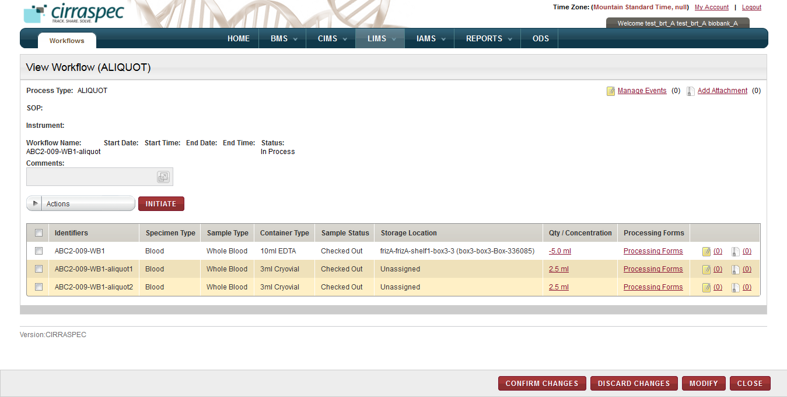

1. View Workflow page

On the **View Workflow** page, you can initiate the following tasks:

* **Modify a workflow:** For more information about how to modify a workflow, see **Modifying a Workflow**.
* **Confirm** **a workflow:** For more information about how to confirm a process workflow, see **Confirming a Process Workflow**.
* **Manage workflow files:** You can upload, download, and delete files that are attached to a workflow. For more information about how to manage attachments, see **Common File Upload**.
* **Manage biospecimen files:** You can upload, download, and delete files that are attached the biospecimens associated with a workflow. For more information about how to upload a file for a workflow sample, see**Uploading a File for Workflow Biospecimens**.
* **Add a new biospecimen identifier:** For more information about how to add a new identifier, see **Adding a New Identifier**.
* **Assign a biospecimen storage location:** For more information about how to assign a storage location, see **Assigning a Storage Location**.
* **Add workflow items to a worklist:** For more information about how to add workflow items to a worklist, see **Adding Workflow Biospecimens to a Worklist**.
* **Generate a report of workflow items:** For more information about how to generate a workflow process report, see **Generating a Workflow Process Report**.
* **Generate labels for workflow items:** For more information about how to generate a barcode label for a workflow item, see **Generating a Label for Workflow Biospecimens**.
* **View and update a processing form:** For more information about how to view and/or update a processing form associated with a workflow item, see **Accessing a Workflow Processing Form**.

### Modifying a Workflow

**Note:** You can modify a workflow only when the workflow has the **In Process** status.

To modify an **In Process** workflow:

1. Log in to the application using your log in credentials.

The CIRRASPEC home page appears.

1. Point to the arrow of the **LIMS** tab, and then click **Workflows**.

The **Workflow Search** page appears.

1. Click **SEARCH**.

The **Workflow Search** page displays a list of workflows.  
**Note**: The list displays all workflows that are accessible based on your login location.

1. Click the row of the workflow that you want to modify.

The **View Workflow** page appears.

1. Click **MODIFY**.

The **Create Workflow** page appears with the existing workflow information in “modify” mode.

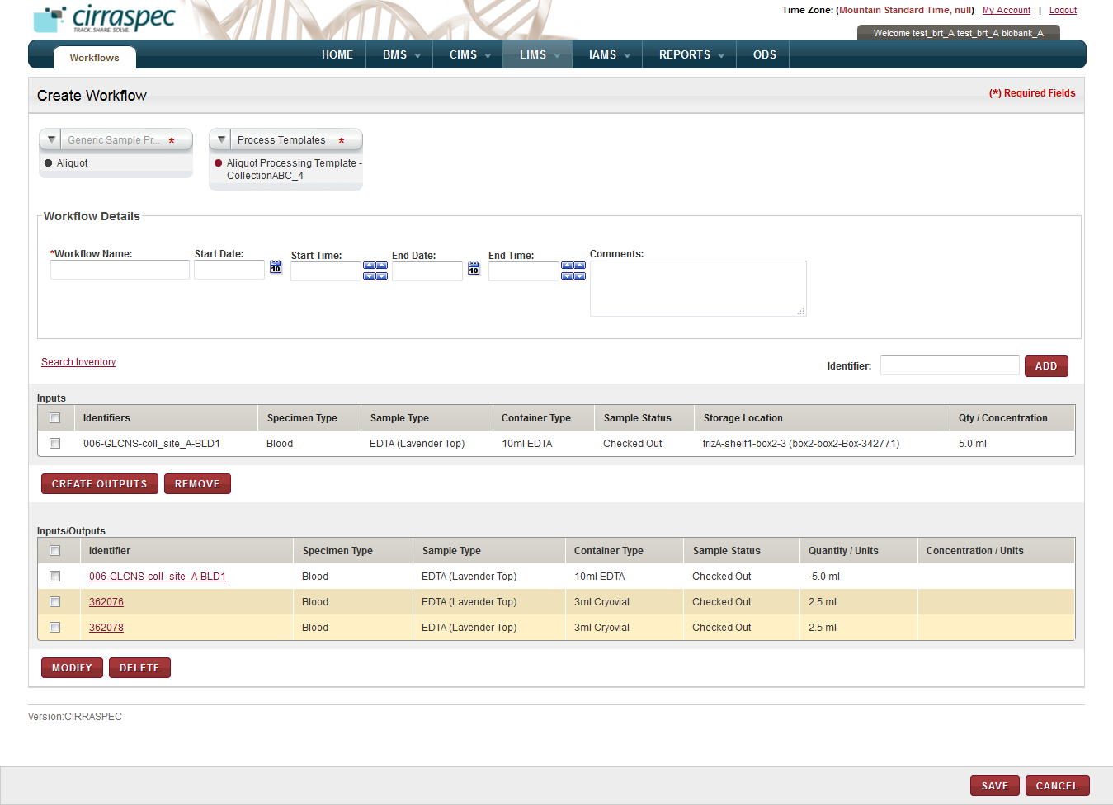

1. Create Workflow page - Modify mode

Select the required **Process Template** from the respective dropdown.

1. To change the **Workflow Details**, enter the information in the appropriate field. Following table lists each field and its description.   
   **Note:** Fields that are marked with the red asterisk (*) are mandatory.

Table 34: Modifying workflow details

| **Field** | **Description** |
| --- | --- |
| **Workflow Name**\* | If you want to change the workflow name, type a new name. |
| **Start Date** | If applicable, click the date icon and then in the pop-up, select the appropriate date for the workflow start date. |
| **Start Time** | If applicable, click the arrow icons to display the appropriate start time for this workflow. |
| **End Date** | If applicable, click the date icon and then in the pop-up, select the appropriate date for the workflow end date.  **Note:** You cannot select a date prior to the start date. |
| **End Time** | If applicable, click the arrow icons to display the appropriate end time for this workflow. |
| **Comments** | If applicable, type your comments regarding modifying this workflow. |

1. To add a new biospecimen to the **Inputs** list:   
   **Note:** You cannot add biospecimens that have the **Checked Out**, **Reserved**, **Deleted**, or **Depleted** status.

1. If you want to add a known sample to this workflow, in the **Identifier** box, type the appropriate sample identifier, and then click **ADD**.
2. If you want to search for samples to add to this workflow, click the **Search Inventory** link.   
   For more information about how to search for inventory samples, see **Using the Search Samples and Worklists Window**.

The specified biospecimens appear in the **Inputs** list on the **Create Workflow** page.

1. To remove a biospecimen from the **Inputs** list, select the checkbox for the appropriate biospecimen, and then click **REMOVE**.

**Note:** To remove all biospecimens from the **Inputs** list, select the checkbox on the header.

The biospecimen is removed and its status is set to **In Inventory**.

1. To create a new sample processing **Output**:
2. Select the checkbox of the appropriate biospecimen(s) in the **Inputs** list.  
   **Note:** To select all biospecimens on the list, select the checkbox in the header.
3. Click **create OUTPUTS**.

A confirmation window appears informing that this action requires sample checkout.

1. Click **OK**.

The **Processing Details** window appears.

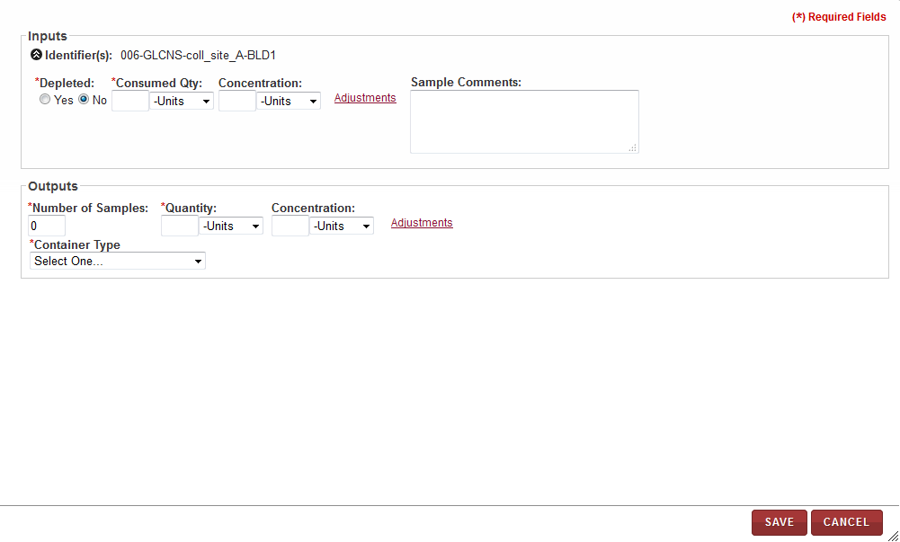

1. Processing details window
2. Enter the appropriate information in each field. The following table lists each field and its description.   
   **Note:** Fields that are marked with the red asterisk (*) are mandatory.

Table 35: Sample processing details

| **Field** | **Description** |
| --- | --- |
| **Inputs  Note:**   * For pooling, the **Inputs** fields defined below will be repeated and displayed for each selected input sample to allow specifying different Consumed/Concentration information for each input source. | |
| **Depleted**\* | Click **Yes** or **No** to indicate whether or not the input sample quantity is being depleted in this process. |
| **Consumed Quantity**\* | To specify the consumed quantity:   1. In the box, type the amount of the input biospecimen that is to be used in this processing. 2. In the **Units** list, click the appropriate quantity unit of measurement. |
| **Concentration** | To specify the concentration:   1. In the box, type the concentration amount of the input biospecimen. 2. In the **Units** list, click the appropriate concentration unit of measurement. **Note:** You must complete this field if you input a concentration value step 1. |
| **Adjustments** | To make an adjustment to the current quantify/concentration of the input biospecimen, click this link. The **Adjusted Qty** and **Adjusted Concentration** fields appear. |
| **Adjusted Qty** | **Note:** This field appears only when you click the **Adjustments** link.  To specify the adjusted quantity:   1. In the box, type the amount you want to add to or subtract from the current quantity for the input biospecimen.  **Note:** You can use decimal or whole numbers to add or subtract. You must use a minus sign to subtract. 2. In the **Units** list, click the appropriate adjusted quantity unit of measurement. **Note:** You must complete this field if you input an adjusted quantity value in step 1. 3. In the **Reason** list, click the appropriate reason for the adjustment. **Note:** You must complete this field if you input an adjusted quantity value in step 1. |
| **Adjusted Concentration** | **Note:** This field appears only when you click the **Adjustments** link.  To specify the adjusted concentration:   1. In the box, type the amount you want to add to or subtract from the current concentration for the input biospecimen.  **Note:** You can use decimal or whole numbers to add or subtract. You must use a minus sign to subtract. 2. In the **Units** list, click the appropriate adjusted concentration unit of measurement. **Note:** You must complete this field if you input an adjusted concentration value in step 1. 3. In the **Reason** list, click the appropriate reason for the adjustment. **Note:** You must complete this field if you input an adjusted concentration value in step 1. |
| **Sample Comments** | Type your comments regarding this processing, if applicable. |
| **Outputs** | |
| **Number of Samples**\* | Type the number of output biospecimen samples you want to create in this processing. |
| **Quantity**\* | To specify the quantity:   1. In the box, type the quantity amount of each output biospecimen being created in this processing. **Note:** The **Number of Samples** multiplied by the **Quantity** shown in this section must equal the **Consumed Qty** in the **Inputs** section. 2. In the **Units** list, click the appropriate quantity unit of measurement. |
| **Concentration** | To specify the concentration:   1. In the box, type the concentration amount of each output biospecimen being created in this processing. 2. In the **Units** list, click the appropriate concentration unit of measurement. |
| **Adjustments** | To make an adjustment to the current quantify/concentration of the output biospecimen(s), click this link. The **Adjusted Qty** and **Adjusted Concentration** fields appear. |
| **Adjusted Qty** | **Note:** This field appears only when you click the **Adjustments** link.  To specify the adjusted quantity:   1. In the box, type the amount you want to add to or subtract from the current quantity for the output biospecimens.  **Note:** You can use decimal or whole numbers to add or subtract. You must use a minus sign to subtract. 2. In the **Units** list, click the appropriate adjusted quantity unit of measurement. **Note:** You must complete this field if you output an adjusted quantity value in step 1. 3. In the **Reason** list, click the appropriate reason for the adjustment. **Note:** You must complete this field if you input an adjusted quantity value in step 1. |
| **Adjusted Concentration** | **Note:** This field appears only when you click the **Adjustments** link.  To specify the adjusted concentration:   1. In the box, type the amount you want to add to or subtract from the current concentration for the output biospecimen.  **Note:** You can use decimal or whole numbers to add or subtract. You must use a minus sign to subtract. 2. In the **Units** list, click the appropriate adjusted concentration unit of measurement. **Note:** You must complete this field if you input an adjusted concentration value in step 1. 3. In the **Reason** list, click the appropriate reason for the adjustment. **Note:** You must complete this field if you input an adjusted concentration value in step 1. |
| **Container Type**\* | **Note:** This field does not appear for Generic Experiment workflows. Click the appropriate container type for the output biospecimen. |
| **Item Type**\* | **Note:** This field only appears for Derivative workflows.  Click the appropriate specimen type for the output biospecimen. |
| **Item State**\* | **Note:** This field only appears for Derivative workflows.  If applicable, click the appropriate sample type for the output biospecimens. |
| **Protocol** | **Note:** This field only appears for Derivative workflows.  If applicable, click the appropriate protocol for the output biospecimens. |
| **Technique** | **Note:** This field only appears for Derivative workflows.  If applicable, click the appropriate technique for the output biospecimens. |

1. Click **SAVE**.

The Processing Details window closes. The modified information appears on the **Inputs/Outputs** list on the Create Workflow page.

1. To delete a biospecimen from the **Inputs/Outputs** list, select the checkbox of the appropriate biospecimen, and then click **DELETE**.

The selected biospecimen is deleted.

1. To assign a new identifier to a biospecimen in the **Input/Outputs** list:
2. Click on the **Identifier** of the biospecimen for whichyou want to add a new identifier.  
   The **Add Identifier(s)** window is displayed.
3. Click on the add icon.   
   The **Source Identifier** and **Identifier Type** fields are added to the **Add Identifier(s)** window.
4. In the **Source Identifier** box, type the new identifier.
5. In the **Identifier Type** list, click on the appropriate identifier type.   
   **Note:** The **Identifier Type** list displays the following identifier types:

* **Internal:** For user-assigned identifiers based on lab or site naming or numbering conventions.
* **Kit Content:** For identifying biospecimen content within a kit.
* **Other:** For any other identifier type.

1. Click the check mark icon.  
   The new identifier is added to the list of Identifiers in the window.
2. Click **SAVE**  
   The Add Identifier(s) window closes. The new identifier replaces the previous identifier on the Create Workflow page.
3. To modify the quantity, concentration or container type for a biospecimen on the **Inputs/Outputs** list:
4. Select the checkbox of the biospecimen in the **Inputs/Outputs** list that you want to modify, and then click **MODIFY**.

The **Processing Details** window appears.

1. Make the appropriate changes and click **SAVE**.

The **Processing Details** window closes. The **Inputs/Outputs** list on the **Create Workflow** page displays the modified information.

1. Click **SAVE.**The **View Workflow** page appears.  
   Changes are saved and the workflow status is set to **In Process** until you confirm the processing.   
   To confirm the workflow processing, see **Confirming a Workflow**.

### Confirming a Workflow

**Note:**

* You can confirm a workflow only when the workflow has the **In Process** status.
* You cannot modify a workflow after you confirm it.

To confirm an **In Process** workflow:

1. Log in to the application using your log in credentials.

The CIRRASPEC home page appears.

1. Point to the arrow of the **LIMS** tab, and then click **Workflows**.

The **Workflow Search** page appears.

1. Click **SEARCH**.

The **Workflow Search** page displays a list of workflows.  
**Note:** The list displays all workflows that are accessible based on your login location.

1. Click the row of the workflow that you want to confirm.

The **View Workflow** page appears.



1. View Workflow page – Confirm mode

1. To upload, download, or delete files:

* For files associated with the workflow, click the **Add Attachment** link at the top of the page. Then, complete the necessary fields in the **Manage Attachments** window. For more information, see **Common File Upload**.
* For files associated with a workflow biospecimen, click the **Add Attachment** icon 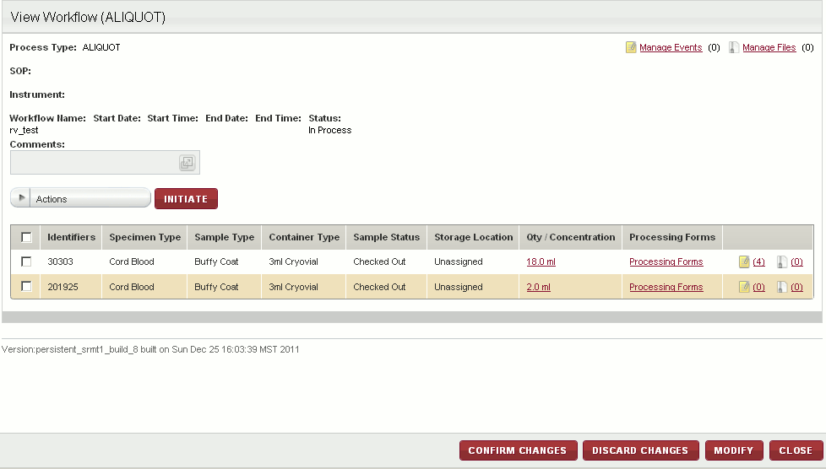 in the last column of the inputs/outputs list for the appropriate biospecimen. Then, complete the necessary fields in the **Manage Attachments** window. For more information, see **Uploading a File for Workflow Biospecimens**

1. To generate a report of the workflow biospecimens, see **Generating a Workflow Process Report**.
2. To generate barcode labels for workflow biospecimens, see **Generating a Label for Workflow Biospecimens**.
3. To add workflow biospecimens to a worklist, see **Adding Workflow Biospecimens to a Worklist**.
4. To view a log of the quantity changes for a biospecimen, click on the link in the **Qty/Concentration** column of the inputs/outputs list for the appropriate biospecimen.  
   The **Quantity Audit Log** window appears.

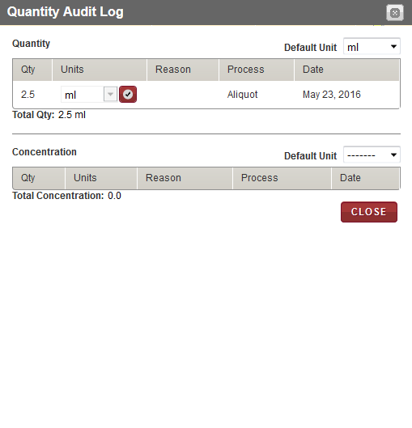

1. Quantity Audit Log window

To close the window, click **CLOSE**.

1. To view or update the processing forms associated with a workflow biospecimen, click on the **Processing Forms** link in the **Processing Forms** column of the inputs/outputs list for the appropriate biospecimen.
2. Click **CONFIRM CHANGES**.

**Note for Aliquot or Derivative processing only**: If there are multiple client-defined label formats, a new window appears with a list of label formats. Select a label format and click **SAVE**.   
  
The workflow is confirmed and its status changes to **Completed**.

The status of the biospecimens associated with this workflow changes to **In Inventory**.

**Note**:

* To discard the workflow processing, click **DISCARD CHANGES**. The workflow processing status changes to **Stopped**.

The status of the biospecimens associated with this workflow changes to **In Inventory**. You can view the workflow record for historical purposes only.

* To exit without confirming the workflow processing, click **CLOSE**.   
  The workflow processing status remains **In Process**.

### Adding a New Identifier

**Note:** You can add an identifier only for biospecimens for a workflow with the **Completed** status.

To add a new identifier for a biospecimen that is associated with a completed workflow:

1. Log in to the application using your log in credentials.

The CIRRASPEC home page appears.

1. Point to the arrow of the **LIMS** tab, and then click **Workflows**.

The **Workflow Search** page appears.

1. Click **SEARCH**.

The **Workflow Search** page displays a list of workflows.  
**Note:** The list displays all workflows that are accessible based on your login location.

1. Click the row of the workflow for which you want to add an identifier for a biospecimen.

The **View Workflow** page appears.

1. Click the identifier link for the appropriate biospecimen.  
   The **Add Identifier(s)** window appears.   
   **Note:** The identifier only appears as a link when the workflow status is **Completed**.
2. Click the add icon .

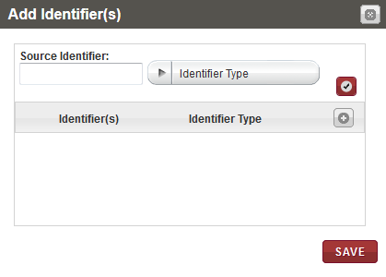

1. Add Identifier(s) window
2. In the **Source Identifier** box, type the identifier you want to add for this biospecimen.
3. In the **Identifier Type** list, click the appropriate type for the new identifier, and then click the check mark icon.

The new identifier and identifier type appear in the list below.

1. Click **SAVE**.

The add identifier window closes. The new identifier is added and appears in the **Identifiers** column for the selected biospecimen.

### Assigning a Storage Location to Workflow Biospecimens

**Note:**

* You can assign a storage location to biospecimens only for workflows with the **Completed** status.
* The biospecimens cannot have the **Checked Out**, **Distributed**, **Deleted** or **Reserved** status.

To assign a storage location for biospecimens associated with a completed workflow:

1. Log in to the application using your log in credentials.

The CIRRASPEC home page appears.

1. Point to the arrow of the **LIMS** tab, and then click **Workflows**.

The **Workflow Search** page appears.

1. Click **SEARCH**.

The **Workflow Search** page displays a list of workflows.  
**Note:** The list displays all workflows that are accessible based on your login location.

1. Click the row of the workflow for which you want to assign a storage location for biospecimens.

The **View Workflow** page appears.

1. Select the checkboxes of the biospecimens for which you want to assign a storage location.

**Note:** To assign a storage location for all the biospecimens, select the checkbox on the header.

1. In the **Actions** list, click **Assign Storage Location**, and then click **INITIATE**.

The **Bulk Storage Assignment** window appears.

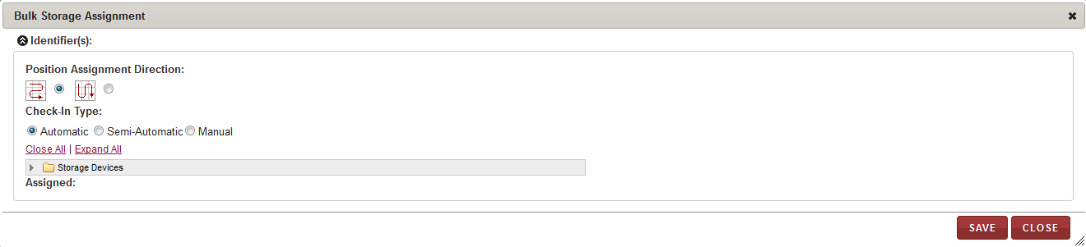

1. Bulk Storage Assignment window
2. Enter appropriate information in each field. Following table lists each field and its description.

Table 36: Assigning a storage location

| **Field** | **Description** |
| --- | --- |
| **Position Assignment Direction** | Click the appropriate direction for assigning a storage location to each of the biospecimens.  **Note:**   * The arrow icon that goes right and left depicts assignment of biospecimens to available cells on the storage map in horizontal rows. * The arrow icon that goes up and down depicts assignment of biospecimens to available cells on the storage map in vertical columns. |
| **Check-In Type** | Click the appropriate means of assigning the storage location:   * **Automatic:** The application automatically assigns the biospecimens that you select to available locations in the storage device starting with the first available location. * **Semi-Automatic:** You can select the initial location and assign it to a biospecimen. The application then assigns each biospecimen to the next available location. * **Manual:** You can assign each biospecimen to a location by selecting a cell on the storage map each time. |

1. To select the storage division where you want the biospecimens stored:
2. Click **Expand All** to expand the **Storage Devices** taxonomy to show all storage devices.
3. Click the appropriate storage device name (blue folder) to display all storage divisions within that device.
4. Click the division where you want to store the biospecimens.   
   The storage map of the cell positions within this division appears on the right.
5. If you selected **Automatic** as **Check-In Type**, click **ASSIGN**.

The application performs the following actions:

* Assigns each biospecimen to the next available location within the selected device.
* Updates the storage map with the new assignments.
* Displays a list of each position assignment in the **Assigned** field at the bottom.

**Note:**

* If a division does not have enough available positions for all the selected biospecimens, you can select another division and proceed until all biospecimens are assigned.

1. If you selected **Semi-Automatic** as **Check-In Type**, perform the following steps:
2. Click the available cell on the storage map where you want to store the first biospecimen.

**Note:**

* Storage Map positions that are available appear in tan or goldenrod color.
* Positions that are used appear in red or rust color.
* The current selection appears in green color.

The **Assign Identifier** window appears.

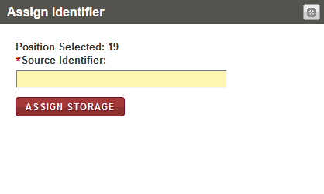

1. Assign Identifier window
2. In the **Source Identifier** box, scan or type the identifier of the first biospecimen that you want to assign to the selected storage map cell.  
   **Note:** You can display the identifiers of the biospecimens to be assigned by clicking on the arrow icon beside the **Identifiers** field in the top left corner of the **Bulk Storage Assignment** window.
3. Click **ASSIGN STORAGE**.

The application performs the following functions:

* Assigns the biospecimen to the cell that you selected and updates the storage map.
* Displays the window again with the **Position Selected** field automatically displaying the next available position.

1. Confirm the assignment of each biospecimen by clicking on **ASSIGN STORAGE** each time the **Assign Identifier** window appears until all biospecimens are assigned.

**Note:**

* If the container type associated with the specified biospecimen is not valid for this storage location, an error message appears. You can select another division and repeat steps a. - c.
* If the storage division does not have enough available positions for all the biospecimens, you can select another division.

1. If you selected **Manual** as **Check-In Type**, perform the following steps:
2. Click the available cell on the storage map where you want to store the first biospecimen.

**Note:**

* Storage Map positions that are available appear in tan or goldenrod color.
* Positions that are used appear in red or rust color.
* The current selection appears in green color.

The **Assign Identifier** window appears.

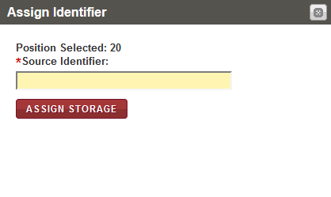

1. Assign Identifier window
2. In the **Source Identifier** box, scan or type the identifier of the first biospecimen that you want to assign to the selected storage map cell.  
   **Note:** You can display the identifiers of the biospecimens to be assigned by clicking on the arrow icon beside the **Identifiers** field in the top left corner of the **Bulk Storage Assignment** window.
3. Click **ASSIGN STORAGE**.

The application assigns the biospecimen to the cell that you selected and updates the storage map.

1. Repeat steps a. – c. until all biospecimens are assigned.

**Note:**

* If the container type associated with the specified biospecimen is not valid for this storage location, an error message appears. You can select another division and repeat steps a. - c.
* If the storage division does not have enough available positions for all the biospecimens, you can select another division.

1. To save the storage assignments, click **SAVE**.  
   The **Bulk Storage Assignment** window closes. The storage assignments are saved and appear in the **Storage Location** column for the selected biospecimens.

### Adding Workflow Biospecimens to a Worklist

To add workflow biospecimens to a new or an existing worklist:

1. Log in to the application using your log in credentials.

The CIRRASPEC home page appears.

1. Point to the arrow of the **LIMS** tab, and then click **Workflows**.

The workflow search page appears.

1. Click **SEARCH**.

The **Workflow Search** page displays a list of workflows.  
**Note:** The list displays all workflows that are accessible based on your login location.

1. Click the row of the workflow for which you want to add biospecimens to a worklist.

The **View Workflow** page appears.

1. Select the checkboxes of the biospecimens that you want to add to a worklist.

**Note:** To add all the biospecimens to a worklist, select the checkbox on the header.

1. In the **Actions** list, click **Add to Worklist**, and then click **INITIATE**.

The **Create/Modify Worklist** page appears with the selected workflow biospecimens.

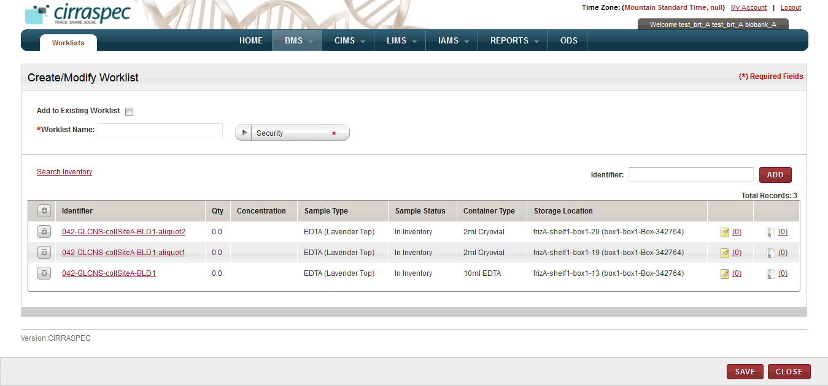

1. Create/Modify Worklist page
2. Enter appropriate information in each field. Following table lists each field and its description. **Note:** Fields that are marked with the red asterisk (*) are mandatory.

Table 37: Adding workflow biospecimens to a worklist

| **Field** | **Description** |
| --- | --- |
| **Add to Existing Worklist** | If you want to add the biospecimens to an existing worklist, select this checkbox. |
| **Worklist Name**\* | If you checked the **Add to Existing** box, then type part or the entire existing worklist name in this field.  **Note:** As you type part of an existing name, a dropdown list appears with existing worklist names that you can select for this field.  If you want to add these biospecimens to a new worklist, type a name for the worklist. |
| **Security**\* | If you want to add the biospecimens to a new worklist, click on the appropriate **Security** value for the new worklist.   * **Private**: Can be viewed, modified or deleted only by the creator of the worklist. Cannot be viewed by other users. * **Shared – Read-Only**: Can be viewed and used by any other authorized users within the organization. Can be viewed, modified or deleted only by the creator of the worklist. * **Shared – Read-Write**: Can be viewed or modified by any authorized user within the organization. Only the creator of the worklist can change the security level or delete the worklist.   **Note:** This field is disabled if the **Add to existing Worklist** box is checked. |
| **Identifier** | If you want to manually add a biospecimen that is not associated with the workflow to the worklist using its identifier:   1. Input or scan a Sample Identifier in the **Source Identifier** text box. 2. Click **ADD**.  The specified biospecimen appears on the list below.   **Note:** You can add multiple biospecimens to the worklist using this field. |
| **Search Inventory** | If you want to search and select additional biospecimens that are not associated with the workflow to the worklist:   1. Click the **Search Inventory** link.   The **Search Samples and Worklists** page appears.   1. Search and select the biospecimens you want to add to this worklist. 2. Click **ADD**.   The search window closes and the selected biospecimens appear on the **Create/Modify Worklist** page. |

1. To remove a biospecimen from the list on the **Create/Modify Worklists** page:
2. Click the trash can icon  next to the appropriate biospecimen identifier.

**Note:** To remove all biospecimens from the list, click the trash can icon  on the header.

A confirmation window appears.

1. Click **OK**.

The biospecimen is removed from the list.

1. Click **SAVE**.

The biospecimens are added to the worklist.

### Generating a Workflow Process Report

To generate a workflow process report for biospecimens that are associated with a workflow:

1. Log in to the application using your log in credentials.

The CIRRASPEC home page appears.

1. Point to the arrow of the **LIMS** tab, and then click **Workflows**.

The **Workflow Search** page appears.

1. Click **SEARCH**.

The **Workflow Search** page displays a list of workflows.  
**Note:** The list displays all workflows that are accessible based on your login location.

1. Click the row of the workflow for which you want to generate a report.

The **View Workflow** page appears.

1. Select the checkboxes of the biospecimens for which you want to generate a report.

**Note:** To generate a report for all the biospecimens, select the checkbox on the header.

1. In the **Actions** list, click **Generate Report**, and then click **INITIATE**.   
   The workflow process report appears in a new window.
2. View, print and/or save the file, as needed.

**Example Report:**



### Generating a Barcode Label for a Workflow Biospecimen

To generate a barcode label for a biospecimen that is associated with a workflow:

1. Log in to the application using your log in credentials.

The CIRRASPEC home page appears.

1. Point to the arrow of the **LIMS** tab, and then click **Workflows**.

The **Workflow Search** page appears.

1. Click **SEARCH**.

The **Workflow Search** page displays a list of workflows.   
**Note:** The list displays all workflows that are accessible based on your login location.

1. Click the row of the workflow for which you want to generate a barcode label for a biospecimen.

The **View Workflow** page appears.

1. Select the checkboxes of the biospecimens for which you want to generate a barcode label.

**Note:** To generate a bar code label for all the biospecimens, select the checkbox on the header.

1. In the **Actions** list, click **Generate Labels**, and then click **INITIATE**.

The print window appears.

1. To print labels to a PDF file, click **PDF** for the appropriate template name, and then click **SUBMIT**.

The image of the barcode labels that are associated with the biospecimens appears below.

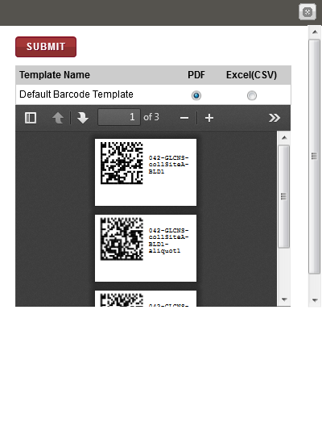

1. Print barcode labels window

**Note**: To identify tools for viewing multiple labels, printing labels and saving the file to your machine, click the arrow icon .

### Uploading Files for Workflow Biospecimens

To upload files for biospecimens associated with a workflow:

1. Log in to the application using your log in credentials.

The CIRRASPEC home page appears.

1. Point to the arrow of the **LIMS** tab, and then click **Workflows**.

The **Workflow Search** page appears.

1. Click **SEARCH**.

The **Workflow Search** page displays a list of workflows.  
**Note:** The list displays all workflows that are accessible based on your login location.

1. Click the row of the workflow for which you want to upload files for multiple biospecimens.

The **View Workflow** page appears.

1. To upload files for a single biospecimen, click the **Add Attachment** icon  for the appropriate biospecimen.   
   OR  
   To upload files for multiple biospecimens, select the checkboxes of each biospecimen for which you want to upload files. Then, in the **Actions** list, click **Upload Files**, and then click **INITIATE**.

OR  
To upload files for all the biospecimens, select the checkbox on the header. Then, in the **Actions** list, click **Upload Files**, and then click **INITIATE**.

The **MANAGE ATTACHMENTS** window appears and displays the identifiers of the biospecimens that you selected.

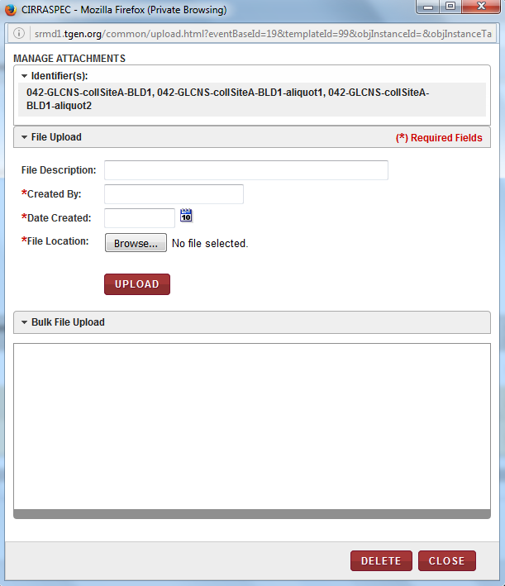

1. Manage Attachments window
2. Enter appropriate information in each field. Following table lists each field and its description.

**Note:** Fields that are marked with the red asterisk (*) are mandatory.

Table 38: Uploading files for workflow biospecimens

| **Field** | **Description** |
| --- | --- |
| **File Description** | Type a description of the file, if applicable. |
| **Created By**\* | Type the name of the person who created the file. |
| **Date Created**\* | Click the date icondate icon, and then click the date when the file was created. |
| **File Location**\* | 1. Click **Browse**, and then select the file that you want to upload.  2. Click **Open**.  The file name appears in a progress bar box below the **File Location** box. |

1. Click **UPLOAD**.  
   The file is uploaded and appears in the **Bulk File Upload** area.  
   **Note:** You can add multiple files to the biospecimens but you must browse and select the files one at a time.
2. To delete a file from the **Bulk File Upload** area:
3. Select the checkbox of the appropriate file.

**Note:** To delete all files in this area, select the checkbox on the header.

1. Click **DELETE**.

A confirmation window appears.

1. Click **OK**.

The file(s) are deleted.

1. Click **CLOSE** to close the **Manage Attachments** window.

### Accessing a Workflow Processing Form

To view a processing form associated with a workflow:

1. Log in to the application using your log in credentials.

The home page appears.

1. Point to the arrow of the **LIMS** tab and then click **Workflow**.

The **Workflow Search** page appears.

1. Click **SEARCH**.

The **Workflow Search** page displays a list of workflows.  
**Note**: The list displays all workflows that are accessible based on your login location.

1. Click the row of the workflow for which you want to access the processing forms of the biospecimens.

The **View Workflow** page appears.

1. Click the **Processing Forms** link in the **Processing Forms** column of the inputs/outputs list for the biospecimen for which you want to view the form.  
   The **Forms** window appears.  
     
   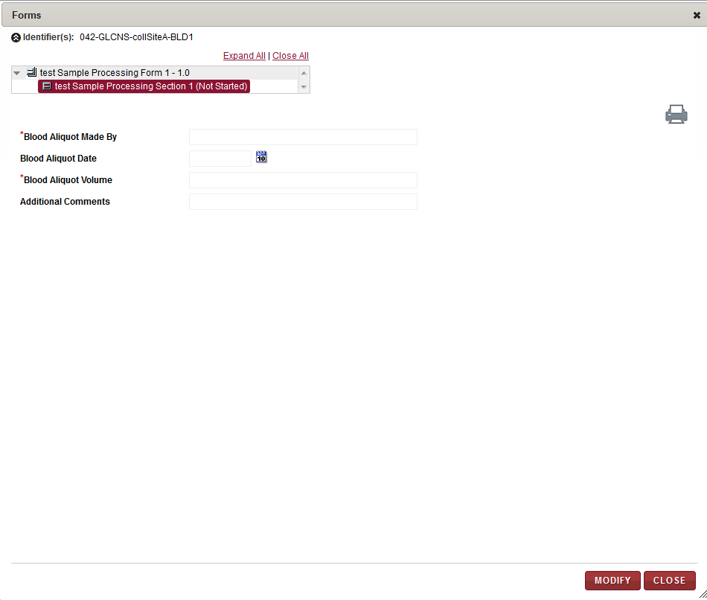
2. Processing Forms link - Forms window
3. Click the **Expand All** link to show all forms.  
   The forms list expands.  
   **Note:**

* Only processing forms assigned in the **Research Project Management System (RPMS)** module during project setup and configuration appear on this list.
* If a form is not assigned in **RPMS** to the processing template that was used when initiating this workflow, no forms will be listed in the **Forms** window.

1. On the list, click the form section you want to view.  
   The information for the specified form section appears on the right.

**Note**: PHI questions (if any) in the form section will be marked with a hash sign (#).

* If the form section contains PHI questions, then the answers (if already filled up) for these are displayed differently for PHI authorized and Non-PHI authorized users.
  + The PHI authorized users are allowed to answer PHI as well as Non-PHI questions. Hence they can also view the answers (if already filled up) to all the questions.
  + However, the Non-PHI authorized users are allowed to answer only the Non-PHI questions. If answers to PHI questions have already been filled up by some PHI user, then these are shown as hashed out (in case of textboxes) and blanked out (in case of radio buttons, dropdowns and checkboxes) to the Non-PHI authorized users.

1. To print the form, click on the icon.  
   The form appears in a new window that allows you to select **File > Print** to print or **File > Save As** to save the form to your machine.
2. To update information on the processing form:
3. Click **MODIFY.**  
   The form data entry fields appear for input.   
   **Note:**

* You can only modify a form when the section status is **Not Started** or **Data Entry Started**.
* PHI questions (if any) in the form section will be marked with a hash sign (#).
  + If the form contains PHI questions, then the input fields for these are displayed differently for PHI authorized and Non-PHI authorized users.
    - The PHI authorized users are allowed to answer PHI as well as Non-PHI questions. Hence all input fields are displayed in an active mode to these users.

They can also view the answers (if already filled up) to all the questions.

* + - However, the Non-PHI authorized users are allowed to answer only the Non-PHI questions. Hence input fields for PHI questions appear in a greyed out mode for such users. The input fields for Non-PHI questions are displayed in an active mode. If answers to PHI questions have already been filled up by some PHI user, then these are shown as hashed out (in case of textboxes) and blanked out (in case of radio buttons, dropdowns and checkboxes) to the Non-PHI authorized users.

1. Make the necessary changes to the form and click **SAVE.**  
   Changes are saved and the section status appears as **Data Entry Started** in the **Forms** window.
2. Once all data entry is completed on the form, click **Data Entry Completed**.  
   The form status appears as **Data Entry** **Completed** in the **Forms** window**.**   
   **Note:**

* You can only perform this task when the form status is **Data Entry Started**.
* In case of forms with one or more PHI questions, this button is displayed only for the PHI authorized users.

1. To change the status of a **Data Entry** **Completed** form so you can modify the form information, click **DATA ENTRY NOT COMPLETED**.

The form status appears as **Data Entry Started** in the **Forms** window**.  
Note:**

* You can only perform this task when the form status is **Data Entry Completed.**
* In case of forms with one or more PHI questions, this button is displayed only for the PHI authorized users.

1. To approve a **Data Entry** **Completed** form, click **APPROVE**.

The form status appears as **Approved** in the **Forms** window**.  
Note:**

* You can only perform this task when the form status is **Data Entry Completed.**
* In case of forms with one or more PHI questions, this button is displayed only for the PHI authorized users.

1. To remove approval of an **Approved** form, click **REMOVE APPROVAL**.

The form status appears as **Data Entry** **Completed** in the **Forms** window**.  
Note:**

* You can only perform this task when the form status is **Approved.**
* In case of forms with one or more PHI questions, this button is displayed only for the PHI authorized users.

# Enroll Subjects/Donor/Patients and View subjects, Modify Forms, Update Collection Event, Attach Files:

### Viewing a list of Subjects

To view a list of subjects:

1. Log in to the application using your log in credentials.

The CIRRASPEC home page appears.

1. Point to the arrow of the **CIMS** tab, and then click **Subject Centric View**.

The **Subject Search** page appears.

1. Click **SEARCH**.

Thesubject search page displays a list of subjects.

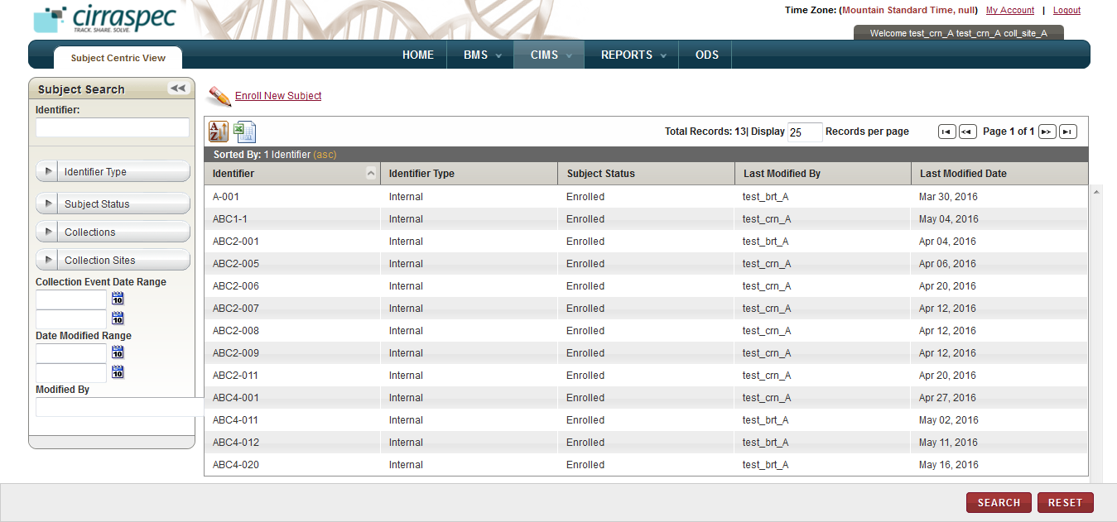

1. Subject Search page

On the subject search page, you can perform the following tasks:

* **View details for a subject:** For more information about how to view the details of a subject, see **Viewing the Subject Details**.
* **Create a subject:** For more information about how to create a subject, see **Creating a Subject**.

### Searching for a Subject

To search for a specific subject or a group of subjects:

1. Point to the arrow of the **CIMS** tab, and then click **Subject Centric View**.

The **Subject Search** page appears.

1. Click **SEARCH**.

The **Subject Search** page displays the **Subject Search** pane.

Arrow hides/displays the Subject Search pane



1. Subject Search page

1. Specify your search criteria by completing one or more fields in the **Subject Search** pane.

**Note:**

* You can use one field or a combination of fields to search for subjects.
* You can type the full or partial value in a search field along with an asterisk (*) before or after the partial value. For example, if you type **02\***, you obtain records that begin with 02. If you type **\*02**, you obtain records that end with 02.

Following table lists each search field and its description.

Table 39: Subject Search fields

| **Field** | **Description** |
| --- | --- |
| **Identifier** | Type identifier of the subject you want to search for. |
| **Identifier Type** | Click appropriate type to search for subjects with that type of Identifier.  **Note:** To search for subjects associated with all types, click **All**. |
| **Subject Status** | Click appropriate status to search for subjects with this subject status.  **Note:** To search for subjects associated with all statuses, click **All**. |
| **Collections** | Click appropriate Collection to search for subjects associated with this Collection.  **Note:** To search for subjects associated with all Collections, click **All**. |
| **Collection Sites** | Click appropriate Site to search for subjects associated with this Collection Site  **Note:** To search for subjects associated with all Collection Sites, click **All**. |
| **Collection Event Date Range** | Click the date icon and then in the pop-up, select appropriate date option to search for Collection Events scheduled in this timeframe. For more information, see **Understanding the Date Range Options** |
| **Date Modified Range** | Click the date icon and then in the pop-up, select appropriate date option to search for subjects modified in this timeframe. For more information, see **Understanding the Date Range Options** |
| **Modified By** | Type log in ID of the user to search for subjects modified by that user. |

1. Click **SEARCH**.  
   The search results appear.   
     
   **Note:** Click the header of the column with which you want to sort the results. For more information about how to sort the search results, see **Sorting Search Results**

### Viewing the Subject Details

To view the details of a subject:

1. Log in to the application using your log in credentials.

The CIRRASPEC home page appears.

1. Point to the arrow of the **CIMS** tab, and then click **Subject Centric View**.

The subject search page appears.

1. Click **SEARCH**.

The **Subject Search** page displays a list of subjects.

1. Click the row of the subject for which you want to view the details.

The **Subject View** page appears with the details of the subject you selected.

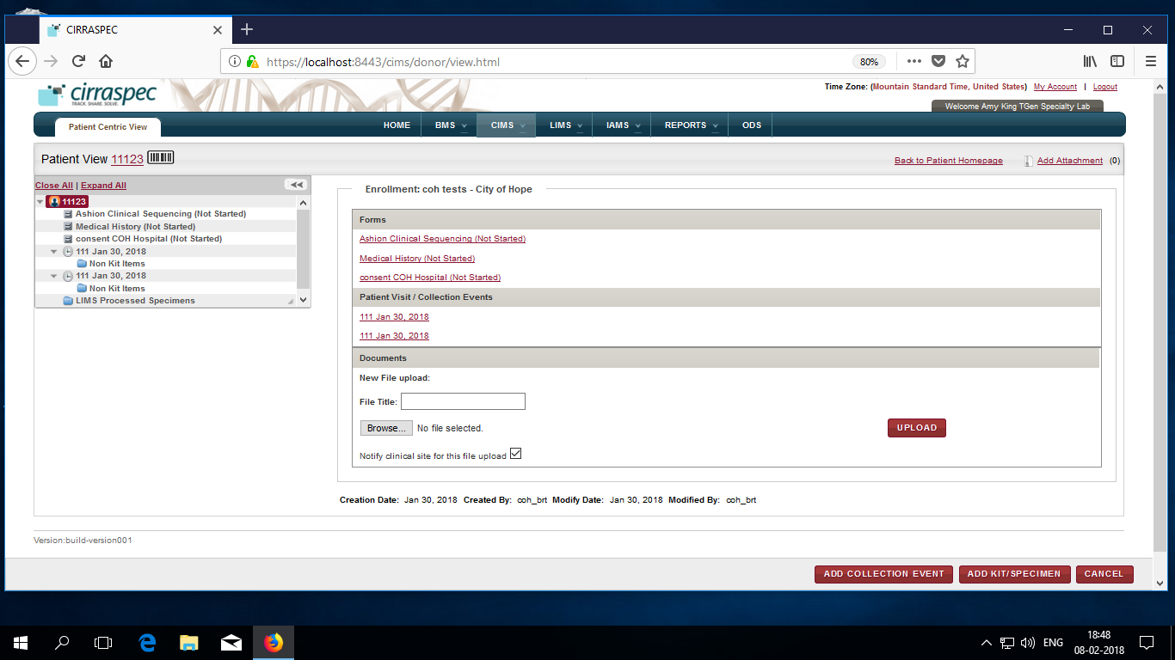

1. Subject Centric View page

**Note:**

* You can expand the subject hierarchy tree displayed on the left by clicking on the **Expand All** link, or by clicking on the arrow icon 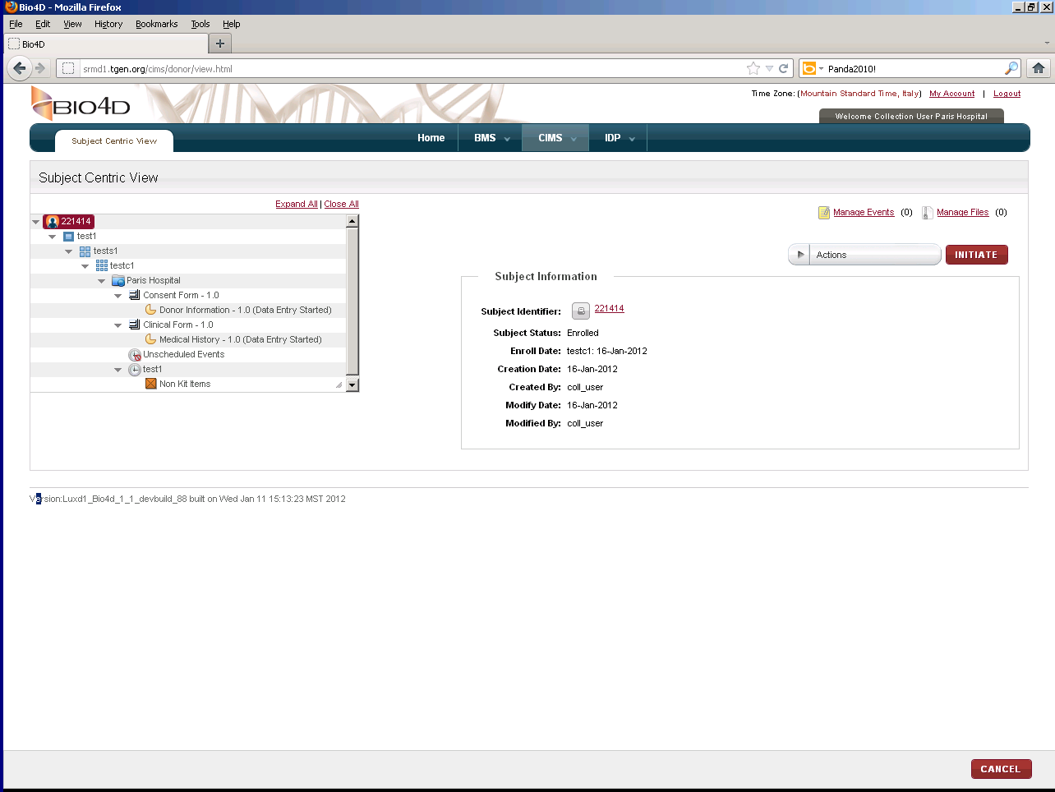for the level you want to expand.
* You can click on the various hierarchy tree levels on the left side of the page, to display information for the selected level.  
  For example, if you click on the Collection level, information for this Collection appears on the right side of the page. If you click on a form level, information for this form appears on the right side of the page.

OR

You can click on the links provided on the right side of the page, to display information for various different levels.

For example, if you click on a **Visit** link under the **Subject Visit / Collection Events** section (which in turn is under the **Enrollment** section), the **View Collection Event** page is displayed on the right side.

If you click on a form section link under the **Forms** section (which in turn is under the **Enrollment** section), the form section appears on the right side of the page.

**Note**: To go back to the homepage with links, click the **Back to Subject Homepage** link towards the center-upper side of the page.

On the **Subject Centric View** page, you can perform the following tasks:

* **Add Attachment:** You can upload, download, and delete files that are attached to a subject by clicking the **Add Attachment** link. For more information about how to attach files, see **Common File Upload**
* **Add a new subject identifier:** For more information about how to add a new identifier, see **Adding a New Identifier to a Subject**.
* **Print a subject label:** For more information about how to print a subject label, see **Printing a Subject Label**.

### Creating a Subject

The **Enroll New Subject** link on the **Subject Search** page allows the user to create and enroll a subject to a collection.

To create a subject:

1. Log in to the application using your log in credentials.

The CIRRASPEC home page appears.

1. Point to the arrow of the **CIMS** tab, and then click **Subject Centric View**.

The **Subject Search** page appears.

1. Click the **Enroll New Subject** link

The **Create/Enroll Subject** page appears.

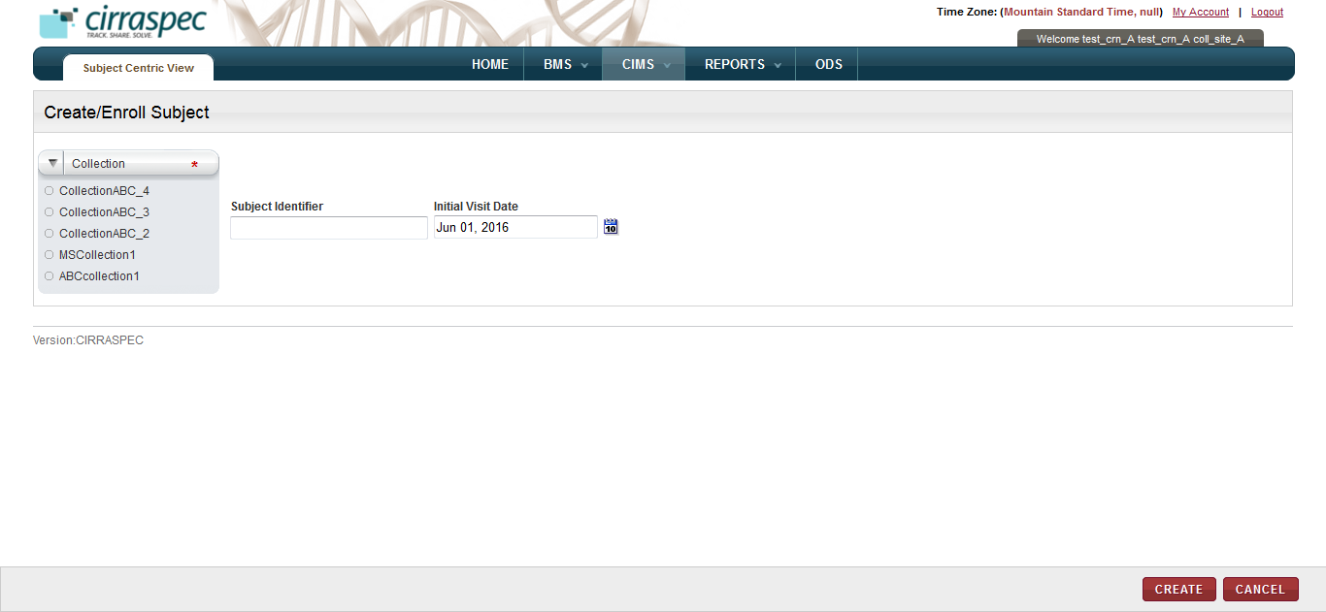

1. Create/Enroll Subject page
2. In the **Collection** list, click the appropriate Collection.

**Note**: A dropdown named **Visit Site** is displayed for BRT users.

1. If required, you can specify the **Subject Identifier** in the textbox provided.
2. Select the **Initial Visit Date** (optional) from the calendar. By default it shows the current date.
3. Click **CREATE**.

The subject is created and enrolled to the **Collection** you selected. The status of this subject is set to **Enrolled** and the new subject information appears on the **Subject View** page.

### 

### Adding a New Identifier to a Subject

To add a new identifier for the subject:

1. Log in to the application using your log in credentials.

The CIRRASPEC home page appears.

1. Point to the arrow of the **CIMS** tab, and then click **Subject Centric View**.

The **Subject Search** page appears.

1. Click **SEARCH**.

The **Subject Search** page displays a list of subjects.

1. Click the row of the subject for which you want to add a new identifier.

The **Subject View** page appears.

1. From the header area of the page, click the **Subject Identifier** link.

The **Add Identifier(s)** window appears.

1. Click the add icon .   
   The new identifier and type fields appear.

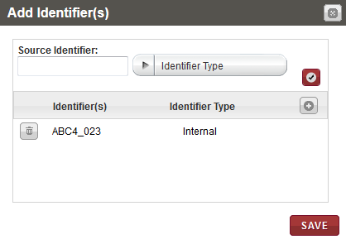

1. Add Identifier(s) window
2. In the **Source Identifier** box, type the identifier you want to add.
3. In the **Identifier Type** list, click the appropriate type. Then click the check mark icon .

The new identifier and identifier type appear in the list below.

1. Click **SAVE**.

The new identifier is added for the subject and appears on the **Subject View** page.

### Printing a Subject Label

To print a subject label:

1. Log in to the application using your log in credentials.

The CIRRASPEC home page appears.

1. Point to the arrow of the **CIMS** tab, and then click **Subject Centric View**.

The **Subject Search** page appears.

1. Click **SEARCH**.

The **Subject Search** page displays a list of subjects.

1. Click the row of the subject for which you want to print a label.

The **Subject View** page appears.

1. From the header area of the page, click the barcode icon .

The print label window appears.

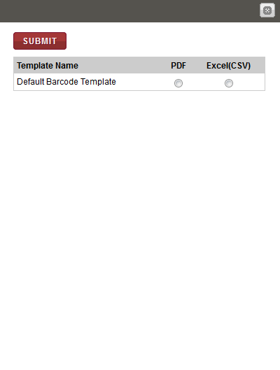

1. Print window
2. To print the label to a PDF file, click **PDF** for the appropriate template name, and then click **SUBMIT**.

A PDF file is created with image of the barcode label.

**Note**: To identify tools for viewing multiple labels, printing labels and saving the file to your machine, hover the cursor over the icons in the horizontal and vertical navigation bars in the window.

### Viewing the Collection Event Details

To view the collection event details for a subject:

1. Log in to the application using your log in credentials.

The CIRRASPEC home page appears.

1. Point to the arrow of the **CIMS** tab, and then click **Subject Centric View**.

The **Subject Search** page appears.

1. Click **SEARCH**.

Thesubject search page displays a list of subjects.

1. Click the row of the subject for which you want to view the collection event details.

The **Subject View** page appears.

1. Click the collection event link under the **Subject Visit / Collection Events** section on the RHS of the page.

Alternatively, you can select the required collection event node from the LHS tree view.

The **View Collection Event** area appears on the right, and displays the details of the collection event.

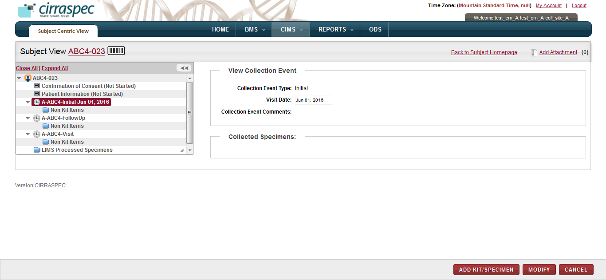

1. View Collection Event area

### Modifying the Collection Event Details

To modify the collection event details for a subject:

1. Log in to the application using your log in credentials.

The CIRRASPEC home page appears.

1. Point to the arrow of the **CIMS** tab, and then click **Subject Centric View**.

The **Subject Search** page appears.

1. Click **SEARCH**.

Thesubject search page displays a list of subjects.

1. Click the row of the subject for which you want to modify the collection event details.

The **Subject View** page appears.

1. Click the collection event link under the **Subject Visit / Collection Events** section on the RHS of the page.

Alternatively, you can select the required collection event node from the LHS tree view.

The **View Collection Event** area appears on the right, and displays the details of the collection event.

1. Click **MODIFY**.

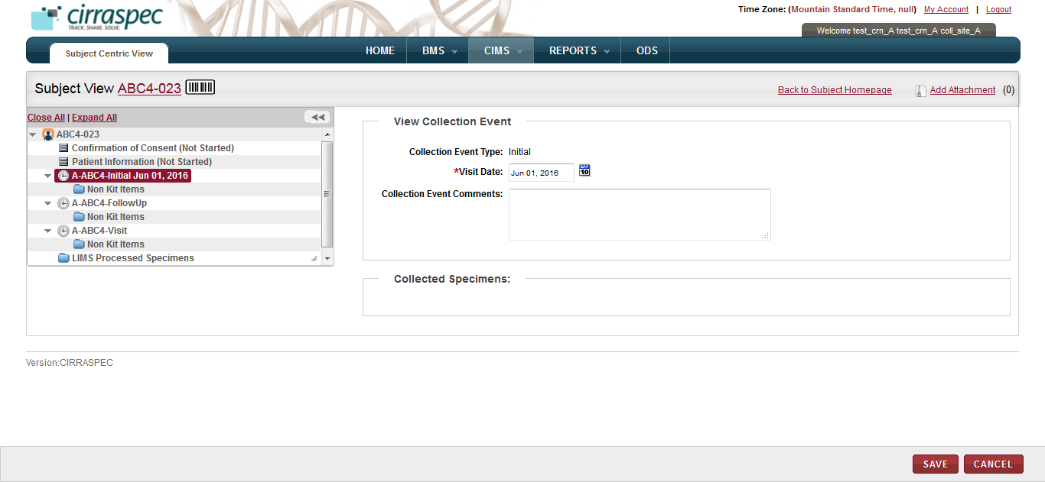

1. View Collection Event area
2. Enter appropriate information in each field. Following table lists each field and its description.

**Note:** Fields that are marked with the red asterisk (*) are madatory.

Table 40: Modifying the collection event details

| **Field** | **Description** |
| --- | --- |
| **Visit Date**\* | Click the date icon date icon, and then click the date the collection event occurred or is scheduled for. |
| **Collection Event Comments** | Type your comments regarding this modification, if applicable. |

1. Click **SAVE**.

The collection event details are modified, and the new information appears in the **View Collection Event** area.

### Assigning a Kit to a Collection Event

Once you have enrolled a subject, you can assign kits to each collection event for the subject.

**Note:** You can only assign a kit that has the **Received-Not Used** status.

To assign a kit to a collection event:

1. Log in to the application using your log in credentials.

The CIRRASPEC home page appears.

1. Point to the arrow of the **CIMS** tab, and then click **Subject Centric View**.

The **Subject Search** page appears.

1. Click **SEARCH**.

The **Subject Search** page displays a list of subjects.

1. Click the row of the subject for which you want to assign a kit.

The **Subject View** page appears.

1. Click the **ADD KIT/SPECIMEN** button on the right hand bottom side of the page.

The ‘Add Kit/Specimen’ pop-up is displayed.

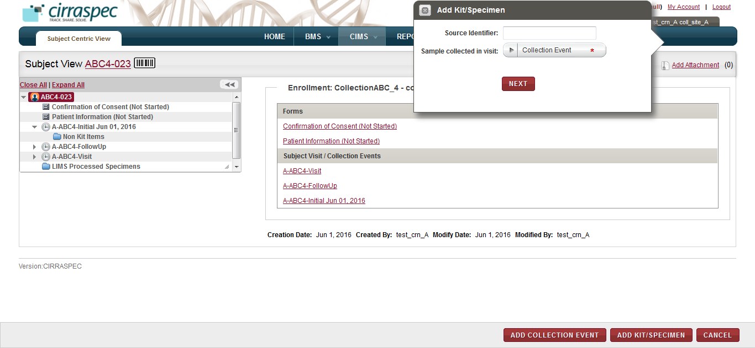

1. Add Kit/Specimen pop-up

**Note**: User can select the collection event first from the LHS tree view and then click **ADD KIT/SPECIMEN** button. This will automatically select that collection event in the **Collection Event** dropdown.

1. In the **Source Identifier** box, type the **Kit Identifier** you want to assign.

Select a **Collection Event** from the dropdown list provided for the same.

Click **NEXT**.

The pop-up closes and the **Assign Kits/Specimen** page is displayed.

The kit items appear in the kits cart under the **Total Items** header.

1. To delete a kit item from the kits cart, click the trash icon  for the appropriate item.

**Note:** To delete all kit items, click the trash can icon  in the header row.

1. To add a comment to a kit item:
2. Click the comments icon  for the appropriate item.

The **Comments** window appears.

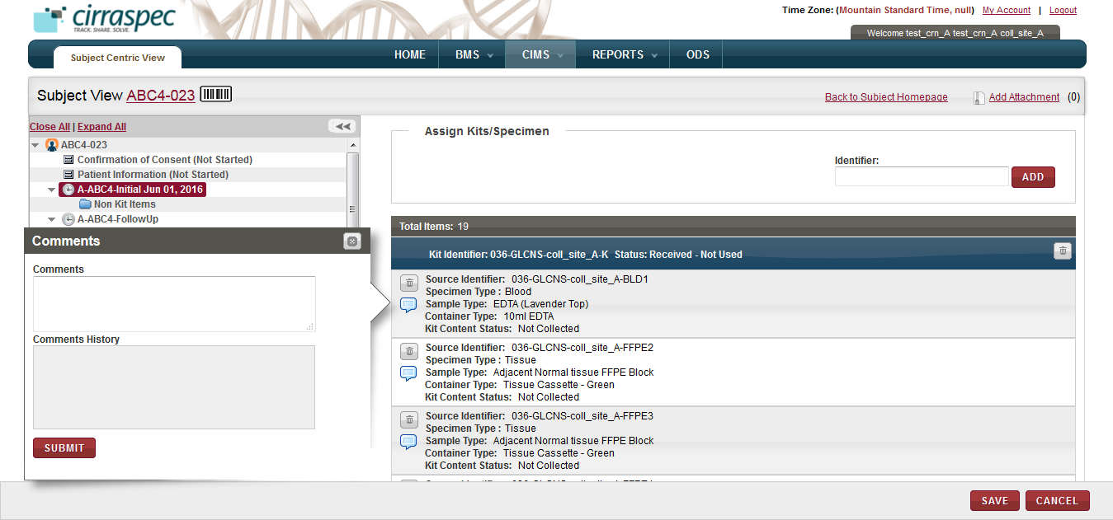

1. Comments window
2. In the **Comments** box, type your comment regarding the kit item, and then click **SUBMIT**.

The comment is added to the kit item.

1. Click **SAVE**.

The kit is assigned to the collection event.

### Assigning a Non Kit Item to a Collection Event

If a subject’s biospecimen is collected that is not associated with the kit assigned to a collection event, you can assign the biospecimen to the event as a non kit item.

To assign a non kit item to a collection event:

1. Log in to the application using your log in credentials.

The CIRRASPEC home page appears.

1. Point to the arrow of the **CIMS** tab, and then click **Subject Centric View**.

The subject search page appears.

1. Click **SEARCH**.

The **Subject Search** page displays a list of subjects.

1. Click the row of the appropriate subject.

The **Subject View** page appears.

1. Click the **ADD KIT/SPECIMEN** button on the right hand bottom side of the page.

The ‘Add Kit/Specimen’ pop-up is displayed.

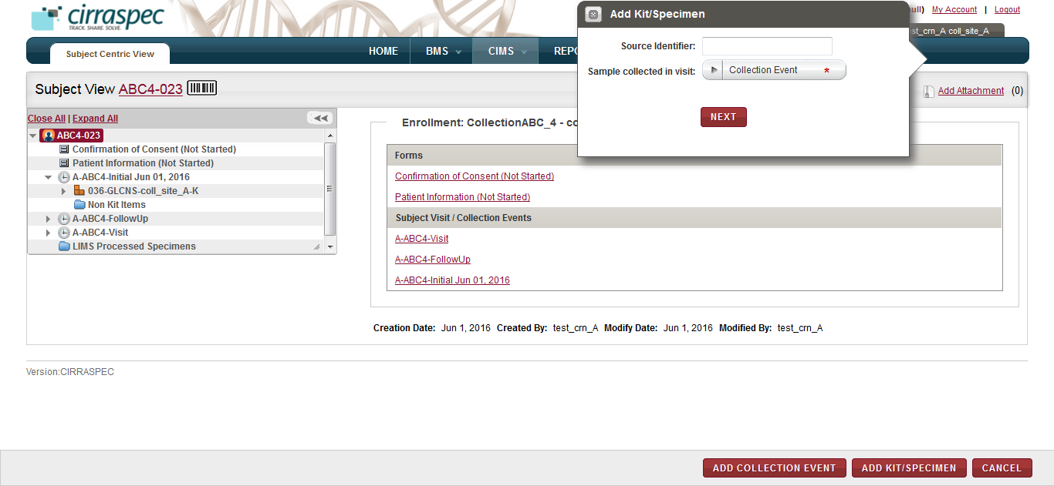

1. Add Kit/Specimen pop-up
2. In the **Source Identifier** box, type the **Specimen Identifier** you want to assign to the non kit item.

Select a **Collection Event** from the dropdown list to which this non kit item needs to be assigned.

Click **NEXT**.

The **Add Kit/Specimen** pop-up refreshes to show dropdowns for specimen details.

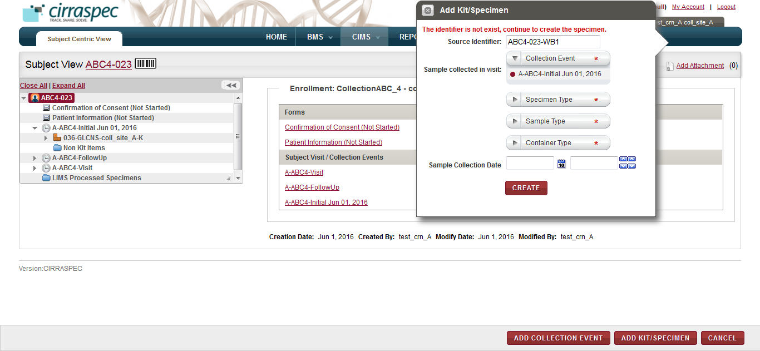

1. Add Kit/Specimen pop-up with specimen details
2. Enter appropriate information in each field. Following table lists each field and its description.

**Note:** Fields that are marked with the red asterisk (*) are madatory.

Table 41: Assigning a non kit item to a collection event

| **Field** | **Description** |
| --- | --- |
| **Specimen Type**\* | Click appropriate specimen type for the specimen you want to add. |
| **Sample Type**\* | Click appropriate sample type for the specimen you want to add. |
| **Container Type**\* | Click appropriate container type for the specimen you want to add. |
| **Sample Collection Date** | Click the calendar and select the collection date of the specimen you want to add.  Then click the up or down arrow icon to specify the time when the biospecimen was collected. |

1. Click **CREATE**.

The tree view on the LHS of the page refreshes to show the new non kit item under the **Non Kit Items** node for the respective Collection Event.

### 

### Viewing the Form Details

To view the details of a clinical form, consent form or a specimen collection form associated with a subject:

1. Log in to the application using your log in credentials.

The CIRRASPEC home page appears.

1. Point to the arrow of the **CIMS** tab, and then click **Subject Centric View**.

The **Subject Search** page appears.

1. Click **SEARCH**.

The **Subject Search** page displays a list of subjects.

1. Click the row of the appropriate subject.

The **Subject View** page appears.

1. From the **Subject Homepage** on the right side of the page, under the **Enrollment** section, click the link of the form section that you want to view.

OR

In the hierarchy tree structure on the left side of the page, click the form section node for which you want to view the details.

The name of the selected form section and the form section data appear on the RHS of the page.  
  
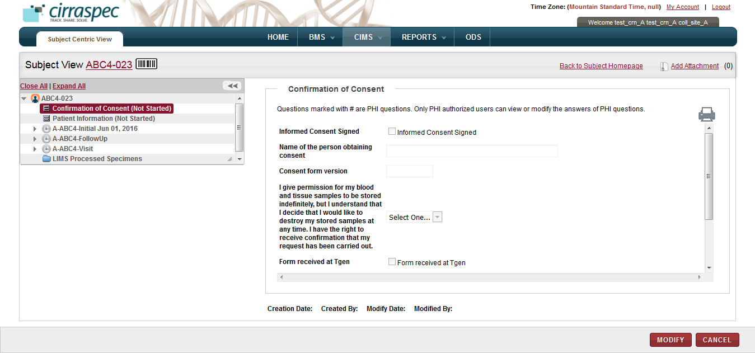

1. Data collection form

**Note:** PHI questions (if any) in the form section will be marked with a hash sign (#).

* If the form section contains PHI questions, then the answers (if already filled up) for these are displayed differently for PHI authorized and Non-PHI authorized users.
  + The PHI authorized users are allowed to answer PHI as well as Non-PHI questions. Hence they can also view the answers (if already filled up) to all the questions.
  + However, the Non-PHI authorized users are allowed to answer only the Non-PHI questions. If answers to PHI questions have already been filled up by some PHI user, then these are shown as hashed out (in case of textboxes) and blanked out (in case of radio buttons, dropdowns and checkboxes) to the Non-PHI authorized users.

1. To view a PDF image of the actual form section, click the **print icon** .  
   The form section appears in a new window.  
   **Note:** You can print the form section from this window.

### Modifying the Form Details

**Note:** You cannot modify a form with the status as **Data Entry Completed** or **Approved**.

If the form status is **Data Entry Completed** or **Approved**, and you want to modify the form, see **Changing the Status of a Form**.

To modify the form details:

1. Log in to the application using your log in credentials.

The CIRRASPEC home page appears.

1. Point to the arrow of the **CIMS** tab, and then click **Subject Centric View**.

The **Subject Search** page appears.

1. Click **SEARCH**.

The **Subject Search** page displays a list of subjects.

1. Click the row of the appropriate subject.

The **Subject View** page appears.

1. From the **Subject Homepage** on the right side of the page, under the **Enrollment** section, click the link of the form section that you want to modify.

OR

In the hierarchy tree structure on the left side of the page, click the form section node for which you want to modify details.

The name of the selected form section and the form section data appear on the RHS of the page.

1. Click **MODIFY**.

The form section data fields appear in modify mode.

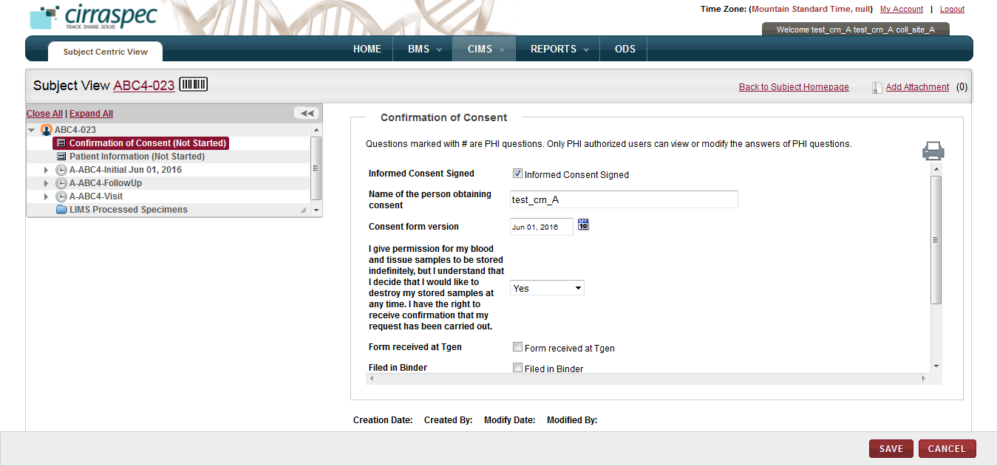

1. Form data – modify mode
2. Modify the form section data by entering new values in the appropriate fields, and then click **SAVE**.

The form section is modified and the status appears as **Data Entry Started**.

**Note:** PHI questions (if any) in the form section will be marked with a hash sign (#).

* If the form contains PHI questions, then the input fields for these are displayed differently for PHI authorized and Non-PHI authorized users.
  + The PHI authorized users are allowed to answer PHI as well as Non-PHI questions. Hence all input fields are displayed in an active mode to these users.

They can also view the answers (if already filled up) to all the questions.

* + However, the Non-PHI authorized users are allowed to answer only the Non-PHI questions. Hence input fields for PHI questions appear in a greyed out mode for such users. The input fields for Non-PHI questions are displayed in an active mode. If answers to PHI questions have already been filled up by some PHI user, then these are shown as hashed out (in case of textboxes) and blanked out (in case of radio buttons, dropdowns and checkboxes) to the Non-PHI authorized users.

1. Make the necessary changes to the form and click **SAVE.**  
   For form sections whose data entry had not started yet, changes are saved and the form status now appears as **Data Entry Started**.

There is no change in the status of the forms sections which already had the **Data Entry Started** status.

1. User can click **CANCEL** to exit the ‘modify’ mode.  
   The status of the form remains **Data Entry Started**.  
   OR  
   If the form is complete, do the following:
2. Click **DATA ENTRY COMPLETED**.

The status of the form appears as **Data Entry Completed**.

**Note:** In case of forms with one or more PHI questions, this button is displayed only for the PHI authorized users.

1. Click **APPROVE**.

The status of the form appears as **Approved**.

**Note:** In case of forms with one or more PHI questions, this button is displayed only for the PHI authorized users.

### Changing the Status of a Form

To modify a clinical, consent or specimen collection form associated with a subject with the status as **Data Entry Completed or Approved**, you must first change the status back to **Data Entry Started**.

To change the status from **Data Entry Completed** to **Date Entry Started**:

1. Log in to the application using your log in credentials.

The CIRRASPEC home page appears.

1. Point to the arrow of the **CIMS** tab, and then click **Subject Centric View**.

The **Subject Search** page appears.

1. Click **SEARCH**.

The **Subject Search** page displays a list of subjects.

1. Click the row of the appropriate subject.

The **Subject View** page appears.

1. From the Subject Homepage on the right side of the page, under the Enrollment section, click the link of the form section whose status you want to change.

OR

In the hierarchy tree structure on the left side of the page, click the form section node for which you want to change the status.

The name of the selected form section and the form section data appear on the RHS of the page.

1. Click **DATA ENTRY NOT COMPLETED.**

The form status is changed to **Data Entry Started**.

**Note:** In case of forms with one or more PHI questions, this button is displayed only for the PHI authorized users.

To change the status from **Approved** to **Data Entry Started:**

1. Log in to the application using your log in credentials.

The CIRRASPEC home page appears.

1. Point to the arrow of the **CIMS** tab, and then click **Subject Centric View**.

The **Subject Search** page appears.

1. Click **SEARCH**.

The **Subject Search** page displays a list of subjects.

1. Click the row of the appropriate subject.

The **Subject Centric View** page appears.

1. From the Subject Homepage on the right side of the page, under the Enrollment section, click the link of the form section whose status you want to change.

OR

In the hierarchy tree structure on the left side of the page, click the form section node for which you want to change the status.

The name of the selected form section and the form section data appear on the RHS of the page.

1. Click **REMOVE APPROVAL.**

The **Electronic Signature** window appears.



1. Electronic Signature window

**Note**: In case of forms with one or more PHI questions, the **REMOVE APPROVAL** button is displayed only for the PHI authorized users.

1. Enter appropriate information in each field. Following table lists each field and its description.

**Note:** Fields that are marked with the red asterisk (*) are mandatory.

Table 42: Modifying a form

| **Field** | **Description** |
| --- | --- |
| **Username**\* | Type your username for login. |
| **Password**\* | Type your password. |
| **Reason**\* | Type a reason for this action. |

1. Click **SIGN**.  
   The form status is changed to **DATA ENTRY COMPLETED.**
2. Click **DATA ENTRY NOT COMPLETED.**

The form status is changed to **Data Entry Started**.

**Note:** In case of forms with one or more PHI questions, this button is displayed only for the PHI authorized users.

### Printing a Form

To print a clinical, consent or specimen collection form associated with a subject:

1. Log in to the application using your log in credentials.

The CIRRASPEC home page appears.

1. Point to the arrow of the **CIMS** tab, and then click **Subject Centric View**.

The **Subject Search** page appears.

1. Click **SEARCH**.

The **Subject Search** page displays a list of subjects.

1. Click the row of the appropriate subject.

The **Subject View** page appears.

1. From the **Subject Homepage** on the right side of the page, under the **Forms** section, click the link of the form section which you want to print.

OR

In the hierarchy tree structure on the left side of the page, click the form section node which you want to print.

The name of the selected form section and the form section data appear on the RHS of the page.

Click the print icon .  
The form section appears in a new window.  
  
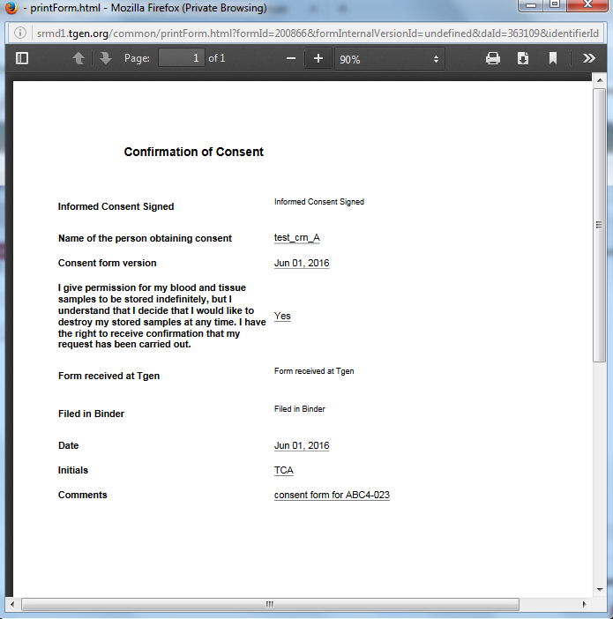

1. Print Form window
2. User can print the form section from this window.

# Other Tasks:

# Perform Redistribution shipments







### Creating a Redistribution Shipment

**Note:** Shipment identifiers for redistribution shipments begin with the letter **R**.

To create a redistribution shipment:

1. Log in to the application using your log in credentials.

The home page appears.

1. Point to the arrow of the **BMS** tab, and then click **Shipments**.

The **Shipment Search** page appears.

1. Click the **Create Redistribution Shipment** link.

The **Create Shipment** page appears.  
  
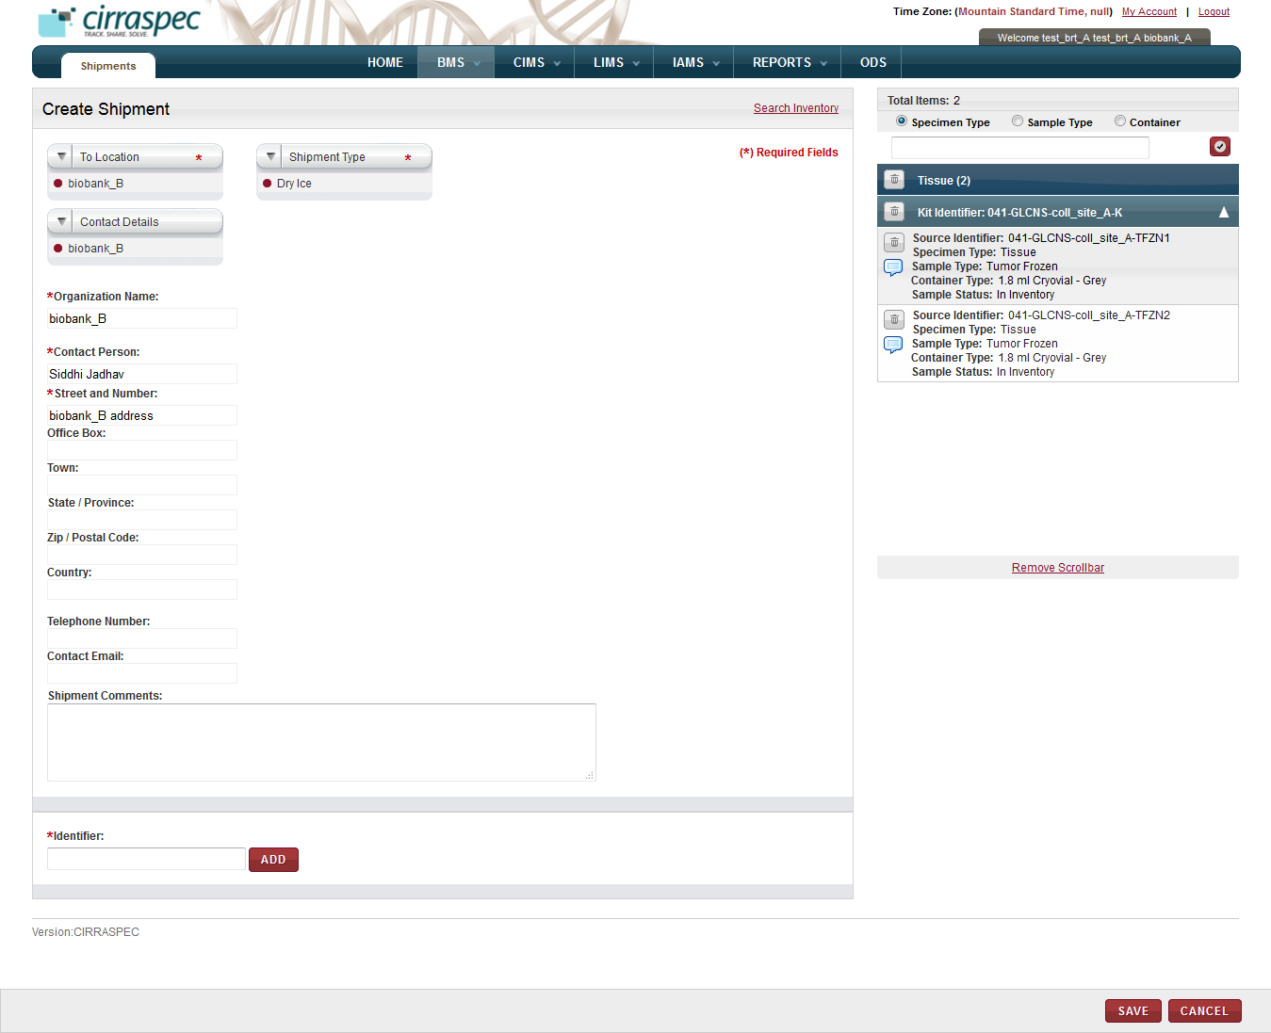

1. Create Shipment page – redistribution shipment
2. Enter appropriate information in each field. Following table lists each field and its description.

**Note:** Fields that are marked with the red asterisk (*) are mandatory.

Table 45: Creating a redistribution shipment

| **Field** | **Description** |
| --- | --- |
| **To Location**\* | Click the location you want the shipment sent to. |
| **External Location** | If Other External Location is selected as the To Location above, click the external location site. |
| **Contact Details** | Click the appropriate contact.  **Note:** If you click a known contact, rest of the fields are populated with data related to this contact. |
| **Organization Name**\* | Type name of the organization associated with the specified delivery location. |
| **Contact Person**\* | Type name of the contact. |
| **Street and Number**\* | Type street address for the contact. |
| **Office Box** | Type office box or mail stop for the contact’s mailing address, if applicable. |
| **Town** | Type town or city of the contact’s mailing address. |
| **State / Province** | Type state or province of the contact’s mailing address. |
| **Zip / Postal Code** | Type postal code of the contact’s mailing address. |
| **Country** | Type country of the contacts mailing address if other than USA. |
| **Telephone Number** | Type contact’s telephone number, if known. |
| **Contact Email** | Type contact’s email address, if known. |
| **Shipment Type**\* | Click the appropriate shipment type. |
| **Shipment Comments** | Type comments, as needed. |
| **Identifier\*** | Type or scan the Identifier of the biospecimen you want to add to the redistribution shipment and click **ADD**. Repeat for each biospecimen you want added to the redistribution shipment (one biospecimen at a time).  The specified biospecimens appear in the shipment cart (right side). |

1. To delete a biospecimen from the shipment cart:
2. Click the trash can icon  for the appropriate biospecimen.

**Note:** To delete all the biospecimens, click the trash can icon  on the blue bar.

A confirmation window appears.

1. Click **OK**.

The biospecimen is deleted.

1. To add a comment for a biospecimen:
2. In the **Total Items** area, click the comments icon  for the appropriate biospecimen.  
   The **Comments** window appears.

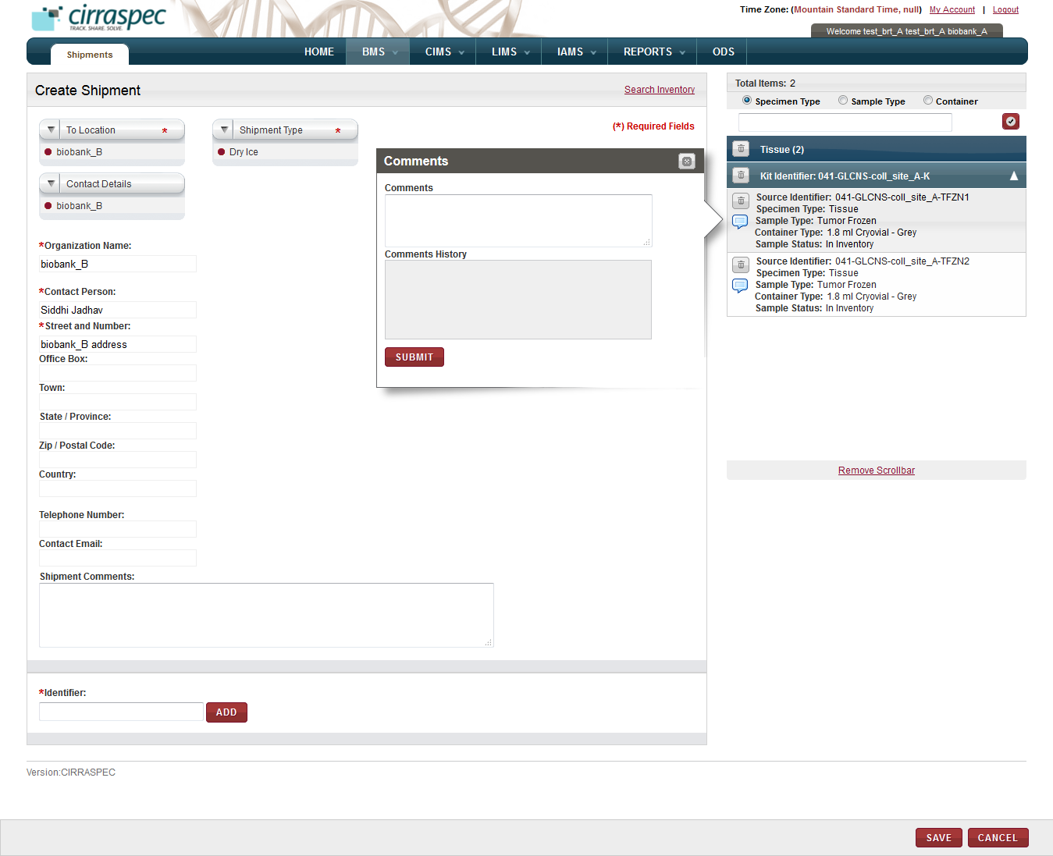

1. Comments window
2. In the **Comments** box, type appropriate comments for this biospecimen.
3. Click **SUBMIT**.

The comment is saved.

1. Click **Save**.

The redistribution shipment is created with an identifier that begins with **R**.

The status of all the biospecimens appears as **Reserved** and

The shipment status appears as **Distributed Shipment in Preparation** on the **View Shipment** page.

### Modifying a Redistribution Shipment

**Note:** The shipment must have the **Distributed Shipment in Preparation** status.

To modify a redistribution shipment:

1. Log in to the application using your log in credentials.

The home page appears.

1. Point to the arrow of the **BMS** tab, and then click **Shipments**.

The **Shipment Search** page appears.

1. Click **SEARCH**.

The shipment search page displays a list of shipments that are accessible based on your login location.

1. Click the row of the redistribution shipment you want to modify.

The **View Shipment** page appears.

1. Click **Modify**.

The **Modify Shipment** page appears.

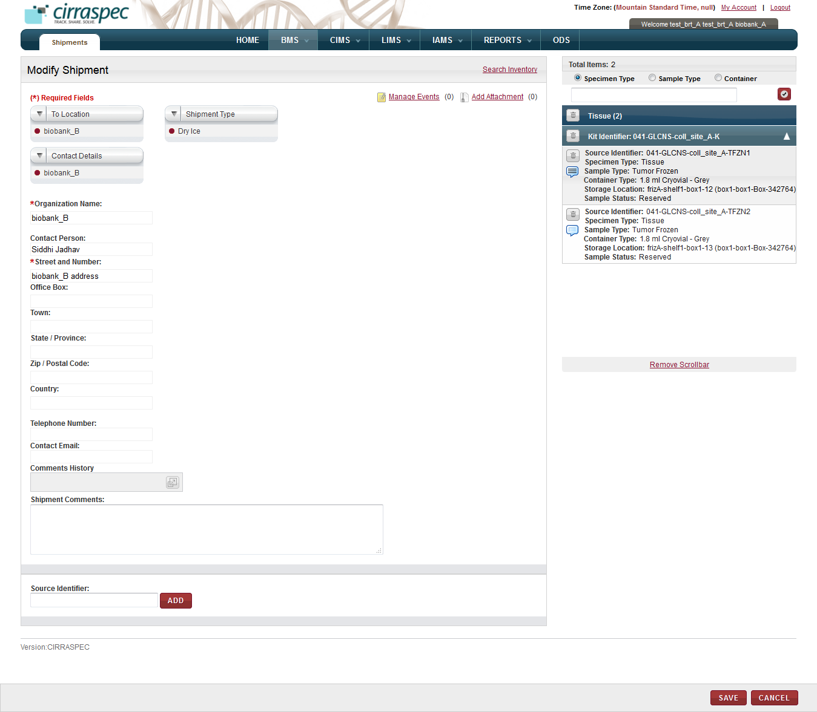

1. Modify Shipment page - Redistribution
2. Modify the redistribution shipment. For more information about redistribution shipment field data, see **Creating a Redistribution Shipment**.
3. To add an event to this shipment, click the **Manage Events** link.   
   The **Manage Events** window appears.  
   **Note:** For more information about how to add an event, see **Managing Events**.
4. To attach a file to this shipment, click the **Add Attachment** link.   
   The **Manage Attachments** window appears.  
   **Note:** For more information about how to attach a file, see **Common File Upload**.
5. Click **SAVE**.

The redistribution shipment is modified. The status of this shipment remains the same.

### Deleting Redistribution Shipment

**Note:** The shipment must have the **Distributed Shipment** **In Preparation** status.

To delete a redistribution shipment:

1. Log in to the application using your log in credentials.

The home page appears.

1. Point to the arrow of the **BMS** tab, and then click **Shipments**.

The **Shipment Search** page appears.

1. Click **SEARCH**.

The shipment search page displays a list of shipments that are accessible based on your login location.

1. Click the row of the redistribution shipment you want to delete.

The **View Shipment** page appears.

1. Click **Delete**.   
   A confirmation window appears.
2. Click **OK**.

The **Shipment Search** page appears.

The redistribution shipment is deleted and no longer appears on the **Shipment Search** page.

The biospecimens previously associated with the shipment return to inventory with a status of **In Inventory.**

### Sending a Redistribution Shipment

**Note:**

* The shipment must have the **Distributed Shipment in Preparation** status.

To send a redistribution shipment:

1. Point to the arrow of the **BMS** tab, and then click **Shipments**.

The **Shipment Search** page appears.

1. Click **SEARCH**.

The shipment search page displays a list of shipments that are accessible based on your login location.

1. Click the row of the redistribution shipment you want to send.

The **View Shipment** page appears.

1. Click **SEND**.

The **Send Shipment** page appears.

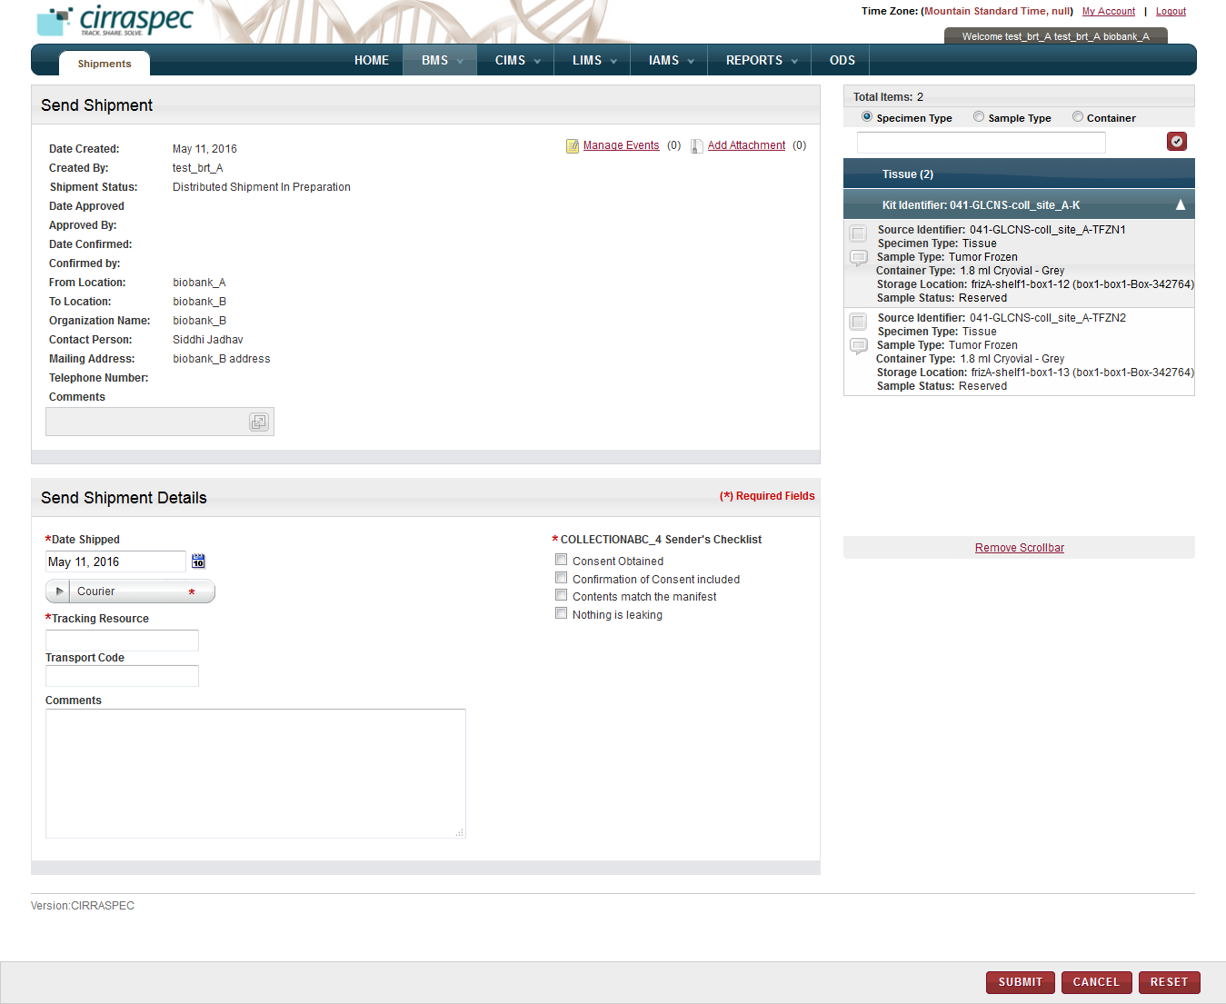

1. Send Shipment page
2. In the **Send Shipment Details** area, enter appropriate information in each field. Following table lists each field and its description.

**Note:** Fields that are marked with the red asterisk (*) are mandatory.

Table 46: Sending a redistribution shipment

| **Field** | **Description** |
| --- | --- |
| **Date Shipped**\* | Click the date icon Search calendar, and then click the date when you are sending the redistribution shipment.  The date appears in the **Date Shipped** box. |
| **Courier**\* | Click the appropriate shipping courier. |
| **Tracking Resource**\* | Type or scan the shipping courier’s tracking number. |
| **Transport Code** | Type the transport code, if applicable. |
| **Comments** | Type comments, as needed. |
| **Sender’s Checklist** | Make sure all the checkboxes are selected and the respective actions have been taken. |

1. To add an event to this shipment, click the **Manage Events** link.   
   The **Manage Events** window appears.  
   **Note:** For more information about how to add an event, see **Managing Events**.
2. To attach a file to this shipment, click the **Add Attachment** link.   
   The **Manage Attachments** window appears.  
   **Note:** For more information about how to attach a file, see **Common File Upload**.
3. Click **SUBMIT**.

The redistribution shipment is sent.

The redistribution shipment status changes to **Distributed Shipment In Transit**.

### Recording Receipt of a Redistribution Shipment

When notified that an external site has received a redistribution shipment, you can update the system.

**Note:** The shipment must have the **Distributed Shipment In Transit** status.

To receive a distribution shipment:

1. Point to the arrow of the **BMS** tab, and then click **Shipments**.

The **Shipment Search** page appears.

1. Click **SEARCH**.

The shipment search page displays a list of shipments that are accessible based on your login location.

1. Click the row of the redistribution shipment you want to receive.

The **View Shipment** page appears.

1. Click **RECEIVE**.

The **Receive Shipment** page appears.

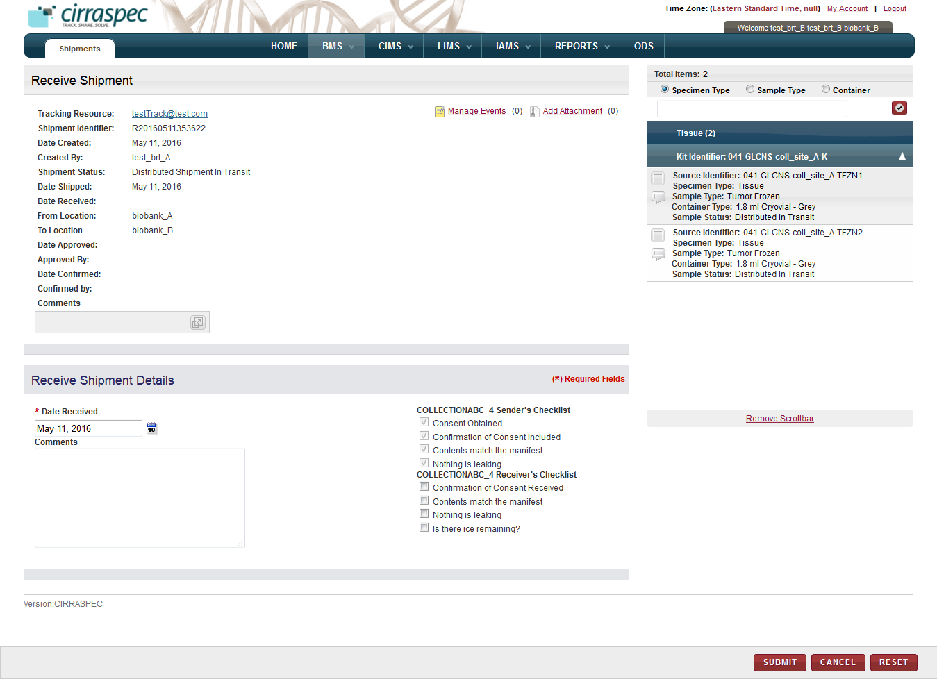

1. Receive Shipment page
2. Click the date icon  next to the **Date Received** box, and then click the date when the shipment was received.   
   **Note:** You cannot select a date before the shipped date.
3. In the **Comments** box, type comments if applicable.
4. Select the checkboxes from the **Receiver’s Checklist** and ensure that the respective actions have been taken.

**Note**: If user does not select any or all of the checkboxes, a message box reading “Receivers checklist is not complete. Do you still want to continue?” is shown. If you need to proceed without selecting these checkboxes, click the OK button.

1. To add an event to this shipment, click the **Manage Events** link.   
   The **Manage Events** window appears.  
   **Note:** For more information about how to add an event, see **Managing Events**.
2. To attach a file to this shipment, click the **Add Attachment** link.   
   The **Manage Attachments** window appears.  
   **Note:** For more information about how to attach a file, see **Common File Upload**.
3. Click **SUBMIT.**

The redistribution shipment is received.

The redistribution shipment status appears as **Distribution Awaiting Samples Check-in** on the **View Shipment** screen.

# In Inventory, Find, View and Manage Biospecimens

### Searching for a Biospecimen

To search for a specific biospecimen or a group of biospecimens:

1. Point to the arrow of the **BMS** tab, and then click **Inventory**.   
   The **Inventory Search** page appears.
2. To apply a search criteria, expand the **Advanced Search** section by clicking on the down-arrow button .

The search fields appear below.  
  
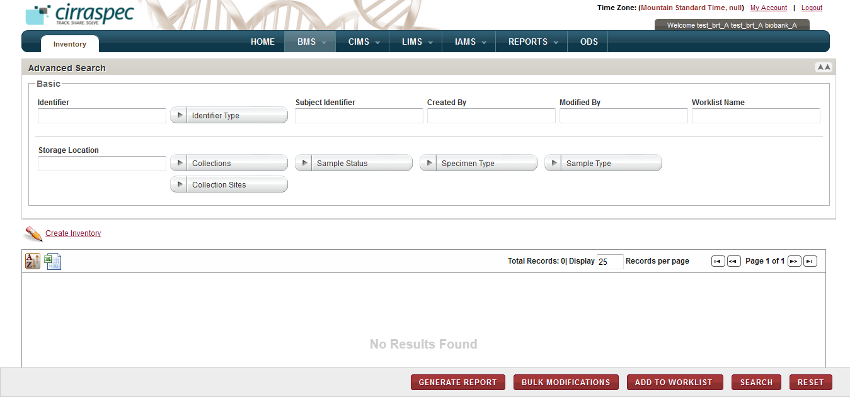

1. Figure Advanced Search window - search fields
2. Enter appropriate information in each field. Following table lists each field and its description.

**Note**:

* You can use one field or a combination of fields to search.
* You can type the full or partial value in a search field along with an asterisk (*) before or after the partial value. For example, if you type **02\***, you obtain records that begin with 02. If you type **\*02**, you obtain records that end with 02

Table 47: Advanced Search fields

| **Field** | **Description** |
| --- | --- |
| **Basic** search fields | |
| **Identifier** | Type a biospecimen identifier to search for a specific biospecimen. |
| **Identifier Type** | Click one or more identifier types to search for all biospecimens with that identifier type. |
| **Subject Identifier** | Type or scan the identifier of the subject that you want to search by. |
| **Created By** | Type the log in ID of the user to search for biospecimens created by that user. |
| **Modified By** | Type the log in ID of the user to search for biospecimens modified by that user. |
| **Worklist Name** | Type the name of the worklist that you want to search for. |
| **Storage Location** | Type a storage location to search for all biospecimens stored in that location. |
| **Collections** | Click the appropriate Collection to search for all biospecimens associated with that Collection. |
| **Collections Sites** | Click the appropriate Collection Site to search for kits associated with this Collection Site.  **Note:** To search for kits associated with all the Collection Sites, click **All**. |
| **Sample Status** | Click one or more samples statuses to search for all biospecimens with that status. |
| **Specimen Type** | Click one or more specimen types to search for all biospecimens with that specimen type. |
| **Sample Type** | Click one or more sample types to search for all biospecimens with that sample type. |

1. Click **SEARCH**.  
   A list of biospecimens that match your search criteria appears.   
   **Note:**

* To completely collapse the **Advanced Search** area, click on the double arrow icon  in the right corner of the **Advanced Search** header bar.
* To sort the list, click the header of the column with which you want to sort.
* For additional information about how to sort the biospecimen list, change the column display and/or the number of records per page, see **Changing Search Results Display**

From the **Inventory Search** page, you can initiate the following tasks:

* **Add new biospecimen to inventory:** For more information about how to add new biospecimen inventory, see **Creating Inventory****.**
* **Print a biospecimen list as an excel spreadsheet:** Click the **Export current view to CSV**  icon, and then in the **File Download** window, click **Save**.   
  The biospecimen list file is saved to your machine for viewing/printing.
* **Generate a biospecimen list report:** For more information about how to generate a biospecimen report, see **Generating a Biospecimen Report****.**
* **Modify biospecimens in bulk:** For more information about how to modify biospecimens in bulk, see **Modifying Biospecimens in Bulk****.**
* **Add biospecimens to a worklist:** You can add biospecimens to an existing worklist or create a new worklist and add biospecimens to it. For more information about how to add a biospecimen to a worklist, see **Adding a Biospecimen to a Worklist**.
* **View biospecimen details:** For more information about how to view the details of a biospecimen, see **Viewing Biospecimen Details**.

### Creating Inventory

To add a new biospecimen to inventory:

1. Log in to the application using your log in credentials.

The home page appears.

1. Point to the arrow of the **BMS** tab and then click **Inventory**.

The **Inventory Search** page appears.

1. Click the **Create Inventory** link below the Advanced Search section.

The **Create Inventory** window appears.

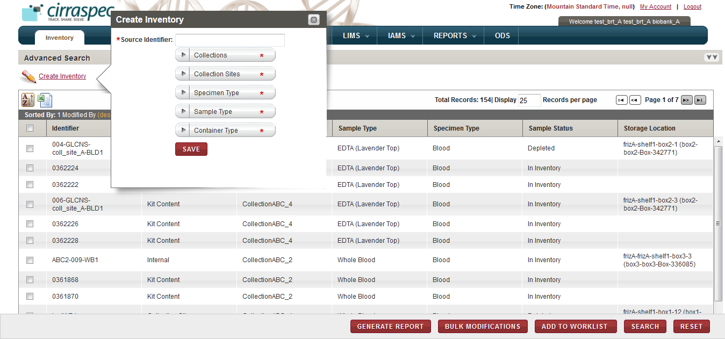

1. Create Inventory window
2. Enter appropriate information in each field. Following table lists each field and its description.

**Note:** Fields that are marked with the red asterisk (*) are mandatory.

Table 48: Creating biospecimen inventory

| **Field** | **Description** |
| --- | --- |
| **Source Identifier**\* | Scan or type a Sample Identifier for the new biospecimen. **Note:** You cannot use an existing identifier. |
| **Collections**\* | Click appropriate Collections to which you want the new biospecimen assigned. |
| **Collection Sites**\* | Click appropriate Collection Site to which you want the new biospecimen assigned. |
| **Specimen Type**\* | Click appropriate specimen type for the new biospecimen. |
| **Sample Type**\* | Click appropriate sample type for the new biospecimen. |
| **Container Type**\* | Click appropriate container type for the new biospecimen. |

1. Click **SAVE**.The **Create Inventory** window closes and the **View Biospecimen** page is displayed with details of the new biospecimen.

Click **CLOSE** to go back to the **Inventory Search** page. This page shows the new biospecimen on the list with **Sample Status** as **In Inventory**.

### Generating a Biospecimen Report

To generate a biospecimen report:

1. Log in to the application using your log in credentials.

The home page appears.

1. Point to the arrow of the **BMS** tab and then click **Inventory**.

The **Inventory Search** page appears.

1. Click **SEARCH**.

The **Inventory Search** page displays a list of biospecimens that are accessible based on your login location.

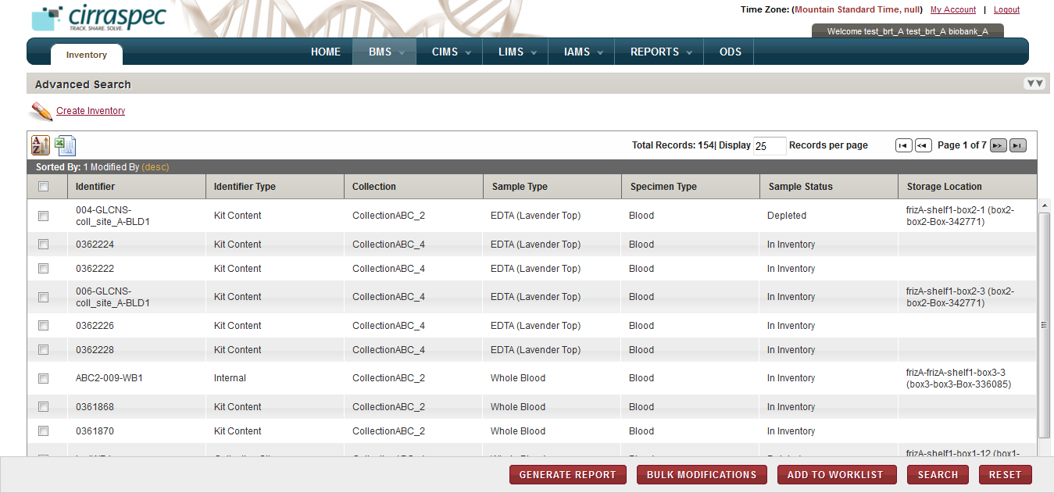

1. Inventory Search page

1. Select the checkboxes of the biospecimens for which you want to generate a report, and then click **GENERATE REPORT**.

The biospecimen report appears in a new window.

1. View, print and/or save the file, as needed.   
   **Note**: Hover the cursor over the icons in the horizontal and vertical navigation bars to identify tools for viewing multiple pages, printing the report and saving the file to your machine.

**Example Report:**



### Adding a Biospecimen to a Worklist

To add a biospecimen to a worklist:

1. Log in to the application using your log in credentials.

The home page appears.

1. Point to the arrow of the **BMS** tab and then click **Inventory**.

The **Inventory Search** page appears.

1. Click **SEARCH**.

The **Inventory Search** page displays a list of biospecimens that are accessible based on your login location.

1. Select the checkboxes of the biospecimens that you want to add to a worklist, and then click **ADD TO WORKLIST**.   
   The **Create/Modify Worklist** page appears with the selected biospecimens listed.

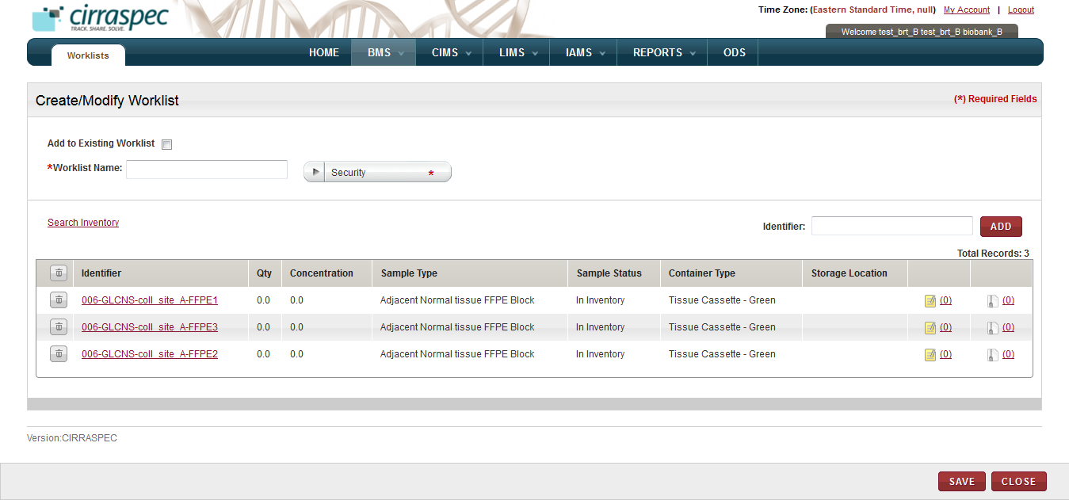

1. Create/Modify Worklist page
2. Enter appropriate information in each field. Following table lists each field and its description. **Note:** Fields that are marked with the red asterisk (*) are mandatory.

Table 49: Adding biospecimens to a worklist

| **Field** | **Description** |
| --- | --- |
| **Add to Existing Worklist** | If you want to add the selected biospecimen to an existing worklist, select this checkbox. |
| **Worklist Name**\* | If you checked the **Add to Existing Worklist** box, then type part or all of the existing worklist name in this field.  **Note:** As you type part of an existing name, a dropdown list appears with existing worklist names that you can select for this field.  If you want to add these biospecimens to a new worklist, type a name for the worklist. |
| **Security**\* | If you want to add the selected biospecimens to a new worklist, click on the appropriate **Security** value for the new worklist.   * **Private**: Can be viewed, modified or deleted only by the creator of the worklist. Cannot be viewed by other users. * **Shared – Read-Only**: Can be viewed and used by any other authorized users within the organization. Can be viewed, modified or deleted only by the creator of the worklist. * **Shared – Read-Write**: Can be viewed or modified by any authorized user within the organization. Only the creator of the worklist can change the security level or delete the worklist.   **Note:** This field is disabled if the **Add to Existing Worklist** box is checked. |
| **Identifier** | To manually add a biospecimen to the worklist using its identifier, input or scan a Kit or Sample Identifier in the **Source Identifier** text box and click on the **ADD** button.  The biospecimen appears on the list below. **Note:** You can add multiple biospecimens to the worklist using this field. |

1. (Optional) To search and select additional biospecimens, click the **Search Inventory** link.

The **Search Samples and Worklists** page appears.

If you want to search and select biospecimens that are associated with a personal worklist:

1. Click the **Search Worklist** tab.
2. In the **Worklist Name** box, type the name of the personal worklist, and click **Search**. **Note:** You can type a partial or full name of the worklist.   
   A list of worklists that match your search criteria appears.
3. Click the appropriate worklist.   
   The list of biospecimens that are associated with the worklist appears below.

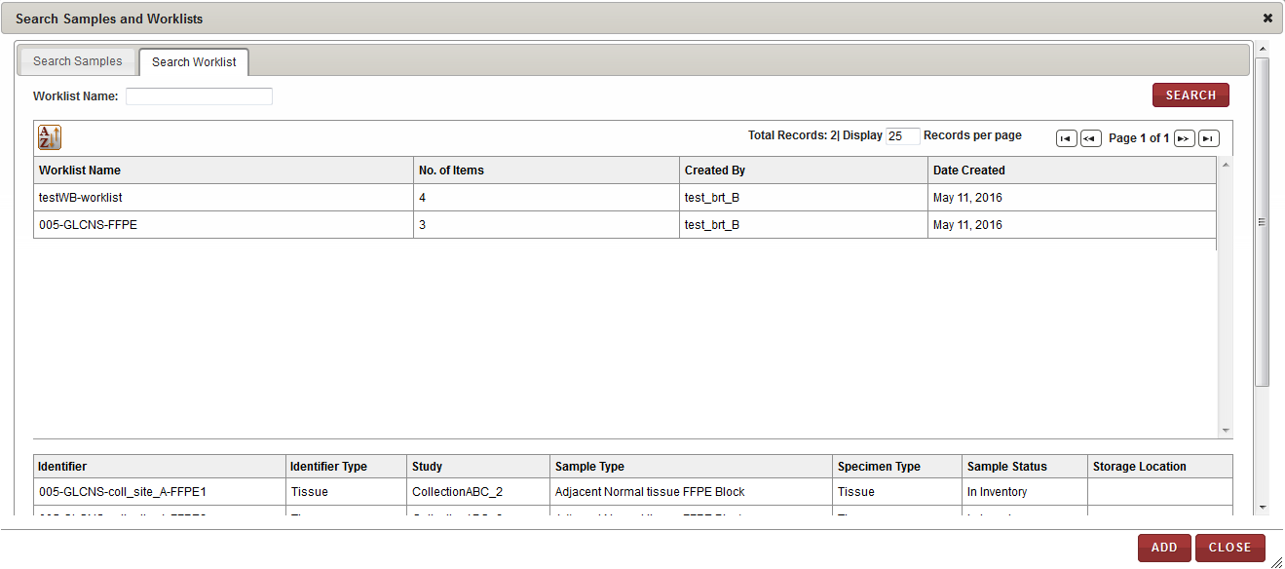

1. Search Worklist window
2. Click **ADD**.

The window closes and the biospecimens associated with the worklist appear on the **Create/Modify Worklists** page.

1. (Optional) If you want to search and select biospecimens by Identifier, Collection, Sample Type, Specimen Type, LIMS workflow type:
2. Click the **Search Samples** tab
3. Select the **Basic**, **Inventory** and/or **LIMS** checkbox to display the available search fields.  
   **Note:** You can select more than one checkbox.   
   The search fields associated with your selection appear.

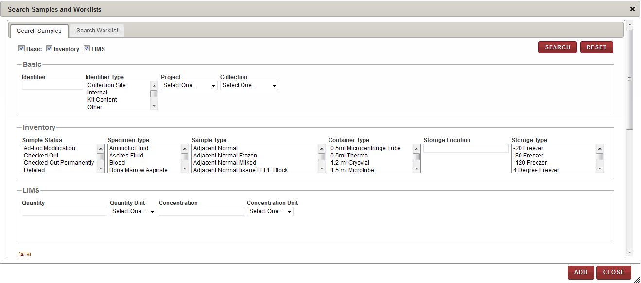

1. Search Samples window – search fields
2. Enter appropriate information in each field. Following table lists each field and its description.   
   **Note:** You can specify multiple search criteria.

Table 50: Selecting additional biospecimes

| **Field** | **Description** |
| --- | --- |
| **Basic** search fields | |
| **Identifier** | Type a biospecimen identifier to search for a specific biospecimen. |
| **Identifier Type** | Click one or more identifier types to search for all biospecimens with that identifier type. |
| **Project** | Click the appropriate Project to search for all biospecimens associated with that Project. |
| **Collection** | Click the appropriate Collection to search for all biospecimens associated with that Collection. |
| **Inventory** search fields | |
| **Sample Status** | Click one or more biospecimen statuses to search for all biospecimens with that status. |
| **Specimen Type** | Click one or more specimen types to search for all biospecimens with that specimen type. |
| **Sample Type** | Click one or more sample types to search for all biospecimens with that sample type. |
| **Container Type** | Click one or more container types to search for all biospecimens with that container type. |
| **Storage Location** | Type a storage location to search for all biospecimens stored in that location. |
| **Storage Type** | Click one or more storage types to search for all biospecimens with that storage type. |
| **LIMS** search fields | |
| **Quantity** | Type a quantity to search for all biospecimens of that quantity. |
| **Quantity Unit** | Click the appropriate unit of measure to search for all biospecimens using that quantity unit of measure. |
| **Concentration** | Type a concentration to search for all biospecimens of that concentration. |
| **Concentration Unit** | Click the appropriate unit of measure to search for all biospecimens using that concentration unit of measure. |

1. Click **SEARCH**.  
   A list of biospecimens that match your search criteria appears.
2. Click the biospecimens that you want to add to the worklist.   
   The biospecimen identifiers appear in the list below.
3. Click **ADD**.  
   The search window closes and the biospecimen identifiers appear on the **Create/Modify Worklist** page.
4. (Optional) To remove a biospecimen from the list on the **Create/Modify Worklists** page,
5. Click the trash can icon  next to the appropriate biospecimen identifier.

**Note:** To remove all the biospecimens from the list, click the trash can icon  on the header.

A confirmation window appears.

1. Click **OK**.

The biospecimen is removed from the list.

1. Click **SAVE**.

**View Worklist** page appears showing the biospecimens added to the worklist.

### Viewing Biospecimen Details

To view the details of a biospecimen:

1. Log in to the application using your log in credentials.

The home page appears.

1. Point to the arrow of the **BMS** tab and then click **Inventory**.

The **Inventory Search** page appears.

1. Click **SEARCH**.

The **Inventory Search** page displays a list of biospecimens that are accessible based on your login location.

1. Click the row of the biospecimen for which you want to view details.

The **View Biospecimen** page appears.

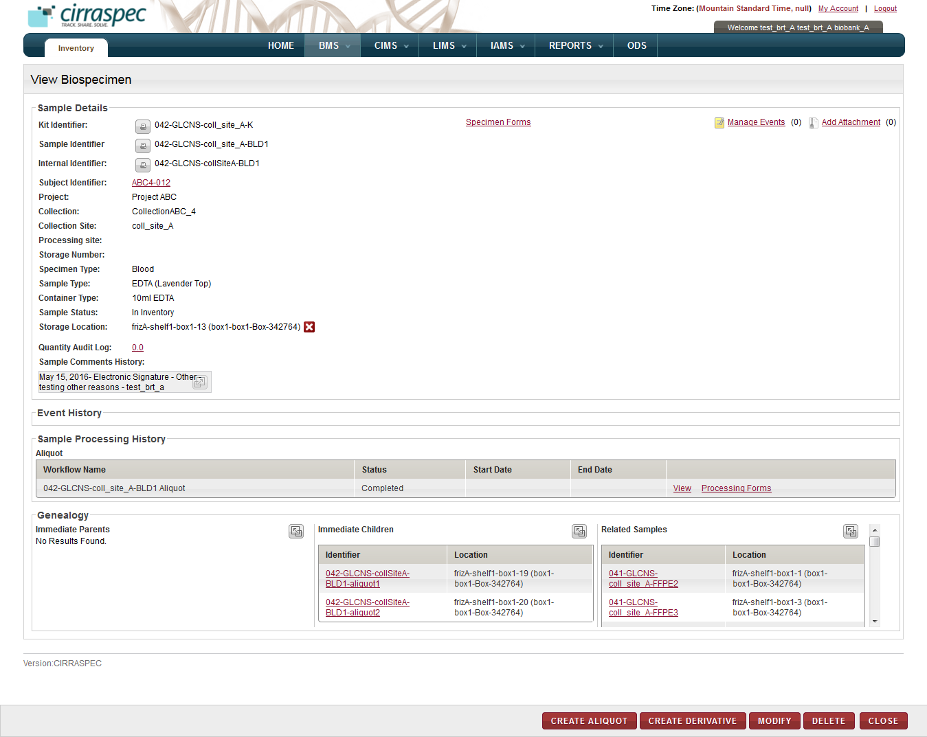

1. View Biospecimen page
2. To print a barcode label associated with this biospecimen, click the  icon next to the identifier for which you want to print labels.

The print barcode window appears.  **Note:** For more information about how to print barcode labels, see **Printing a Barcode Label for a Biospecimen****.**

1. To view a specimen collection form associated with this biospecimen:
2. Click the **Specimen Forms** link at the top of the page.  
   **Note:** The link displays only if there are specimen collection forms associated with this biospecimen.  
   The **Forms** window appears.

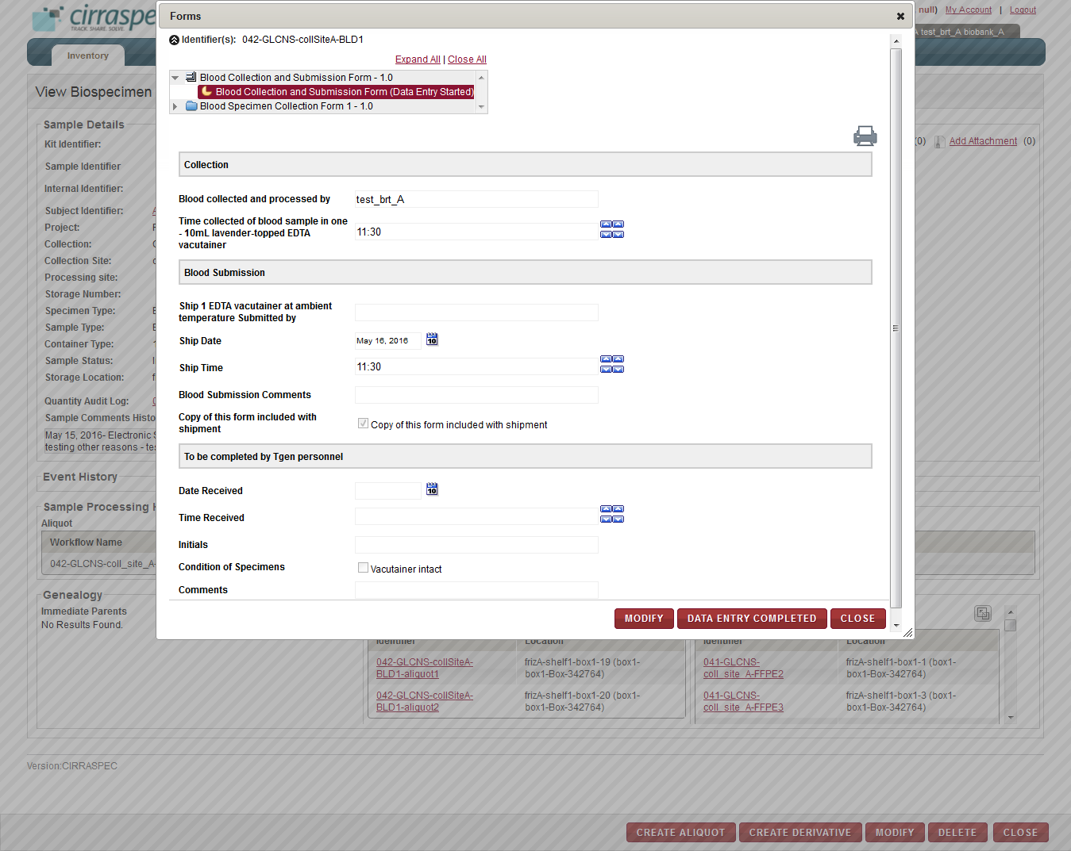

1. View Biospecimen page – Forms window
2. Click the down arrow to expand the list of form sections.
3. Click the form section you want to view.   
   The form section information appears.  
   **Note:**

* If the form contains PHI questions, then the answers (if already filled up) for these are displayed differently for PHI authorized and Non-PHI authorized users.
  + The PHI authorized users are allowed to answer PHI as well as Non-PHI questions. Hence they can also view the answers (if already filled up) to all questions.
  + However, the Non-PHI authorized users are allowed to answer only the Non-PHI questions. If the answers to PHI questions have already been filled up by some PHI user, then these are shown as hashed out (in case of textboxes) and blanked out (in case of radio buttons, dropdowns and checkboxes) to the Non-PHI authorized users.
* To update the form information or status, see **Updating a Specimen Collection Form for a Biospecimen**.

1. To print the form, click on the icon.  
   The form appears in a new window that allows you to do File > Print or File > Save As functions.
2. To add an event to this biospecimen, click the **Manage Events** link.   
   The **Manage Events** window appears.   
   **Note:** For more information about how to add an event, see **Managing Events**.
3. To attach a file to this biospecimen, click the **Add Attachment** link.   
   The **Manage Attachments** window appears.   
   **Note:** For more information about how to attach a file, see **Common File Upload**.
4. To release the storage location for this biospecimen:
5. Click the  icon in the **Storage Location** field.   
   A confirmation message appears.  
   **Note:** The icon displays only if a storage location is assigned to this biospecimen.
6. Click OK .  
   The message window closes and the assigned storage location is released for storing other biospecimen. The **Storage Location** for this biospecimen appears as **Unassigned** on the **View Biospecimen** screen.
7. To view the quantity history for this biospecimen, click the **Quantity Audit Log** link.  
   The **Quantity Audit Log** window appears.

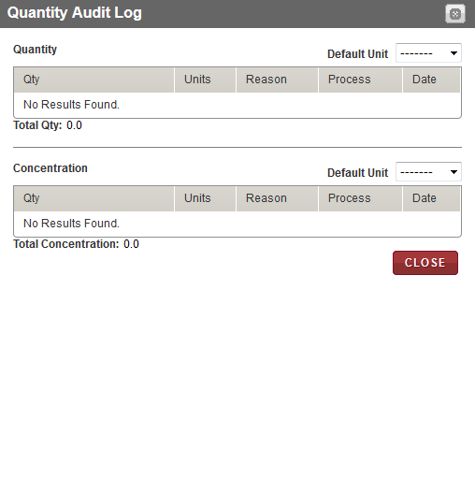

1. View Biospecimen page – Quantity Audit Log window
2. To view the LIMS processing workflow details for this biospecimen, click the **View** link in the last column of the **Sample Processing History** table.

The **View Workflow** page appears.  
 **Note:** The link displays only if this biospecimen has a sample processing workflow associated with it.

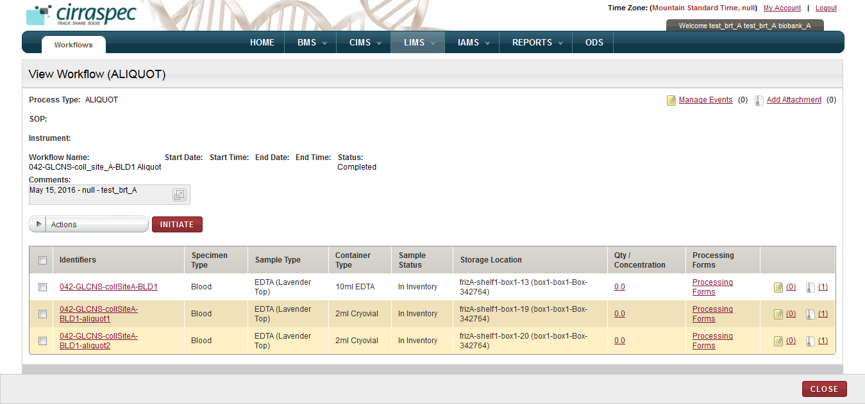

1. View Biospecimen page – View Workflow sample processing page
2. To view details of the parent of this biospecimen, click the **Identifier** link in the **Immediate Parents** table in the **Genealogy** section.

The **View Biospecimen** page appears with all the information for the selected parent biospecimen.

**Note:**

* The link is displayed only if this biospecimen was created as a result of a sample processing workflow.
* You can expand this section by clicking the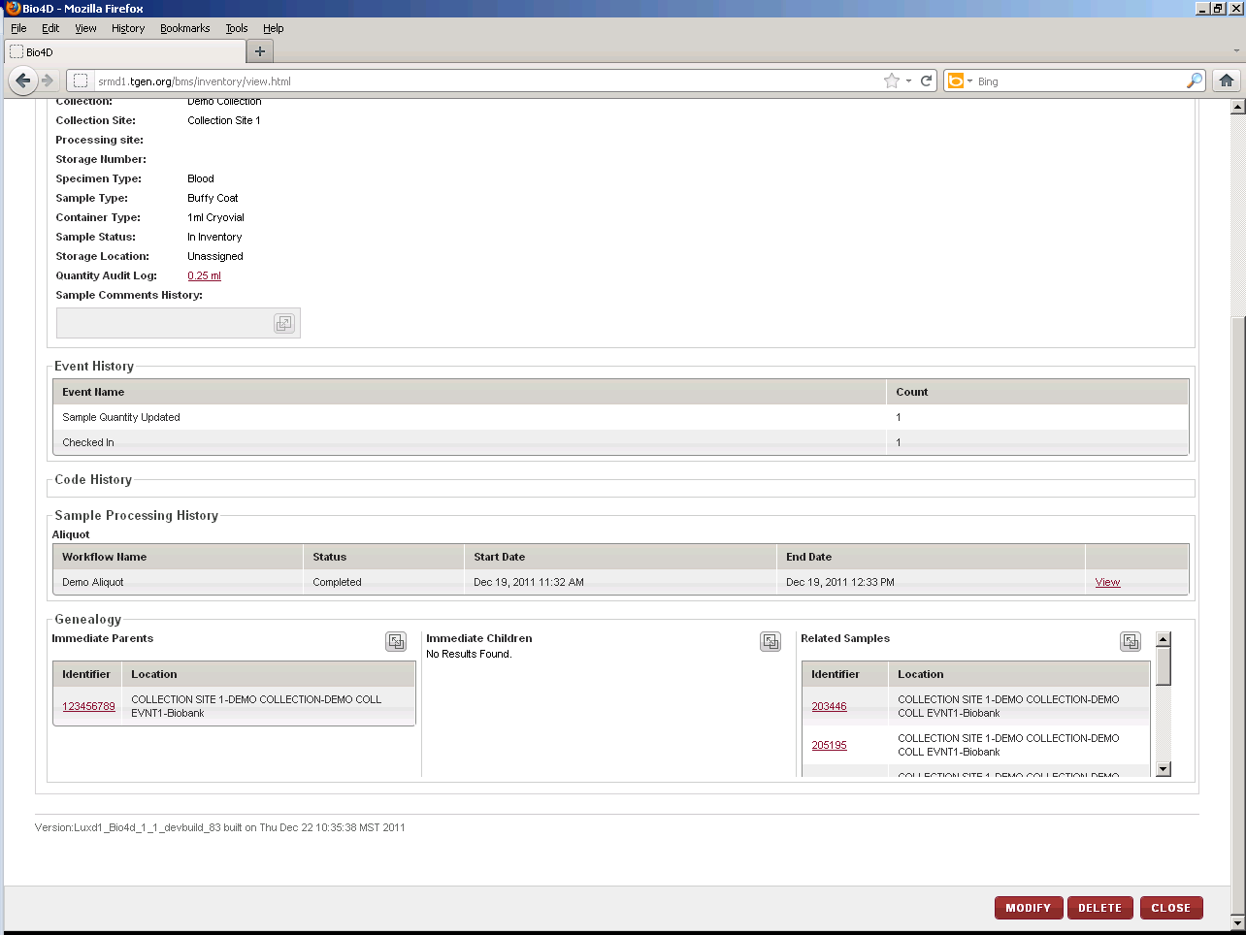icon.

1. To view details of a child of this biospecimen, click the **Identifier** link in the **Immediate Children** table in the **Genealogy** section.

The **View Biospecimen** page appears with all the information for the selected child biospecimen.

**Note:**

* The link is displayed only if this biospecimen was a parent in a sample processing workflow.
* You can expand this section by clicking the****icon.

1. To view details of a similar related biospecimen, click an **Identifier** link in the **Related Samples** table in the **Genealogy** section.

The **View Biospecimen** page appears with all the information for the selected biospecimen.

**Note:**

* The link is displayed only if there are related biospecimens in inventory.
* The list displays only identifiers of biospecimens with the same Specimen Type and Sample Type.
* You can expand this section by clicking the****icon.

### Printing a Barcode Label for a Biospecimen

To print a barcode label for a biospecimen:

1. Log in to the application using your log in credentials.   
   The home page appears.
2. Point to the arrow of the **BMS** tab and then click **Inventory**.  
   The **Inventory Search** page appears.
3. Click **SEARCH**.  
   The **Inventory Search** page displays a list of biospecimens that are accessible based on your login location.
4. Click the row of the biospecimen for which you want to print a barcode label.   
   The **View Biospecimen** page appears.
5. In the **Sample Details** area, click the  icon next to the applicable identifier field.   
   The print barcode window appears.

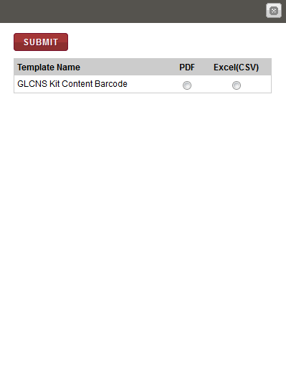

1. Print barcode window
2. To print the label to a PDF file, click **PDF**, and then click **SUBMIT**.

The image of the barcode label that is associated with the biospecimen appears below.  
  
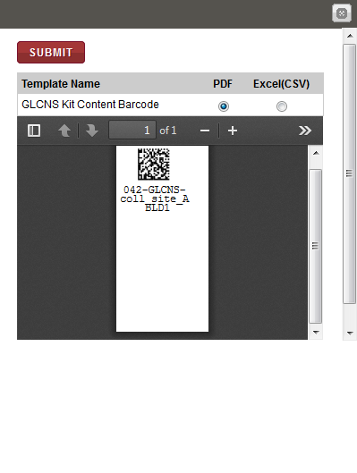

1. Print barcode window with label

**Note**: To identify tools for viewing multiple labels, printing labels and saving the file to your machine, hover the cursor over the icons in the horizontal and vertical navigation bars.

### Modifying the Biospecimen Information

**Note:** Only a Biobank user can modify biospecimen information.

To modify the biospecimen information:

1. Log in to the application using your log in credentials.

The home page appears.

1. Point to the arrow of the **BMS** tab and then click **Inventory**.

The **Inventory Search** page appears.

1. Click **SEARCH**.

The **Inventory Search** page displays a list of biospecimens that are accessible based on your login location.

1. Click the row of the biospecimen for which you want to modify the information.

The **View Biospecimen** page appears.

1. Click **MODIFY**.

The **Modify Biospecimen** page appears.

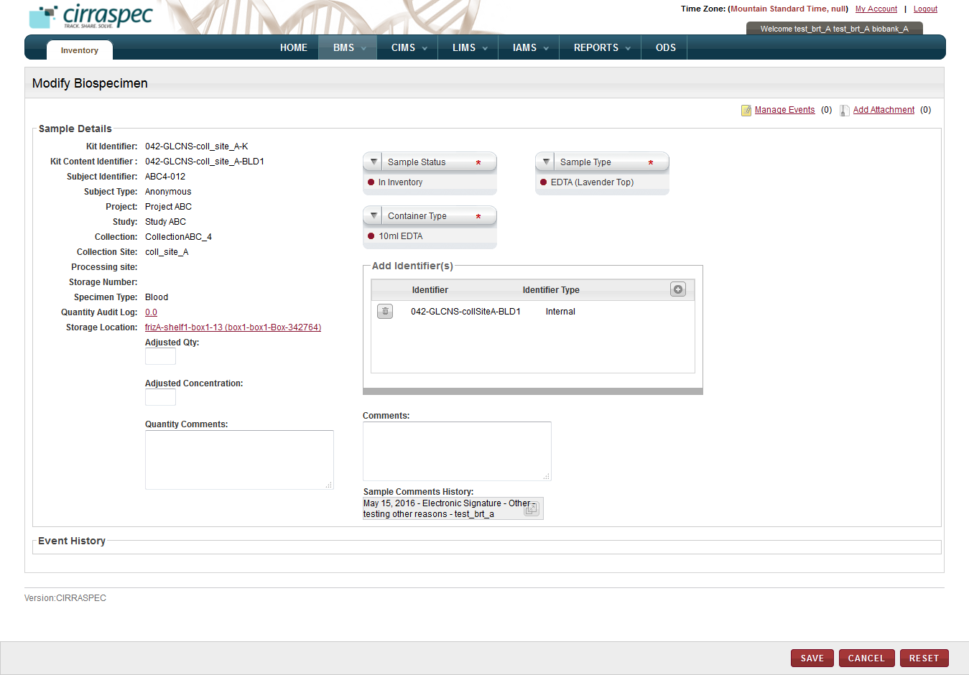

1. Modify Biospecimen page
2. To add an event to this biospecimen, click the **Manage Events** link.   
   The **Manage Events** window appears.   
   **Note:** For more information about how to add an event, see **Managing Events**.
3. To attach a file to this biospecimen, click the **Add Attachment** link.   
   The **Manage Attachments** window appears.   
   **Note:** For more information about how to attach a file, see **Common File Upload**.
4. To modify the unit of measure shown in the **Quantity Audit Log** field for this biospecimen:
5. Click the **Quantity Audit Log** link.  
   The **Quantity Audit** **Log** window appears.

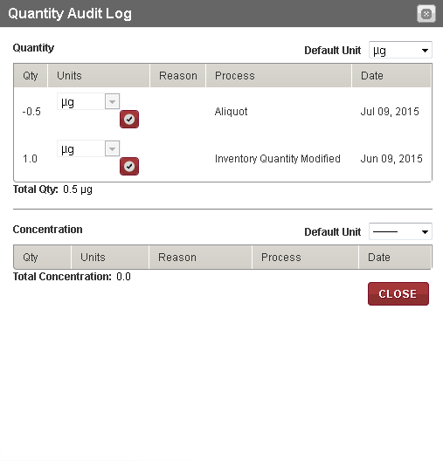

1. Quantity Audit Log window
2. To modify the default unit for Quantity, click on the Quantity **Default Unit** field and select the appropriate unit of measure.
3. To modify the default unit for Concentration, click on the Concentration **Default Unit** field and select the appropriate unit of measure.
4. Click the 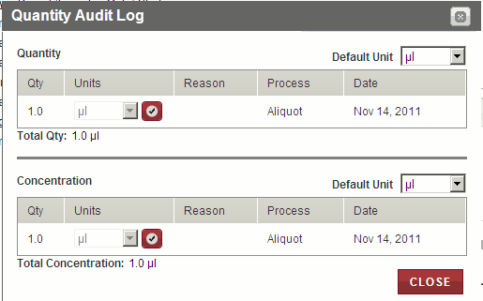icon.  
   The unit of measure is updated in the **Quality Audit Log** window and on the **Modify Biospecimen** screen.
5. Click **CLOSE**.  
   The **Quality Audit Log** window closes.
6. To modify the storage location for this biospecimen:
7. In the **Storage Location** field, click the link.

The **Storage Location** window appears.

1. If you are assigning a storage location for this biospecimen for the first time, the window displays a collapsed Storage Devices list without a storage map.   
     
   Click on the **Expand All** link to display all of the storage devices.

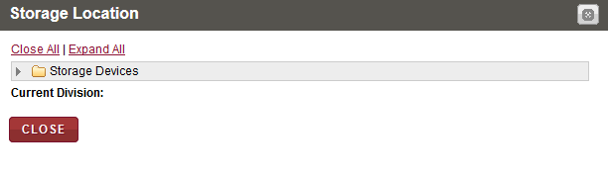

1. Storage Location window – assigning storage for first time

If you are modifying an existing storage location for this biospecimen, the window displays an expanded device list and the storage map with the current storage assignment cell position shown in green.

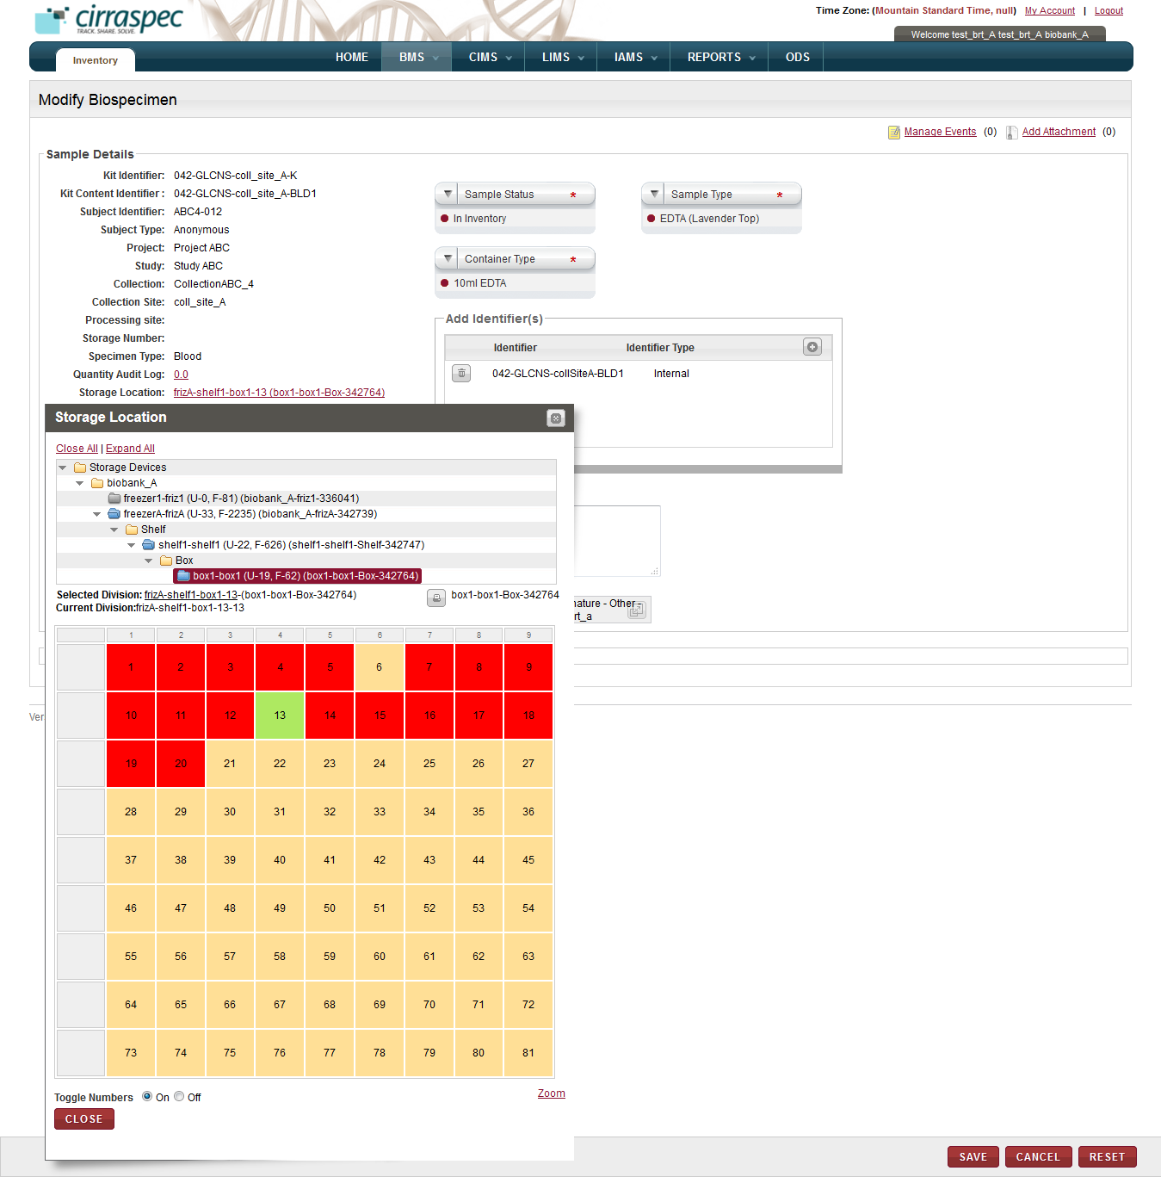

1. Storage Location window – modifying existing storage assignment
2. Click the storage device name (blue folder) on the list where you want to store this biospecimen.  
   All storage divisions within that device appear below.
3. Click the division under the device name where you want to store this biospecimen.   
   For example, Device X, Shelf 1, Box 3.  
   The storage map with all of the cell positions for the selected division appears.   
   **Note:**

* Available cells display on the storage map in yellow or tan.
* Used cells display on the storage map in red.

1. Click an available storage map cell to indicate where you want to store this biospecimen.  
   The selected cell displays in green to indicate your current selection. The storage path of the current selection also appears in the **Selected Division** field above the storage map.
2. Click **Save.**  
   The new storage assignment is saved and the **Storage Location** window closes. The storage location appears in the **Storage Location** field on the **Modify Biospecimen** screen.
3. To modify the biospecimen information, enter appropriate information in each field. Following table lists each field and its description.   
   **Note:** Fields that are marked with the red asterisk (*) are mandatory.

Table 51: Modifying the biospecimen information

| **Field** | **Description** |
| --- | --- |
| **Adjusted Qty** | Type the amount of change you want to make to the quantity for this biospecimen. **Note:** The **Quantity Audit Log** field displays the current quantity.   * To decrease the current quantity, type a negative number. For example to decrease the quantity from 1.50 to 1.00, type -.50. * To increase the current quantity, type a positive number. For example, to increase the quantity from 1.50 to 2.00, type .50. |
| **Adjusted Concentration** | Type the amount of change you want to make to the concentration for this biospecimen.   * To decrease the current concentration, type a negative number. For example to decrease the concentration from 1.50 to 1.00, type -.50. * To increase the current concentration, type a positive number. For example, to increase the concentration from 1.50 to 2.00, type .50. |
| **Quantity Comments** | Type your comments regarding the quantity adjustment, if applicable. |
| **Sample Status**\* | Click the appropriate value in this field to change the status for this biospecimen. |
| **Sample Type**\* | Click the appropriate value in this field to change the sample type for this biospecimen. |
| **Container Type**\* | Click the appropriate value in this field to change the container type for this biospecimen. |
| **Add Identifier(s)** | To add an identifier for this biospecimen:   1. In the Add identifier(s) section, click the add icon add icon.   The identifier fields appear   1. Type the identifier to be assigned to this biospecimen in the **Source Identifier** box. 2. Click the appropriate **Identifier** **Type** for the new identifier. 3. Click the check mark icon check mark icon.  The identifier and its type appear in the list below. |
| **Comments** | Type your comments regarding this biospecimen, if applicable. |

1. Click **SAVE**.

The Electronic Signature window appears.

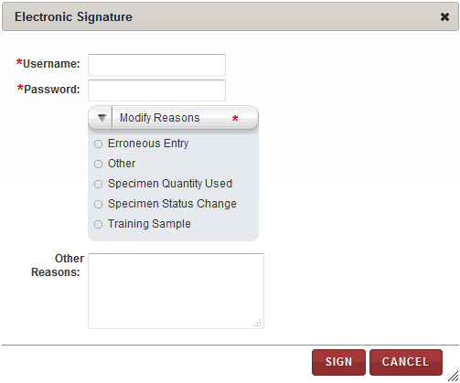

1. Electronic Signature window
2. Enter appropriate information in each field. Following table lists each field and its description.   
   **Note:** Fields that are marked with the red asterisk (*) are mandatory.

Table 52: Specifying the reason for modifying the biospecimen information

| **Field** | **Description** |
| --- | --- |
| **Username**\* | Type your login username |
| **Password**\* | Type you password. |
| **Modify Reasons**\* | Click the appropriate reason for modifying this biospecimen. |
| **Other Reasons** | If you selected **Other** on the **Modify Reasons** list, type the reason for modifying this biospecimen. |

1. Click **SIGN**.   
   The changes to the biospecimen information are saved and appear on the **View Biospecimen** page.

### Deleting a Biospecimen

**Note:** You cannot delete a biospecimen that has the **Reserved** or **Checked-Out Permanently** status.

To delete a biospecimen:

1. Log in to the application using your log in credentials.

The home page appears.

1. Point to the arrow of the **BMS** tab and then click **Inventory**.

The **Inventory Search** page appears.

1. Click **SEARCH**.

The **Inventory Search** page displays a list of biospecimens.

1. Click the row of the biospecimen that you want to delete.

The **View Biospecimen** page appears.

1. Click **Delete**.

The **Electronic Signature** window appears.

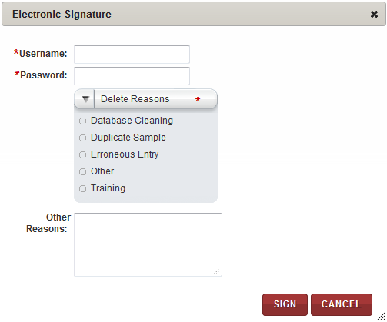

1. Electronic Signature window
2. Enter appropriate information in each field. Following table lists each field and its description.   
   **Note:** Fields that are marked with the red asterisk (*) are mandatory.

Table 1: Deleting a biospecimen

| **Field** | **Description** |
| --- | --- |
| **Username**\* | Type your user Log in ID. |
| **Password**\* | Type you password. |
| **Delete Reasons**\* | Click the appropriate reason for deleting this biospecimen. |
| **Other Reasons** | If you selected **Other** as **Delete Reason**, type the reason for deleting. |

1. Click **SIGN**.   
   The sample status appears as **Deleted** on the **View Biospecimen** screen and the biospecimen record is “view” only. Once deleted, the biospecimen is not available for sample processing or redistribution.

### Updating a Specimen Collection Form for a Biospecimen

**Note:** You can update the form only when the form status is **Not Started** or **Data Entry Started**.

To update the collection information on a Specimen Collection Form:

1. Log in to the application using your log in credentials.

The home page appears.

1. Point to the arrow of the **BMS** tab and then click **Inventory**.

The **Inventory Search** page appears.

1. Click **SEARCH**.

The **Inventory Search** page displays a list of biospecimens that are accessible based on your login location.

1. Click the row of the biospecimen for which you want to update the Specimen Collection Form.

The **View Biospecimen** page appears.

1. Click the **Specimen Forms** link at the top of the page.  
   **Note**: The link is displayed only if there is a Specimen Collection Form associated with the biospecimen.  
   The **Forms** window appears.

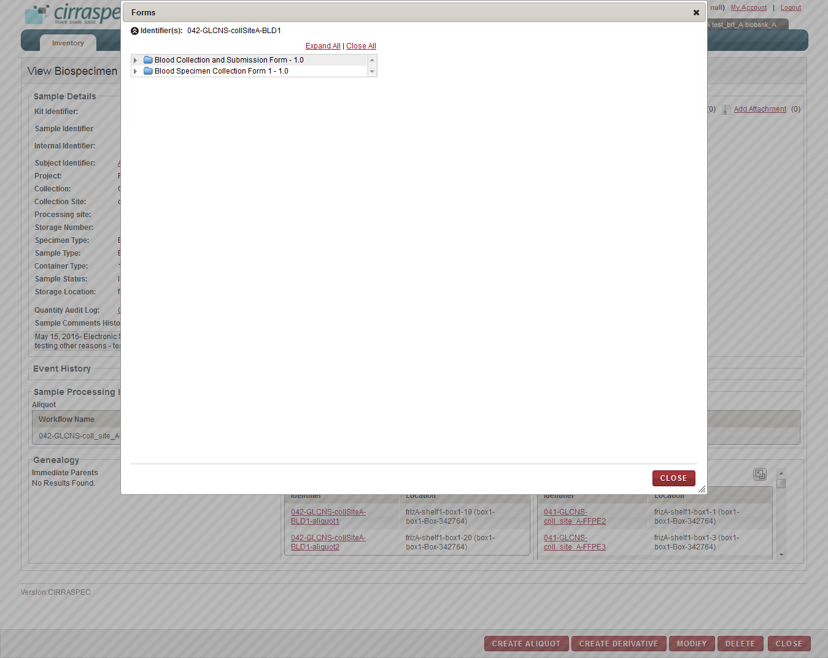

1. Specimen Forms link - Forms window
2. Click the **Expand All** link to show all form sections.  
   The forms list expands.  
   **Note:**

* Only Specimen Collection Forms assigned in the **Research Project Management System (RPMS)** module during Project setup and configuration appear on this list.

1. Click the form section you want to modify on the list.  
   The information for the specified form section appears on the right.

**Note:**

* If the form contains PHI questions, then the answers (if already filled up) for these are displayed differently for PHI authorized and Non-PHI authorized users.
  + The PHI authorized users are allowed to answer PHI as well as Non-PHI questions. Hence they can also view the answers (if already filled up) to all the questions.
  + However, the Non-PHI authorized users are allowed to answer only the Non-PHI questions. If answers to PHI questions have already been filled up by some PHI user, then these are shown as hashed out (in case of textboxes) and blanked out (in case of radio buttons, dropdowns and checkboxes) to the Non-PHI authorized users.

1. Click **MODIFY**.  
   The form data entry fields appear for input.   
   **Note:**

* You can only modify a form when the status is **Not Started** or **Data Entry Started.**
* If the form contains PHI questions, then the input fields for these are displayed differently for PHI authorized and Non-PHI authorized users.
  + The PHI authorized users are allowed to answer PHI as well as Non-PHI questions. Hence all input fields are displayed in an active mode to these users.
  + However, the Non-PHI authorized users are allowed to answer only the Non-PHI questions. Hence input fields for PHI questions appear in a greyed out mode for such users. The input fields for Non-PHI questions are displayed in an active mode.

1. Make the necessary changes to the form and click **SAVE.**  
   For form sections whose data entry had not started yet, changes are saved and the form status now appears as **Data Entry Started** in the **Forms** window.

There is no change in the status of the forms sections which already had the **Data Entry Started** status.

To indicate that data entry is complete on the form:

1. Click **Data Entry Completed**.  
   The form status appears as **Data Entry** **Completed** in the **Forms** window**.**   
   **Note:**

* You can only perform this task when the form status is **Data Entry Started**.
* In case of forms with one or more PHI questions, this button is displayed only for the PHI authorized users.

To change the status of a completed form so you can modify the form information:

1. Click **DATA ENTRY NOT COMPLETED**.

The form status appears as **Data Entry Started** in the **Forms** window**.  
Note:**

* You can only perform this task when the form status is **Data Entry Completed.**
* In case of forms with one or more PHI questions, this button is displayed only for the PHI authorized users.

To approve a completed form:

1. Click **APPROVE**.

The form status appears as **Approved** in the **Forms** window**.  
Note:**

* You can only perform this task when the form status is **Data Entry Completed.**
* In case of forms with one or more PHI questions, this button is displayed only for the PHI authorized users.

To remove approval of a completed form:

1. Click **REMOVE APPROVAL**.

The form status appears as **Data Entry** **Completed** in the **Forms** window**.  
Note:**

* You can only perform this task when the form status is **Approved.**
* In case of forms with one or more PHI questions, this button is displayed only for the PHI authorized users.

**Create Aliquots of a Biospecimen**

You can create aliquots for the biospecimen in the inventory.

To create aliquots:

1. Log in to the application using your log in credentials.

The home page appears.

1. Point to the arrow of the **BMS** tab and then click **Inventory**.

The **Inventory Search** page appears.

1. Click **SEARCH**.

The **Inventory Search** page displays a list of biospecimens that are accessible based on your login location.

1. Click the row of the biospecimen for which you want to update the Specimen Collection Form.

The **View Biospecimen** page appears.

1. Click **CREATE ALIQUOT**

Create Aliqout popup is displayed.

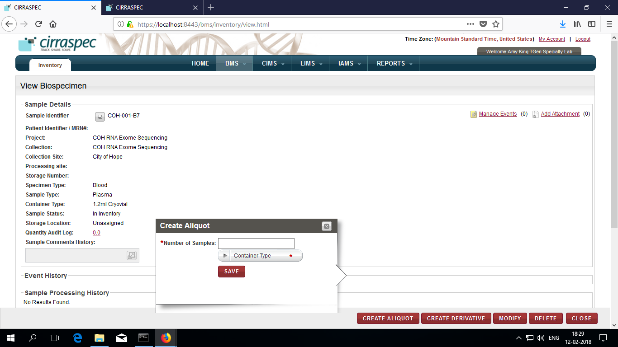

5.a. Enter **Number of samples** and Select **Container Type**

5.b. Click **SAVE.**

1. Aliquot details appear under **Sample Processing History** section.

**Create Derivatives of a Biospecimen**

You can create derivatives for the biospecimen in the inventory.

To create aliquots:

1. Log in to the application using your log in credentials.

The home page appears.

1. Point to the arrow of the **BMS** tab and then click **Inventory**.

The **Inventory Search** page appears.

1. Click **SEARCH**.

The **Inventory Search** page displays a list of biospecimens that are accessible based on your login location.

1. Click the row of the biospecimen for which you want to update the Specimen Collection Form.

The **View Biospecimen** page appears.

1. Click **CREATE DERIVATIVE**

Create Aliqout popup is displayed.

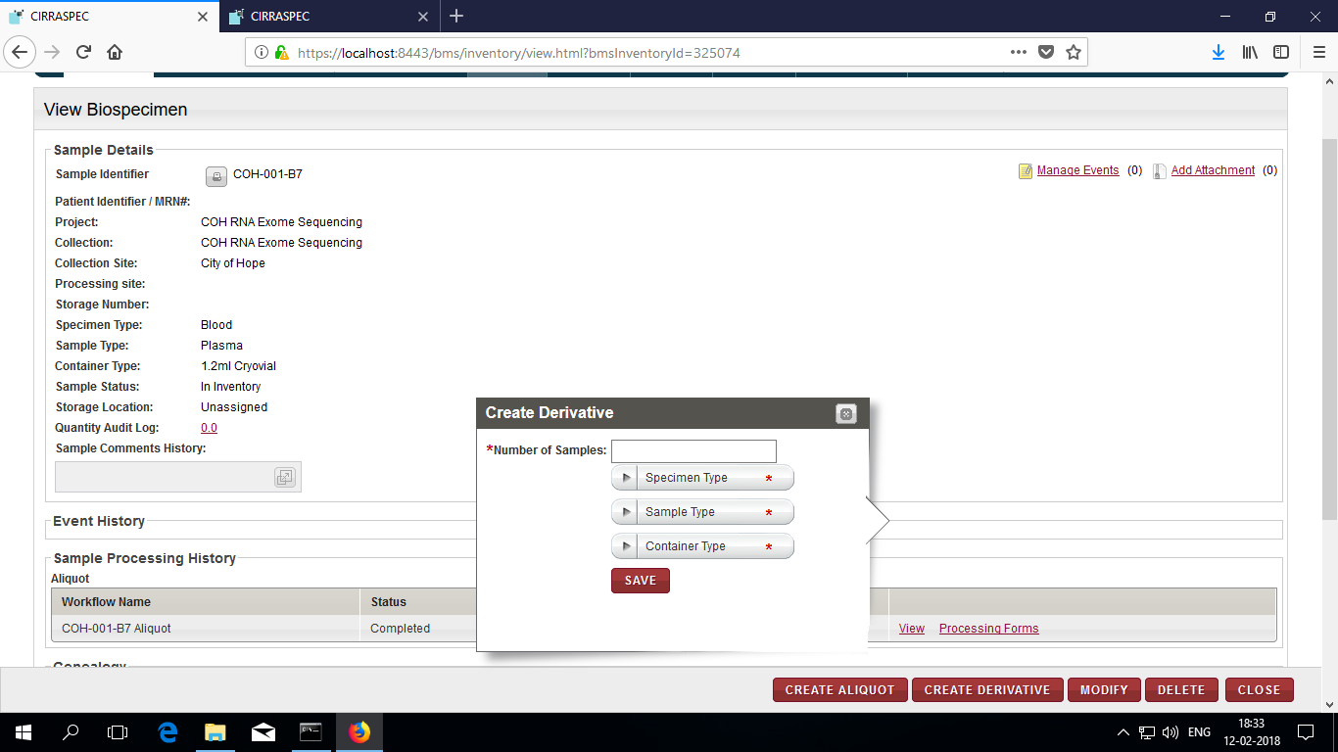

5.a. Enter **Number of samples** and Select **Specimen Type, Sample Type, Container Type.**

5.b. Click **SAVE.**

1. Derivative details appear under **Sample Processing History** section.

# Perform Actions on a group of biospecimens

To access the **Inventory Bulk Modifications** page:

1. Log in to the application using your log in credentials.

**Note:** If you have more than one assigned location, you are prompted to select the location for which you want to access CIRRASPEC data.  
The CIRRASPEC home page appears.

1. Point to the arrow on the **BMS** tab, and then click **Bulk Modifications**.

The **Inventory Bulk Modifications** page appears.

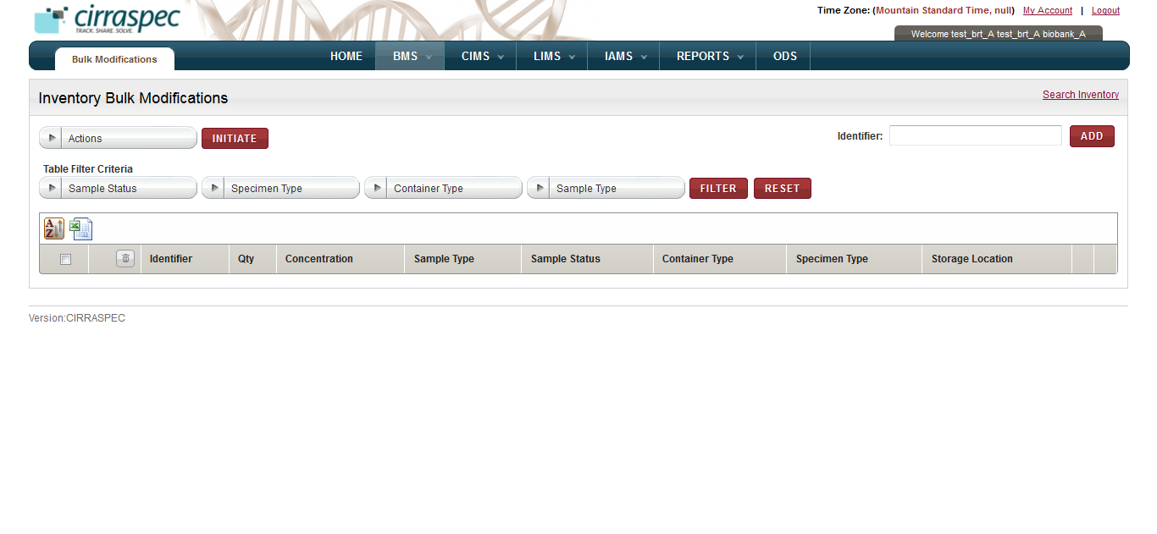

1. Inventory Bulk Modifications page

On the **Inventory Bulk Modifications** page, you can initiate the following tasks using the **Actions** list:

* **Assign a storage location:** For more information about how to assign a storage location, see  **Assigning a Storage Location in Bulk**.
* **Add an event:** For more information about how to add an event, see **Adding an Event in Bulk**.
* **Generate a label:** For more information about how to generate a barcode label, see **Generating Labels for Biospecimens in Bulk**.
* **Generate a report:** For more information about how to generate a report, see **Generating a Biospecimen Report in Bulk**.
* **Delete biospecimens:** For more information about how to delete biospecimens, see **Deleting Biospecimens in Bulk**.
* **Modify biospecimens:** For more information about how to modify biospecimens, see **Modifying Biospecimens in Bulk**.
* **Add Attachment:** For more information about how to upload, download, and delete files that are attached to biospecimens, see **Uploading Files in Bulk**.

### Using the Search Samples and Worklists Window

You can search for biospecimens during many of the **Bulk Modifications** processes by using the **Search Sample and Worklists** window.

To access the **Search Samples and Worklists** window:

1. Log in to the application using your log in credentials.

The CIRRASPEC home page appears.

1. Point to the arrow on the **BMS** tab, and then click **Bulk Modifications**.

The **Inventory Bulk Modifications** page appears.

1. Click the **Search Inventory** link.

The **Search Samples and Worklists** window appears.

To search for biospecimens by Basic, Inventory or LIMS data:

1. Click the **Search Inventory** link.  
   The **Search Samples and Worklists** page appears.
2. On the **Search Samples** tab, select the appropriate checkbox to display the Basic, Inventory or LIMS search fields.  
   **Note:** You can select more than one checkbox.   
   The search fields associated with your selection appear.

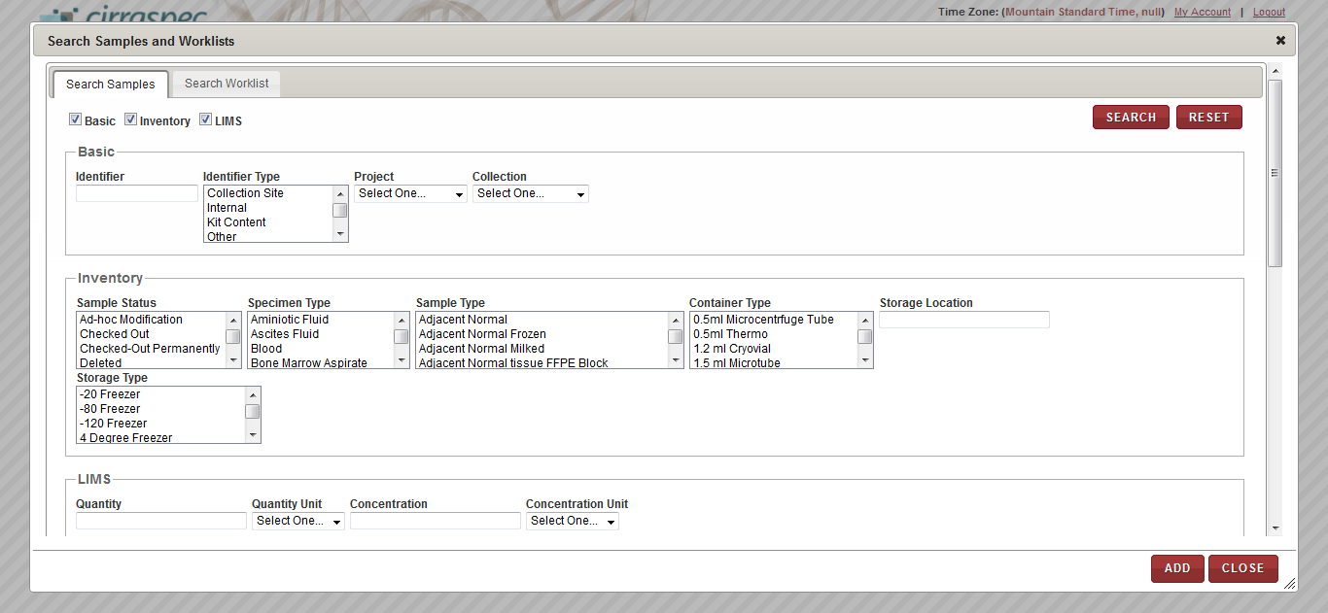

1. Search Samples window – search fields

Enter appropriate information in each field. Following table lists each field and its description.   
**Note:**

* You can use one field or a combination of fields to search for a biospecimen.
* You can type the full or partial value in a search field along with an asterisk (*) before or after the partial value. For example, if you type **02\***, you obtain records that begin with 02. If you type **\*02**, you obtain records that end with 02.

1. **Table 53: Search Samples search fields**

| **Field** | **Description** |
| --- | --- |
| **Basic** search fields | |
| **Identifier** | Type a biospecimen identifier to search for a specific biospecimen. |
| **Identifier Type** | Click one or more identifier types to search for all biospecimens with that identifier type. |
| **Project** | Click the appropriate Project to search for all biospecimens associated with that Project. |
| **Collection** | Click the appropriate Collection to search for all biospecimens associated with that Collection. |
| **Inventory** search fields | |
| **Sample Status** | Click one or more biospecimen statuses to search for all biospecimens with that status. |
| **Specimen Type** | Click one or more specimen types to search for all biospecimens with that specimen type. |
| **Sample Type** | Click one or more sample types to search for all biospecimens with that sample type. |
| **Container Type** | Click one or more container types to search for all biospecimens with that container type. |
| **Storage Location** | Type a storage location to search for all biospecimens stored in that location. |
| **Storage Type** | Click one or more storage types to search for all biospecimens with that storage type. |
| **LIMS** search fields | |
| **Quantity** | Type a quantity to search for all biospecimens of that quantity. |
| **Quantity Unit** | Click the appropriate unit of measure to search for all biospecimens using that quantity unit of measure. |
| **Concentration** | Type a concentration to search for all biospecimens of that concentration. |
| **Concentration Unit** | Click the appropriate unit of measure to search for all biospecimens using that concentration unit of measure. |

1. Click **SEARCH**.

A list of biospecimens that match your search criteria appears.

1. Click each biospecimen that you want to add to the worklist.

The biospecimen identifiers appear in the list below.

1. Click **ADD**.  
   The search window closes and the biospecimen identifiers appear on the Inventory **Bulk Modifications** page.

To search for biospecimens associated with a worklist:

1. Click the **Search Inventory** link.  
   The **Search Samples and Worklists** page appears.
2. Click the **Search Worklist** tab.
3. In the **Worklist Name** box, type the name of the worklist from which you want to select biospecimens, and click **Search**. **Note:** You can type a partial or full name of the worklist.   
   A list of worklists that match your search criteria appears.
4. Click the appropriate worklist.   
   The list of biospecimens that are associated with the worklist appears below.

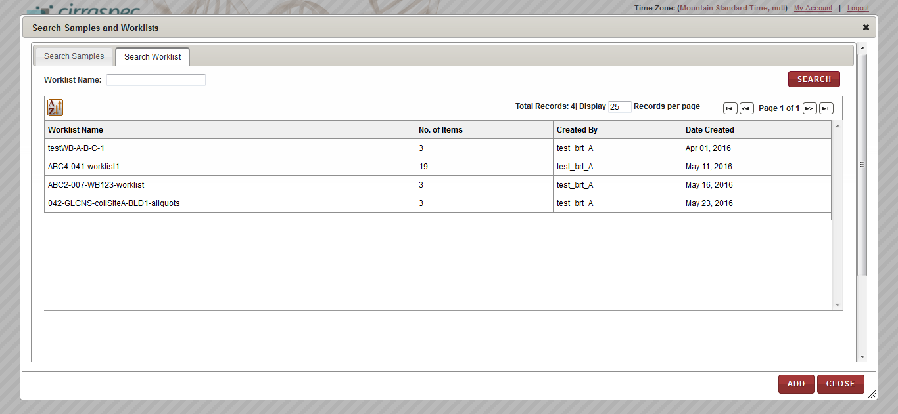

1. Search Worklist window
2. Click **ADD**.

The biospecimens associated with the worklist appear on the **Inventory Bulk Modifications** page.

### Filtering the Search Results List

Once the biospecimen list is populated on the **Inventory Bulk Modifications** screen, you can use the **Table Filter Criteria** fields to search for a specific biospecimen or a group of biospecimens.

To filter the biospecimens list on the **Inventory Bulk Modifications** screen:

1. Log in to the application using your log in credentials.

The CIRRASPEC home page appears.

1. Point to the arrow on the **BMS** tab, and then click **Bulk Modifications**.

The **Inventory Bulk Modifications** page appears.

1. Enter appropriate information in the **Table Filter Criteria** fields. Following table lists each field and its description.

Table 54: Performing a searching of biospecimens

| **Field** | **Description** |
| --- | --- |
| **Sample Status** | Click appropriate sample status for which you want to search. |
| **Specimen Type** | Click appropriate specimen type for which you want to search. |
| **Container Type** | Click appropriate container type for which you want to search. |
| **Sample Type** | Click appropriate sample type for which you want to search. |
| **FILTER** | Click **FILTER**. The biospecimens list at the bottom of the screen displays the filter results based on the selections you made above.  For example: If you select **In Inventory** as the **Sample Status** and **Blood** as the **Specimen Type** and click **FILTER**, the biospecimens list displays only blood biospecimens with status of **In Inventory**. |

**Note:** You can use one field or a combination of fields to filter the search.

### Adding a New Identifier on the Inventory Bulk Modifications Page

To add a new identifier to biospecimens on the **Inventory Bulk Modifications** page:

1. Log in to the application using your log in credentials.

The CIRRASPEC home page appears.

1. Point to the arrow on the **BMS** tab, and then click **Bulk Modifications**.

The **Inventory Bulk Modifications** page appears.

1. Click the **Search Inventory** link.  
   The **Search Sample and Worklists** window appears.
2. In the **Search Samples and Worklists** window, search, select and add the biospecimens for which you want to add a new identifier.  
   The **Inventory Bulk Modifications** page displays the biospecimens that you selected.   
   **Note:** For information about using the **Search Samples and Worklists** window, see **Using the Search Samples and Worklists Window****.**
3. On the list of biospecimens on the **Inventory Bulk Modifications** page, click the identifier link of the biospecimen for which you want to add a new identifier.

The **Add Identifier(s)** window appears.

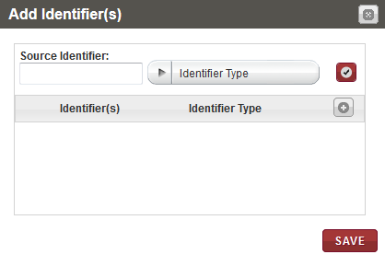

1. Add Identifier(s) window with identifier fields
2. Click the add icon .

The identifier fields appear.

1. Type the **Source Identifier** to be assigned to the biospecimen.
2. Click the appropriate **Identifier** **Type** for the new identifier.
3. Click the check mark icon .   
   The identifier and its type appear in the list below.
4. Click **SAVE**.

The new identifier is assigned to the biospecimen and appears on the **Inventory Bulk Modifications** page.

### Modifying Biospecimens in Bulk

To modify biospecimens in bulk:

1. Log in to the application using your log in credentials.

The CIRRASPEC home page appears.

1. Point to the arrow on the **BMS** tab, and then click **Bulk Modifications**.

The **Inventory Bulk Modifications** page appears.

OR

Point to the arrow on the **BMS** tab, and then click **Inventory** **Bulk** andClick **Bulk Modifications**.

The **Inventory Bulk Modifications** page appears.

1. Click the **Search Inventory** link, and then select the biospecimens that you want to add.

The **Inventory Bulk Modifications** page displays the biospecimens that you selected.

1. In the **Search Samples and Worklists** window, search, select and add the biospecimens you want to modify.

The **Inventory Bulk Modifications** page displays the biospecimens that you selected.   
**Note:** For information about using the **Search Samples and Worklists** window, see **Using the Search Samples and Worklists Window**.

1. On the list of biospecimens on the **Inventory Bulk Modifications** page, select the check boxes of each biospecimen that you want to modify.   
   **Note:**

* To select all biospecimens, select the checkbox on the gray header.
* You cannot select biospecimens with a sample status shown on the **Inventory Bulk Modifications** page as **Checked Out**, **Reserved**, **Deleted** or **Distributed**.

1. In the **Actions** list, click **Modify Samples**, and then click **INITIATE**.

The **Modify Inventory** window appears and displays the identifiers of the biospecimens.

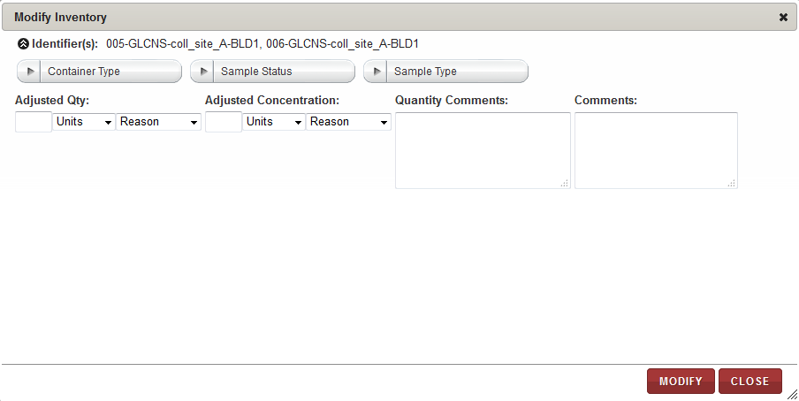

1. Modify Inventory page
2. Enter appropriate information in each field. Following table lists each field and its description.

Table 55: Modifying biospecimens in bulk

| **Field** | **Description** |
| --- | --- |
| **Container Type** | Click appropriate container type for the selected biospecimens. |
| **Sample Status** | Click appropriate sample status type for the selected biospecimens. |
| **Sample Type** | Click appropriate sample type for the selected biospecimens. |
| **Adjusted Qty** | To specify the new adjusted quantity:   * + 1. In the box, type the amount of change you want to make to the quantity. * To decrease the current quantity, type a negative number.  For example, to decrease the quantity from 1.50 to 1.00, type -.50. * To increase the current quantity, type a positive number.  For example, to increase the quantity from 1.50 to 2.00, type .50.   2. In the **Units** list, click the appropriate unit of measure for the quantity.  3. In the **Reason** list, click the reason for the adjustment. |
| **Adjusted Concentration** | To specify the new adjusted concentration:   * + 1. In the box, type the amount of change you want to make to the concentration. * To decrease the concentration, type a negative number.  For example, to decrease the concentration from 1.50 to 1.00, type -.50. * To increase the concentration, type a positive number.  For example, to increase the concentration from 1.50 to 2.00, type .50.   2. In the **Units** list, click the appropriate unit of measure for the concentration.  3. In the **Reason** list, click the reason for the adjustment. |
| **Quantity Comments** | Type your comments regarding the quantity adjustments, if applicable. |
| **Comments** | Type your comments regarding the modifications, if applicable. |

1. Click **MODIFY**.

The **Electronic Signature** window appears.

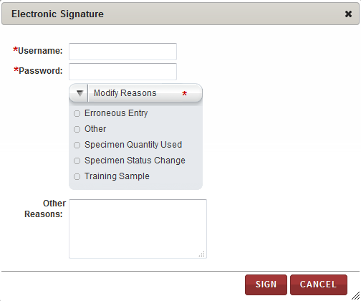

1. Electronic Signature window

1. Enter appropriate information in each field. Following table lists each field and its description.

**Note**: Fields that are marked with the red asterisk (*) are mandatory.

Table 56: Modifying biospecimens in bulk

| **Field** | **Description** |
| --- | --- |
| **Username**\* | Type your user Log in ID. |
| **Password**\* | Type you password. |
| **Modify Reasons**\* | Click the appropriate reason for modifying the biospecimens. |
| **Other Reasons** | If you selected **Other** on the **Modify Reasons** list, type the reason for modifying the biospecimens. |

1. Click **SIGN**.   
   The biospecimens are modified and the new information appears on the **Inventory Bulk Modifications** page.

### Uploading Files in Bulk

To upload files for biospecimens in bulk:

1. Log in to the application using your log in credentials.

The CIRRASPEC home page appears.

1. Point to the arrow on the **BMS** tab, and then click **Bulk Modifications**.

The **Inventory Bulk Modifications** page appears.

1. Click the **Search Inventory** link, and then select the biospecimens that you want to add.

The **Inventory Bulk Modifications** page displays the biospecimens that you selected.

1. In the **Search Samples and Worklists** window, search, select and add the biospecimens to which you want to upload files.

The **Inventory Bulk Modifications** page displays the biospecimens that you selected.

**Note:** For information about using the **Search Samples and Worklists** window, see **Using the Search Samples and Worklists Window**.

1. On the list of biospecimens on the **Inventory Bulk Modifications** page, select the checkboxes of each biospecimen to which you want to upload files.   
   **Note:** To select all biospecimens, select the checkbox on the gray header.
2. In the **Actions** list, click **Upload Files**, and then click **INITIATE**.

The **Manage Attachments** window appears and displays the identifiers of the biospecimens.

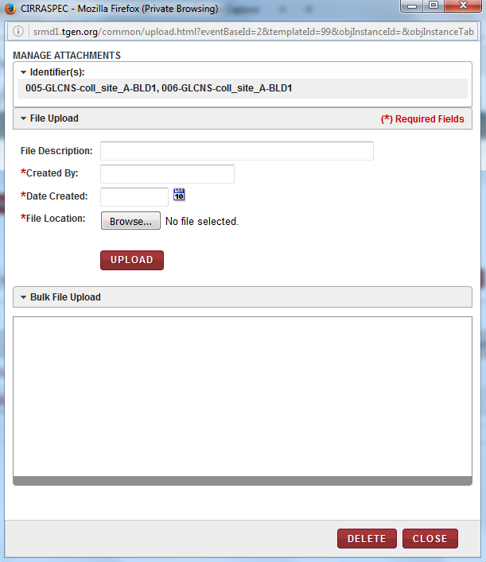

1. Manage Attachments window
2. Enter appropriate information in each field. Following table lists each field and its description.

**Note:** Fields that are marked with the red asterisk (*) are mandatory.

Table 57: Uploading files for worklist biospecimens

| **Field** | **Description** |
| --- | --- |
| **File Description** | Type a description of the file, if applicable. |
| **Created By**\* | Type the name of the person who created the file. |
| **Date Created**\* | Click the date icon date icon, and then click the date when the file was created. |
| **File Location**\* | 1. Click **Browse**, and then select the file that you want to upload.  2. Click **Open**.  The file name appears in a progress bar box below the **File Location** box. |

1. Click **UPLOAD**.  
   The file is uploaded and appears in the **Bulk File Upload** area.  
   **Note:** You can add multiple files to the biospecimens.
2. To delete a file from the **Bulk File Upload** area:   
   Select the checkbox of the appropriate file.

**Note:** To delete all the files in this area, select the checkbox on the header.

1. Click **DELETE**.

A confirmation window appears.

1. Click **OK**.

The file(s) are deleted.

1. Click **CLOSE** to close the **Manage Attachments** window.

### Adding an Event in Bulk

To add an event to biospecimens in bulk:

1. Log in to the application using your log in credentials.

The CIRRASPEC home page appears.

1. Point to the arrow on the **BMS** tab, and then click **Bulk Modifications**.

The **Inventory Bulk Modifications** page appears.

1. Click the **Search Inventory** link, and then select the biospecimens that you want to add.

The **Inventory Bulk Modifications** page displays the biospecimens that you selected.

1. In the **Search Samples and Worklists** window, search, select and add the biospecimens for which you want to add an event.

The **Inventory Bulk Modifications** page displays the biospecimens that you selected.

**Note:** For information about using the **Search Samples and Worklists** window, see **Using the Search Samples and Worklists Window**.

1. On the list of biospecimens on the **Inventory Bulk Modifications** page, select the checkboxes of each biospecimen for which you want to add an event.

**Note:** To select all biospecimens, select the checkbox on the gray header.

1. In the **Actions** list, click **Add Events**, and then click **INITIATE**.

The **Manage Events** window appears and displays the identifiers of the biospecimens.

1. Click the **Create New Event** link.

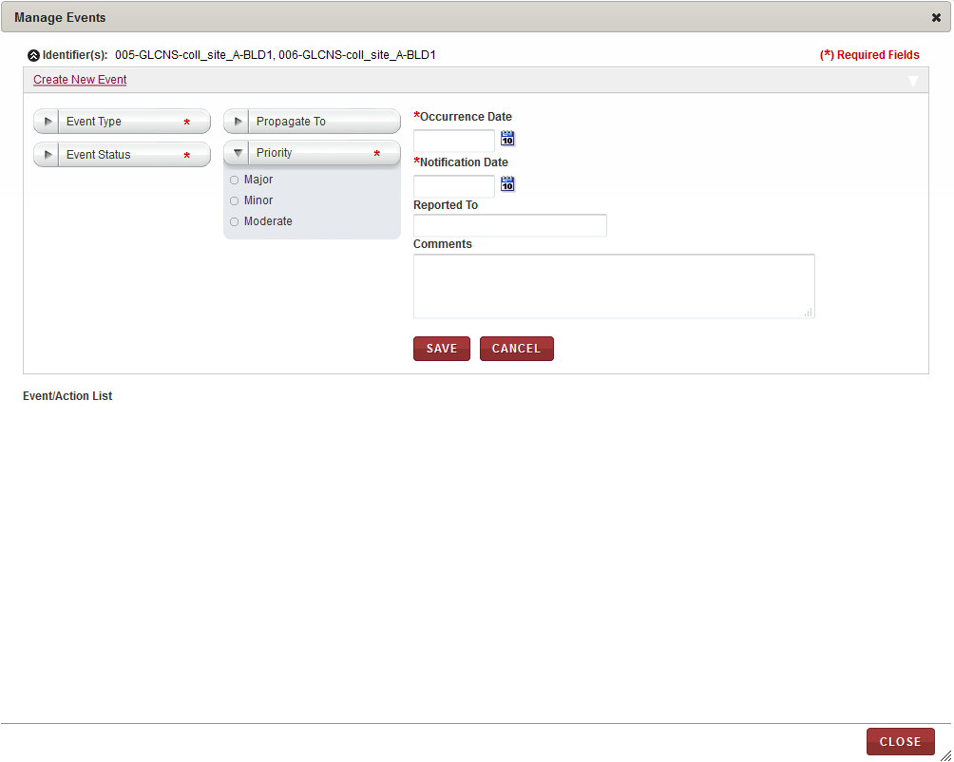

1. Manage Events window
2. Enter appropriate information in each field. Following table lists each field and its description.

**Note:** Fields that are marked with the red asterisk (*) are mandatory.

Table 58: Adding an event to biospecimens

| **Field** | **Description** |
| --- | --- |
| **Event Type**\* | Click the appropriate event type for this event. |
| **Event Status**\* | Click the appropriate status for this event. |
| **Propagate To** | Click the appropriate shipment cascading option to identify what items associated with the initial item should also have the event attached. Example: All items associated with the shipment, or Biospecimens associated with the shipment. |
| **Priority**\* | Click the appropriate priority for this event. |
| **Occurrence Date**\* | Click the date icon Search calendar, and then click the date when the event occurred. |
| **Notification Date**\* | Click the date icon Search calendar, and then click the date when you were notified of the event. |
| **Reported To** | Type the person or organization to which the event was reported. |
| **Comments** | Type the appropriate comments for this event. |

1. Click **SAVE**.

The event is saved and appears in the **Event/Action List** area of the **Manage Events** window.   
**Note:** You can add multiple events to the biospecimens.

1. Click **CLOSE** to close the **Manage Events** window.

### Assigning a Storage Location in Bulk

To assign a storage location to biospecimens in bulk:

1. Log in to the application using your log in credentials.

The CIRRASPEC home page appears.

1. Point to the arrow on the **BMS** tab, and then click **Bulk Modifications**.

The **Inventory Bulk Modifications** page appears.

1. Click the **Search Inventory** link, and then select the biospecimens that you want to add.

The **Inventory Bulk Modifications** page displays the biospecimens that you selected.

1. In the **Search Samples and Worklists** window, search, select and add the biospecimens for which you want to assign a storage location.

The **Inventory Bulk Modifications** page displays the biospecimens that you selected.

**Note:** For information about using the **Search Samples and Worklists** window, see **Using the Search Samples and Worklists Window**.

1. On the list of biospecimens on the **Inventory Bulk Modifications** page, select the checkboxes of the biospecimens for which you want to assign a storage location.   
   **Note:**

* To select all biospecimens, select the checkbox on the gray header.
* The biospecimens must not have the **Checked Out**, **Reserved**, **Deleted**, or **Distributed** status.

1. In the **Actions** list, click **Assign Storage Location**, and then click **INITIATE**.   
   The **Bulk Storage Assignment** window appears.

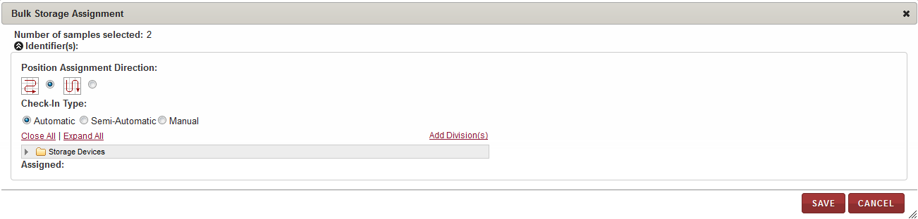

1. Bulk Storage Assignment window
2. Enter appropriate information in each field. Following table lists each field and its description.

Table 59: Assigning storage location

| **Field** | **Description** |
| --- | --- |
| **Position Assignment Direction** | Click the appropriate direction for assigning a storage location to each of the biospecimens.  **Note:**   * The arrow icon that goes right and left depicts assignment of biospecimens to available cells on the storage map in horizontal rows. * The arrow icon that goes up and down depicts assignment of biospecimens to available cells on the storage map in vertical columns. |
| **Check-In Type** | Click the appropriate means of assigning the storage location:  **Automatic:** The application automatically assigns the biospecimens that you select to available locations in the storage device starting with the first available location.  **Semi-Automatic:** You can select the initial location and assign it to a biospecimen. The application then assigns each biospecimen to the next available location.  **Manual:** You can assign each biospecimen to a location by selecting a cell on the storage map each time. |

1. To select the storage division where you want the biospecimens stored:
2. Click **Expand All** to expand the Storage Devices taxonomy to show all storage devices.
3. Click the appropriate storage device name (blue folder) to display all storage divisions within that device.
4. Click the division where you want to store the biospecimens. For example, Freezer X, Shelf 1, Box 3.  
   The storage map of the cell positions within this division appears on the right.
5. If you selected **Automatic** as **Check-In Type**, click **ASSIGN**.

The application performs the following actions:

* Assigns each biospecimen to the next available location within the selected device.
* Updates the storage map with the new assignments.
* Displays the position assignments in the **Assigned** field at the bottom.

**Note:** If a division does not have enough available positions for all the selected biospecimens, you can select another division and proceed until all biospecimens are assigned.

1. If you selected **Semi-Automatic** as **Check-In Type**, perform the following steps:
2. Click the available cell on the storage map where you want to store the first biospecimen.

**Note:**

* Storage Map positions that are available appear in tan or goldenrod color.
* Positions that are used appear in red or rust color.
* The current selection appears in green color.

The **Assign Identifier** window appears.  
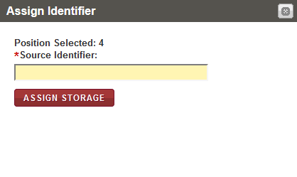

1. Assign Identifier window
2. In the **Source Identifier** box, scan or type the identifier of the first biospecimen that you want to assign to the selected storage map cell.  
   **Note:** You can display the identifiers of the biospecimens to be assigned by clicking on the arrow icon beside the **Identifiers** field in the top left corner of the **Bulk Storage Assignment** window.
3. Click **ASSIGN STORAGE**.

The application performs the following functions:

* Assigns the biospecimen to the cell that you selected and updates the storage map.
* Displays the window again with the **Position Selected** field automatically displaying the next available position.

1. Confirm the assignment of each biospecimen by clicking on **ASSIGN STORAGE** each time the **Assign Identifier** window appears until all biospecimens are assigned.

**Note:**

* If the container type associated with the specified biospecimen is not valid for this storage location, an error message appears. You can select another division and repeat steps a. - c.
* If the storage division does not have enough available positions for all the biospecimens, you can select another division.

1. If you selected **Manual** as **Check-In Type**, perform the following steps:
2. Click the available cell on the storage map where you want to store the first biospecimen.

**Note:**

* Storage Map positions that are available appear in tan or goldenrod color.
* Positions that are used appear in red or rust color.
* The current selection appears in green color.

The **Assign Identifier** window appears.

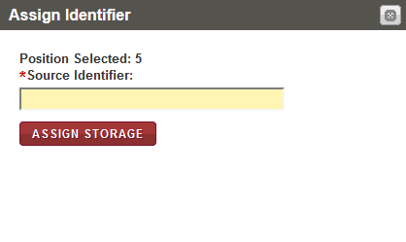

1. Assign Identifier window
2. In the **Source Identifier** box, scan or type the identifier of the first biospecimen that you want to assign to the selected storage map cell.  
   **Note:** You can display the identifiers of the biospecimens to be assigned by clicking on the arrow icon beside the **Identifiers** field in the top left corner of the **Bulk Storage Assignment** window.
3. Click **ASSIGN STORAGE**.

The application assigns the biospecimen to the cell that you selected and updates the storage map.

1. Repeat steps a. – c. until all biospecimens are assigned.

**Note:**

* If the container type associated with the specified biospecimen is not valid for this storage location, an error message appears. You can select another division and repeat steps a. - c.
* If the storage division does not have enough available positions for all the biospecimens, you can select another division.

1. Click **SAVE**.  
   The **Bulk Storage Assignment** window closes. The storage assignments are saved and appear in the **Storage Location** column on the **Inventory Bulk Modifications** page.

### Generating a Report for Biospecimens in Bulk

To generate a report for biospecimens in bulk:

1. Log in to the application using your log in credentials.

The CIRRASPEC home page appears.

1. Point to the arrow on the **BMS** tab, and then click **Bulk Modifications**.

The **Inventory Bulk Modifications** page appears.

1. Click the **Search Inventory** link.  
   The **Search Samples and Worklists** window appears.
2. In the **Search Samples and Worklists** window, search, select and add the biospecimens for which you want to generate a report.

The **Inventory Bulk Modifications** page displays the biospecimens that you selected.

**Note:** For information about using the **Search Samples and Worklists** window, see **Using the Search Samples and Worklists Window**.

1. On the list of biospecimens on the **Inventory Bulk Modifications** page, select the checkboxes of the biospecimens for which you want to generate a report.   
   **Note:** To select all biospecimens, select the checkbox on the gray header.
2. In the **Actions** list, click **Generate Report**, and then click **INITIATE**.   
   The report for the biospecimens appears in a new window.
3. View, print and/or save the file, as needed.   
   **Note**: Hover the cursor over the icons in the horizontal and vertical navigation bars to identify tools for viewing multiple pages, printing the report and saving the file to your machine.

### Deleting Biospecimens in Bulk

To delete biospecimens in bulk:

1. Log in to the application using your log in credentials.

The CIRRASPEC home page appears.

1. Point to the arrow on the **BMS** tab, and then click **Bulk Modifications**.

The **Inventory Bulk Modifications** page appears.

1. Click the **Search Inventory** link, and then select the biospecimens that you want to add.

The **Inventory Bulk Modifications** page displays the biospecimens that you selected.

1. In the **Search Samples and Worklists** window, search, select and add the biospecimens that you want to delete.  
   The **Inventory Bulk Modifications** page displays the biospecimens that you selected.   
   **Note:** For information about using the **Search Samples and Worklists** window, see **Using the Search Samples and Worklists Window**.
2. Select the checkboxes of the biospecimens that you want to delete.

**Note:**

* To delete all biospecimens, select the checkbox on the gray header.
* You cannot select biospecimens with the status shown on the **Inventory Bulk Modifications** screen as **Checked Out**, **Reserved**, **Distributed** or **Deleted** status.

1. In the **Actions** list, click **Delete Samples**, and then click **INITIATE**.

The **Electronic Signature** window appears.

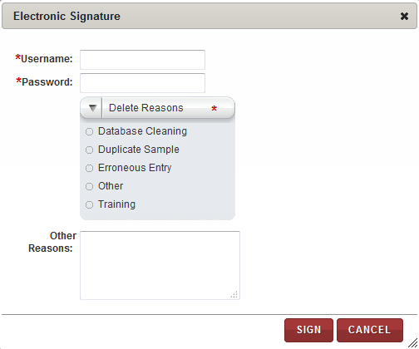

1. Electronic Signature window
2. Enter appropriate information in each field. Following table lists each field and its description.

**Note:** Fields that are marked with the red asterisk (*) are mandatory.

Table 60: Deleting biospecimens in bulk

| **Field** | **Description** |
| --- | --- |
| **Username**\* | Type your user log in ID. |
| **Password**\* | Type your password. |
| **Delete Reasons**\* | Click the appropriate reason for deleting the biospecimens. |
| **Other Reasons** | If you clicked **Other** in the **Delete Reasons** list, type a reason for deleting the biospecimens. |

1. Click **SIGN**.

The biospecimens are deleted. You can only view deleted biospecimens or add comments to them.

### Generating Labels for Biospecimens in Bulk

To generate barcode labels for biospecimens in bulk:

1. Log in to the application using your log in credentials.

The CIRRASPEC home page appears.

1. Point to the arrow on the **BMS** tab, and then click **Bulk Modifications**.

The **Inventory Bulk Modifications** page appears.

1. Click the **Search Inventory** link, and then select the biospecimens that you want to add.

The **Inventory Bulk Modifications** page displays the biospecimens that you selected.

1. In the **Search Sample and Worklists** window, search, select and add the biospecimens for which you want to generate labels.  
   The **Inventory Bulk Modifications** page displays the biospecimens that you selected.   
   **Note:** For information about using the **Search Samples and Worklists** window, see **Using the Search Samples and Worklists Window**.
2. On the list of biospecimens on the **Inventory Bulk Modifications** page, select the checkboxes of the biospecimens for which you want to generate labels.   
   **Note:** To select all biospecimens, select the checkbox on the gray header.
3. In the **Actions** list, click **Generate Labels**, and then click **INITIATE**.

The print barcode window appears.

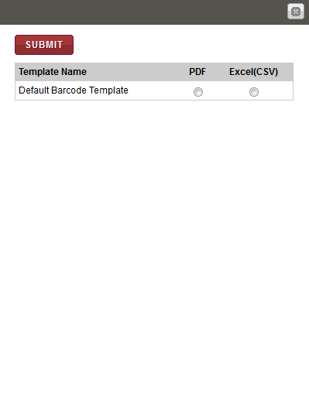

1. Print barcode window
2. To print labels to a PDF file, click **PDF** next to the label template for which you want to generate a barcode label, and then click **SUBMIT**.

The image of the barcode label that is associated with the biospecimen appears below.  
  
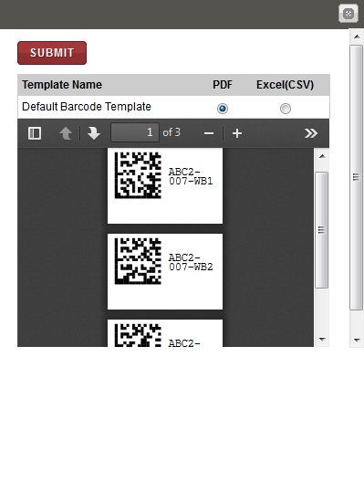

1. Print barcode window with label

**Note**: To identify tools for viewing multiple labels, printing labels and saving the file to your machine, hover the cursor over the icons in the horizontal and vertical navigation bars.

# 

# Search by Date Ranges, Change Search Results display, Manage Events and Upload Files

## Understanding the Date Range Search Options

You can search for information using the date range options in the search pane of any module in BMS.

To understand the date range options:

1. Log in to the application using your log in credentials.

The home page appears.

1. Point to the arrow of the **BMS** tab, and then click the module (Kits Inventory, Kits Shipment, for which you want to access the search pane.

The search pane for the module that you selected appears on the left side of the page.

1. To specify the date range, click the date icon  for the **Date Range** box.

A list of date range options appears.

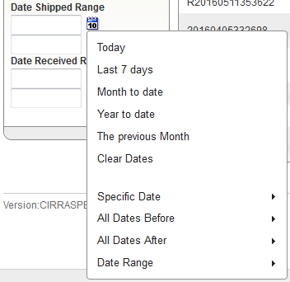

1. Date range options
2. Click the appropriate daterange option. Following table lists each range option and its description.

Table 61: Date range options

| **Option** | **Description** |
| --- | --- |
| **Today** | To search for information for the current day, click this option. |
| **Last 7 days** | To search for information for the last seven days, click this option. |
| **Month to date** | To search for information from the start date of the current month to the current date, click this option. |
| **Year to date** | To search for information from the start date of the current year to the current date, click this option. |
| **The previous Month** | To search for information for the previous month, click this option. |
| **Clear Dates** | To clear the information in the **Date Range** box, click this option. |
| **Specific Date** | To search for information for a specific date:   1. Click this option.   The **Specific Date** calendar appears.  **Note:**   * The calendar displays the current month and year. To update the month, click the arrow icons next to the month name. * To update the year, in the year list, click the appropriate year.  1. Click the appropriate date, and then click **Done**.   The date appears in the **Date Range** box. |
| **All Dates Before** | To search for information on all dates before a specific date:   1. Click this option.   The **All Dates Before** calendar appears.  **Note:**   * The calendar displays the current month and year. To update the month, click the arrow icons next to the month name. * To update the year, in the year list, click the appropriate year.  1. Click the appropriate date, and then click **Done**.   The date appears in the **Date Range** box. |
| **All Dates After** | To search for information from a specific date to the current date:   1. Click this option.   The **All Dates After** calendar appears.  **Note:**   * The calendar displays the current month and year. To update the month, click the arrow icons next to the month name. * To update the year, in the year list, click the appropriate year.  1. Click the appropriate date, and then click **Done**.   The date appears in the **Date Range** box. |
| **Date Range** | To search for information within a specific date range:   1. Click this option.   The **Start date** and **End date** calendars appear.  **Note:**   * The calendars display the current month and year. To update the month, click the arrow icons next to the month name. * To update the year, in the year list, click the appropriate year.  1. In the **Start date** calendar, click the start date of the date range. 2. In the **End date** calendar, click the end date of the date range. 3. Click **Done**.   The dates appear in the **Date Range** box. |

### 

## Changing the Search Results Display

### Changing the Number of Records Per Page

You can specify the number of records that are displayed on each page of the search results.

To specify the number of records displayed on a page:

1. Log in to the application using your log in credentials.

The home page appears.

1. Point to the arrow of the **BMS** tab, and then click the module for which you want to access the search pane.   
   The search pane for the module that you selected appears on the left side of the page.
2. Click **SEARCH**.   
   A list of items within the module that you selected appears.
3. Enter appropriate number of records you want to display in the **Display** **Records per page**

Box.  
The specified number of records is displayed on the search results page.

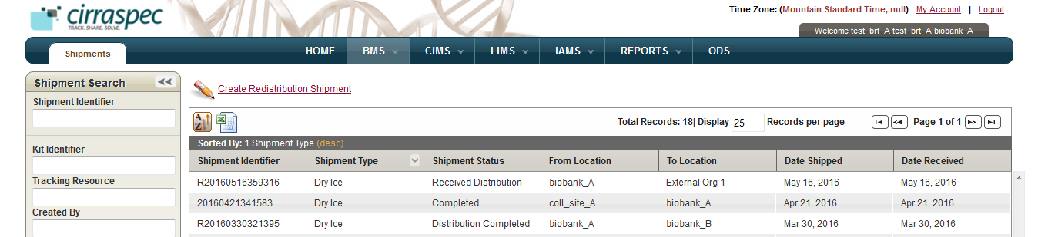

1. Changing the number of records per page

### Changing the Display Columns

You can change the search results display columns.

To change the display columns:

1. Log in to the application using your log in credentials.

The home page appears.

1. Point to the arrow of the **BMS** tab, and then click the module for which you want to access the search pane.   
   The search pane for the module that you selected appears on the left side of the page.
2. Click **SEARCH**.   
   A list of items within the module that you selected appears.
3. Click the **Sort Table** button .

The sort window appears and displays the Column Visibility check boxes.

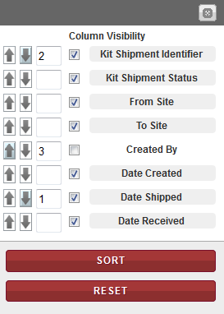

1. Sort window: Column Visibility checkboxes
2. If you want to hide a column in the search results, de-select the checkbox for that column.   
   The search results appear without the specified column.   
     
   If you want to display a column in the search results, select the checkbox for that column.  
   The search results appear without the specified Colum.   
   **Note:** To clear all the selections, click **RESET**.

### Sorting Search Results

You can sort your search results in ascending and descending order based on one column or based on multiple columns.

To sort the search results based on one item:

1. Log in to the application using your log in credentials.

The home page appears.

1. Point to the arrow of the **BMS** tab, and then click the module for which you want to access the search pane.   
   The search pane for the module that you selected appears on the left side of the page.
2. Click **SEARCH**.   
   A list of items within the module that you selected appears.
3. Click the column item name by which you want to sort.   
   The search results are sorted according to the column that you selected.   
     
   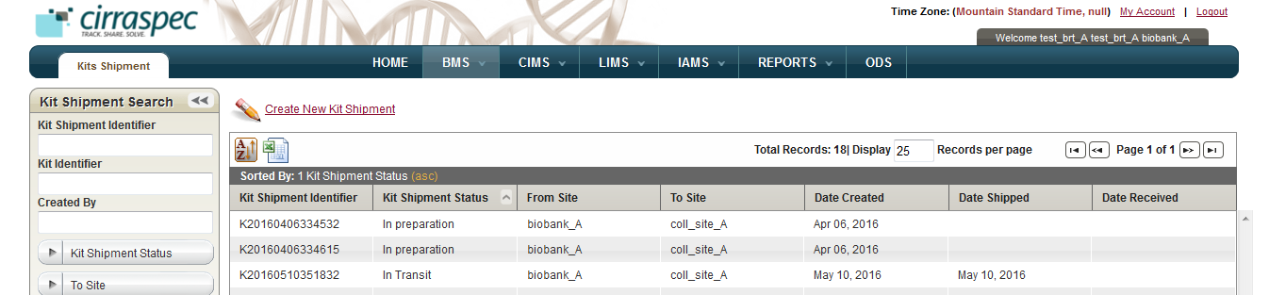

To sort the search results based on multiple items:

1. Log in to the application using your log in credentials.

The home page appears.

1. Point to the arrow of the **BMS** tab, and then click the module for which you want to access the search pane.   
   The search pane for the module that you selected appears on the left side of the page.
2. Click **SEARCH**.   
   A list of items within the module that you selected appears.
3. Click the **Sort Table** button .

The sort window appears and displays the sort options.



1. Sort window
2. If you want to sort the search results in ascending order, click the **Sort Ascending** button  next to the appropriate item column.

If you want to sort the search results in descending order, click the **Sort Descending** button  next to the appropriate item column.

1. To set the sorting priority of an item column, type the appropriate number in the box next to the item column that you want to prioritize.

For example, in the following figure, you sort the search results in descending order first by Date Shipped, then by Kit Shipment Identifier and then in ascending order by Created By:

* **Date Shipped** to **1** in **descending** order
* **Kit Shipment Identifier** to **2** in **descending** order
* **Created By** to **3** in **ascending** order



1. Sort order example
2. Click **SORT**.

The search results are sorted according to the sort order that you specified.

**Note:** To clear all the selections, click **RESET**.

## Managing Events

The Manage Events functionality allows you to view the existing events that are associated with items, such as kits and kit shipments. You can also create new events using this functionality.

### Viewing an Event

To view an existing event:

1. Log in to the application using your log in credentials.

The home page appears.

1. Point to the arrow of the **BMS** tab, and then click the module (Kits Inventory, Kits Shipment, Shipment, Worklists) for which you want to access the search pane.

The search pane for the module that you selected appears on the left side of the page.

1. Click **SEARCH**.

A list of items within the module that you selected appears.

1. Click on the row of the item for which you want to view an event.

**Manage Events** link

A page that displays the details of the item appears.

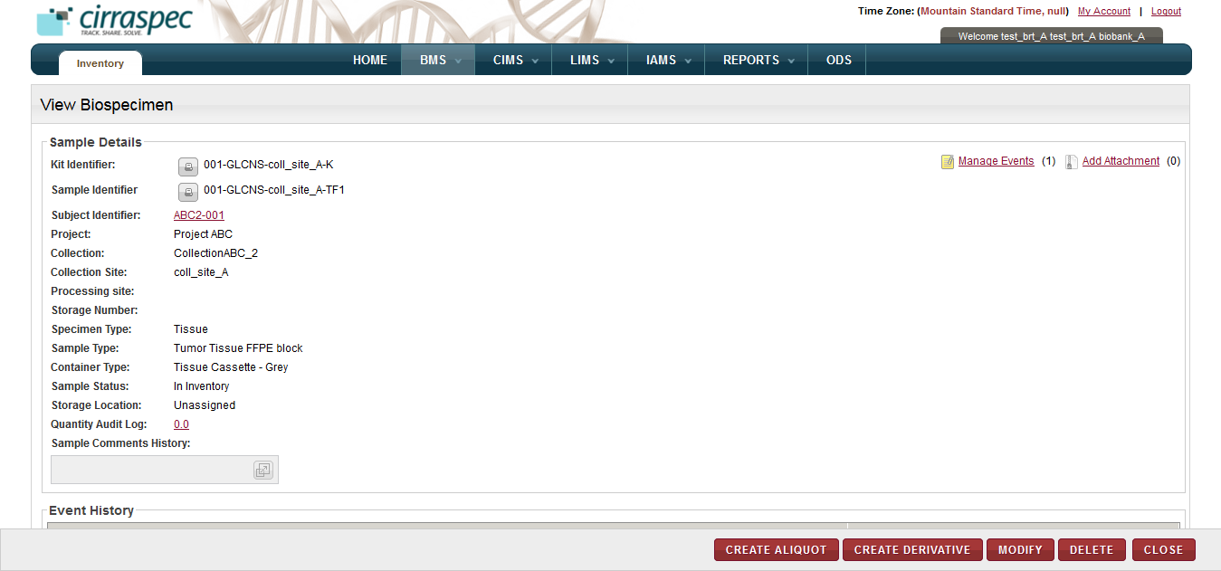

1. Manage Events link
2. Click the **Manage Events** link. Or Click the **yellow icon** as link for manage events on each row.  
   The **Manage Events** window appears. The **Event/Action List** area displays the existing events.

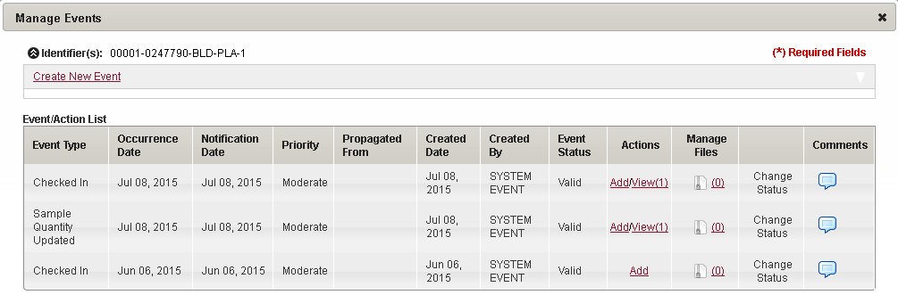

1. Manage Events window

### Creating an Event

To create an event:

1. In the **Manage Events** window, click the **Create New Event** link.

The **Create New Event** area appears.

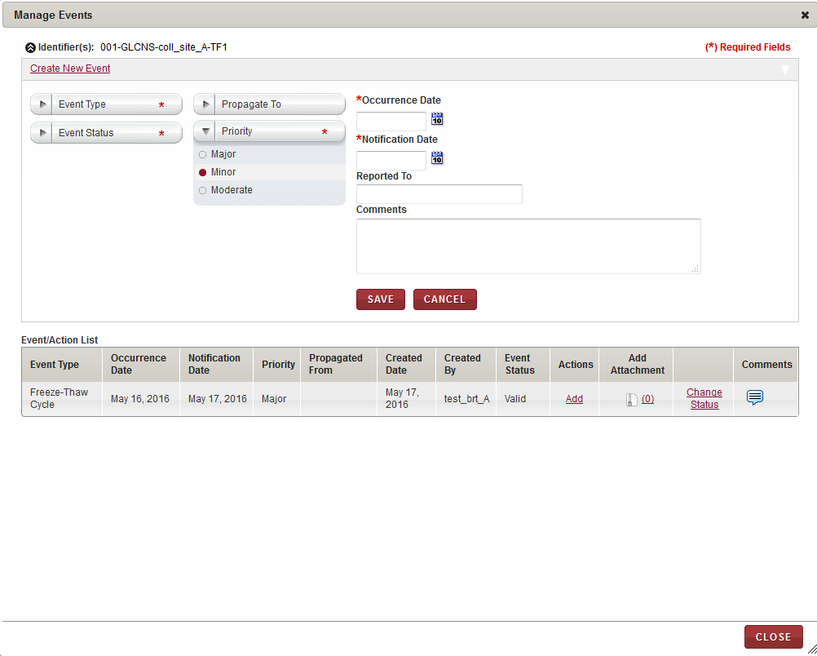

1. Create New Event area

1. Enter appropriate information in each field. Following table lists each field and its description.   
   **Note:** Fields that are marked with the red asterisk (*) are mandatory.

Table 62: Creating an event

| **Field** | **Description** |
| --- | --- |
| **Event Type\*** | Click the appropriate event type for this event. |
| **Event Status**\* | Click the appropriate status for this event. |
| **Propagate To** | Click the appropriate shipment cascading option to identify what items associated with the initial item should also have the event attached. Example: All items associated with the shipment, or biospecimens associated with the shipment. |
| **Priority** | Click the appropriate priority for this event. |
| **Occurrence Date**\* | Click the date icon Search calendar, and then click the date when the event occurred. |
| **Notification Date**\* | Click the date icon Search calendar, and then click the date when you were notified of the event. |
| **Reported To** | Type the person or organization to which the event was reported. |
| **Comments** | Type the appropriate comments for this event. |

1. Click **SAVE**.

The event is created. This event appears in the **Event/Action List** area.

### Changing the Status of an Event

To change the status of an event:

* In the **Manage Events** window, click the **Change Status** link.  
  The event status shown in the pop-up is modified from **Valid** to **Invalid** (or vice versa).

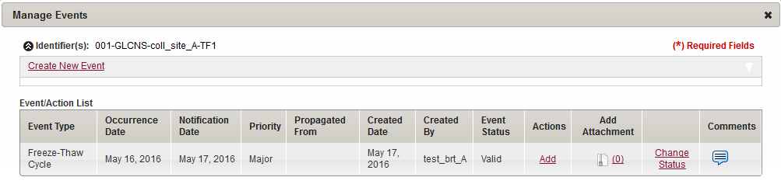

1. Change Status link

Allows you to change the event status

### Viewing or Adding Comments to an Event

To view comments associated with an event:

* In the **Manage Events** window, click the **Comments** icon in the Comments column.  
  The **Comments** window appears with previous comments displayed in **Comments History** area.

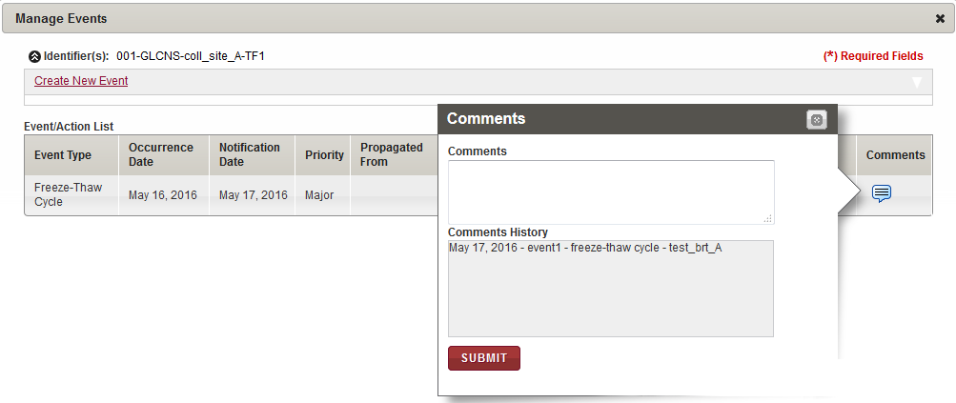

1. Comments window

To add comments associated with an event:

* In the **Comments** window, type your comments in **Comments**, and then click **SUBMIT**.  
  Your comments are added to the **Comments History** and the **Comments** window closes.

### Adding an Action for an Event

To add an action for an event in the **Event/Action List** area:

1. In the of the **Actions** column, click the **Add** link of the event for which you want to add an action.

The **Action** area appears.

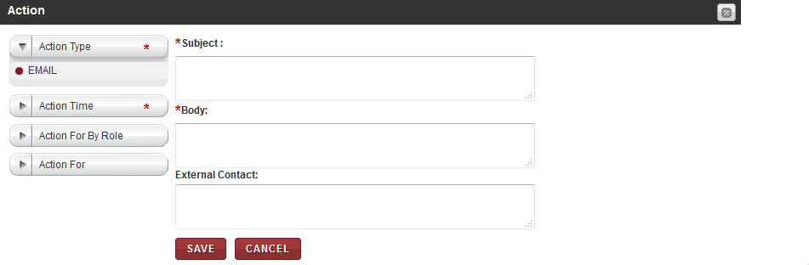

1. Action area
2. Enter appropriate information in each field. Following table lists each field and its description.

**Note:** Fields that are marked with the red asterisk (*) are mandatory.

Table 63: Adding an action for an event

| **Field** | **Description** |
| --- | --- |
| **Action Type**\* | Click the appropriate type of action.  **Note:** The default action is **EMAIL**. |
| **Action Time**\* | Click the time when you want to perform the action. |
| **Action For By Role** | If you want to specify to which CIRRASPEC user role(s) the action pertains, click on the field and select one or more roles. All users with the specified role(s) will receive the e-mail. |
| **Action For** | If you want to specify the CIRRASPEC user(s) to whom the action pertains, click on the field and select one or more users. The specified users will receive the e-mail. |
| **Subject**\* | Type a subject for the e-mail. |
| **Body**\* | Type the appropriate text for the e-mail message. |
| **External Contact** | If you want to specify an external contact to which the action pertains, type one or more external e-mail addresses. The specified external users will receive the e-mail. **Note:**  For multiple e-mail addresses, you must separate the e-mail addresses with a comma.  You must complete one of the following fields: **Action For By Role** or **Action For** or **External Contact** for the EMAIL action. |

1. Click **SAVE**.

The action is added to the **Actions** column for that event.

### Viewing the Actions Associated with an Event

To view the actions associated with an event in the **Event/Action List** area:

* In the **Actions** column, click the **View** link of the event for which you want to view an action.

Allows you to collapse the action row

Allows you to view the actions

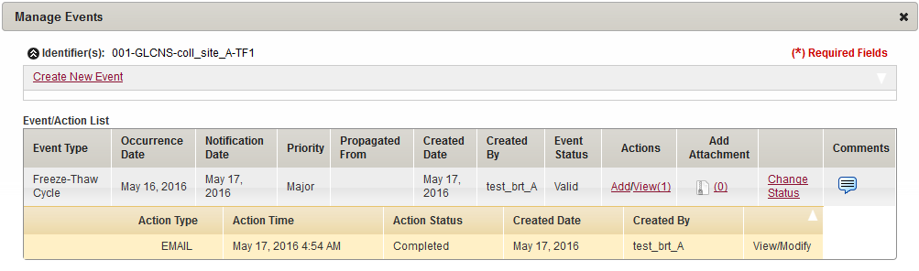

Action row

1. Action row

The action row appears below the event and displays the action details.   
**Note:** To collapse the action row, in the upper-right corner of the action row header, click the arrow icon.

## Common File Upload

The Common File Upload functionality allows you to upload, download and delete files that are attached to items, such as kits and shipments.

### Uploading a File

To upload a file, do the following:

1. Log in to the system using your log in credentials

The home page appears.

1. Point to the arrow of the **BMS** tab, and then click the module for which you want to access the search pane

The search pane for the module that you selected appears on the left side of the page.

1. Click **SEARCH**.

A list of items within the module that you selected appears.

1. Click the appropriate item.

**Add Attachment** link

A page that displays the details of the item appears.



1. Add Attachment link
2. Click the **Add Attachment** link.  
   The **MANAGE ATTACHMENTS** window appears

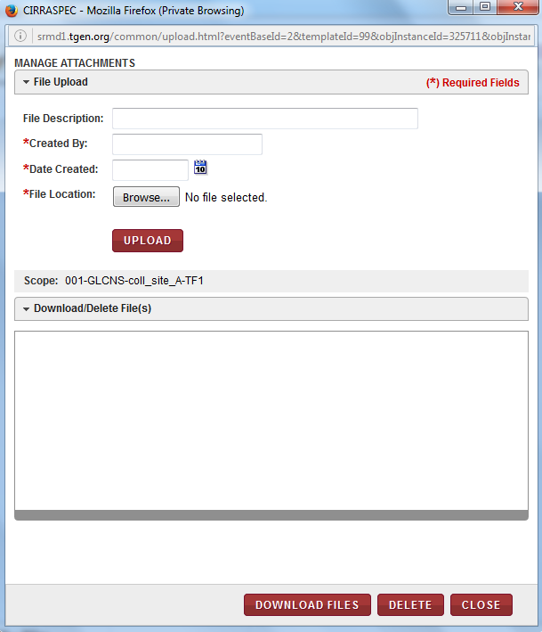

1. Manage Attachments window
2. In the **File Upload** area, enter appropriate information in each field. Following table lists each field and its description.

**Note:** Fields that are marked with the red asterisk (*) are madatory.

Table 64: Uploading a file

| **Field** | **Description** |
| --- | --- |
| **File Description** | Type a description for the file that you want to upload. |
| **Created By**\* | Type the name of the person who created this file. |
| **Date Created**\* | Click the date icon Search calendar, and then click the date on which the file was created. |
| **File Location**\* | To select the file that you want to upload:   1. Click **Browse.**  The browse files window appears. 2. Select the filethat you want to upload in the window, and click **Open**.   The browse window closes and the file name appears below the **File Location** box.  **Note:**   * You can select multiple files, one at a time, by repeating this browse step. * You can remove a selected file by clicking on the in the upper right corner of the selected file box. |

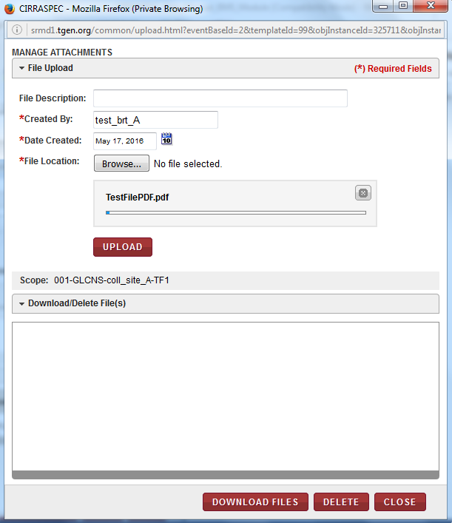

1. Manage Attachments Upload window with selected file
2. Click **UPLOAD**.  
   The file is uploaded and appears in the **Download/Delete File(s)** area.

### Downloading a File

To download a file in the **MANAGE ATTACHMENTS** window:

1. In the **Download/Delete File(s)** area, select the checkbox of the file that you want to download.

**Note:** To download all the files, select the checkbox on the header of the **Download/Delete File(s)** area.

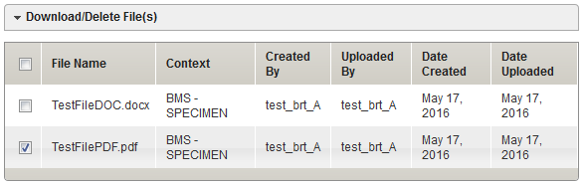

1. Download/Delete File(s) area
2. Click **DOWNLOAD FILES**.  
   The **Opening download** window appears. **Note:** You might not have the permission to download all the files in the **Download/Delete File(s)** area. If you do not have the permission to download a particular file, an error message appears.

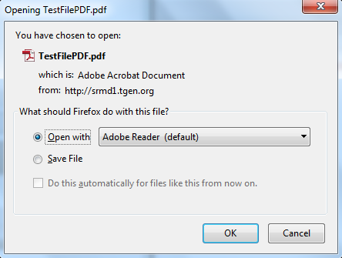

1. Download window
2. Click the applicable field to either open the file or to save it to your machine.  
   The following table provides a description of the download fields:

Table 65: Download fields

| **Field** | **Description** |
| --- | --- |
| **Open with** | Click this field if you just want to open and view the file. |
| **Save File** | Click this field to save the file to your machine. |

### Deleting a File

To delete a file in the **MANAGE ATTACHMENTS** window:

1. In the **Download/Delete File(s)** area, select the checkbox of the file that you want to delete.

**Note:** To delete all the files, select the checkbox on the header of the **Download/Delete File(s)** area.

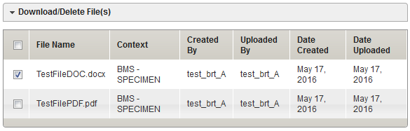

1. Download/Delete File(s) area
2. Click **DELETE**.

A confirmation window appears.   
**Note:** You might not have the permission to delete all the files in the **Download/Delete File(s)** area. If you do not have the permission to delete a particular file, an error message appears.

1. Click **OK**.

The file is deleted from the **Download/Delete File(s)** area.

# Upload Data using predefined spreadsheets

System Allows you to import data by uploading a pre-defined standardized spreadsheet templates.

**Note:**

You can request a copy of the various spreadsheet templates from the System Administrator or via email to [cirraspec@tgen.org](mailto:Bio4Dhelp@tgen.org).

* Template must be saved as an Excel Workbook with .xlsx extension.
* In the template, column names are in light blue cells. Above the column names, you will find description in orange cells to fill the columns too.

Various Available templates are as follows:

Note: For detailed steps to prepare the template and Upload Data, refer to the respective section following this table.

|  |  |  |
| --- | --- | --- |
| **Template Name** | **Used For** | **Effect on Template Upload by**  **IAMS > Import Data** |
|  |  |  |
| **Inventory Bulk Upload template** | To add biospecimens in bulk to inventory. | * Biospecimens are added to inventory * The information from the spreadsheet is viewable for each biospecimen in the **BMS Inventory** module. |
| **Kit Creation / Shipment template** | To create kits, and send and receive kit shipments. |  |
| **Batch Specimen Shipment template** | To create shipments of biospecimens collected from subjects, check them into inventory, and associate the samples to an existing or new subject. |  |
| **Redistribution Shipment**  **between Biobank template** |  |  |
| **Forms template** | To complete Specimen Collection or LIMS processing forms in bulk. |  |
| **LIMS Workflow Upload template** | To create LIMS Aliquot, Derivative, Pooling and Generic Experiment processing workflows in bulk. |  |



### Uploading an Inventory Bulk spreadsheet

To upload a inventory bulk spreadsheet:

1. Prepare the **Inventory Bulk Upload** spreadsheet for the biospecimens you want to upload.

The following table lists each field and its description.

**Note:**

* Fields that are marked with the red asterisk (*) are mandatory.
* You can use any of the standard excel tools to complete this spreadsheet.

For example, the first value in a column can be copied to additional rows and numbers can be incremented using the standard excel “select & drag” feature.

* You can access user information in **IAMS Address Book**.
* You can access Collection information in the **RPMS Configuration** module.

Table 67: Completing the Inventory Bulk Upload spreadsheet

| **Field** | **Description** |
| --- | --- |
| **Language\*** | Type “en” to indicate the preferred language is English. **Note:**  Language is based on the option shown on the **Communication** tab of the **IAMS Address Book** for the Biobank user you type in the Desitination Site Username field below. |
| **Locale\*** | Type “GB” or “US” to indicate the country locale for the user you type in the Desitination Site Username field below.  **Note:**  Locale is based on the option shown on the **Geography** tab of the **IAMS Address Book** for that user. |
| **Time Zone\*** | Type the appropriate time zone for the user you type in the Desitination Site Username field below.  **Note:**  Time zone is based on the option shown on the **Geography** tab of the **IAMS Address Book** for that user. |
| **Upload Type\*** | Indicates the type of upload performed with this template.  **Note**: “Bulk Inventory” is the default and it should not be changed. |
| **Create inventory\*** | Indicates that the specified samples should be added to inventory.  **Note**: “Yes” is the default and it should not be changed. |
| **Associate Donor\*** | Indicates that the specified samples should not be associated with a donor in Subject Centric View.  **Note**: “No” is the default and it should not be changed. |
| **Collection Event Code\*** | Type a valid Collection Event Code associated with the Collection of the specified sample.  **Note:** Collection must be published in **RPMS** with this Collection Event Code. |
| **Source Site Name\*** | Type the name of the Collection Site associated with the Collection of the specified sample.  **Note:** Site must be active in **IAMS Address Book** and Collection must be published with this site assigned in **RPMS**. |
| **Destination Site Name\*** | Type the name of the Processing or Biobank site associated with the specified sample.  **Note:** Site must be active in **IAMS Address Book** and Collection must be published with this site assigned in **RPMS**. |
| **Destination Site Username\*** | Type a valid Biobank User login username. **Note:** User must be active in **IAMS Address Book** and assigned to a published collection in **RPMS**. |
| **Sample Identifier\*** | In this column, type an identifier for each biospecimen you want to include in the upload. **Note:**  You cannot use an existing sample identifier.  The sample identifier must be unique. |
| **Donor Identifier** | In this column, type donor for each biospecimen you included in the upload. |
| **Sample Status\*** | In this column, indicate the status for each biospecimen you want to include in the upload:   * Click this field, and then click on the arrow to display a list of options. * Click the appropriate status. |
| **Storage Location** | To assign a storage location to the biospecimen, type the path of the storage location where each biospecimen is stored, followed by the storage map cell position you want to assign.   * For example, if the biospecimen is stored in Device 1-D1 and you want the biospecimen assigned to Rack 1-R1, Box 1-B1, cell 1, the path for the spreadsheet is D1-R1-B1, 1. * You can assign additional biospecimen line items to the same storage location by incrementing the cell position at the end by 1. * You can verify the path for an existing device as follows: * Access the **IAMS** module and click **Storage Designer**. * Click **Search**. * Click on the device where the biospecimen is stored. * Expand the device hierarchy tree located at the bottom of the page and click on the division where the biospecimen is stored. * Click the **Storage Map Report** link.   Eg: Report displayed:     * Click **Map Only**.   Eg: Report displayed:     * Note the **Storage Path** and the next available cell position. * You can only assign storage for a biospecimen with the **In Inventory** status. * You can only assign storage to a division with the **In Service** status. |
| **Specimen Type\*** | To indicate the specimen type for each biospecimen you want to include in the upload:   * Click this field, and then click on the arrow to display a list of options. * Click the appropriate type. |
| **Sample Type\*** | To indicate the sample type for each biospecimen you want to include in the upload:   * Click this field, and then click on the arrow to display a list of options. * Click the appropriate type. |
| **Container Type\*** | To indicate the container type for each biospecimen you want to include in the upload:   * Click this field, and then click on the arrow to display a list of options. * Click the appropriate type. |
| **Quantity** | Type the initial quantity of each biospecimen. |
| **Quantity Unit** | To indicate the unit of measure for the initial quantity of each biospecimen:   * Click this field, and then click on the arrow to display a list of options. * Click the appropriate unit.   **Note:** This field is required if you entered an amount in **Quantity**. |
| **Concentration** | Type the initial concentration of each biospecimen. |
| **Concentration Unit** | To indicate the unit of measure for the initial concentration of each biospecimen:   * Click this field, and then click on the arrow to display a list of options. * Click the appropriate unit.   **Note:** This field is required if you entered an amount in **Concentration**. |
| **Comment** | Type your comments for any of the biospecimen, as applicable. |

1. Log in to the application using your log in credentials.

The CIRRASPEC home page appears.

1. Point to the arrow of the **IAMS** tab, and then click **Import Data**.

The **Import Data** page appears.

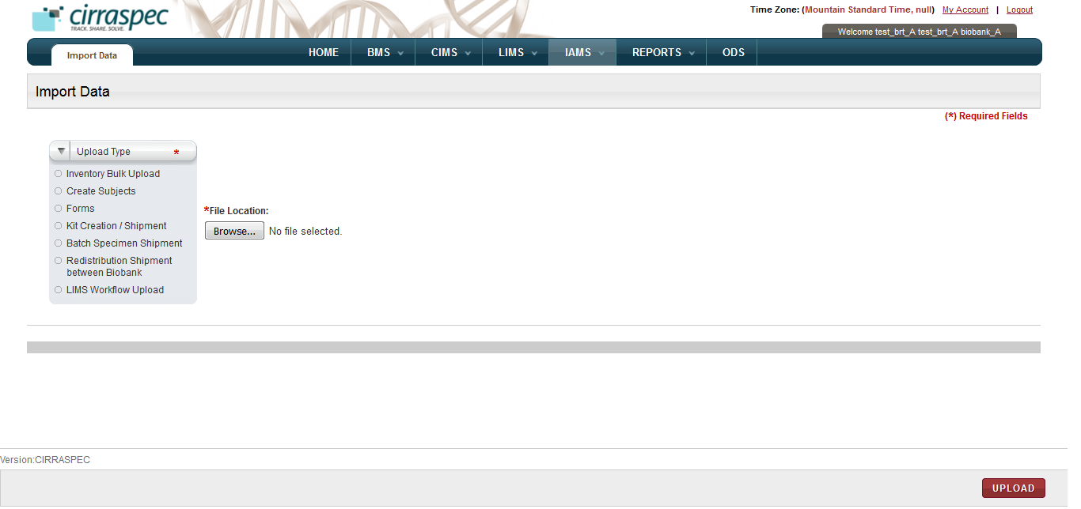

1. Import Data page
2. In the **Upload Type** list, click **Inventory Bulk Upload**.
3. Click **Browse** below the **File Location** field, and then select the bulk inventory spreadsheet that you want to upload.

The path of the template that you select appears on the right side of the **Browse** button.

1. Click **UPLOAD**.

The spreadsheet is uploaded. The **Import Data** page displays a confirmation and summary of the upload.

**Note:**

* The biospecimens from the spreadsheet are added with status as **In Inventory.**
* The information from the spreadsheet is viewable for each biospecimen in the **BMS Inventory** module.

### Uploading a Kit Creation / Shipment spreadsheet

To upload a kit creation and or Kit shipment template:

1. Prepare the **Kit Creation / Shipment** upload spreadsheet for the kit creation and kit shipment data you want to upload.   
   **Note:**

This template has two tabs: Kit Shipment and Kit Creation. Each tab can performs its designated function and they can be submitted together or independently.

The following table lists each field and its description.

**Note:**

* Fields that are marked with the red asterisk (*) are mandatory.
* You can use any of the standard excel tools to complete this spreadsheet. For example, the first value in a column can be copied to additional rows and numbers can be incremented using the standard excel “select & drag” feature.
* You can access user information in **IAMS Address Book**.
* You can access Collection information in the **RPMS Configuration** module.

Table 68: Completing the Kit Creation / Shipment spreadsheet

| **Field** | **Description** |
| --- | --- |
| **Kit Shipment Tab** | |
| **Language\*** | Type “en” to indicate the preferred language is English. **Note:** Language is based on the option shown on the **Communication** tab of the **IAMS Address Book** for the Biobank user you type in the Desitination Site Username field below. |
| **Locale\*** | Type “GB” or “US” to indicate the country locale for the user you type in the Desitination Site User field below.  **Note:**  Locale is based on the option shown on the **Geography** tab of the **IAMS Address Book** for the for that user. |
| **Time Zone\*** | Type the appropriate time zone for the user you type in the Desitination Site User field below.  **Note:**  Time zone is based on the option shown on the **Geography** tab of the **IAMS Address Book** for that user. |
| **Upload Type\*** | Indicates the type of upload performed with this template.  **Note**:  “Kit Shipment” is the default and it should not be changed. |
| **Shipment Detail Provided\*** | To indicate whether you want to specify shipment data or just use the default values for shipment fields:   * If you want to use only the default values and are not going to input kit shipment details below, type **No**. * If you want to input kit shipment details in any of the shipment fields below, type **Yes**. |
| **Shipment Number\*** | To include multiple kit shipments on the same spreadsheet:   1. Type **1** in this field in front of each row of information for the first shipment. 2. Type **2** in this field in front of each row of information to for the second shipment. 3. Repeat as needed.   **Note:** If multiple kit shipments are included on the same spreadsheet, each separate shipment must have a unique Shipment Number (1, 2, 3 etc. ). |
| **Shipment Tracking** | Type the tracking number of the shipment. |
| **Courier** | Type the courier used for the shipment. |
| **Shipment Date** | Type the date the kits were shipped to the collection site. **Note:**   * Valid format is mm/dd/yyyy. * The default value is the current date. |
| **Receive Date** | Type the date the shipment was received by the collection site. **Note:**   * Valid format is mm/dd/yyyy. * The default value is the current date. |
| **Kit Identifier\*** | Type the identifier of the kit being shipped. **Note:**  Identifier must be a valid existing kit identifier with Kit Status as **In Stock** or a new identifier being assigned via the Kit Creation tab of this upload. |
| **Source Site Name\*** | Type the name of the sending location for the specified kit.  **Note:**  Site must be active in **IAMS Address Book**  Collection must be published with this site assigned in **RPMS**. |
| **Source Site Username\*** | Type a valid Biobank User login username  **Note**:  User must be active in IAMS Address Book and assigned to a published collection in RPMS. |
| **Destination Site Name\*** | Type the name of the receiving location for the specified kit. **Note:**  Site must be active in **IAMS Address Book**  Collection must be published with this site assigned in **RPMS**. |
| **Destination Site Username\*** | Type a valid user login usernameat the receiving location. **Note:**  User must be active in **IAMS Address Book** and assigned to a published collection in **RPMS**. |
| **Kit Creation Tab** | |
| **Language\*** | Type “en” to indicate the preferred language is English. **Note**: Language is based on the option shown on the Communication tab of the IAMS Address Book for the Biobank user you type in the Desitination Site User field below. |
| **Locale\*** | Type “GB” or “US” to indicate the country locale for the user you type in the Desitination Site User field below.  **Note**: Locale is based on the option shown on the Geography tab of the IAMS Address Book for the for that user. |
| **Time Zone\*** | Type the appropriate time zone for the user you type in the Desitination Site User field below.  **Note**: Time zone is based on the option shown on the Geography tab of the IAMS Address Book for that user. |
| **Upload Type\*** | Indicates the type of upload performed with this template.  **Note**: “Kit Creation” is the default and it should not be changed. |
| **Collection Event Code\*** | Type the Collection Event Code associated with the kit to be created.  **Note:** Collection must be published in RPMS with this Collection Event Code. |
| **Kit Template\*** | Type the name of the kit template associated with the kit to be created. |
| **Number of Kits\*** | Type the number of kits to be created for the kit template and collection event. |
| **Source Site Name\*** | Type the name of the creating location for the specified kit.  **Note:**  Site must be active in IAMS Address Book and Collection must be published with this site assigned in RPMS. |
| **Source Site Username\*** | Type a valid Biobank user login ID.  **Note:**  User must be active in IAMS Address Book and assigned to a published Collection in RPMS. |
| **Destination Site Name\*** | Type the name of the receiving location for the specified kit. **Note:**  Site must be active in IAMS Address Book and Collection must be published with this site assigned in RPMS. |

1. Log in to the application using your log in credentials.

The CIRRASPEC home page appears.

1. Point to the arrow of the **IAMS** tab, and then click **Import Data**.

The **Import Data** page appears.



1. Import Data page
2. In the **Upload Type** list, click **Kit Creation / Shipment**.
3. Click **Browse** below the **File Location** field, and then select the kit shipment spreadsheet that you want to upload.

The path of the template that you select appears on the right side of the **Browse** button.

1. Click **UPLOAD**.

The spreadsheet is uploaded. The **Import Data** page displays a confirmation and summary of the upload.

**Note:**

* The new kits are created and assigned to the specified kit template and collection event.
* The shipment is added with status as **Received.**
* The shipment information from template is accessible via the **Kits Shipments** module.
* The specified shipped kits are added with Kit status as **Received-Not used**, and kit content status as **Not Collected**. The kit information from template is accessible via the **Kits Inventory** module.

### Uploading a Batch Specimen Shipment spreadsheet

To upload a batch specimen shipment template:

1. Prepare the **Batch Specimen Shipment** upload spreadsheet for the collection shipment data you want to upload.
2. The following table lists each field and its description.

**Note:**

* Fields that are marked with the red asterisk (*) are mandatory.
* You can use any of the standard excel tools to complete this spreadsheet. For example, the first value in a column can be copied to additional rows and numbers can be incremented using the standard excel “select & drag” feature.
* You can access user information in **IAMS Address Book**.
* You can access Collection information in the **RPMS Configuration** module.

Table 69: Completing the Batch Specimen Shipment spreadsheet

| **Field** | **Description** |
| --- | --- |
| **Language\*** | Type “en” to indicate the preferred language is English. **Note:** Language is based on the option shown on the **Communication** tab of the **IAMS Address Book** for the user you type in the Desitination Site User field below. |
| **Locale\*** | Type “GB” or “US” to indicate the country locale for the user you type in the Desitination Site User field below.  **Note:** Locale is based on the option shown on the **Geography** tab of the **IAMS Address Book** for that user. |
| **Time Zone\*** | Type the appropriate time zone for the user you type in the Desitination Site User field below.  **Note:** Time zone is based on the option shown on the **Geography** tab of the **IAMS Address Book** for that user. |
| **Upload Type\*** | Indicate the type of upload performed with this template.  **Note**: “Batch Shipment” is the default and it should not be changed. |
| **Create inventory\*** | Indicates that the specified samples should not be added to inventory.  **Note**: “No” is the default and it should not be changed. |
| **Associate Donor\*** | To indicate whether or not the specified biospecimens in the shipment should be associated with an existing donor subject in Subject Centric View:   * If you want to associate the biospecimens with a donor, type **Yes**. * If you do not want to associate the biospecimens with a donor, type **No**. |
| **Shipment Number\*** | To group multiple biospecimens in the same shipment:   1. Type **1** in this field in front of each biospecimen line item to be included in the first shipment. 2. Type **2** in this field in front of each biospecimen line item to be included in the second shipment. 3. Repeat as needed.   **Note:** If multiple shipments are included on the same spreadsheet, each separare shipment must have a unique Shipment Number (1, 2, 3 etc. ). |
| **Shipment Type** | Type the type of shipment.  **Note:**   * Valid types are: Ambient, Cold Pack, Cryoport, Dry Ice, Ice Pack,Other and Wet Ice. * The default value is Other. |
| **Shipment Tracking** | Type the tracking number of the shipment. |
| **Courier** | Type the courier used for the shipment. |
| **Shipment Date** | Type the date the samples were shipped by the collection site.  **Note:**   * Valid format is mm/dd/yyyy. * The default value is the current date. |
| **Receive Date** | Input the date the shipment was received. **Note:**   * Valid format is mm/dd/yyyy. * The default value is the current date. |
| **Source Site Name\*** | Type the name of the sending location for the shipment.  **Note:**  Site must be active in **IAMS Address Book** and Collection must be published with this site assigned in **RPMS**. |
| **Destination Site Name\*** | Type the name of the receiving location for the shipment.  **Note:**  Site must be active in **IAMS Address Book** and Collection must be published with this site assigned in **RPMS**. |
| **Source Site Username\*** | Type a valid Collection Site user login username. **Note:**  User must be active in **IAMS Address Book** and assigned to a published collection in **RPMS**. |
| **Destination Site Username\*** | Type a valid Biobank user login username. **Note:**  User must be active in **IAMS Address Book** and assigned to a published collection in **RPMS**. |
| **Sample Identifier\*** | Type an identifier for each biospecimen you want to include in the upload.  **Note:**  The current status of each biospecimen specified in this field must be **Received-Not Used**.  Or **Not Collected.** |
| **Donor Identifier** | If you typed **Yes** in the **Associate Donor** field at the top of the spreadsheet, type the identifier of the donor to be associated with each biospecimen in this field. |
| **Sample Status\*** | To indicate the check-in status for each biospecimen included in the upload:   1. Click this field, and then click on the arrow to display a list of options. 2. Click the appropriate status.   **Note:** Valid options are **In Inventory** and **Hold**. |
| **Collection Date** | Type the date when each biospecimen was collected.  **Note:**   * Valid format is mm/dd/yyyy. * The default value is the Shipment Date. If shipment date field is left blank, then default is Received Date. If both are blank, tehn default is current date. |
| **CollectionTime** | Type the time when each biospecimen was collected.  **Note:**  Valid format is hh:mm. |
| **Destination Storage Location** | To assign a storage location to the biospecimens, type the path of the storage location where each biospecimen is stored, followed by the storage map cell position you want to assign.   * For example, if the biospecimen is stored in Device 1-D1 and you want the biospecimen assigned to Rack 1-R1, Box 1-B1, cell 1, the path for the spreadsheet is D1-R1-B1, 1. * You can assign additional biospecimen line items to the same storage location by incrementing the cell position at the end by 1. * You can verify the path for an existing device as follows: * Access the **IAMS** module and click **Storage Designer**. * Click **Search**. * Click on the device where the biospecimen is stored. * Expand the device hierarchy tree and click on the division where the biospecimen is stored. * Click the **Storage Map Report** link.   Eg: Report displayed     * Click **Map Only**.   eg: Report displayed     * Note the Storage Path and the next available cell position. * You can only assign storage for a biospecimen with the **In Inventory** status. * You can only assign storage to a division with the **In Service** status. |
| **Quantity** | Type the initial quantity of each biospecimen included in the upload. |
| **Quantity Unit** | To indicate the unit of measure for the initial quantity of each biospecimen:   * Click this field, and then click on the arrow to display a list of options. * Click the appropriate unit.   **Note:** This field is required if you entered an amount in **Quantity** field. |
| **Concentration** | Type the initial concentration of each biospecimen included in the upload. |
| **Concentration Unit** | To indicate the unit of measure for the initial concentration of each biospecimen:   1. Click this field, and then click on the arrow to display a list of options. 2. Click the appropriate unit.   **Note:** This field is required if you entered an amount in **Concentration** field. |
| **Comment** | Type your comments regarding this upload, if applicable. |
| **New Kit Item** | To add the specified biospecimen as a new kit item, type **Yes.**  Otherwise, type **No** or leave blank**.** |
| **Kit Identifier** | To add a new kit item, type the Identifier of the kit to which the new item is to be added. **Note:** This field is only used (and is required) if you typed **Yes** in the **New Kit Item** field |
| **Component Group** | To add a new kit item, type the name of the component group to which the new kit item is to be added (e.g., blood, tissue).  **Note:** This field is only used (and is required) if you typed **Yes** in the **New Kit Item** field |
| **New Non Kit Item** | To add the specified biospecimen as a new non kit item, type **Yes**.  Otherwise, type **No or** leave blank. |
| **Collection Event Code** | To add a new non kit item, type the Collection Event Code associated with the Non Kit Item.  **Note:**   * Collection must be published in **RPMS** with this collection event code. * This field is only used (and is required) if you typed **Yes** in the **New Non Kit Item** field. |
| **Specimen Type** | To indicate the specimen type for a new kit item or a new non kit item:   1. Click this field, and then click on the arrow to display a list of options. 2. Click the appropriate type.   **Note:** This field is only used (and is required) if you typed **Yes** in the **New Kit Item** field or the **New Non Kit Item** field. |
| **Sample Type** | To indicate the sample type for a new kit item or a new non kit item:   1. Click this field, and then click on the arrow to display a list of options. 2. Click the appropriate type.   **Note:**  This field is only used (and is required) if you typed **Yes** in the **New Kit Item** field or the **New Non Kit Item** field. |
| **Container Type** | To indicate the container type for a new kit item or a new non kit item:   1. Click this field, and then click on the arrow to display a list of options. 2. Click the appropriate type.   **Note**:  This field is only used (and is required) if you typed **Yes** in the **New Kit Item** field or the **New Non Kit Item** field. |

1. Log in to the application using your log in credentials.

The CIRRASPEC home page appears.

1. Point to the arrow of the **IAMS** tab, and then click **Import Data**.

The **Import Data** page appears.



1. Import Data page
2. In the **Upload Type** list, click **Batch Specimen Shipment**.
3. Click **Browse** below the **File Location** field, and then select the batch shipment spreadsheet that you want to upload.

The path of the template that you select appears on the right side of the Browse button.

1. Click **UPLOAD**.

The spreadsheet is uploaded. The **Import Data** page displays a confirmation and summary of the upload.

**Note:**

* The shipment is added with status as **Completed.** The shipment information from template is accessible via the **BMS > Shipments** module.
* Kit samples are marked as **Collected.**

The kit status is set as **Completed** if all samples in kit were used and shipped, or **Collection Started** if some kit contents were not used/shipped.

The Kit information is available via the **BMS > Kits Shipment** module.

* The biospecimens are checked in with status as **In Inventory.**

Thebiospecimen information from template is accessible via the **BMS > Inventory** module.

* If a new or existing subject identifier was indicated on the spreadsheet, the specified kit is assigned to that subject.

The subject-related information from the template is accessible via the **CIMS > Subject Centric View** module.

### Uploading a Redistribution Shipment between Biobank spreadsheet

To upload a redistribution shipment between biobank template:

1. Prepare the **Redistribution Shipment between Biobank** spreadsheet for the redistribution shipment data you want to upload.

The following table lists each field and its description.

**Note:**

* Fields that are marked with the red asterisk (*) are mandatory.
* You can use any of the standard excel tools to complete this spreadsheet. For example, the first value in a column can be copied to additional rows and numbers can be incremented using the standard excel “select & drag” feature.
* You can access user information in **IAMS Address Book**.
* You can access Collection information in the **RPMS Configuration** module.

Table 70: Completing the Redistribution Shipment between Biobank spreadsheet

| **Field** | **Description** |
| --- | --- |
| **Language\*** | Type “en” to indicate the preferred language is English. **Note:**  Language is based on the option shown on the **Communication** tab of the **IAMS Address Book** for the user you type in the Desitination Site User field below. |
| **Locale\*** | Type “GB” or “US” to indicate the country locale for for the user you type in the Desitination Site User field below.  **Note:**  Locale is based on the option shown on the **Geography** tab of the **IAMS Address Book** for the for that user. |
| **Time Zone\*** | Type the appropriate time zone for the user you type in the Desitination Site User field below.  **Note:**  Time zone is based on the option shown on the **Geography** tab of the **IAMS Address Book** for that user. |
| **Create Shipment\*** | Indicates that a shipment should be created.  **Note**:  “Yes” is the default and it should not be changed. |
| **Create Inventory\*** | Indicates that the specified samples should not be added to inventory. **Note**:  “No” is the default and it should not be changed. |
| **Shipment Number\*** | To group multiple biospecimens in the same shipment:   1. Type **1** in this field in front of each biospecimen line item to be included in the first shipment. 2. Type **2** in this field in front of each biospecimen line item to be included in the second shipment. 3. Repeat as needed.   **Note:**  If multiple shipments are included on the same spreadsheet, each separare shipment must have a unique Shipment Number (1, 2, 3 etc. ). |
| **Shipment Type** | Type the type of shipment.  **Note:**   * Valid types are: Ambient, Cold Pack, Cryoport, Dry Ice, Ice Pack,Other and Wet Ice. * The default value is Other. |
| **Shipment Tracking** | Type the tracking number of the shipment. |
| **Courier** | Type the courier used for the shipment. |
| **Shipment Date** | Type the date the distribution samples were shipped.  **Note:**   * Valid format is mm/dd/yyyy. * The default value is the current date. |
| **Receive Date** | Type the date the distribution shipment was received. **Note:**   * Valid format is mm/dd/yyyy. * The default value is the current date. |
| **Source Site Name\*** | Type the name of the sending location for the shipment.  **Note:** Site must be active in **IAMS Address Book** and Collection must be published with this site assigned in **RPMS**. |
| **Destination Site Name\*** | Type the name of the receiving location for the shipment.**Note:** Site must be active in **IAMS Address Book** and Collection must be published with this site assigned in **RPMS**. |
| **Source Site Username\*** | Type a valid Source Site user login ID. **Note:** User must be active in **IAMS Address Book** and assigned to a published collection in **RPMS**. |
| **Destination Site Username\*** | Type a valid Destination Site user login ID. **Note:** User must be active in **IAMS Address Book** and assigned to a published collection in **RPMS**. |
| **Sample Identifier\*** | Type an identifier for each biospecimen you want to include in the upload.  **Note:** The current status of each biospecimen specified in this field must be **In Inventory**. |
| **Sample Status\*** | To indicate the check-in status for each biospecimen included in the upload:   1. Click this field, and then click on the arrow to display a list of options. 2. Click the appropriate status.   **Note:** Valid options are **In Inventory** and **Hold**. |
| **Storage Location** | To assign a storage location to the biospecimens, type the path of the storage location where each biospecimen is stored, followed by the storage map cell position you want to assign.   * For example, if the biospecimen is stored in Device 1-D1 and you want the biospecimen assigned to Rack 1-R1, Box 1-B1, cell 1, the path for the spreadsheet is D1-R1-B1, 1. * You can assign additional biospecimen line items to the same storage location by incrementing the cell position at the end by 1. * You can verify the path for an existing device as follows: * Access the **IAMS** module and click **Storage Designer**. * Click **Search**. * Click on the device where the biospecimen is stored. * Expand the device hierarchy tree and click on the division where the biospecimen is stored. * Click the **Storage Map Report** link.   Eg: Report displayed     * Click **Map Only**.   eg: Report displayed     * Note the **Storage Path** and the next available cell position. * You can only assign storage for a biospecimen with the **In Inventory** status. * You can only assign storage to a division with the **In Service** status. |
| **Comment** | Type your comments regarding this upload, if applicable. |

1. Log in to the application using your log in credentials.

The CIRRASPEC home page appears.

1. Point to the arrow of the **IAMS** tab, and then click **Import Data**.

The **Import Data** page appears.



1. Import Data page
2. In the **Upload Type** list, click **Redistribution Shipment between Biobank**.
3. Click **Browse** below the **File Location** field, and then select the redistribution shipment spreadsheet that you want to upload.

The path of the template that you select appears on the right of the Browse button.

1. Click **UPLOAD**.

The spreadsheet is uploaded. The **Import Data** page displays a confirmation and summary of the upload.

**Note:**

* The shipment is added with status as **Distribution Completed**

An “R” preceding the Shipment Identifier is added to designate it as a redistribution shipment.

The shipment information from template is accessible via the **BMS > Shipments** module.

* The biospecimens are checked in with status as **In Inventory.**

Thebiospecimen information from template is accessible via the **BMS > Inventory** module.



### Uploading a Forms spreadsheet

To upload a forms data template:

1. Prepare the **Forms** upload spreadsheet for the form data you want to upload.   
   **Note:**

* This template cannot be currently used to upload PHI data.

The following table lists each field and its description.

**Note:**

* Fields that are marked with the red asterisk (*) are mandatory.
* You can use any of the standard excel tools to complete this spreadsheet. For example, the first value in a column can be copied to additional rows and numbers can be incremented using the standard excel “select & drag” feature.
* You can access user information in **IAMS Address Book**.
* You can access Collection information in the **RPMS Configuration** module.

Table 72: Completing the Forms spreadsheet

| **Field** | **Description** |
| --- | --- |
| **Language\*** | Type “en” to indicate the preferred language is English. **Note:** Language is based on the option shown on the **Communication** tab of the **IAMS Address Book** for the user you type in the Desitination Site User field below. |
| **Locale\*** | Type “GB” or “US” to indicate the country locale for the user you type in the Desitination Site User field below.  **Note:** Locale is based on the option shown on the **Geography** tab of the **IAMS Address Book** for that user. |
| **Time Zone\*** | Type the appropriate time zone for the user you type in the Desitination Site User field below.  **Note:** Time zone is based on the option shown on the **Geography** tab of the **IAMS Address Book** for that user. |
| **Upload Type\*** | Indicate the type of upload performed with this template.  **Note**: “Dyna Form” is the default and it should not be changed. |
| **Form Type** **Name\*** | Type the name of the form associated with this upload. |
| **Form Section Name\*** | Type the section name of the form associated with this upload. |
| **Form Section Version\*** | Type the version number of the section of the form associated with this upload. |
| **Destination Site Username\*** | Type the user login username of the person performing the form upload .**Note:**  User must be active in **IAMS Address Book** and assigned to a published collection in **RPMS**. |
| **Sample Collection Forms** | |
| **Donor Identifier\*** | Type the identifier of the donor subject for which this form is being completed. |
| **Kit Identifier\*** | Type the identifier of the kit to which this form is associated. |
| **Form Specific Attributes\*** | Type (or select) the appropriate value for each of the form attribute fields on the template.  **Note:** Since the collection forms are client defined, the form attribute fields vary and are provided by the System Administrator based on the Collection for which the form is used.  This template cannot be currently used to upload PHI data. |
| **Sample Processing Forms** | |
| **Destination Site Name\*** | For LIMS workflow processing forms, type the name of the site where the sample processing was performed.  **Note:** This field displays only for LIMS sample processing forms. Site must be active in **IAMS Address Book** and Collection must be published with this site assigned in **RPMS**. |
| **Sample Identifier\*** | Type the identifier of the biospecimen for which this form is being completed. |
| **Workflow Name\*** | Type name of the workflow for which this form is being completed. |
| **Form Specific Attributes\*** | Type (or select) he appropriate value for each of the form attribute fields on the template**.**  **Note:** Since the sample processing forms are client defined, the form attribute fields vary and are provided by the System Administrator based on the Collection for which the form is used.  This template cannot be currently used to upload PHI data. |

1. Log in to the application using your log in credentials.

The CIRRASPEC home page appears.

1. Point to the arrow of the **IAMS** tab, and then click **Import Data**.

The **Import Data** page appears.



1. Import Data page
2. In the **Upload Type** list, click **Form**.
3. Click **Browse** below the **File Location** field, and then select the **Forms** template spreadsheet that you want to upload.

The path of the template that you select appears on the right side of the **Browse** button.

1. Click **UPLOAD**.

The form data is uploaded. The **Import Data** page displays a confirmation and summary of the upload.

**Note:**

* The form associated with the specified subject, kit or LIMS workflow is completed with the information from the template.
* The form Status is set to “Data Entry Started” if few fields data is uploaded. If all fields data is uploaded
* The completed form is immediately available for viewing and approving.

Consent and Collection forms are accessible via the **CIMS > Subject Centric** **View.**

Sample Processng forms are accessible via the **LIMS > Workflows** modules.

### Uploading a LIMS Workflow spreadsheet

To upload a LIMS sample processing workflow template:

1. Prepare the **LIMS Workflow Upload** spreadsheet for the sample processing workflow you want to upload.

The following table lists each field and its description.

**Note:**

* Fields that are marked with the red asterisk (*) are mandatory.
* You can use any of the standard excel tools to complete this spreadsheet. For example, the first value in a column can be copied to additional rows and numbers can be incremented using the standard excel “select & drag” feature.
* You can access user information in **IAMS Address Book**.
* You can access Collection information in the **RPMS Configuration** module.

Table 73: Completing the LIMS Workflow Upload spreadsheet

| **Field** | **Description** |
| --- | --- |
| **Language\*** | Type “en” to indicate the preferred language is English. **Note:** Language is based on the option shown on the **Communication** tab of the **IAMS Address Book** for the user you type in the Desitination Site User field below. |
| **Locale\*** | Type “GB” or “US” to indicate the country locale for the user you type in the Desitination Site User field below.  **Note:** Locale is based on the option shown on the **Geography** tab of the **IAMS Address Book** for that user. |
| **Time Zone\*** | Type the appropriate time zone for the user you type in the Desitination Site User field below.  **Note:** Time zone is based on the option shown on the **Geography** tab of the **IAMS Address Book** for that user. |
| **Upload Type\*** | Indicate the type of upload performed with this template.  **Note**: “LIMS Workflow” is the default and it should not be changed. |
| **Workflow Process Type\*** | Type the sample processing type for each workflow in the upload: - Aliquot - Derivative - Pooling  - Generic Experiment |
| **Name\*** | Type a unique name for each workflow in the upload. |
| **Start Date** | Type the processing start date, if applicable.  **Note:** Valid format is mm/dd/yyyy. |
| **Start Time** | Type the processing start time, if applicable. **Note:** Valid format is hh:mm - 24 hour military time (e.g: 14:30). |
| **End Date** | Type the processing end date, if applicable.  **Note:** Valid format is mm/dd/yyyy. |
| **End Time** | Type the processing end time, if applicable.  **Note:** Valid format is hh:mm - 24 hour military time (e.g., 14:30). |
| **Process Template\*** | Type the name of the processing template associated with each workflow in the upload.  **Note:**  Name is based on the Workflow Type and must match the Process Templates menu options shown on the LIMS > Create Workflow screen. |
| **Parent Sample Barcode\*** | Type Parent Specimen barcode.  Enter multiple comma separated barcodes for pooling process type. |
| **Parent Sample Consumed Quantity\*** | Type quantity of each biospecimen consumed.  If multiple biospecimens enter a comma separated list of quantities equal to number of samples. |
| **Parent Sample Consumed Quantity Unit\*** | To indicate the unit of measure for the initial quantity of each biospecimen:   * Click this field, and then click on the arrow to display a list of options. * Click the appropriate unit.   **Note:** This field is required if you entered an amount in **Quantity** field. |
| **Parent Sample Depleted\*** | Type Yes or No.  **Note**: Defaults to No if left blank |
| **Unique Child Barcode ID\*** | Enter child barcode |
| **Child Sample Quantity\*** | Type Quantity of each child sample required.  If single number is entered same quantity for each sample will be considered |
| **Child Sample Quantity Unit\*** | To indicate the unit of measure for the child sample quantity of each biospecimen:   * Click this field, and then click on the arrow to display a list of options. * Click the appropriate unit.   **Note:** This field is required if you entered an amount in **Child Sample Quantity** field. |
| **Child Specimen Type\*** | To indicate the specimen type for child specimens:   * Click this field, and then click on the arrow to display a list of options. * Click the appropriate type.   **Note:**  This field is only used (and is required) for **Workflow Process Types** : Derivative, Generic Experiment |
| **Child Sample Type\*** | To indicate the sample type for a new kit item or a new non kit item:   * Click this field, and then click on the arrow to display a list of options. * Click the appropriate type.   **Note:**  This field is only used (and is required) for **Workflow Process Types** :  Derivative, Generic Experiment |
| **Container Type\*** | To indicate the container type for a new kit item or a new non kit item:   * Click this field, and then click on the arrow to display a list of options. * Click the appropriate type.   **Note**:  This field is only used (and is required) for **Workflow Process Types** :  Derivative, Generic Experiment |
| **Source Site Username\*** | Type the Username of person undertaking the process |
| **Source Site Name\*** | Type the site where process will be or was carried out |
| **Comments** | Type your comments regarding this upload, if applicable |

1. Log in to the application using your log in credentials.

The CIRRASPEC home page appears.

1. Point to the arrow of the **IAMS** tab, and then click **Import Data**.

The **Import Data** page appears.



1. Import Data page
2. In the **Upload Type** list, click **LIMS Workflow Upload**.
3. Click **Browse** below the **File Location** field, and then select the **LIMS Workflow creator** template spreadsheet that you want to upload.

The path of the template that you select appears on the right side of the **Browse** button.

1. Click Upload

LIMS workflow is created in the system. The **Import Data** page displays a confirmation and summary of the upload.

Note:

* The workflow record is added with a status of “Completed”, and the workflow information from the template is accessible via **LIMS > Workflow** module.
* New “child” biospecimens are created, as specified in the template. The status of the “parent” and “child” biospecimens is set to “In Inventory”.
* Parent and child biospecimens are immediately available for all searches and processing.
* Any Sample Processing Forms associated with the workflow can be viewed or modified via the Processing Forms link in the workflow record.



# Reports

Allows you to view reports as per you requirements and download them for further use.

You can use FF Browser with adobe flash plugin enabled to view reports.

### Viewing Reports Page

To access reports:

* + 1. Log in to Cirraspec using your credentials.

The CIRRASPEC home page appears.

* + 1. Point to the arrow of the **Reports** tab, and then click **Reports**.

The **Reports** page appears.

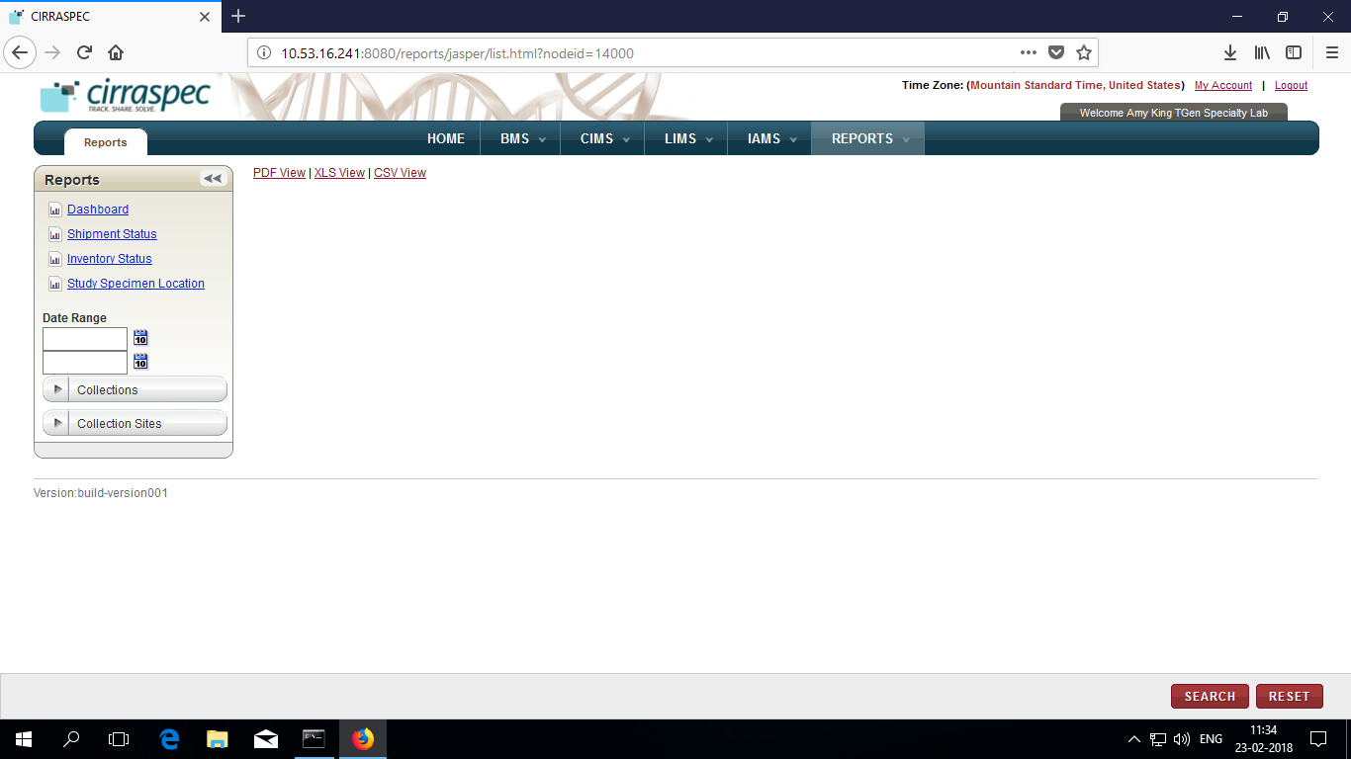

On this page, you can view reports as below and also generate custom reports:

* + - **Dashboard**

Summarized graphs for Inventory, Shipment, Kits are displayed on Dashboard.

For more information see **View Dashboard**.

* + - **Shipment Status**

For each Study, tracks Number of Shipments on every shipment status for each ShipmentType.

For more information see **View Shipment Status.**

* + - **Inventory Status**

For each study, tracks number of specimens on every specimen status for each specimen type.

For more information, see **View Inventory Status.**

* + - **Study Specimen Location**

Enables to Track number of Specimens by Donor/Subject, Location, Specimen Type.

For more information, see **View Study Specimen Location.**

* + - **Custom Reports**

You can also generate custom reports, For more information see **Custom report generation.**

**Note:** On Reports, Study refers to Collection. Donor refers to Subject.

### View Dashboard

To view Dashboard:

* + 1. Log in to Cirraspec using your credentials.

The CIRRASPEC home page appears.

* + 1. Point to the arrow of the **Reports** tab, and then click **Reports**.

The **Reports** page appears.

* + 1. Click on Dashboard link.

Dashboard appears.

You will see below graphs on this Dashboard:

* Inventory : Displays number of samples of each Specimen Type for every Sample Status.
* Kits : Displays number of kits of each Kit template for every Kit Status
* Shipments: Displays number of shipments of each Shipment Type at every Shipment status.

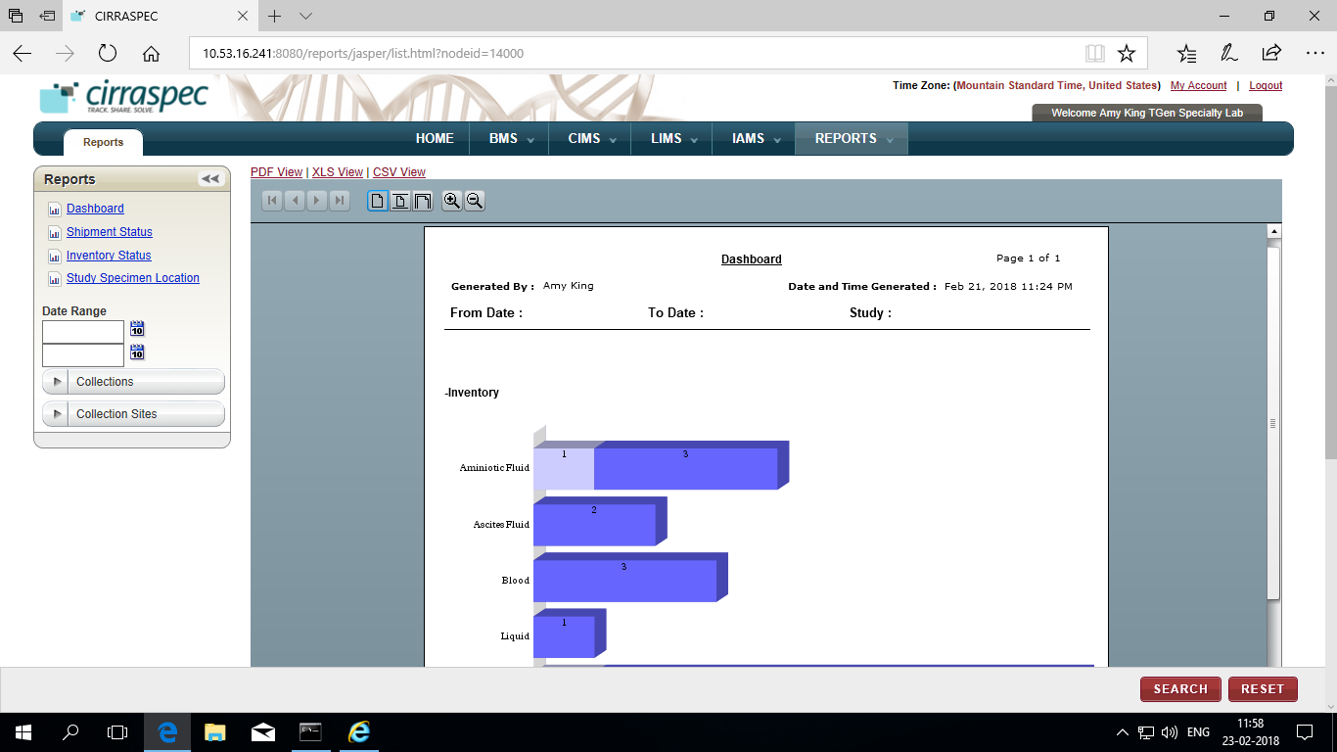

a. On top panel, you can use options to view report to Fit page, Fit width or zoom in, zoom out.

b. To access same Dashboard in different formats, Click on following links :

* PDF View
* XLS View
* CSV View

On the pop-up displayed, You can choose to either Open the Dashboard or Save the file onto your system.

Example of Dashboard pdf :



### View Shipment Status

To view Shipment Status Report:

* + 1. Log in to Cirraspec using your credentials.

The CIRRASPEC home page appears.

* + 1. Point to the arrow of the **Reports** tab, and then click **Reports**.

The **Reports** page appears.

* + 1. Click on **Shipment Status** link.

Shipment Status Report appears.

You will see below on this report:

* Table : Displays fields: Study, Type ( i.e Shipment Type), Status ( i.e Shipment Status), Count

Also after every Study, Count column Displays Total Count of Shipments for each study.

* Graphs : Displays Number of Shipment Types for every shipment status

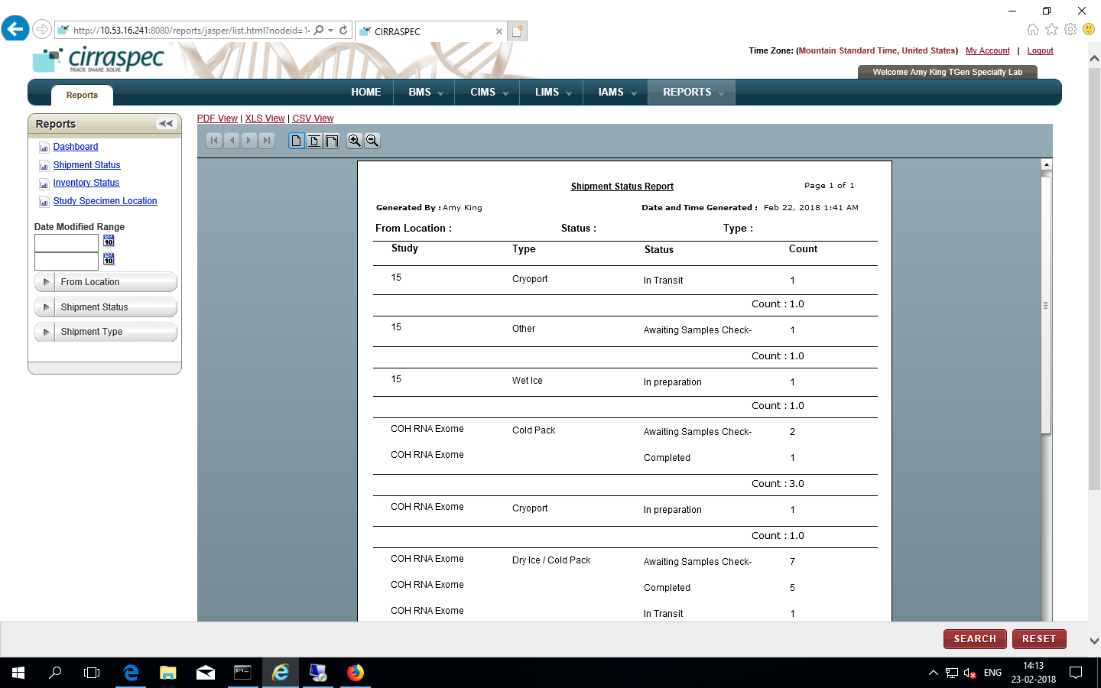

a. On top panel, you can use options to view report to Fit page, Fit width or zoom in, zoom out.

b. To access same Dashboard in different formats, Click on following links :

* PDF View
* XLS View
* CSV View

On the pop-up displayed, You can choose to either Open or Save the file onto your system.

Example of Shipment Status Report pdf :



### View Inventory Status

To view Inventory Status Report:

* + 1. Log in to Cirraspec using your credentials.

The CIRRASPEC home page appears.

* + 1. Point to the arrow of the **Reports** tab, and then click **Reports**.

The **Reports** page appears.

* + 1. Click on **Inventory Status** link.

Inventory Status Report appears.

You will see below on this report:

* Table : Displays fields: Study, Type ( i.e Sample Type), Status ( i.e Sample Status), Count

Also after every Study, Count column Displays Total Count of Samples for each study.

* Graphs : Displays Total count of Sample Staus for every Sample Type

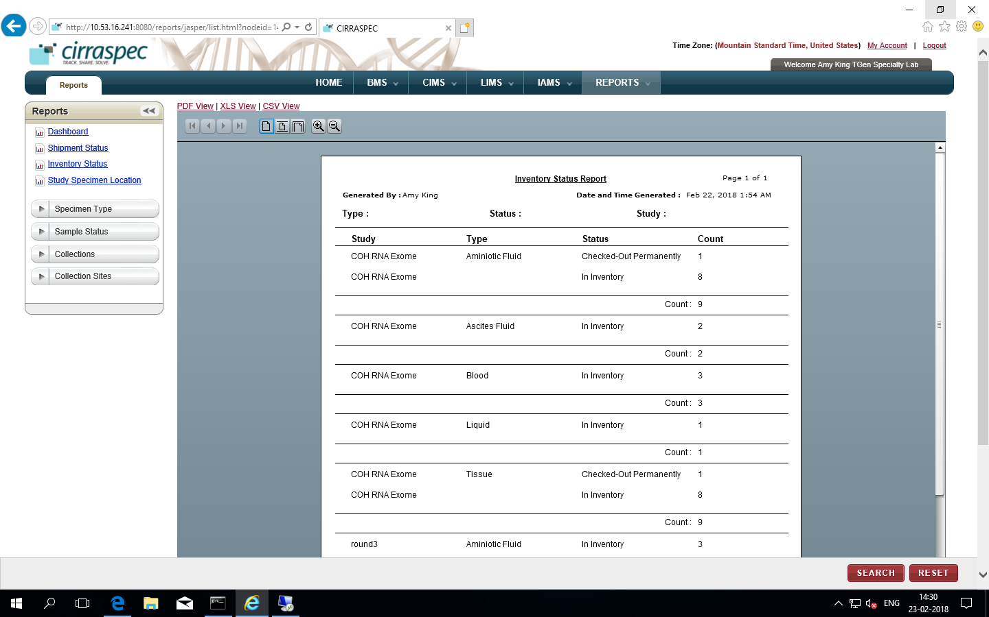

4.

a. On top panel, you can use options to view report to Fit page, Fit width or zoom in, zoom out.

b. To access same Dashboard in different formats, Click on following links :

* PDF View
* XLS View
* CSV View

On the pop-up displayed, You can choose to either Open or Save the file onto your system.

Example of Inventory Status Report pdf:



### View Study Specimen Location

* + 1. Log in to Cirraspec using your credentials.

The CIRRASPEC home page appears.

* + 1. Point to the arrow of the **Reports** tab, and then click **Reports**.

The **Reports** page appears.

* + 1. Click on **Study Specimen Location** link.

**Study Specimen Location** tableau dashboard appears.

You will see below on this:

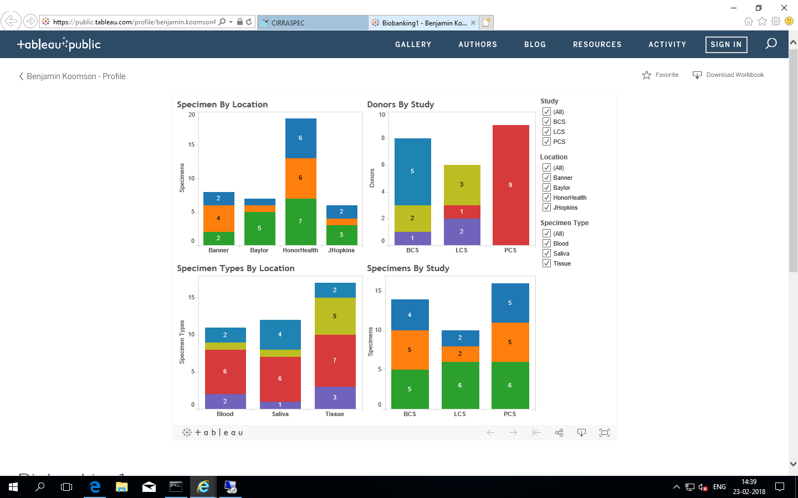

**Note:**

* On top panel right panel use filters for Study, Location and Specimen Type to view graphs as required.
* You can also, click on Download workbook to export a copy to your system.

### Custom Report Generation

To view custom reports using search options from the left pane:

* + 1. Log in to Cirraspec using your credentials.

The CIRRASPEC home page appears.

* + 1. Point to the arrow of the **Reports** tab, and then click **Reports**.

The **Reports** page appears.

* + 1. Click on the Report link on left for which you require to generate a customized report.

Search options on left pane get updated.

Refer below table to know the search critera for each report:

|  |  |
| --- | --- |
| Dashboard | Date Range, Collections, Collection Site |
| Shipment Status | Date Modified Range, From Location, Shipment Status, Shipment Type |
| Inventory Status | Specimen Type, Sample Status, Collections, Collection Sites |

* + 1. Click Search.

The Report gets generated as per the search criteria.

5.

a. On top panel, you can use options to view report to Fit page, Fit width or zoom in, zoom out.

b. To access same in different formats, Click on following links :

* PDF View
* XLS View
* CSV View

On the pop-up displayed, You can choose to either Open or Save the file onto your system.

# Alternative Paths on Home Page for Common Use Functionalities:

You can access the CIRRASPEC home page from any other page by clicking the **Home** tab.

You can directly go to the page to perform below functions using the **Easy Access Links** on the Home page.

Click on the link on Home page & move to the respective section in this manual for detailed steps to perform.

Specimen Inventory

* Search Specimens
* Add Specimens

Kits Inventory

* Search Kits
* Create and ship Kits

Patient Management

* Search Patients
* Enroll <<Collection name>>

Shipments

* Search Shipments
* Ship Shipments
* Receive Shipments
* Redistribute Shipments

Workflows

* Search Workflows
* Generate Derivatives
* Generate Aliquots

**Note: You can Search for Patient, Kit, Specimen using their barcodes.**

To search by barcodes:

* + 1. Scan or enter the barcode
    2. Click on Search icon

